NAME: ………………………………………………... INDEX NO. …………………

DATE: ….……………………………… CANDIDATE'S SIGNATURE: ……………
CLASS: ………………………
312/2
GEOGRAPHY PAPER 2
SEPTEMBER, 2021
Time: 2¾ hours
KASSU-JET JOINT MOCK EXAMINATION.
Kenya Certificate of Secondary Education
PAPER TWO
GEOGRAPHY.
INSTRUCTIONS TO CANDIDATES
This paper has two sections: A & B.
- Answer all questions in section A.
- In section B ,answer question 6 and any other two questions.
- All answers to be written in foolscaps provided.
FOR OFFICIAL USE ONLY
SECTION A | 1 | 2 | 3 | 4 | 5

SECTION B | 6 | 7 | 8 | 9 | 10

This paper consists of 8 printed pages. Candidates should check the question paper to ascertain that all pages are printed as indicated and that no pages are missing.
SECTION A

Answer all the questions in this section.
- a) What is Agroforestry? (2 marks)

b) Outline three exotic softwood tree species grown in Kenya. (3 marks)

2. a) Distinguish between Land reclamation and Land rehabilitation. (2 marks)

b) Identify three methods of Land reclamation used in Kenya. (3 marks)

3. a) What is Eco-tourism. (2 marks)

b) State three benefits of Domestic tourism in Kenya. (3 marks)

4. a) Define the term Trade. (2 marks)

b) Name three major imports of Kenya from the Middle East. (3 marks)

5. a) Apart from road transport, give two other forms of Land transport. (2 marks)

b) State three advantages of road transport. (3 marks)

SECTION B
6. (a) The photograph below shows some mining activities. Study and use it to answer the questions that follow. 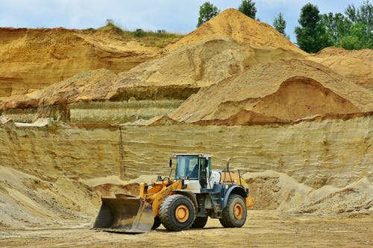
- Identify the type of photograph. (1 mark)
- Give reasons for your answer in (i) above. (3marks)
- Draw a rectangle measuring 10cm by 12cm to represent the photograph. (1 mark)
- On it, mark and label four main features. (4marks)
- State three negative effects of the mining method shown in the photograph to the physical environment. (3marks)
(b) (i) Name two gold mining areas in South Africa. (2marks)
- Describe the process of gold processing. (5marks)
- Explain three economic benefits of petroleum to the oil producing countries in the Middle East region. (6 marks)

7. (a) (i) Define pastoral farming. (2 marks)
(ii) Name three pastoral communities in Kenya. (3 marks)
(b) (i) Identify two exotic beef cattle breeds kept in Kenya. (2 marks)
(ii) Outline three characteristics of nomadic pastoralism. (3 marks)
(c) (i) Explain three factors favouring beef farming in Kenya. (6 marks)
(ii) State four similarities between beef farming in Kenya and Argentina. (4 marks)
(d) Your class carried a field study on tea processing.
(i) Outline 3 stages of tea processing that the class may have observed.
(3 marks)
(ii) State two methods that the class may have used to present data. (2 marks)
8. (a) The diagram below shows a fishing ground in the pacific ocean.
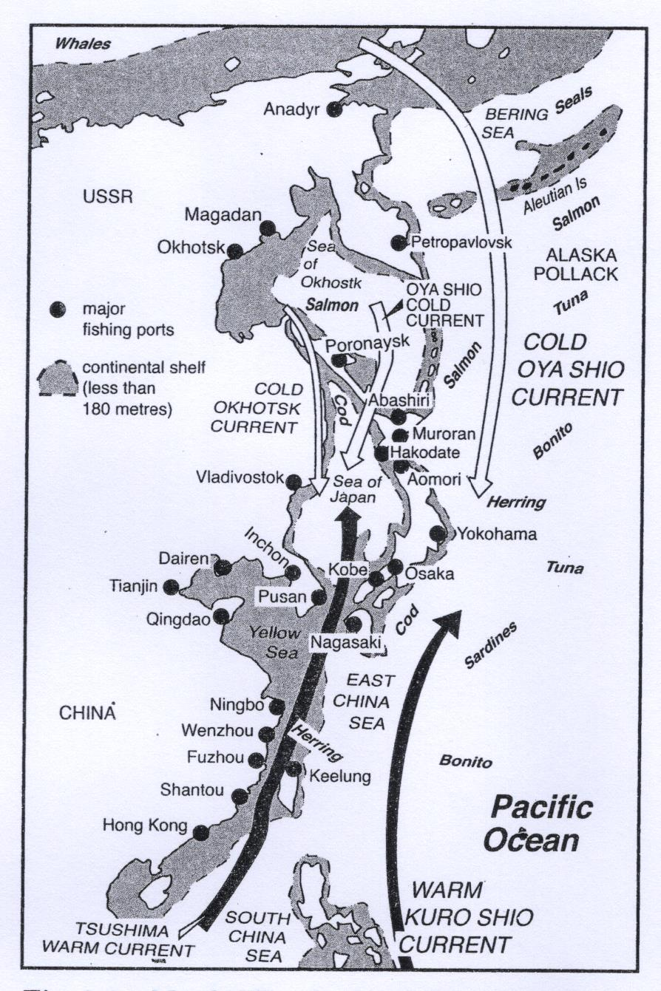
- Identify the fishing ground shown above. (2 marks)
- Name two types of fish species found in the fishing ground above. (2 marks)
(b) (i) Differentiate between fishing and fisheries. (2 marks)
(ii) Name two inland types of fisheries in Kenya. (2 marks)
(c) (i) Describe the long lining fishing method. (4 marks)
(ii) Explain three physical factors that have influenced the development of fishing in
Japan. (6 marks)
(d) (i) State four problems that face Marine fishing in Kenya. (4 marks)
(ii) Give three ways of conserving fresh water fisheries in Kenya. (3 marks)
9. (a) (i) Define the term energy. (2 marks)
(ii) Name two types of renewable energy. (2 marks)
(b) Study the diagram of the seven forks dam power project provided below and use it to answer the questions that follow.
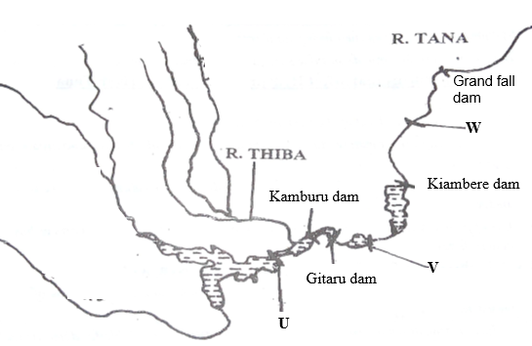
(i) Identify the dams labeled U and V. (2 marks)
(ii) Explain three physical factors that favored the establishment of the seven forks power project. (6 marks)
(iii) State three benefits of the seven forks power scheme. (3 marks)
(c) (i) What is energy crisis? (2 marks)
(ii) Explain four effects of the energy crisis to the economies. (8 marks)
10. (a) (i) Define industrial decentralization. (2 marks)
(ii) State three causes of industrial inertia. (3 marks)
(b) Name three non-agricultural industries in Kenya. (3 marks)
(c) Explain four measures the government of Kenya is undertaking to promote
Jua kali industry in Kenya. (8 marks)
(d) Study the map of Ruhr region below and use it to answer question (a).

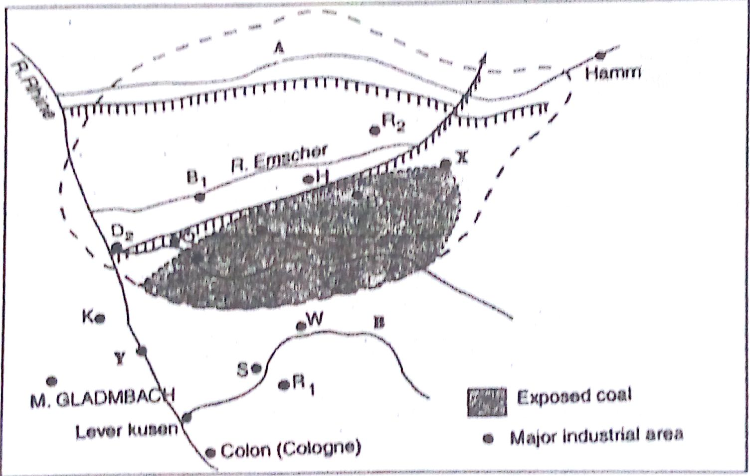

(i) Identify
- the river marked A. (1 mark)
- the canal marked H. (1 mark)
- the town marked Y. (1 mark)

(ii) Explain three human factors that led to the growth of Ruhr industrial region.
(6 marks)

