312/1
NAME…………………………………………….……. INDEX NO………..…………………..
SIGNATURE……………………………….………………DATE……………………………..

ASUMBI GIRLS HIGH SCHOOL
POST -MOCK 1
AUGUST/SEPTEMBER
2022
AUGUST / SEPTEMBER - 2022

GEOGRAPHY - PAPER 1
TIME: 2³/₄ HRS
INSTRUCTIONS TO CANDIDATES.
- Write your name, class and admission number in the spaces provided above.
- Sign and write the date of the examination in the spaces provided above.
- This paper has two sections: A and B.
- Answer all the questions in sections A.
- Answer question 6 and any other two questions from Section B.
- All answers must be written in the answer booklet provided.
- This paper consists of 3 printed pages.
- Candidates should check the question paper to ascertain that all the pages are printed as indicated and that no questions are missing.
- Candidates should answer the questions in English.

For Examiner’s Use Only
Section | Questions | Maximum  Score | Candidate’s  Score
A | 1 – 5 | 25
 | 6 | 25
B |  | 25
 |  | 25
 |  | Total Score

SECTION A
Answer all the questions in this section.
1. (a) State three effects of the rotation of the earth on its axis. (3 marks)
(b) Give two proofs that the earth is spherical. (2 marks)
2. (a) State three factors that influence how the wind blow. (3 marks)
(b) Identify two types of local winds. (2 marks)
3. (a) Identify two characteristics of minerals. (2 marks)
(b) Give three classifications of mechanically formed sedimentary rocks. (3 marks)
4. (a) Identify two scales used to measure earthquakes. (2 marks)
(b) State three effects of earthquakes. (3 marks)
5. (a) State three characteristics of Savanna vegetation. (3 marks)
(b) Give two uses of Savanna vegetation to man. (2 marks)
SECTION B
Answer question 6 and any other two questions from this section.
6. Study the map of NYERI 1:50,000 (sheet 120/4) provided to answer the following questions.
(a) (i) Convert the linear scale of the map to a Representative Fraction (RF) scale. (1 mark)
(ii) Identify two districts shown on the map. (2 marks)
(b) (i) Give the six figure grid reference of the road junction at Gunyumu Farm. (2 marks)
(ii) Measure the distance of all-weather road bound surface D435 from grid reference 715549 to grid
reference 654549 (2 marks)
(c) (i) Give the direction and bearing of the Ark Lodge in grid square 5661 from the trigonometrical station
in grid square 5164. (2 marks)
(ii) Give the longitudinal position of the North Eastern corner of the area covered by the map. (2 marks)
(d) (i) Describe how relief has influenced transport in the area covered in the map. (4 marks)
(ii) Describe the factors that have influenced the distribution of settlement in the area covered by the
map. (6 marks)
(e) Citing evidence from the map, describe two functions of Mweiga town. (4 marks)
7. (a) (i) What is faulting? (2 marks)
(ii) Identify four types of faults. (4 marks)
(b) Using a well-labelled diagram, describe the formation of block mountains by tensional forces. (8 marks)
(c) Explain four positive effects of faulting to human environment. (8 marks)
(d) You are supposed to carry out a field study on faulting in the Rift-Valley field study.
- State two objectives for your study. (2 marks)
- Identify two follow up activities you are likely to carry out after the field study. (2 marks)
8. (a) (i) Identify three processes through which waves erode the coastline. (3 marks)
(ii) Apart from blowholes, list three features that are produced by wave erosion along the coast.
(3 marks)
(b) With aid of well-labelled diagrams, describe how a blowhole is formed. (8 marks)
(c) Describe how a spit is formed. (4 marks)
(d) AGHS students conducted a field study on coastal features along the Kenyan coast.
- List three features of coastal emergence they are likely to have studied. (3 marks)
- State four ways in which features resulting from coastal emergence are of significance to Kenya.
(4 marks)
9. Use the world map below to answer questions (a) and (b).
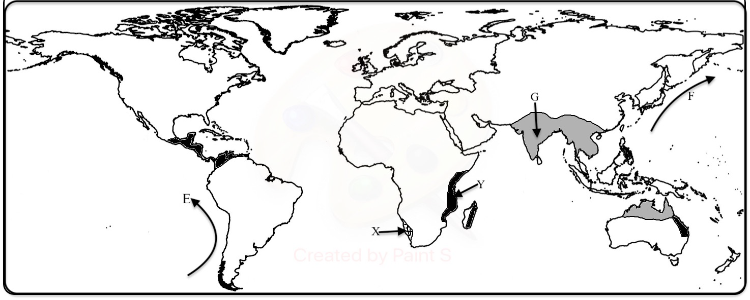
(a) (i) Identify the climate marked X and Y. (2 marks)
(ii) Name the ocean currents marked E and F. (2 marks)
(b) Describe the characteristics of the climate marked G. (8 marks)
(c) Explain how the following factors influence climate:
- Latitude; (2 marks)
- Aspect; (2 marks)
- Configuration of the coastline. (2 marks)
(d) (i) State three factors that influences atmospheric pressure. (3 marks)
(ii) Describe how relief rainfall is formed. (4 marks)
10. (a) State four factors that determine the amount of surface run-off. (4 marks)
(b) Describe three ways in which a river transport its load. (6 marks)
(c) Using diagrams,describe the following drainage patterns:
(i) Dendritic; (2 marks)
(ii) Trellis; (2 marks)
(iii) Centripetal. (2 marks)
(d) (i) What is a delta? (2 marks)
(ii) State three ideal conditions under which a delta may be formed. (3 marks)
(iii) State four factors that lead to river deposition. (4 marks)

