ASUMBI GIRLS HIGH SCHOOL
POST -MOCK 1
AUGUST/SEPTEMBER

2022

GEOGRAPHY PP2 MS

SECTION A
- (a) Name two counties where floriculture is practiced in Kenya. (2 marks)
  - Kiambu.
  - Kajiado.
  - Nyeri.
  - Nakuru.
  - Nyandarua.
- State three characteristics of horticultural farming in Kenya. (3 marks)
  - Farms are small in size.
  - Land is intensively farmed.
  - Advanced scientific methods are used.
  - It is labour intensive for the management of crops.
  - Practiced in areas with well – developed roads/air transport.
  - It is capital intensive to purchase inputs.
  - It is export oriented.
- (a) Name two agricultural food processing industries in Kenya. (2 marks)
  - Sugar processing.
  - Tea processing.
  - Brewing.
  - Bakeries.
  - Meat processing
  - Grain milling.
  - Fruit canning.
  - Vegetable processing.
- State three problems facing Jua – Kali industries in Kenya. (3 marks)
  - Difficulty in getting raw materials limits production of jua kali products.
  - Inadequate capital for expansion.
  - Inadequate marketing skills or strategies limits flow of jua kali products.
  - Inadequate security hence theft of products.

- (a) The sketch map below shows Hydroelectric Power(H.E.P) along the River Tana. Use it to answer question (a)
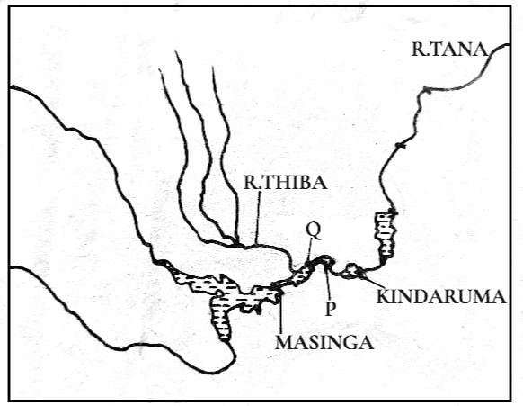
Name the Hydroelectric power (H.E.P) stations marked P and Q. (2 marks)
- Gitaru
- Kamburu
- State three reasons that limit the use of nuclear energy in Kenya. (3 marks)
  - Insufficient technology and skill.
  - Risks of accidents causes fear to install nuclear plants.
  - Insufficient uranium reserves.
  - It is expensive to install nuclear plants/inadequate capital.
- (a) Give two effects of the liberalization of the oil industry in Kenya. (2 marks)
  - It has created variation in oil prices.
  - It has led to mushrooming of many petrol dealers.
  - It has encouraged importation of refined products.
  - Frequent price adjustments.
  - Widespread availability of petrol products.
- State three problems that have hindered the decentralization of industries in Kenya. (3 marks)
  - Some industries depend on each other hence it is difficult to separate them.
  - Inadequate market in the rural areas discourages investor from locating industries.
  - Insecurity in some areas discourages investment in such areas.
  - Collapse of industries in rural areas discourages fresh investments in similar industries.

  - Inaccessibility of remote areas such as rural area discourages investors.
- (a) Apart from pastoral farming, name two other types of commercial livestock farming practiced in Kenya.
(2 marks)
  - Dairy farming
  - Beef cattle farming.
- State three factors that favour pastoral farming in Kenya. (3 marks)
  - Presence of gently sloping landscape for easier movement of pastoralist and their cattle.
  - Presence of large and extensive tracts of land due to sparse population.
  - Scarcity of water and pasture.
  - Absence of tsetse lies in the grazing areas.

SECTION B
Answer question 6 and any other two questions from this section.
- Use the data provided to answer the questions that follow.

Kenya: Value by Foreign Trade between 1999 – 2007 in million Ksh.

YEAR | 1999 | 2000 | 2001 | 2002 | 2003 | 2004 | 2005 | 2006 | 2007
EXPORTS | 985 | 1.230 | 1,170 | 1,080 | 1,020 | 1,310 | 1,450 | 1,590 | 1,860
IMPORTS | 2,270 | 2,910 | 3,195 | 4,029 | 4,131 | 4,247 | 4,585 | 4,422 | 4,516
- (i) Draw comparative line graphs to represent the data given. Use a scale of 1 cm to represent 500 million Ksh. on the vertical axis. (7 marks)

COMPARATIVE LINE GRAPHS REPRESENTING VALUE OF FOREIGN TRADE IN KENYA BETWEEN 1999 – 2007 IN MILLION KSH
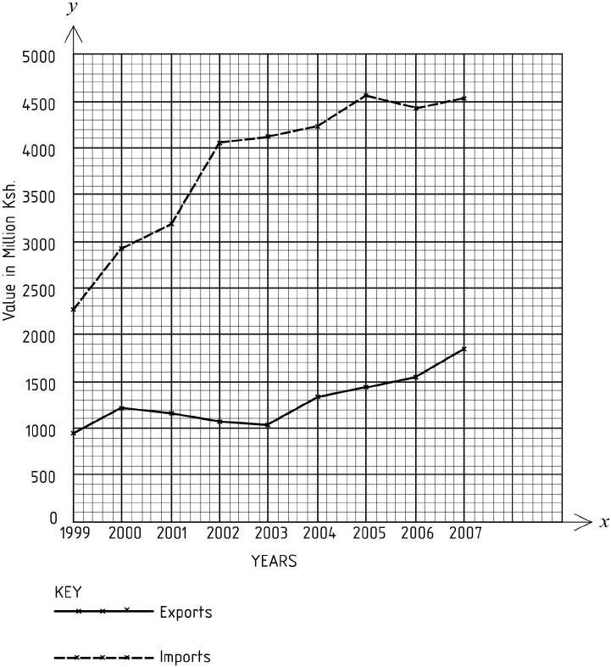

- Describe the trend of value of exports from 1999 to 2007. (3 marks)
  - The value was low in 1999 then increased in 2000.
  - It then declined from 2001 to 2003.
  - The value then increased from 2004 to 2007.
- Describe the factors which may have led to the increased export earnings from 2004. (6 marks)
  - Improved industrial technology which led to improved quality of goods thus fetching high prices.
  - Aggressive promotion of goods from the Kenya abroad which created a large international market leading to selling of more goods.
  - Improved transport such as roads, air transport and communication which led to fast movement of goods.
  - Diversification of exports which led to more goods to more earnings.

  - More tourists visiting the country leading to more earnings.

- Explain why Kenya experiences unfavorable balance of trade. (6 marks)
  - Kenya mainly exports agricultural raw materials that fetch low prices.
  - She imports manufactured goods which are very expensive.
  - Goods face stiff completion in the world market which leads to reduced sales and less earnings.
  - Other countries impose quotas on goods from Kenya and this limits the amount of goods that can be exported leading to reduced sales and earnings.
  - Some of the goods exported from the Kenya are low quality and hence earn very little.
- State three ways in which the Kenya government is promoting export trade. (3 marks)
  - The government is signing international trade agreements with other countries in order to promote trade e.g. she is a member of COMESA,EAC.
  - The government has established Export Processing Zones(EPZ) that produce goods for export.
  - The government has reduced import duty on raw materials.
  - The government is encouraging foreign investors to establish more industries in the country for production of export goods.
  - Issuing of licenses promptly by the government to those willing to engage in trade.
  - The government has introduced export compensation schemes on locally produced goods to encourage more traders.
  - The country participates in trade fairs and international exhibitions to display goods.
  - It encourages production of high quality goods.

  - The government is improving roads and communication systems such as internet to improve volume of

trade/transactions.
- The diagram below represents a fishing method. Use it to answer question (a) below.
3  1 = 3 marks

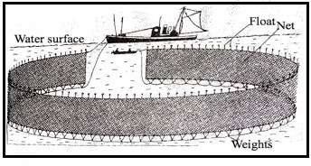

- (i) Identify the method of fishing shown below. (1 mark)
  - Purse seining.
- Describe how the above method is used in fishing. (5 marks)
  - It uses two boats, one large and other small.
  - It uses a large net.
  - The net has floats on top and weight at the bottom to keep it in a vertical position while in water.
  - The net has a string along its bottom edge.
  - The fishermen begins by locating a shoal/area rich in fish.
  - The small boat drags the net to enclose the area that has fish.
  - The string at the bottom of the net is pulled to close the net at the bottom and trap the fish.
  - The net is pulled out of the water and fish hauled into the large boat for preservation and transportation

to the shore.

- Give three examples of fish species caught by the above method. (3 marks)

  - Salmon.
  - Tuna.
  - Herring.
  - Halibut.
  - Sardines.
  - Hake.

- Explain four factors that favour the fishing industry in Japan. (8 marks)
  - The cool waters that are ideal for fish breeding because of the abundant fish food.
  - The Japanese coast has many off – shore islands which provide sheltered inlets idea; for the establishment of fishing ports/villages.
  - The indented coastline provides secure breeding ground for fish.
  - The meeting/convergence of warm Kuro Siwo and the cold Oya Siwo ocean currents result in upwelling of sea water thus bringing minerals for the planktons from the sea bed too the surface.
  - The mountainous nature of the country restricts agricultural activities hence fishing is an alternative economic activity.
  - Most settlements are found along the coast and the main occupation is fishing.
  - The Japanese have advanced deep sea fishing technology that is used in fishing, processing and preservation of fish.
  - Japan has a dense population which provide large local market for fish.
  - Japanese have a long history of marine activities thus they are highly experienced in fishing.
  - The broad shallow continental shelf allow light to the sea bed for growth of plankton which is fish food.
  - The presence of cool waters encourages thriving of numerous species of aquatic life.
- Explain four reasons why East Africa does not export large quantities of fish. (8 marks)
  - There is low production in the three East African countries due to poor fishing methods√/inadequate capital√/ fishing technology. √
  - Fish from tropical water are small and oily which make them fetch low prices at the international market.
  - Frequent outbreak of diseases like cholera/ebola discourages other countries from importing fish from East Africa due to fear of diseases.
  - Some methods of fishing used by fishermen such as use of chemicals to kill fish have discouraged many potential importers.
  - The narrow and irregular continental shelf reduce the amount of fish existing in the region.
  - Stiff competition from more efficient fishing nations such as China/Japan which limit the foreign market.

- (a) Identify three kinds of roads used in Africa. (3 marks)
- All weather roads.
- Dry weather roads.
- Tracks/motorable.
- Footpaths.
- Name four major high ways in Africa. (4 marks)
- Trans-African Highway
- Trans-Saharan Highway
- West African Highway.
- The Great North Road.
(c) (i) Name four major world sea routes. (4 marks)
- Panama canal sea route.
- Cape of Good Hope Sea route.
- North Pacific sea route.
- Mediterranean Asiatic Sea route.
- North Pacific Sea route.
(ii)Explain two factors that make the major sea and ocean routes to be concentrate in the Northern Hemisphere.
- marks)
- The high degree of industrialization which are needed to transport the finished products to the international market and raw materials to industries reduces transport cost via sea.
- Intensive trading activities necessitates sea route to transport heavy and bulky goods.
- Availability of numerous ocean terminals in the developed countries of Europe provide deep sea water for docking of ship.
(d) (i) Give two forms of written communication. (2 marks)
- Letters.
- Reports.
(ii) Explain four human problems facing transport in Africa. (8 marks)
- Inadequate capital among African countries to construct roads forces many countries to borrow loans from foreign countries/many roads are unmaintained.
- Inadequate skilled labour causes many African countries to rely on foreign expatriates which are expensive/roads wear out easily.
- Low population density in some regions hinders construction of roads/railway since it is
uneconomical.
- Existence of different railway and road systems hinders connectivity.
- Vandalism of some road signs causes loss of direction on roads/insecurity.
- Mismanagement of the transport sector
- The diagrams below shows the population structures of two countries A and B. Study it and answer the questions that follow.
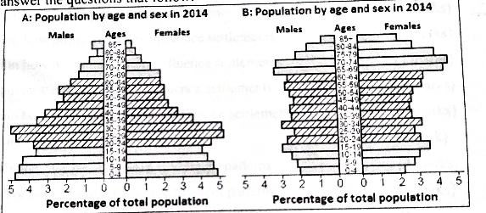
- Identify the type of graph above. (1 mark)
- Population pyramid/age-sex pyramid.
- (i) Which one belongs to Kenya. (1 mark)
- A
(ii) Which one belongs to Sweden. (1 mark)
- B
- Describe five characteristics of population structure for country A. (5 marks)
- Aging population is low.
- Life expectancy is low.
- Dependency ration is high.
- The population has a high birth rate – wide base
- The population has a high death rate/mortality rate.
- From age 0-34 the population is high.
- The working population is lower than the dependants.
- There are more females than males.
- (i) List two types of internal migration. (2 marks)
- Rural-rural
- Urban-urban
- Rural-urban
- Urban-rural
(ii) Give three ways in which government policy causes migration. (3 marks)
- Establishment of irrigation schemes causes displace of people.
- Government mining projects like the case of titanium mining in Kwale cause displacement of people.
- Establish of hydropower project by the government which resettle the people and compensate them.
- State any four problems resulting from high population growth rate. (4 marks)
- Presence of many dependants i.e dependents are more than those working, hence less investment.
- High dependency ratio means there is a little saving for investment at local level.
- The forests and marginal lands are invaded by the landless leading to land degradation.
- The government concentrates more in provision of basic facilities e.g school, food, health
services rather than investing.
- Increased unemployment since job opportunities are low compare to the pace at which the
population is growing.
- It makes the government to concentrates in food production. This competes the cash crops thus reduced
exports ,hence less foreign exchange.
- Explain four factors that have contributed to high population growth in Kenya. (8 marks)
- Improved health facilities. Some childhood diseases such as measles and whooping cough are
now controlled by vaccination increases chances of survival.
- Improved nutrition and increased food production reduces mortality rate.
- High fertility rates and decreasing mortality rates improves life span for many Kenyans.
- Many Kenyans have ignored family planning methods/artificial birth control methods due to
religious belief.
- Cultural belied have contributed to large families e.g preference for many children as security
in old age.
- Early marriages increase their fertility rates.
- Preference of certain sex of a child and polygamy result to large families.

- (a) Identify two irrigation schemes in Kenya other than Mwea Tebere. (2 marks)
  - Kibirigwi.
  - Rupingazi.
  - Ishara.
  - Mtonguu.
  - Kunai.
  - Bura.
  - Hola(Galole).
  - Perkerra.
  - Turkwell
  - Kibwezi.
  - Ahero.
  - Bunyala.
- Differentiate between land rehabilitation and land reclamation. (2 marks)
  - Land reclamation is a process by which unproductive land is converted to productive land and used for crop farming or settlement while land rehabilitation is the restoration of land that had been destroyed through human activities to its former productivity.
- Explain three factors that have led to the success of Mwea Tebere Irrigation Scheme. (6 marks)
  - Availability of constant supply of water from perennial rivers Murubara,Nyamindi and Thiba throughout the year required for irrigation.
  - Availability of adequate capital from foreign countries/expertise from foreign countries necessary to purchase farm inputs.
  - Presence of black cotton /loamy soils which can hold water for a while.
  - Existence of low-lying gently sloping land which enable water to flow by gravity.
- State four significance of irrigation farming in Kenya. (4 marks)
  - Irrigation farming leads to increased food production.
  - The crops grown can be exported to earn foreign exchange.
  - It earns income to farmers through sales of the produce.
  - It creates employment opportunities enable people earn income.
  - It opens up remote areas for economic development.

  - It makes use of underutilized land.
  - Some provide raw materials to industries.
  - It leads to diversification of the economy.
- Explain two methods are used to rehabilitate land. (4 marks)
  - Afforestation/re – afforestation/agroforestry which controls soil erosion.
  - Controlling of soil erosion through various methods such as terracing/planting cover crops.
  - Application of manure and fertilizers helps to improve/restore soil fertility.
  - By filling open pits/land scaping in order to be used for farming/settlement.
  - By constructing terraces thereby reducing the speed of surface runoff.
  - By planting trees / grass strips on degraded land thereby protecting it against the agents of erosion.
  - By building gabions in order to hold/trap the soil carried by water.
  - By constructing dykes along river banks/dams across rivers in order to control floods.
  - By irrigating semi – arid areas/during dry seasons in order to provide water required for crop growth.
  - Bush fallowing to allow land to regain fertility.
  - Mulching / cover crops/ cut off drains to retain soil moisture/ add humus.
  - Drainage trenches to remove excess water from the land.
  - Controlled grazing to allow regeneration of pastures.
- Explain the steps followed in reclaiming land in Netherlands. (7 marks)
  - Protective dykes are constructed to enclose the area to be reclaimed.
  - Ring canals are constructed to carry out water back into the sea.
  - Pumping stations are installed/built to pump water from the land to the ring canal.
  - Water is pumped out of the area.
  - Reeds are sown to drain excess water/check weeds.
  - Drainage ditches are cut into the land and drainage pipes laid.
  - More pumping stations put to
  - Area is divided into rectangular blocks using inner dykes and canals.
  - Soils are treated with chemicals to lower salinity flushed with fresh water to remove excess salt from the soil.
  - Pumping out of the water from fresh water is then continuous.
  - Experimental crops are planted.

