NAME…………………………………………………………………………………...INDEX NO………………………
CANDIDATE SIGNATURE……………………………………
DATE………………………………………

443/1

AGRICULTURE.
PAPER 1.

JULY / AUGUST 2019.
TIME: 2 HOURS.

GATUNDU SOUTH SUB-COUNTY JOINT EVALUATION EXAMINATION 2019.
AGRICULTURE PAPER 1.
JULY/AUGUST 2O19.
INSTRUCTION TO THE CANDIDATE
1. Write your name and index number in the space provided.
2. The paper consists of section A, B and C.
3. Answer all questions in section C in the space provided.
For examiner use only
SECTION | QUESTIONS | MAXIMUM SCORE | CANDIDATES SCORE
A | 1-13 | 30
B | 14-19 | 20
C | 20-22 | 20
TOTAL |  | 90

SECTION A (30 MARKS)
ANSWER ALL QUESTIONS

- (a)Give two advantages of organic farming in regard to environmental conservation (1mark)
i)……………………………………………………………………………………………………………………………………………………………………………………………………………………………………………………………………………………………………….

ii)……………………………………………………………………………………………………………………………………………………………………………………………………………………………………………………………………………………………………….
(b)State two importance of ridging (1mark)
I) …………………………………………………………………………………………………………………………………………………………………………………………………………………………………………………………………………………………………………..ii) ………………………………………………………………………………………………………………………………………………………………………………………………………………………………………………………………………………………………………..

2. State the three economic conceits (1 ½ marks)
i)…………………………………………………………………………………………………………………………………………………………………………………………………………………………………………………………………………………………………………..ii)……………………………………………………………………………………………………………………………………………………………………………………………………………………………………………………………………………………………………………………………………………………………………………………………………………………………………………………………………………………………………………………………………………………………………………………………………………….
3. List down three types of nurseries in crop production (1 ½ marks)
i)………………………………………………………………………………………………………………………………………………………………………………………………………………………………………………………………………………………………………………………ii)………………………………………………………………………………………………………………………………………………………………………………………………………………………………………………………………………………………………………………………iii)…………………………………………………………………………………………………………………………………………………………………………………………………………………………………………………………………………………………………………………………………………………………………………………………………………………………………………………………………………………………

4. State four harmful effects of weeds in pasture production and livestock nutrition (2 marks)
i)………………………………………………………………………………………………………………………………………………………………………………………………………………………………………………………………………………………………………………………ii)………………………………………………………………………………………………………………………………………………………………………………………………………………………………………………………………………………………………………………………iii)…………………………………………………………………………………………………………………………………………………………………………………………………………………………………………………………………………………………………………………………………………………………………………………………………………………………………………………………………………………………

5. Agriculture is said to be source of market for some industrial products. Name four such products (2 marks)

i)…………………………………………………………………………………………………………………………………………………………………………………………………………………………………………………………………………………………………………..ii)………………………………………………………………………………………………………………………………………………………………………………………………………………………………………………………………………………………………………..iii)………………………………………………………………………………………………………………………………………………………………………………………………………………………………………………………………………………………………..………iv)………………………………………………………………………………………………………………………………………………………………………………………………………………………………………………………………………………………………………
6. List four factors which should be considered when determining the depth of planting maize seeds (2 marks)

i)…………………………………………………………………………………………………………………………………………………………………………………………………………………………………………………………………………………………………………..ii)………………………………………………………………………………………………………………………………………………………………………………………………………………………………………………………………………………………………………..iii)………………………………………………………………………………………………………………………………………………………………………………………………………………………………………………………………………………………………..………iv)………………………………………………………………………………………………………………………………………………………………………………………………………………………………………………………………………………………………………

7. After soil analysis, a farmer was informed that his soil needed 20 kg (N) per hectare .How much of urea 45% (N) did he apply to satisfy nitrogen needs in his 5 hectares of farm (3 marks)
i)………………………………………………………………………………………………………………………………………………………………………………………………………………………………………………………………………………………………………………………ii)………………………………………………………………………………………………………………………………………………………………………………………………………………………………………………………………………………………………………………………iii)………………………………………………………………………………………………………………………………………………………………………………………………………………………………………………………………………………………………………………………………………………………………………………………………………………………………………………………………………………

8. Describe four different problems brought by water on the farm (2 marks)

i)…………………………………………………………………………………………………………………………………………………………………………………………………………………………………………………………………………………………………………..ii)………………………………………………………………………………………………………………………………………………………………………………………………………………………………………………………………………………………………………..iii)………………………………………………………………………………………………………………………………………………………………………………………………………………………………………………………………………………………………..………iv)………………………………………………………………………………………………………………………………………………………………………………………………………………………………………………………………………………………………………

9. (a) List down four important details in a tittle deed.(2 marks)

i)…………………………………………………………………………………………………………………………………………………………………………………………………………………………………………………………………………………………………………..ii)………………………………………………………………………………………………………………………………………………………………………………………………………………………………………………………………………………………………………..iii)………………………………………………………………………………………………………………………………………………………………………………………………………………………………………………………………………………………………..………iv)………………………………………………………………………………………………………………………………………………………………………………………………………………………………………………………………………………………………………

(b)Define the term “individual tenure system” (1 marks)

I) …………………………………………………………………………………………………………………………………………………………………………………………………………………………………………………………………………………………………………..ii) ………………………………………………………………………………………………………………………………………………………………………………………………………………………………………………………………………………………………………..

10. (a) Name four types of financial documents (2 marks)

i)…………………………………………………………………………………………………………………………………………………………………………………………………………………………………………………………………………………………………………..ii)………………………………………………………………………………………………………………………………………………………………………………………………………………………………………………………………………………………………………..iii)………………………………………………………………………………………………………………………………………………………………………………………………………………………………………………………………………………………………..………iv)………………………………………………………………………………………………………………………………………………………………………………………………………………………………………………………………………………………………………

(b)Name four sources of capital available to the Kenya farmer for agriculture production. (2 marks)

i)…………………………………………………………………………………………………………………………………………………………………………………………………………………………………………………………………………………………………………..ii)………………………………………………………………………………………………………………………………………………………………………………………………………………………………………………………………………………………………………..iii)………………………………………………………………………………………………………………………………………………………………………………………………………………………………………………………………………………………………..………iv)………………………………………………………………………………………………………………………………………………………………………………………………………………………………………………………………………………………………………

11. Give four reasons why needs out-complete crops in the field (2 marks)

i)…………………………………………………………………………………………………………………………………………………………………………………………………………………………………………………………………………………………………………..ii)………………………………………………………………………………………………………………………………………………………………………………………………………………………………………………………………………………………………………..iii)………………………………………………………………………………………………………………………………………………………………………………………………………………………………………………………………………………………………..………iv)………………………………………………………………………………………………………………………………………………………………………………………………………………………………………………………………………………………………………

12. Name four types of lands which may be reclaimed. (2marks)
i)…………………………………………………………………………………………………………………………………………………………………………………………………………………………………………………………………………………………………………..ii)………………………………………………………………………………………………………………………………………………………………………………………………………………………………………………………………………………………………………..iii)………………………………………………………………………………………………………………………………………………………………………………………………………………………………………………………………………………………………..………iv)………………………………………………………………………………………………………………………………………………………………………………………………………………………………………………………………………………………………………
13. (a) List down four basis of herbicides application. (2 marks)

i)…………………………………………………………………………………………………………………………………………………………………………………………………………………………………………………………………………………………………………..ii)………………………………………………………………………………………………………………………………………………………………………………………………………………………………………………………………………………………………………..iii)………………………………………………………………………………………………………………………………………………………………………………………………………………………………………………………………………………………………..………iv)………………………………………………………………………………………………………………………………………………………………………………………………………………………………………………………………………………………………………

(b)Outline two methods of pruning (1 mark)

i)……………………………………………………………………………………………………………………………………………………………………………………………………………………………………………………………………………………………………….

ii)……………………………………………………………………………………………………………………………………………………………………………………………………………………………………………………………………………………………………….

SECTION B.
Answer all questions
14. The following information was found in Tumu’s farm for the year ended 31:12:2018.
 | K SH
Dairy cattle | 25000.00
Maize in stoke | 10000.00
buildings | 150000.00
Fertilizer in stoke | 3000.00
Wool sheep | 15000.00
Pigs | 7000.00
Land (100 ha) | 160000.00
Machinery | 10600.00
Feeds in stoke | 600.00
Office equipments | 1400.00

On the same day, the farmer had ksh.5000,300.00 ksh cash at hand .the farm was owed ksh.3000.00 for beef and ksh .5000.00 for milk .the farm owed KGGCU ksh 2500 for fertilizers and sigma feeds ksh.5000.00 for feeds.
- Draw the balance sheet for the farm as at 31:12:2018 ( 4 marks)

- Was the farm solvent or insolvent (1 mark)
…………………………………………………………………………………………………………………………………………………………………………………………………………………………………………………………………………………………………….
15.The diagram labelled T and U below illustrate some arable weeds .study the diagrams and answer the questions that follows

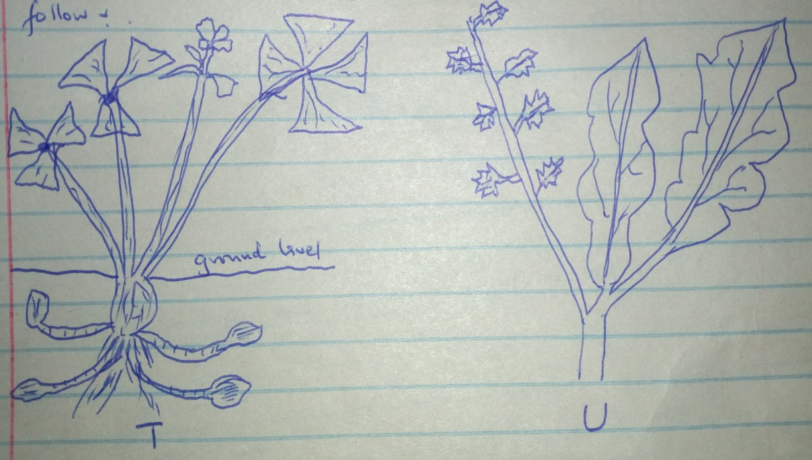

  - Identify the weed T and U (2 marks)

T.

U.

  - Why is weed T difficult to control in the field (1 marks)
…………………………………………………………………………………………………………………………………………………………………………………………………………………………………………………………

  - State two harmful effects of used U in crop production(2 marks)

I)……………………………………………………………………………………………………………………………………………………………………………………………………………………………………………………….
II)………………………………………………………………………………………………………………………………………………………………………………………………………………………………………………………

16.The diagram below illustrates some methods of collecting soil samples from a field .carefully study the diagram and answer the question that follows

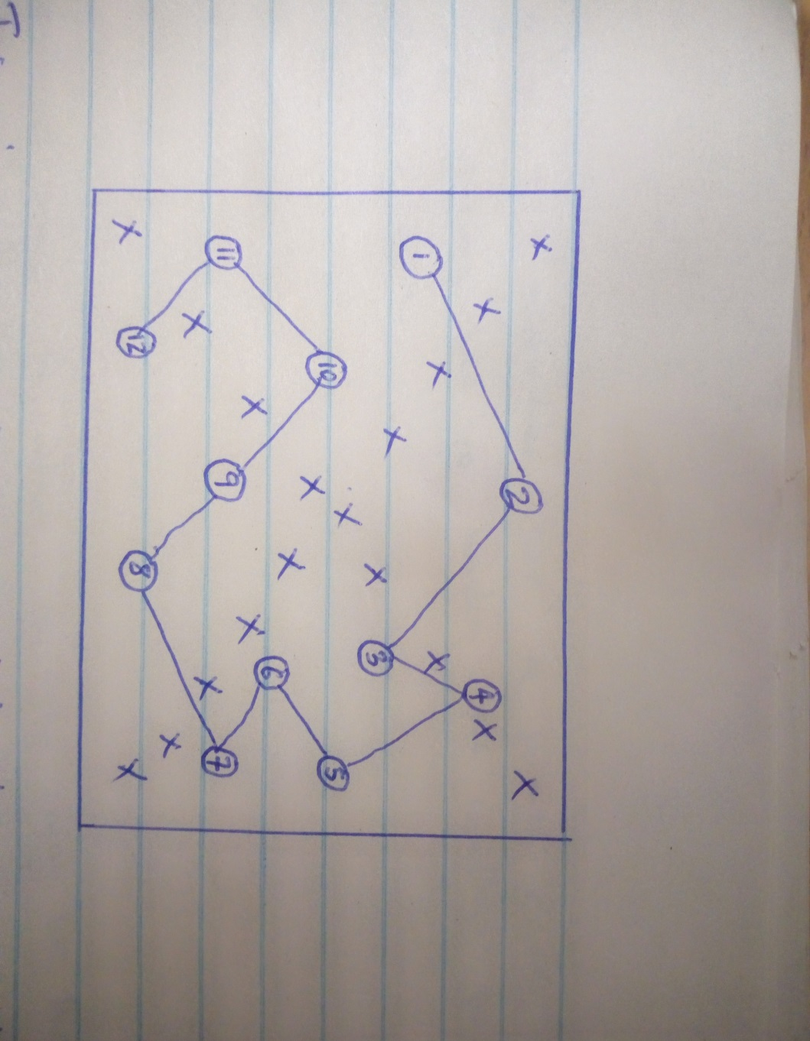

- Identify the method represented by letter X and (1-12) (marks)
- X
ii) (1-12)
- List down two important details that should be indicated on the composite soil sample before sending it for testing (2 marks)
………………………………………………………………………………………………………………………………………………………………………………………………………………………………………………………………………………………………………………………………………………………………………………………………………………….…

- State the advantages of method represented by (1 -12) compared to X (1 mark)
17.(a)state three reason why raising seedlings in polythene sleeves is advisable than in a ground nursery (3 marks) i)…………………………………………………………………………………………………………………………………………………………………………………………………………………………………………………………………………………………….ii)…………………………………………………………………………………………………………………………………………………………………………………………………………………………………………………………………………………………….iii)………………………………………………………………………………………………………………………………………………………………………………………………………………………………………………………………………………………………..………………………………………………………………………………………………………………………………………..

(b). State 2 activities that a farmer carries out in his nursery bed to harden the seedlings before transplanting (2 marks)
i)…………………………………………………………………………………………………………………………………………………………………………………………………………………………………………………………………………………………….ii)…………………………………………………………………………………………………………………………………………………………………………………………………………………………………………………………………………………………….

18. State three ways in which nitrogen may be lost from the soil (3 marks)

i)…………………………………………………………………………………………………………………………………………………………………………………………………………………………………………………………………………………………….ii)…………………………………………………………………………………………………………………………………………………………………………………………………………………………………………………………………………………………….
19. Define the term minimum tillage (1 mark)
i)…………………………………………………………………………………………………………………………………………………………………………………………………………………………………………………………………………………………….ii)…………………………………………………………………………………………………………………………………………………………………………………………………………………………………………………………………………………………….
Explain 4 importance of carrying out minimum tillage (4 marks)

i)…………………………………………………………………………………………………………………………………………………………………………………………………………………………………………………………………………………………………………..ii)………………………………………………………………………………………………………………………………………………………………………………………………………………………………………………………………………………………………………..iii)………………………………………………………………………………………………………………………………………………………………………………………………………………………………………………………………………………………………..………iv)………………………………………………………………………………………………………………………………………………………………………………………………………………………………………………………………………………………………………

SECTION C:
ANSWER ALL QUESTIONS
20. Describe the production of bulrush millet under the following
a)Ecological requirements (4 marks)
……………………………………………………………………………………………………………………………………………………………………………………………………………………………………………………………………………………………………………………………………………………………………………………………………………………………………………………………………………………………………………………………………………………………………………………………………………………………………………………………………………………………………………………………………………………………………………………………………………………………………………………………………………………………………………………………………………………………………………………………………………………………………………………………………………………………………………………………………………………………………………………………………………………………………………………………………………………………………………………………………………………………………………………………………………………………………………………………………………………………
(b)Field preparation and planting (6 marks)
……………………………………………………………………………………………………………………………………………………………………………………………………………………………………………………………………………………………………………………………………………………………………………………………………………………………………………………………………………………………………………………………………………………………………………………………………………………………………………………………………………………………………………………………………………………………………………………………………………………………………………………………………………………………………………………………………………………………………………………………………………………………………………………………………………………………………………………………………………………………………………………………………………………………………………………………………………………………………………………………………………………………………………………………………………………………………………………………………………………………

(c)Pest ,diseases and weed control (6 marks) ……………………………………………………………………………………………………………………………………………………………………………………………………………………………………………………………………………………………………………………………………………………………………………………………………………………………………………………………………………………………………………………………………………………………………………………………………………………………………………………………………………………………………………………………………………………………………………………………………………………………………………………………………………………………………………………………………………………………………………………………………………………………………………………………………………………………………………………………………………………………………………………………………………………………………………………………………………………………………………………………………………………………………………………………………………………………………………………………………………………………

(d)Harvesting ,storage(4 marks) ……………………………………………………………………………………………………………………………………………………………………………………………………………………………………………………………………………………………………………………………………………………………………………………………………………………………………………………………………………………………………………………………………………………………………………………………………………………………………………………………………………………………………………………………………………………………………………………………………………………………………………………………………………………………………………………………………………………………………………………………………………………………………………………………………………………………………………………………………………………………………………………………………………………………………………………………………………………………………………………………………………………………………………………………………………………………………………………………………………………………

21.(a)Describe the use of water in a farm (10marks)

…………………………………………………………………………………………………………………………………………………………………………………………………………………………………………………………………………………………………………………………………………………………………………………………………………………………………………………………………………………………………………………………………………………………………………………………………………………………………………………………………………………………………………………………………………………………………………………………………………………………………………………………………………………………………………………………………………………………………………………………………………………………………………………………………………………………………………………………………………………………………………………………………………………………………………………………………………………………………………………………………………………………………………………………………………………………………………………………………………………………………………………………………………………………………………………………………………………………………………………………………………………………………………………………………………………………………………………………………………………………………………………………………………………………………………………………………………………………………………………………………………………………………………………………………………………………………………………………………………………………………………………………………………………………………………………………………………………………………………………

(b)State the cultural methods of pest control in crop production (10 marks)
……………………………………………………………………………………………………………………………………………………………………………………………………………………………………………………………………………………………………………………………………………………………………………………………………………………………………………………………………………………………………………………………………………………………………………………………………………………………………………………………………………………………………………………………………………………………………………………………………………………………………………………………………………………………………………………………………………………………………………………………………………………………………………………………………………………………………………………………………………………………………………………………………………………………………………………………………………………………………………………………………………………………………………………………………………………………………………………………………………………………
……………………………………………………………………………………………………………………………………………………………………………………………………………………………………………………………………………………………………………………………………………………………………………………………………………………………………………………………………………………………………………………………………………………………………………………………………………………………………………………………………………………………………………………………………………………………………………………………………………………………………………………………………………………………………………………………………………………………………………………………………………………………………………………………………………………………………………………………………………………………………………………………………………………………………………………………………………………………………………………………………………………………………………………………………………………………………………………………………………………………

22.(a)Describe the features of good farm records (5 marks ) ……………………………………………………………………………………………………………………………………………………………………………………………………………………………………………………………………………………………………………………………………………………………………………………………………………………………………………………………………………………………………………………………………………………………………………………………………………………………………………………………………………………………………………………………………………………………………………………………………………………………………………………………………………………………………………………………………………………………………………………………………………………………………………………………………………………………………………………………………………………………………………………………………………………..

(b)Outline the factors affecting the supply of farm products (5 marks) ………………………………………………………………………………………………………………………………………………………………………………………………………………………………………………………………………………………………………………………………………………………………………………………………………………………………………………………………………………………………………………………………………………………………………………………………………………………………………………………………………………………………………………………………………………………………………………………………………………………………………………………………………………………………………………………………………………………………………………………………………………………………………………………………………………………………………………………………………………………………………………………………………………………………………………………………………………………………………………………………………………………………………………………………………………………………………………………………………………………………………………………………………………………………………………………………………………………………………………………………………………………………………………………….………………………………………………………………………………………………………………………………………………………………………………

(c)Describe how farmers can improve production of the farm (5marks) …………………………………………………………………………………………………………………………………………………………………………………………………………………………………………………………………………………………………………………………………………………………………………………………………………………………………………………………………………………………………………………………………………………………………………………………………………………………………………………………………………………………………………………………………………………………………………………………………………………………………………………………………………………………………………………………………………………………………………………………………………………………………………………………………………………………………………………………………………………………………………………….……………………………………………………………………………………………………………………………………………………………………………………………………………………………………………………………………………………………………………………………………………………………………………………………………………………………………………………………………………………………………………………………………………………………………………..………………………………………………………………………………………………………………………………

(d)State the precautions to be taken when taking soil samples from the field ………………………………………………………………………………………………………………………………………………………………………………………………………………………………………………………………………………………………………………………………………………………………………………………………………………………………………………………………………………………………………………………………………………………………………………………………………………………………………………………………………………………………………………………………………………………….…………………………………………………………………………………………………………………………………………………………………………………………………………………………………………………………………………………………………………………………………………………………………………………………………………………………………………………………………………………………………………………………………………………………………………………………………………………………………………………………………………………………………………………………………………………………………………………………………………………………………………

End of the paper.

