Name………………………………………………………………….. Index No…………………
BIOLOGY 231/1 Date……………………………
(Theory)
JULY 2019 Sign……………………………
2 hours
GATUNDU SOUTH EVALUATION EXAMINATION
(Kenya Certificate of Secondary education)
Instructions
- Write your Name and Index Number in the spaces provided above.
- Write the date of the examination in the space provided above.
- Answer all the questions in the spaces provided.

For Examiner’s use only
Question | Maximum Score | Candidate’s Score
1-32 | 80

This paper consists of 8 printed pages.
Candidates should check the question paper to ascertain that all the pages are printed as indicated and no questions are missing.

1.Name the class to which the following organisms belong. [2mks]
[i] Spider ………………………………………………..
[ii] Bean plant…………………………………………….
2. Give a reason why coarse adjustment knob should not be used when viewing with high power objective lens. [1 mk]
…………………………………………………………………………………………………………………………………………
3. a) State two functions of an electron microscope. (2 marks)
………………………………………………………………………………………………………………………………………………………………………………………………………………………………………………………………………………………………………………….
b)A Student was examining cells from an unidentified rabbit organ under an electron microscope and found that most cells are rich in rough endoplasmic reticulum and golgi bodies .What conclusion can you make concerning the organ .[2mks]
………………………………………………………………………………………………………………………………………………………………………………………………………………………………………………………………………………………………………………….
4.. A student dropped a small piece of fresh liver in a beaker containing hydrogen peroxide. A lot of fizzling and frothing was observed.
a. Name the gas produced. [1mk]
…………………………………………………………………………………….
b. write the word equation for the reaction above. [1mk]
…………………………………………………………………………………………………………………………………………………
5. Compare the composition of blood in umbilical artery and umbilical vein. [2mks]
………………………………………………………………………………………………………………………………………………………………………………………………………………………………………………………………………………………………………………………………………………………………………………………………………………………………………………………………………………………
6. Give a reason why pre mature baldness tuft of hair in the nose and ear are characteristics found in males only. [1mk]
………………………………………………………………………………………………………………………………………………………
7. Distinguish between osmotic pressure and osmotic potential. [2mks]
……………………………………………………………………………………………………………………………………………………………………………………………………………………………………………………………………………………………………………………………………………………………………………………………………………………………………………………………………………………..
8.. State two ways in which one can investigate the rate of transpiration in plants. [2mks]
………………………………………………………………………………………………………………………………………………………………………………………………………………………………………………………………………………………………………………………………………………………………………………………………………………………………………………………………………………………
9. What is the effect of eating a meal with too much salt to urine production in human. [2mks]
……………………………………………………………………………………………………………………………………………………………………………………………………………………………………………………………………………………………………………………………………………………………………………………………………………………………………………………………………………………
10. Name the blood vessel that links arterioles with venules. [1mk]
………………………………………………………………………………………………………………………………………….
b. State two ways in which the blood vessel named in [a ] above is adapted to its functions. [2mks]
………………………………………………………………………………………………………………………………………………………………………………………………………………………………………………………………………………………………………………………………………………………………………………………………………………………………………………………………………………..
11. (i) What is a dichotomous key? (1 mark)
………………………………………………………………………………………………………………………………………………………………………………………………………………………………………………………………………………………
(ii) State two characteristics of class Arachnida. (2 marks)
…………………………………………………………………………………………………………………………………………………………………………………………………………………………………………………………………………………………………………………………………………………………………………………………………………………………………………………………………………
12. Outline two physiological conditions that may increase energy required per day in a woman. [2mks]
…………………………………………………………………………………………………………………………………………………………………………………………………………………………………………………………………………………………………………………………..
13. Tongue rolling is dominant over the inability to roll the tongue. In a family both the father and mother can roll their tongue of their two children one is a roller and the other is a non-roller. Use letter R to represent the tongue rolling gene.
a. Write the possible genotypes of. [3mks]
i. father ……………………………………………………………………………………………………………………..
ii. mother …………………………………………………………………………………………………………………..
iii. non –roller child ………………………………………………………………………………………………………….
b) Name the type of variation exhibited in the above case. [1mk]
…………………………………………………………………………………………………………………………….
14. Distinguish between the terms protandry and protogyny as used in reproduction in plants. (2 marks)
………………………………………………………………………………………………………………………………………………………………………………………………………………………………………………………………………………………………………………………………………………………………………………………………………………………………………………………………………………………..
15. A person of blood group A cannot receive blood from a person of blood group B. Explain. [2mks]
…………………………………………………………………………………………………………………………………………………………………………………………………………………………………………………………………………………………………………………………
16. State two most significant factors that favour exponential growth of a population in any given habitat. (2 marks)
………………………………………………………………………………………………………………………………………………………………………………………………………………………………………………………………………………………………………………………………………………………………………………………………………………………………………………………………………………….....
17. State two economic importance of bacteria in nature. (2 marks)
………………………………………………………………………………………………………………………………………………………………………………………………………………………………………………………………………………………………………………………………………………………………………………………………………………………………………………………………………………….....
18. A patient blood was found to have the parasite below:
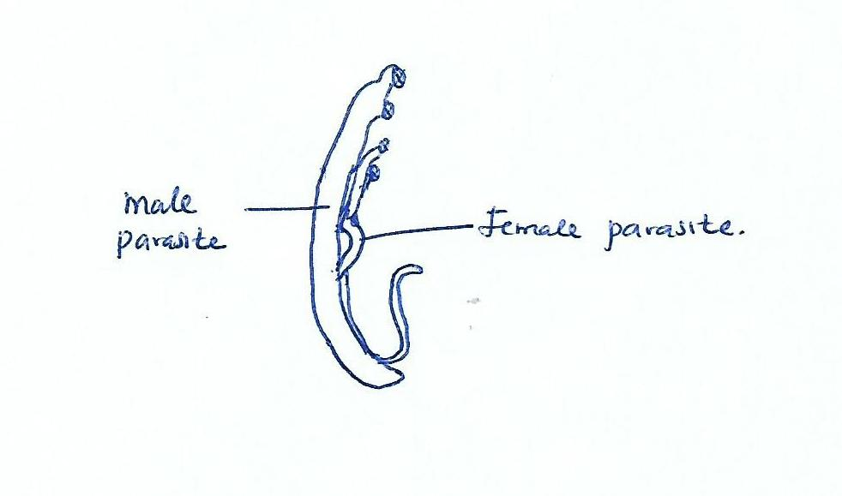
a.Name the parasite; [1mk]
…………………………………………………………………………………………………………………………………………………….

b. Name the disease the patient was suffering from; [1mk]
……………………………………………………………………………………………………………………………………………………..

c. State three ways the above disease can be controlled. [3mks]
………………………………………………………………………………………………………………………………………………………………………………………………………………………………………………………………………………………………………………………………………………………………………………………………………………………………………………………………………………………

19. A human egg is described as haploid.

i.what is meant by the term haploid. [1mk]
……………………………………………………………………………………………………………………………………………………………

ii. What is the importance of eggs being haploid? [1mks]
……………………………………………………………………………………………………………………………………………………………

20. Below is a diagram of a plant cell
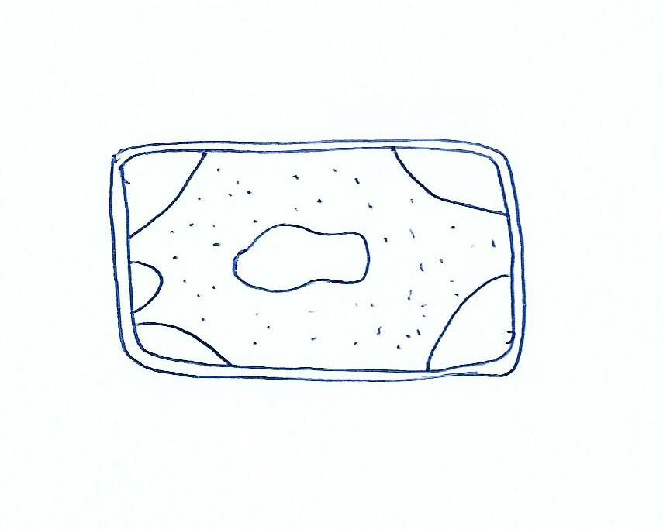
a. what name is used to describe such a cell. [1mk]
…………………………………………………………………………………………………………………………………………………………………

b. Describe what has happened to the cell [3mks]
………………………………………………………………………………………………………………………………………………………………………………………………………………………………………………………………………………………………………………………………………………………………………………………………………………………………………………………………………………………………….....
21. Explain how each of following affect enzyme controlled reaction;

i. Temperature (2mks)
…………………………………………………………………………………………………………………………………………………………………………………………………………………………………………………………………………………………………………………………

ii. pH (1mk)
.....................................................................................................................................................
22. Name the cartilage found in between vertebrae of vertebral column [1mk]
……………………………………………………………………………………………………………………………………………..

b. State two functions of the cartilage named in [a] above [2mks]
…………………………………………………………………………………………………………………………………………………………………………………………………………………………………………………………………………………………………………………………………………………………………………………………………………………………………………………………………

23. State two differences between smooth muscles and skeletal muscles [2mks]
………………………………………………………………………………………………………………………………………………………………………………………………………………………………………………………………………………………………………………………………………………………………………………………………………………………………………………………………………………………

24. Give the difference between pyramid of biomass and pyramid of numbers [2mks]
………………………………………………………………………………………………………………………………………………………………………………………………………………………………………………………………………………………………………………………………………………………………………………………………………………………………………………………………………………………

b. Why is pyramid of biomass a better method of representing ecological relationships in habitats [1mk]
…………………………………………………………………………………………………………………………………………………………………………………………………………………………………………………………………………………………………………………………

25. Explain why an athlete pants heavily after sprint race [2mks]
………………………………………………………………………………………………………………………………………………………………………………………………………………………………………………………………………………………………………………………………………………………………………………………………………………………………………………………………………………………

26. In an experiment a shoot tip of a young tomato plant was decapitated as shown below

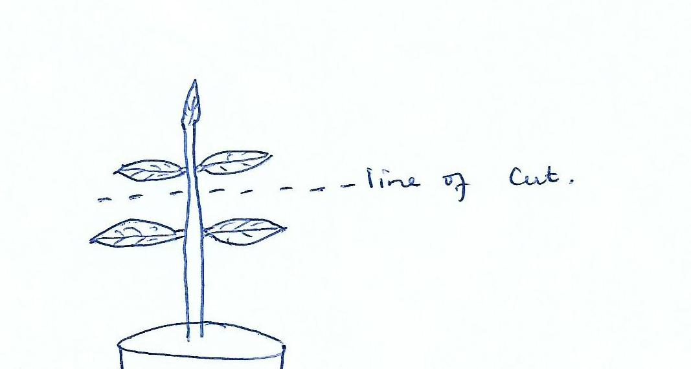

- State the expected results after two weeks [1mk]
…………………………………………………………………………………………………………………………………………………………….

- Give a reason for your answer in [a] above [2mks]
………………………………………………………………………………………………………………………………………………………………………………………………………………………………………………………………………………………………………………………………………………………………………………………………………………………………………………………………………………………

27. State the importance of fossils as evidence of organic evolution. [2mks]
………………………………………………………………………………………………………………………………………………………………………………………………………………………………………………………………………………………………………………………………………………………………………………………………………………………………………………………………………………………

28. State the importance of the following features in a respiratory surface. [2mks]
i. moist
…………………………………………………………………………………………………………………
ii. thin wall
………………………………………………………………………………………………………………………..
29. When seedlings are grown in the dark, they become tall with long internodes, yellow in Colour and weak.
a. What name is used to describe the phenomenon. (1mk)
…………………………………………………………………………………………………………………………………………………….

- Explain the observation made above:(2mks)
……………………………………………………………………………………………………………………………………………………………………………………………………………………………………………………………………………………………………

30. a) What is glycolysis (1 mark)
………………………………………………………………………………………………………………………………………………………….
b) Where in a cell does glycolysis occur. (1 mark)
…………………………………………………………………………………………………………………………………………………………………
C)Explain why patients who cannot feed orally are given glucose in a drip. (1 mark)
………………………………………………………………………………………………………………………………………………………
31.State the function of the following structures in the human ear.

- Semi – circular canals. (1mark)
…………………………………………………………………………………………………………….

- Eustachian tube. (1mark)
…………………………………………………………………………………………………………….

32. The table below shows some physiological changes observed in a person in two different regions. The results were taken after the person stayed in each region for 2 weeks.

Physiological change | Region I | Region II
Heart beat per minute | 80 | 71
Breath | Very deep | Average
Breathing rate | fast | Average

- Which one of the regions was likely to be at 4,000M above sea level? Give a reason for your answer. (2 marks)
………………………………………………………………………………………………………………………………………………………………………………………………………………………………………………………………………………………………………………………………………………………………………………………………………………………………………………………………………………………

- Why was it necessary to take results after a duration of 2 weeks? (1marks)
…………………………………………………………………………………………………………………………………………………………….

