GATUNDU SOUTH SUB-COUNTY
Name……………………………………………………………………………………..Index NO……………..
Signature…………………………………………………………………………………….Date………………..
231/2
Biology Theory
Paper 2
July 2019
Time : 2hours
Biology examinations
Kenya Certificate of Secondary Education 2019
Instructions to candidates
Answer all questions in section A in the spaces after each question
In section B answer question 6(compulsory) and either question 7 or 8in the spaces provided after question 8
Answer all the questions in the spaces provided
Candidates should answer all questions in English
For Examiners use only

Section A: Answer all questions

- (a) What is sex linkage in genetics? (1mk)
…………………………………………………………………………………………………………………………………………………………………………………………………………………………………………………………………………………………………………
(b) Haemophilia is a sex-linked disorder in human. It is caused by a recessive allele [h] present on the X-chromosome. A normal man marries a carrier female.
i) What are the genotypes of the parents in this marriage? (2mks)
……………………………………………………………………………………………………………………………………………………...............................................................................................................................................
ii) What would be the genotypes of the offsprings in the marriage above?
Show your working. [4mks]
………………………………………………………………………………………………………………………………………………………………………………………………………………………………………………………………………………………………………………………………………………………………………………………………………………………………………………………………………………………………………………………………………………………………………………………………………………………………………………………………………………………………………………………………………………
iii) From the offsprings obtained in ii] above, give the phenotype of completely normal children to haemophiliac children. [1mk]
………………………………………………………………………………………………………………………………………………………………………………………………………………………………………………………………………………………………
- (a) A Student was studying red blood cells and the effect of different solutions on them. He puts 10ml of solution X, Y and Z in three boiling tubes. The solutions were of different concentration. Into each of the three solutions, he puts three drops of the blood samples. The experiment was left to stand for 30 minutes. He placed one drop of solution X on a glass slide and observed under the microscope. The same procedure was repeated for solution Y and Z. He made the following observations.
Solution Observation
X normal cells
Y wrinkled cells
Z no cells observed.
i] What was the physiological process being investigated? [1mk]
……………………………………………………………………………………………………………………………………………………
(b) Explain why red blood cells observed in solution Y were wrinkled [3mk]
…………………………………………………………………………………………………………………………………………………………………………………………………………………………………………………………………………………………………………………………………………………………………………………………………………………………………………………………………………………………………………………………………………………………………………………………………………………………………………………………………………………………………………………………………………………………………………………………………………………………………………..
(c) A three centimeter long piece of kale [sukumawiki] stem was cut half way along its length as shown below
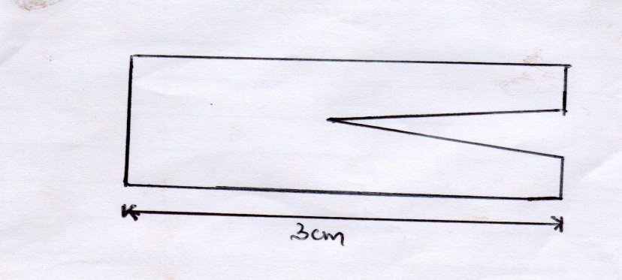
- If the piece was placed in solution Z for 30 minutes its shape changed. Draw a diagram, in the space provided below, to show the expected change. (1 mk)

- Explain the results obtained in (b) (i) above. (3 mks)

…………………………………………………………………………………………………………………………………………………………………………………………………………………………………………………………………………………………………………………………………………………………………………………………………………………………………………………………………………………………………………………………………………………………………………………………………………………………………………………………………………

3. (a) Name the gaseous exchange structure in the following organisms.
(i) Amoeba (1 mark)
…………………………………………………………………………………………………
(ii) Grasshopper (1mark)
…………………………………………………………………………………………………
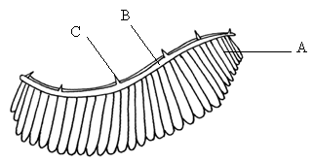
(b) The diagram below illustrates the structure of a gill from a bony fish.

(i) Name the parts labelled A, B, C (3 marks)
A ………………………………………………
B ………………………………………………
C ……………………………………………….
(ii) State the function of the part labelled C (1 mark)
…………………………………………………………..………………………………………
(iii) How is part A adapted to carry its functions (2 marks)
………………………………………………………………………………………………………………………………………………………………………………………………………………………………………………………………………………………………………
- Study the diagram below and answer the questions that follows

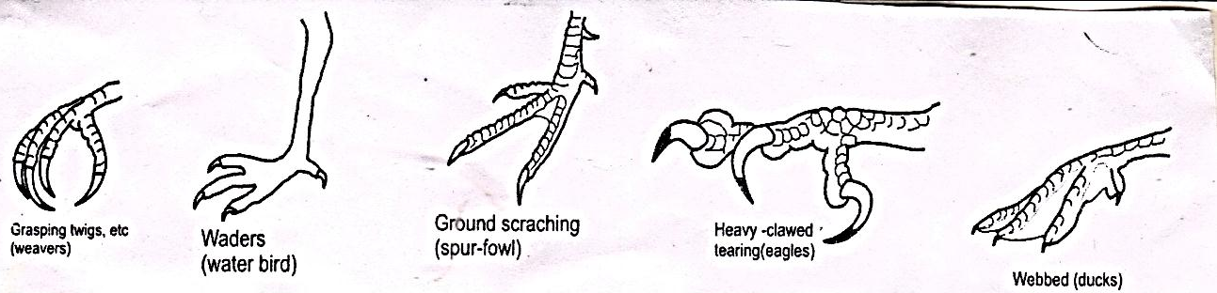
- What type of evolution is illustrated by the limbs (1mk)

……………………………………………………………………………………………………..
- What does the origin of the limbs suggest about the ancestry of these animals (1mk)

…………………………………………………………………………………………………………..
(c) (i.) What are vestigial structures? (1mk) ………………………………………………………………………………………………………………………………………………………………………………………………………………………………………………………………………………………………………………………………………………………..
(ii). State an example of vestigial structure in humans (1mk
……………………………………………………………………………………………………………….
- (i) What is natural selection? (2mks) …………………………………………………………………………………………………………………………………………………………………………………………………………………………………………………………………………………………………………………………………………………………
(ii) Give one example of nature selection in action (1mk)
…………………………………………………………………………………………………………………………………………………………………….
(e) Explain comparative serology as evidence of evolution. 1mk
…………………………………………………

- The diagram below shows front view of male human urino-genital system. Study it to answer the questions that follow.
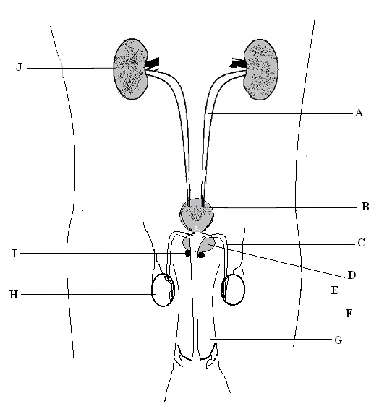
a) Name the parts labeled J, A, B and F. (4 marks)
J……………………………… A…………………………………………………
B………………………………..F…………………………………………………
b) State the function of parts labeled H and E. (2 marks)
……………………………………………………………………………………………………………………………………………………………………………………………………………………………………………………………………………………………………………………………………………………………….
(c) Name the secretion produced by structure D and I . (2 marks)

D……………………………………………………………………………………………I…………………………………………………………………………………………….

SECTION B
Answer question 6 (compulsory) and either question 7 or 8 in the spaces provided after question 8

- Diabetes mellitus is a condition whereby the body is unable to maintain a constant concentration of glucose in blood. It is caused by failure of pancreas to secrete sufficient insulin hormone.
The condition can be controlled by periodic administration of insulin; which can be done through injection into a vein, or breathing in a nasal spray.
The table below shows the concentration of glucose of a person after injecting or inhaling insulin.
Time (hrs) | 0 | 1 | 2 | 3 | 4 | 5 | 6 | 7 | 8
Glucose concentration in blood (Mg/100 ml) after injection of insulin) | 100 | 68 | 46 | 30 | 22 | 33 | 36 | 38 | 40
Glucose concentration in Blood (Mg/100ml) after inhaling insulin. | 100 | 42 | 25 | 12 | 16 | 28 | 40 | 52 | 56

- On the same axis, draw graphs of blood glucose concentration against time. (8 mks)
- (i)After what time is the blood glucose concentration equal? (1 mk)
………………………………………………………………………………………………………………………………………………(ii)Account for the effect of injecting or inhaling insulin on blood glucose concentration for the first one hour. (3 mks)
………………………………………………………………………………………………………………………………………………………………………………………………………………………………………………………………………………………………………………………………………………………………………………………………………………………………………………………………………………………………………………………………………………………………………………………………(iii)Explain how insulin influences change in blood glucose concentration. (3 mks)
……………………………………………………………………………………………………………………………………………………………………………………………………………………………………………………………………………………………………………………………………………………………………………………………………………………………………………………………………………………………………………………………………………………………………………………………………………………………………………………………………………………………..
- (i) For a healthy person, in which organ is insulin produced? (1 mk)

………………………………………………………………………………………………………………………………………………
(ii) State two symptoms of a person suffering from Diabetes mellitus. (2 mks)
………………………………………………………………………………………………………………………………………………………………………………………………………………………………………………………………………………………………………………………………………………………………………………………………………………………………………………………………………………………………………………………
- Suggest one advantage and one disadvantage of inhaling insulin rather than injecting it. (2 mks)
Advantage: ……………………………………………………………………………………………………………………………………………………………………………………………………………………………………………………………………………………
Disadvantage………………………………………………………………………………………………………………………………………………………………………………………………………………………………………………………………………
- (a) Describe the adaptation of hydrophytes to their photosynthetic function [10mks]
(b) Explain how mammalian ileum is adapted to perform its function. [10mks
8. Explain how seeds and fruits are adapted to the various methods of dispersal. (20 marks)

………………………………………………………………………………………………………………………………………………………………………………………………………………………………………………………………………………………………………………………………………………………………………………………………………………………………………………………………………………………………………………………………………………………………………………………………………………………………………………………………………………………………………………………………………………………………………………………………………………………………………………………………………………………………………………………………………………………………………………………………………………………………………………………………………………………………………………………………………………………………………………………………………………………………………………………………………………………………………………………………………………………………………………………………………………………………………………………………………………………………………………………………………………………………………………………………………………………………………………………………………………………………………………………………………………………………………………………………………………………………………………………………………………………………………………………………………………………………………………………………………………………………………………………………………………………………………………………………………………………………………………………………………………………………………………………………………………………………………………………………………………………………………………………………………………………………………………………………………………………………………………………………………………………………………………………………………………………………………………………………………………………………………………………………………………………………………………………………………………………………………………………………………………………………………………………………………………………………………………………………………………………………………………………………………………………………………………………………………………………………………………………………………………………………………………………………………………………………………………………………………………………………………………………………………………………………………………………………………………………………………………………………………………………………………………………………………………………………………………………………………………………………………………………………………………………………………………………………………………………………………………………………………………………………………………………………………………………………………………………………………………………………………………………………………………………………………………………………………………………………………………………………………………………………………………………………………………………………………………………………………………………………………………………………………………………………………………………………………………………………………………………………………………………………………………………………………………………………………………………………………………………………………………………………………………………………………………………………………………………………………………………………………………………………………………………………………………………………………………………………………………………………………………………………………………………………………………………………………………………………………………………………………………………………………………………………………………………………………………………………………………………………………………………………………………………………………………………………………………………………………………………………………………………………………………………………………………………………………………………………………………………………………………………………………………………………………………………………………………………………………………………………………………………………………………………………………………………………………………………………………………………………………………………………………………………………………………………………………………………………………………………………………………………………………………………………………………………………………………………………………………………………………………………………………………………………………………………………………………………………………………………………………………………………………………………………………………………………………………………………………………………………………………………………………………………………………………………………………………………………………………………………………………………………………………………………………………………………………………………………………………………………………………………………………………………………………………………………………………………………………………………………………………………………………………………………………………………………………………………………………………………………………………………………………………………………………………………………………………………………………………………………………………………………………………………………………………………………………………………………………………………………………………………………………………………………………………………………………………………………………………………………………………………………………………………………………………………………………………………………………………………………………………………………………………………………………………………………………………………………………………………………………………………………………………………………………………………………………………………………………………………………………………………………………………………………………………………………………………………………………………………………………………………………………………………………………………………………………………………………………………………………………………………………………………………………………………………………………………………………………………………………………………………………………………………………………………………………………………………………………………………………………………………………………………………………………………………………………………………………………………………………………………………………………………………………………………………………………………………………………………………………………………………………………………………………………………………………………………………………………………………………………………………………………………………………………………………………………………………………………………………………………………………………………………………………………………………………………………………………………………………………………………………………………………………………………………………………………………………………………………………………………………………………………………………………………………………………………………………………………………………………………………………………………………………………………………………………………………………………………………………………………………………………………………………………………………………………………………………………………………………………………………………………………………………………………………………………………………………………………………………………………………………………………………………………………………………………………………………………………………………………………………………………………………………………………………………………………………………………………………………………………………………………………………………………………………………………………………………………………………………………………………………………………………………………………………………………………………………………………………………………………………………………………………………………………………………………………………………………………………………………………………………………………………………………………………………………………………………………………………………

