NAME…………………………………………………INDEX NO ……………

CANDIDATE’S SIGNATURE ………….DATE……………………………..

312/1
GEOGRAPHY
PAPER 1
2 ¾ HOURS

GATUNDU SOUTH SUB - COUNTY FORM FOUR JOINT EVALUATION TEST 2019
KENYA CERTIFICATE OF SECONDARY EDUCATION

INSTRUCTIONS TO CANDIDATES

- This paper has two sections A and B
- Answer ALL questions in section A
- Answer question 6 and any other two questions from section B.
- All answers must be written in answer sheets provided.

FOR EXAMINERS USE ONLY
A | 6 | 7 | 8 | 9 | 10 | TOTAL

SECTION A
Answer all the questions in this section.
1. (a) List down two isothermal layers of the atmosphere. (2 marks)
(b)State any three characteristics of the lowest layer of the atmosphere. (3marks)
2. (a) Differentiate between faulting and folding (2 marks)
(b) Apart from Fold Mountains name three other land forms resulting from folding (3 marks)
3. (a) What is Mass wasting? (2 marks)
(b) State three economic benefits of the weathering process. (3 marks)
4. (a) What is soil degeneration? (2 marks)
(b)Identify three types of soil degeneration. (3 marks)
5. (a) Name the type of delta found at the mouth of: (2 marks)
(i) River Nile.
(ii) River Omo.
(b) State one effect for each of the following types of river erosion. (3 marks)
- Headward erosion.
- Lateral erosion.
- Vertical erosion
SECTION B
Answer question 6 and any other two questions
- Study the map of Taita Hills 1:50000 (sheet 189/4) provided and answer the questions that follow.
a. (i) Calculate the area (in square kilometers) enclosed by the railway line to the south Eastern part of the area shown. (2 marks)
(ii) Give the four figure grid reference of the school at Mrabenyi. (1mark)
(iii) Identify the adjoining sheet number to the south East of Taita Hills. (1mark)
(iv) Name the vegetation type in grid square 3314. (1mark)

b. (i) Citing evidence from the map, give two economic activities carried out in the area covered by the map. (4marks)
(ii)Briefly explain three factors influencing the distribution of settlement in
the mapped area. (6marks)
c. (i) Using a vertical scale of 1cm to represent a 20 meters draw a cross-section along northing 15 and between easting 31 and 39 (5marks)
(ii) On the cross-section; mark and label. (3marks)
- Road C104
- Railway line.
- Hill
(iii) Calculate the vertical exaggeration for the cross-section. (2marks)
7. (a) (i) State four factors which influence the development of karst landforms. (4marks)

(ii) The diagram below shows some surface features in a karst region. Name the features marked P, Q
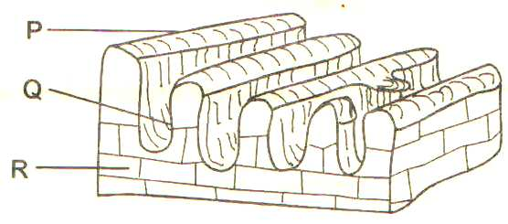
and R. (3marks)

(b) Using a well labeled diagram describe the occurrence of an artesian basin. (6marks)
(c) Give three reasons why there are few settlements on a Karst landscape. (6marks)
(d) Form four students of your school undertook field work on a karst landscape.
(i) State two objectives of their study. (2marks)
(ii) Prepare a simple working schedule for the field study. (4marks)
8. (a) Define the term glacier (2marks)
(b) Explain three ways in which glaciation negatively influence the human environment (6marks)
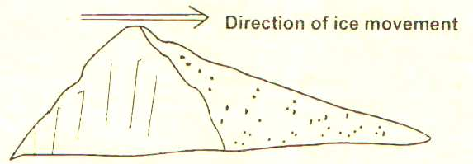
(c) With the aid of well labeled diagrams describe the formation of a cirque. (7marks) (d)The figure below shows a feature formed in a glaciated landscape. Use it to answer the questions that follow.

- Identify the feature. (1mark)
- Describe how the above feature is formed. (4mark)
(e) The form four class planned to conduct a field study on glaciation in Mount Kenya
(i)Identify any two types of moraines they are likely to see (2marks)
(ii)State any three problems they are likely to encounter (3marks)
9.(a)(i) Explain three factors that influence distribution of vegetation in Kenya., (6marks)
(ii) State three major vegetation zones in Kenya. (3marks)
(b)(i) Describe any four characteristics of the tropical rainforests. (4marks) . (ii) Give four factors that limit the exploitation of tropical rainforest in Africa. (4marks)
(c) What is climax vegetation? (2 mark)

(d) Explain three factors that have led to a decline of natural grassland in Kenya. (6 marks)

10. (a) (i) Define the term Aridity. (2 marks)
(ii) With the aid of well labeled diagrams describe how a rock pedestal is formed. (5marks)
(b) Your class intends to carry out a field study in an arid area near your school.
- How would you prepare for the field study? (3 marks)
- What are the advantages of studying aridity through field study? (3marks)
- What advice would you give the residents of the area on curbing the spread of Aridity and desertification? (4marks)
- Name two main wind depositional features they are likely to have identified. (2 marks)
(c)Explain three physical factors causing aridity and desertification. (6marks)

