AMUKURA PARISH
Kenya Certificate of Secondary Education 2021
HOMESCIENCE FORM THREE
THEORY
MARKING SCHEME

- Ante-natal care (1x1) (1mk)
- Is the care given to the expectant mother before delivery
- Signs of pregnancy. (1x3) (3mks)
- Missing/ topping of menstruation
- Morning sickness/ nausea
- Backache
- Skin pigmentation
- Dislikes & like of certain foods.
- Types of advertisement (1x3) (3mks)
- Information
- Persuasive
- Competitive
- Ways of generating money by a homescience student. (1x4) (4mks)
- Making and selling foodstuff
- Repairing clothes at a fee
- Doing laundry at a fee
- Tutoring students at a fee
- Ways of improving a wardrobe. (1x3) (3mks)
- Wooden rack with nails for hanging clothes
- Nails on the wall serve as hooks and clothes are hung with hangers
- A rope fastened across two walls and clothes hung with hangers
- Two ways in which scrap material can be used. (1x2) (2mks)
- Used for patch work to make decorations / clothes
- Can be filled up in a case to make cushions
- Improvised and put in a stick to make a floor mop
- A course: A dish/dishes eaten as part of a meal (1x2) (2mks)
Meal: is a dish/ group of dishes taken at a particular time of the day eg. lunch.
- Items needed for a baby’s bath. (½x4) (2mks)
- Basin
- A baby soap/ mild soap
- Some baby jelly
- Cotton wool & cotton buds
- A bath towel / flannel
- A comb/ brush
- A bucket with lid for soiled clothes
- Four reasons for consumer education. (½x4) (2mks)
- Wire buying
- Consumer rights
- His/her role as a consumer
- Getting information about different products
- Interpretation of advertisement
- For family planning of finances to avoid wastage,
- Reasons why wool is not suitable for making an apron. (1x2) (2mks)
- It shrinks easily
- It can pull out of shape easily
- It is not resistant to direct sunlight since it turns yellow when spread to sunlight
- Three functions of carbohydrates in the body (1 x3) (3mks)
- Provides of energy and heat.
- Provides roughages to prevent constipation
- Stores glycogen
- Protein-sparing action.
- Points to observe when laundering loose coloured cotton blouse. (1x3) (3mks)
- Use of warm detergent water to preserve colour
- Use kneading & squeezing method to prevent felting to shrinkage.
- Use of salt in final rinsing water to fix colour
- Dry inside out under shade as sunlight will cause fading of the colour.
- Iron on the w.s using moderate hot iron to preserve colour
- Wear is thinning/ weakening of a section of a garment/ household article where as a tear is a hole found on any part of a garment/ household article. (1x2) (2mks)
Disinfectant liquid - is used on surface to kill germs.
- Reasons for sorting articles before washing (1x3) (3mks)
- For economical reasons so that less soiled articles are washed before clearly soiled ones.
- For hygienic reasons so that items such as tables liner are not washed together with personal garments
- So that they are given correct treatment according to nature of fabric of degree of soiling
- Factors to consider when choosing an ironing board. (½ x4) (2mks)
- Should be firm to avoid accidents.
- Should not have dye that can stain damp clothes.
- The surface should be well-padded to remove creases effectively
- Should have a heat –proof plate for placing the hot iron during use
- Should be smooth to allow easy gliding of the iron.
- Methods of disposing organic refuse. (1x 2) (2mks)
- Burning which is used to dispose carton boxes, empty bulk packets, plastics & poluthene papers
- Burying clothes, broken glasses, tins and used batteries deep in the soil
- Recycling – The process of chemically treating inorganic refuse so that it can be used again.
- Three methods of modern houses (1x3) (3mks)
- Bughouse- All rooms are on the same floor.
- Maisonettes – Some rooms are on the ground floor while others are on the upper floor
- Apartments – they are complete house units that are built on different floors.

- Thorough clean muddy leather shoes with laces. (1x8) (8mks)
- Collect cleaning equipment & materials.
- Cover/ protect working area with newspapers
- Remove shoelaces and wash separately according to material
- Remove mud from shoes using mud scrapper
- Wipe off remaining mud with a wet/ damp cloth & leave them stiffed.
- Remove stuffing and apply polish sparingly using shoes brush/ rag
- Leave shoes for a few minutes for polish to set.
- Brush the shoes firmly with shoes brush/ rub with rag if cream has been used
- Use a clean fluffy cloth to buff the shoes
- Fasten shoes lace
- Stuff shoes before storing
- Clean equipment used and store well.
- Launder a knitted cotton vest (1x7) (7mks)
- Collect cleaning equipment & materials
- Mend/ repair appropriately if necessary
- Sort as necessary
- Soak in cold water for a short time.
- Rinse off soaked water
- Wash in warm soapy water using kneading & squeezing method to prevent loss of shape
- Rinse thoroughly in warm water to remove soap and duts. Final rinse in cold water to refreshed it
- Dry outdoors flat hang along warp threads to prevent loss of shape.
- Press on W.S using moderately hot iron
- Air to dry completely
- Fold & store appropriately
- Clean equipment used & store well
- Thorough clean aluminum water jar (5mks)
- Collect equipment & cleaning materials
- Wash in hot soapy water
- Rub any stains with nylon scouring pad / steel wool
- Work towards the same direction when scrubbing
- Rinse thoroughly in clean hot water to remove all soap & dirt
- Dry well
- Store well
- Clean equipment used & store well
- Thorough cleaning plastic chairs. (1x4) (4mks)
- Wash in hot soapy water using a soft cloth/ sponge
- Use mild bleach/ citric acid to remove stubborn stains
- Rinse thoroughly in hot water.
- Dry completely to rub/ buff with a soft cloth to shine them.
- Store appropriately.
- a) Making of open seam. (1x7) (7mks)
- Place two pieces of fabrics with R.S facing
- Pin through the fitting lines at intervals to prevent the top layer from shifting a long on the one under
- Tack along the fitting line
- Remove pins and machine on fitting line.
- Finish off the tread ends & remove tacking
- Trim seam allowance to 1cm and neaten the raw edges using edge stitching
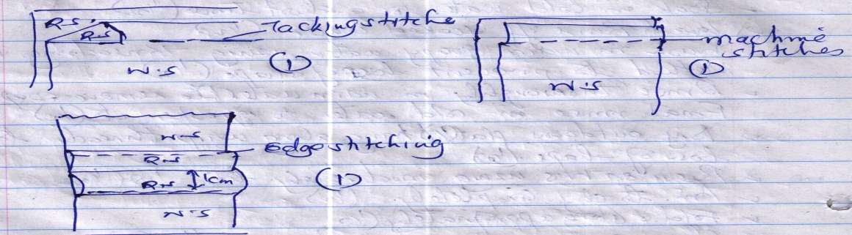
b) Rules when cooking vegetables (1 x5) (5mks)
- Wash before cutting
- Cook for a short while
- Shred them in large sizes to preserve nutrients
- Cover with a lid to cook faster
- Cook them the last minutes before serving to preserve nutrients
- Factors to consider when providing family shelter. (2x4) (8mks)
- Size of the house – Large enough to accommodate all family members.
- Cost – Should be pocket friendly be it building & buying
- Nearness to social amenities – To ease movements eg to hospital, market places etc.
- Availability of communication facilities eg road, telephone, facilities & public transport
- Neighbour hood – For security reasons.
- Design of the house in relation to convenience and comfort ability eg. Wardrobe, kitchen shelves & cupboard
- a) Rules governing steaming by bowl method (1x5) (5mks)
- Cover the food container well with grease proof paper to avoid direct contact with steam.
- Let the bowl stand in a pan of boiling water and cover with light lid.
- Always add boiling water to the water bath when necessary to maintain the temperature of the water bath
- Do not allow the water bath to dry to avoid burning the food
- When removing the lid remove it while the steam is away from you
b) Needs of a pregnant woman. (2 x 4) (8mks)
- Nutritional needs – She needs a diet that will provide all the nutrients necessary for her and the growing foetus eg extra iron, calcium, proteins, calories, protective foods
- Physical needs – She must have adequate sleep, avoid working too much, wear loosely fitted clothes, be clean and occasionally needs to rest her feet on a low stool to prevent them from swelling.
- Emotional needs – She need a peaceful environment free from quarrels and anxiety since too much shouting & quarreling disturbs the foetus.
- Social needs – the family members should be supportive and not making any nasty remarks about her condition.
c) Categories of permanent stiches (2x3) (6mks)well explained with example
- Decorative stitches – Used to add beauty at the edges of a garment e.g chain stitch.
- Neatening stitches – Use to neaten the raw edges of a garment eg button hole stitch.
- Joining stiches – Used to join two or more pieces of fabric together eg machine stitch/ back stitch
d) A brunch is a heavy meals served in between breakfast and lunch. (1mk)
21. a) Points to consider when planning meals for vegetarians (6mks)
- Balanced meal
- Meal should be well flavored by use of seasoning monotony.
- Should contain appropriate amount of vegetables, fats & oils
- For lack –vegetarians, goo use should be made of the animal protein
- For strict- vegetarians, different food should be mixed together to ensure completeness of protein supply.
b) Categories of kitchen equipment (6mks)
- Small kitchen equipment- They include kitchen tools eg knives spatulas, can openers, potato peelers
- Large kitchen equipment – They include the big equipment used in the kitchen eg gas cookers, refrigerators
- Time and labour – Saving kitchen equipment – They are modifications of kitchen equipment to ease in food preparation by making it faster eg. Dishwashers, food mincers
c) Procedure for preparing and attaching a patch print (1x7) (7mks)
- Cut a piece of fabric of the required size and add 1cm seam turnings.
- Fold the seam turning to the WS and metre the corners
- Press the patch and hold the folded turning in position by using tacking stitches
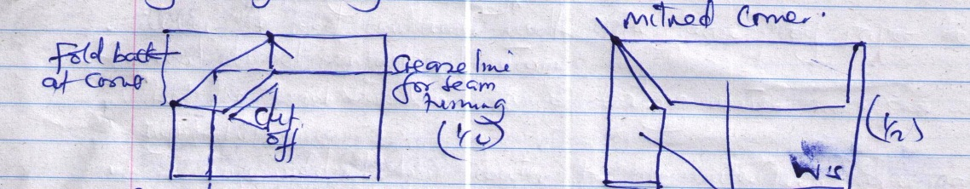

- Pin and tack the patch in position ½ seam turning to WS
- Remove the pins and over sew the patch in position
- Remove the tacking and press the patch
- Trim the worn out part on the WS. Leaving 1 cm turning on all sides
- Neaten the edges using loop stitches

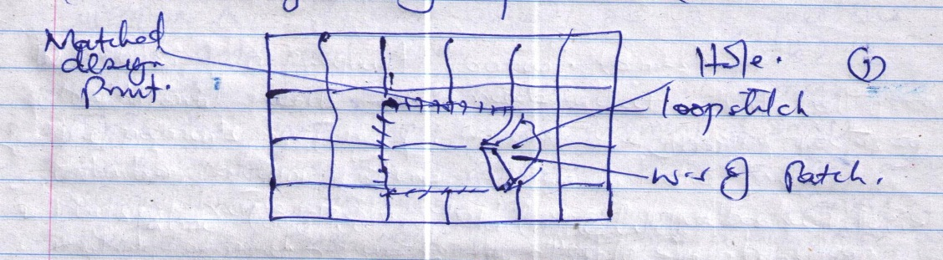

- Malnutrition is inadequate or excess nutrients in the body (1mk)

