Name: …………………………………………………………… Adm No ……..…...................................

School: ……………………………………………………....…. Candidate’s sign ……………………....

Date: ……………………………………………………………

441/2
HOMESCIENCE
PAPER 2

TIME: 2 ½ HOURS

POST MOCK 2019 -September
Kenya Certificate of Secondary Education (K.C.S.E.)
FORM FOUR

441/2 HOME SCIENCE
(CLOTHING & TEXTILE CONSTRUCTION)

A pattern of a child’s dress is provided. You are advised to study the sketches, instructions and the layout well before you begin the test.

MATERIALS PROVIDED:
- Pattern pieces for the dress:
A – Dress front
B – Dress back
C – Sleeve
D – Cuff
E – Pocket
F – Cuff interfacing
G – Sleeve opening binding
- Plain light weight cotton fabric 70cm long by 90cm wide.
- Cotton sewing thread to match the fabric.

THE TEST:
Using the materials provided cut out and make the LEFT HALF of the child’s dress to show the following:
- The working of the shoulder dart.
- The preparation and attachment of the pocket.
- The joining of the shoulder seam using a neatened plain seam.
- The joining of the side seam using a neatened open seam.
- The making of the bound opening of the sleeve.
- The joining of the under arm seam using a French seam.
- The preparation and attachment of an interfaced cuff.
- The preparation and attachment of the sleeve, without trimming the seam allowance.

At the end of the examination, firmly sew onto your work, on a single fabric, a label bearing your name and index number. Remove the needles and pins from your work, and then fold your work neatly.

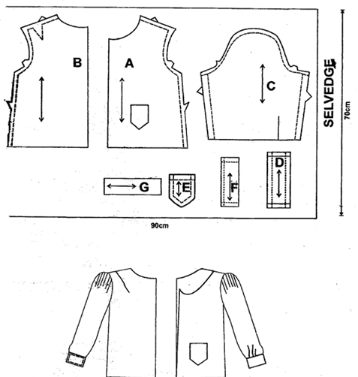
THE LAYOUT IS NOT DRAWN TO SCALE

SELVEDGE

