451/1
COMPUTER STUDIES
Form2
THEORY
July/August 2015
EVALUATION TEST – 2015
Marking scheme

SECTION A (40 marks)
- (a) What is meant by the term suite as used in application programs? (1mk)
Package of related application program put together as one.
(b) List two programs under the ms office suite. (1mk)
Ms Word
Ms Excel
Ms Power point
Ms Outlook express
Ms Access.
Ms Publisher
Msinfopath

- Write the following statement “mock examinations” in (2mks)
i. Title case……………MOCK EXAMINATIONS
ii. Toggle case………MOCK EXAMINATIONS
- a) What is a hard copy (lmks)
Tangible output mostly produced on paper
b) State two reasons why hardcopy output is still very necessary today (lmk)
- To provide communication with clients
  - For back up purposes
- - to communicate with persons not using the computers (Any 2x1=2mks)
- Define the following terms (2mks)
a) Digital data: data that is discrete form.
Analogue data:datathat is continuous in nature… ………

- Define the following terms as pertaining computer software (3mks)
a) User friendliness- The ease with which a user can get acquainted to the different features of the software
b) PortabilityThe ability of software to be used in different families of computers
c) Compatibility The ability of the software to read and process files of the existing software.
- Explain the importance of the following: (2mks)
a) Disk defragmentation:It is a tool used to rearrange scattered folder and files on a storage media in
Order to speed up access to files and folders
b) Disk compressionCompressing storage media contents to fit in smaller space helps to create more free space on the
- Name and explain the two types of primary memory. (3mks)
Static Random Access memory: fast memory that holds its contents as long as there is power
Dynamic Random Access :Holds contents for short periods even when there is power hence requires
- Outline two advantages of hard disk over floppy disk. (2mks)
A Hardisk has faster data access speed than a floppy
A hard disk has larger storage capacity than a floppy
A hard disk is more reliable than a floppy i.e has a longer lifespan than a floppy
- State one function of each of the following terms (3mks)
- Buffer:Special purpose memory used during input\output operations or processing to temporarily hold data or instructions between communicating elements
- An accumulator: Temporarily holds the results of the last processing step of the ALU
- Cache memory: A high speed SRAM whose purpose is to allow the processor to access data and instructions faster
- What is the meaning of the following as used in word-processing: (2mks)
i) Word wrap:a feature that automatically moves a word to a new line if it does not fit at the end of the current line
ii) Drop capsA feature used to enlarge the first letter of a paragraph so that it drops to cover 2 to more lines in the paragraph……
- a) State two ways of minimizing dust in the computer laboratory. (2mks)
- The floor should have a carpet.
- Metallic grills to remove mud.
- Students/rulers can remove shoes.
- Curtains to prevent dust
- An air-conditioning system to filter dust particles from the lab
(b) Why should one switch on the ups before switching on the system unit and the monitor. (1mk)
It is the ups that supplies power to the system unit and monitor from the mains
- State the functions of the following keys in a computer key board
- Insert (1mk)
It is used to shift between different typing modes in a computer i.e. type over mode and insert mode
- Num lock key (1mk)
When pressed once the keys on the numeric keypad can be used as cursor movement and editing keys while when pressed again the keys can be used for easy entry of numeric data
- Explain the three parts of a task bar. (3mks)
Start button- this is on the extreme left end with a word start together with a Microsoft logo-It is used to access a list of programs as installed on the computer.
Task Manager — this is the middle part of the bar which displays any task / program that is running
System tray- this is the right most part which shows the icons of programs running in the background e.g. system clock,Antivirus
b)List FOUR factors to consider when purchasing an operating system (2mks)
- Hardware configuration e.g. memory capacity, processor speed and hard disk capacity
- The type of computer in terms of size and make e.g. some Apple computers would not run Microsoft windows OS
- The application software intended for the computer
- User friendliness of the OS
- Availability of documentation
- Cost
- Reliability and security provided by the OS
- The number of processors and hardware it can support
- The number of users it can support
- What is the importance of a file extension? (1mk)
Identifies the type of file
e) Distinguish between a folder and a subfolder. (1mk)
A folder is a named storage location using for storage of related files while a sub folder is a folder found within another folder
- Distinguish between special and embedded computers (2mks)
Special purpose computer are computers designed to perform one specific task while embedded computers are computers found within other devices that control the functioning of those devices

SECTION B (60 marks)
Answer questions 16 and any other question from this section.
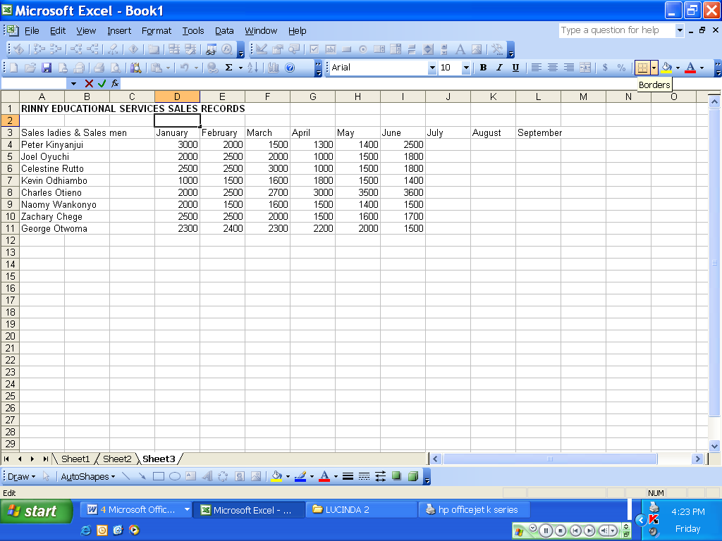
vi
i
ii
iii
v
iv
- The above is a diagram of a spreadsheet program. Use it to answer the following questions
- Appropriately label the parts labeled I,ii,iii,iv,v (5mks)
- Name box
- Formular bar
- Active cell pointer
- Row header
- Worksheet tab

- Name the function of the part labledI,ii,iii (3mks)
- Name box: it displays the address of the currently selected cell, can be used to navigate to a specific cell by entering the cell address in it
- It is used to enter,display and edit data and formula entered in the currently active cell
- It helps the user to identify the currently active cell
- Name THREE examples of spreadsheet application programs (3mks)
- Ms Excel
- open office calc,
- lotus 1-2-3
- Corel Quattro pro
- State and explain any FOURapplication areas of spread sheets (5mks)
Accounting:- used in recording daily transactions and keeping financial records as they come with inbuilt functions that make accounting easier
Scientific application:- used by engineers, scientists and technical users to store empirical Data, perform statistical analysis, build and prepare complex mathematical models using spreadsheets
Data management:- allows neat arrangement of data into tabular structure data management functions include sorting, filtering etc.
Statistical analysis:-they have inbuilt statistical tools that can speed up data manipulation e.g. average, median, mode, maximum, sum etc.
Forecasting(what if analysis):- this feature allows the changing the value of one of the arguments in a formula to see the difference the change would make in the calculation
Home and personal use:-used to track cash flow, preparing home budgets and personal financial statements

- a) Describe any three mouse techniques/skills. (3mks)
Clicking: pressing and releasing the left mouse button once
Double clicking: pressing and releasing the left mouse button twice in quick succession
Right clicking: pressing and releasing the right hand side mouse button once
Drag and drop: clicking and holding down the left mouse button while selecting and item, then moving the pointer to a different location on screen, then releasing the mouse button
b) List four key groupings on a computer keyboard citing two examples in each. (4mks)
Numeric keypad : 0-9, *,+,.,/,
Alphanumeric keys: A-Z,0-9, tab, enter ,backspace, space bar, caps lock
Cursor movement and editing keys: page up, page down, home, end, insert, del, arrow keys
Function keys: f1-f12
Special purpose keys: Ctrl, Alt, Shift,Esc

c) Name and explain the function of the following key symbols.
i) Enter: moves the cursor to the beginning of the next line/used to execute selected commands (2mks)

ii) Shift: used in combination with other keys to perform various functions (2mks)

iii) Tab : used to move the cursor at a set interval on the same line (2mks)
iv) Esc Escape used in combination with other keys to perform various functions (2mks)

- Study the following diagram and answer the questions that follow
20GB Hard disk
Floppy drive
CD drive
Printer
Mouse
Speaker
Monitor

CPU
128MB RAM
32MB ROM
Scanner

- Name two devices that are used for long term storage (2mks)
20 GB hard disk
32 MB ROM

- Name three peripheral devices shown in the diagram that are used for input (3mks)
Scanner
Mouse
- Name the input device that is not shown in the diagram above that the school secretary would requireKeyboard (1mk)
- Name the TWO categories that monitors classified (2mks)
Cathode ray tubes
Flat panel monitors
- Highlight FOUR advantages of non-impact printers over impact printers (4mks)
Non Impact printers have higher output speed
Non impact printers produce output that is neater
Non impact printer can print multiple copies
Non impact printers are quite as compared to impact printers

- a)Msambweni auto mechanics intends to purchase an output device to produce their engineering drawings. Which device would you advice them to purchasePlotter2mks)
b) Name the two types available of the above mentioned device (1mk)
Flat bed plotter
Drum plotter

