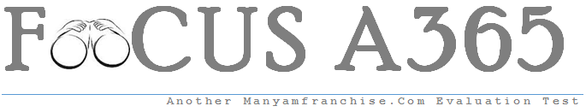

Gatitu Mixed Secondary School
Form 4 | Term 1 | 121 A - Mathematics | 07-Jan-16 | Opener
- Without using mathematical tables evaluate 4mks

Sin 60 tan 30 tan 45 – cos 45 sin 45 cos 60

Cos 30 tan 60 sin 30 – cos 60 sin 60 cos 30

- Syengo spends 1/3 of his salary on food, ¼ on rent , 3/5 of the remainder on transport and saves the rest. If he spends sh. 1800 on transport, find how much money he saves. 3mks

- The fig shows 2 circles centre A and B and radii 6 cm respectively. The circles intersect at P and Q. angle PAB = 42⁰ and angle ABQ = 30⁰.

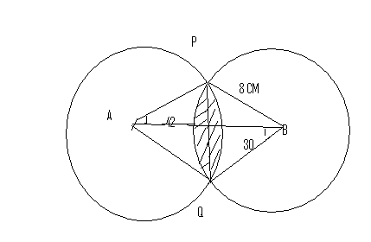

- Find the size of angle PAQ and PBQ 2mks

- Calculate to one decimal place the area of
- Sector APQ and PBQ 2mks

- Triangle APQ and PBQ 2mks

- The shaded area (take II =22/7) 4mks

- Vectors r and s are such that r= 7i +2j – k and s= -I +j –k find /r+s/ 3mks

- Muga bought a plot of land for ksh. 280,000. After 4 years , the value of the plot was ksh, 495,000. Determine the rate of appreciation, per annum, correct to one decimal place. 3mks

- Points A( -2,2) and B (-3,7) are mapped onto A1(4,-10) and B1(0,10) by an enlargement. Find the scale factor of enlargement. 3mks

- The table below shows the frequency distribution of marks cored by students in a test.
marks | Frequency
1-10 | 2
11-20 | 4
21-30 | 11
31-40 | 5
41-50 | 3
Determine the median mark correct to 4 s.f. 4mks

