GATITU MIXED SECONDARY SCHOOL
MATHEMATICS FORM 4 PAPER
MID TERM EXAM 2015

SECTION I (50MKS)
ANSWER ALL THE QUESTIONS IN THIS SECTION
- Evaluate 3mks
28 - (-18) - 15 - (-2) (-6)
-2 -3

- Evaluate 4mks

1/3 of (2 ¾ - 5 ½) × 3 6/7 ÷9/4

- Expand

(2x + 3y) 3 4mks

- Four interior angles of a heptagon are 100,150,125 and 105 respective. The fifth interior angle is twice the size of the sixth and the seventh angle is half the sixth angle. Find the size of the fifth angle. 4mks

- Expand the following expression and the factorise as far as possible. 4mks
( 3x +y)² - (x -3y)²

- The lines passing through the points A(-1, 3k) and B (k,3) is parallel to the line whose equation is 2y +3x =9 write down the co-ordinates of AB. 4mks

- The base of a triangle is 3cm longer than its height. Given that the area of the triangle is 35cm² determine the height of the triangle. 4mks

- Simplify

1 - 1

√7 + 3√3 √7- 3 √3 and write in the form a√3 + b√7 hence state the values of a and b. 4mks

- It would take 15 men 8 days to dig a trench 240m long. Find how many days it would take 18 men to dig a trench 360 m long working at the same rate. 3mks

- Use the method of completing the square to solve the quadratic equation. 4mks
2x² - 13 x + 15 =0

- Make A the subject of the formula 4mks

T = 2m /n
L –A
3K

- The sum of the first 8 terms of an AP is 236 and the sum of the first 6 terms of the same series is 147. Find the sum of the first 12 terms of the series. 4mks

- Mueni bought maize and beans at sh . 20 per kg and sh, 50 per kg respectively. She mixed them In a ratio such that after selling the mixture at sh 39 per kg, she made a profit of 50%. Find the ratio in which she mixed them. 4mks

SECTION II (50MKS)
ANSWER ANY FIVE QUESTIONS IN THIS SECTION.
- Two friends mwangi and kaveta live 40km apart. One morning Mwangi left his house at 9.00 am and cycled towards Kavete’s house at an average speed of 2o km/hr. Kaveta left his house at 10.30 am on the same day and cycled towards Mwangi’s house at an average speed of 30km/hr.
- The distance from Mwangi’s house where the two friends met. 8mks

- The time of day that the two met. 2mks

- A school water reservoir is supplied with water by two pumps P and Q.The probability that pump P fails is 1/10 and the probability pump Q fails is 1/5.
- Draw a simple tree diagram to illustrate this information. 2mks

- Calculate the probability that
- Both pumps are working. 2mks

- Both pumps are not working. 2mks

- Only one pump is working. 2mks

- At least one pump is working. 2mks

- A salesman is paid a basic salary of sh. 4500 and a house allowance of sh. 1800 per month. On top of this, he is paid a commission at the rate of 5% on the first sh. 10,000 worth of goods sold and a further commission of 7 ½ % on anything above this. At the end of the first month, he received a gross income of sh. 7595 while at the end of the second month; he received a commission of sh. 1445. Determine the difference in the value of goods he sold during the two months. 10mks

- In the figure OPQ is a triangle in which QS= 1/3 OP and OR= 1/3 OQ. T is a point on OS such that QT= ¾ QS.

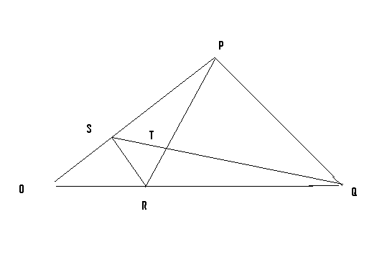

- Given that OP= p and OQ=q , express the following vectors in terms of p and q:
- SR 2mks

- QS 2mks

- PT 2mks

- TR 2mks
- Hence or otherwise show that the points P,T and R are collinear. 2mks

- Mwenga bought a plot of land at sh. 300,000 per hectare in a town where land value appreciates t a constant rate of 10% per annum. After two years, he sold the whole plot to a customer who was willing to pay sh. 50,000 per hectare. In the transaction Mwenga received sh. 274,000 more than the present value of the plot.
Determine
- The present land value per hectare 4mks

- The size of Mwenga’s plot in hectares 6mks

- Forty students in a form two class were weighed and their masses recorded to the nearest kilogram as below.
45 48 56 39 47 36 45 49 50 46
37 46 33 43 51 42 47 39 42 48
47 40 46 41 45 43 46 50 38 45
54 42 51 39 42 45 44 35 52 46
- Using class intervals of 5kg tabulate this data in a frequency table. 4mks

- Find the modal class. 1mk

- Modify the table and use it to calculate the mean mass of the students. 5mks

