## PERFECT STEPS PUBLISHERS

END TERM EXAMS 2015

**0721 745374/ 0721 707626 NAIROBI**

Name: ……………………………………… Adm no ..…..................Class: ……....….

**FORM 3**

**MATHEMATICS**

**PAPER 1**

**121/2**

**TIME: 2 ½ HOURS**

**INSTRUCTIONS TO CANDIDATES:**

* *Write your* ***name****,* ***admission no*** *, and class in the spaces provided*
* *The paper contains* ***two*** *sections. Section I and Section II.*
* *Answer* ***ALL*** *the questions in section I and any* ***five*** *questions in section II.*
* *Answers and working* ***must*** *be written on the question paper in the spaces provided below each question.*
* *Show all steps in your calculations below each question.*
* *Marks may be given for correct working even if the answer is wrong.*

*.*

**SECTION 1**

|  |  |  |  |  |  |  |  |  |  |  |  |  |  |  |  |  |  |
| --- | --- | --- | --- | --- | --- | --- | --- | --- | --- | --- | --- | --- | --- | --- | --- | --- | --- |
| **Question** | 1 | 2 | 3 | 4 | 5 | 6 | 7 | 8 | 9 | 10 | 11 | 12 | 13 | 14 | 15 | 16 | **TOTAL** |
| **Marks** |  |  |  |  |  |  |  |  |  |  |  |  |  |  |  |  |  |

**SECTION II**

|  |  |  |  |  |  |  |  |  |  |
| --- | --- | --- | --- | --- | --- | --- | --- | --- | --- |
| **Question** | 17 | 18 | 19 | 20 | 21 | 22 | 23 | 24 | **TOTAL** |
| **Marks** |  |  |  |  |  |  |  |  |  |

**Grand Total**

**SECTION I (50 MKS) *(Answer all the question in this section)***

1. Without using mathematical tables or a calculator evaluate (3mks)



1. Without using a calculator, evaluate, , leaving the answer as a fraction in its simplest form (3mks)
2. Peter, James and David contributed sh.19, 000. The ratio of contribution of Peter to David was 3:7 and that of David to James was 6:5. How much did David contribute? (3mks)
3. The line y=2x is reflected in the x-axis. Find the equation of the image of the line. (3mks)
4. Find all the integers satisfying the inequalities  (3mks)
5. Using a ruler and a pair of compasses only, construct the triangle ABC in which AB = 10cm, and. Hence, determine the height of the triangle taking AB as the base. (3mks)
6. If the exchange rate is 1US dollar = sh.76.45, how much money in US dollars would a returning US tourist receive from a bank at the airport if he changed sh.10, 000 and the bank takes a 5% commission? (3mks)
7. The size of each interior angle of a regular polygon is five times the size of the exterior angle. Find the number of sides of the polygon. (3mks)
8. Factorize completely  (3mks)
9. Solve for x in the equation for  (3mks)
10. Make P the subject of the formula  (3mks)
11. A town P is 200km West of Q. Town R is at a distance of 80km on a bearing of 0490 from P. Town S is due East of R and due North of Q. By scale drawing, determine the bearing of S from P. (4mks)
12. The diagram below represents a right pyramid on a square base of sides 3cm. The slant edge of the pyramid is 4cm.

4 cm

V

C

D

B

A

3 cm

(a) Draw the net of the pyramid (2mks)

(b) Using the net, calculate the surface area of the pyramid (2mks)

1. The equation of line L1 is and line L2 passes through the point and . Without drawing the lines L1 and L2. Show that the two lines are perpendicular to each other. (3mks)
2. A rally car traveled for 2 hours 40 minutes at an average speed of 120km/h. The car consumes an average of 1 litre of fuel for every 4 kilometers. A litre of fuel costs ksh.59. Calculate the amount of money spent on the fuel. (3mks)
3. Find the value of y and z in the figure below (3mks)

5

9

4

y

z

**SECTION II (50 MARKS)**

***(Answer any five questions in this section)***

1. A farmer has two tractors A and B. The two tractors working together can plough a farm in 2½ hours. One day, the tractors started to plough the farm, together. After one hour ten minutes, tractor B broke down but A continued alone and completed the job after a further 4 hours. Find:

(a) The fraction of the job done by the tractors, working together for one hour. (2mks)

(b) The fraction of the job done by tractor A after B broke down. (4mks)

(c) The time each tractor working alone would have taken to plough the farm. (4mks)

1. An arithmetic progression of 41 terms is such that the sum of the first five terms is 560 and the sum of the last five terms is -250. Find:

(a) The first term and the common difference (5mks)

(b) The last term (2mks)

(c) The sum of the progression (3mks)

1. Two parallel walls stand on level ground. The first wall is 20m high. Two points A and B point on the second wall such that P is at the top of the wall and Q is at the base of the wall directly below P. From a point P at the top of the first wall, the angle of A is 400 and the angle of depression of B is 250. The line AB is directly opposite to P.

(a) Using the scale: 1cm represents 4m, construct a diagram showing the position of A,

B and P. (4mks)

(b) Measure;

(i) the distance between the walls. (2mks)

(ii) The height of the second wall (2mks)

(c) A point R at the top of the first wall is 30m from P. By further drawing on the

diagram, determine the angle of elevation of the point A from R. (2mks)

1. The figure below is a triangle OAB, where =, and . A point R divides AB in the ratio 2:5 and a point T divides OB in the ratio 1:3. and intersect at D.

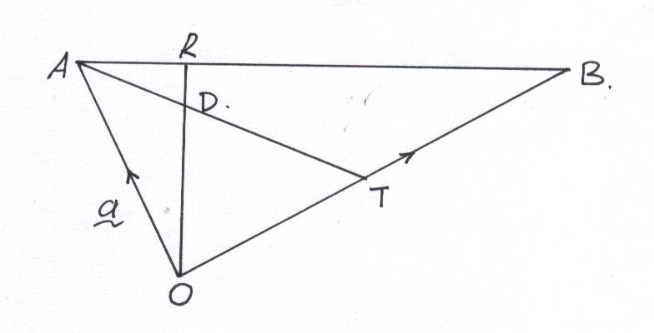

(a) Find in terms of and 

(i)  (2mks)

(ii)  (2mks)

(iii)  (2mks)

(b) Given that and where k and h are scalars. Find the values

of k and h. Hence express AD in terms of and . (4mks)

1. The diagram below shows the speed-time graph for a train between two stations. The train starts from rest and accelerates uniformly for 150 seconds. it then travels at a constant speed for 300 seconds and finally comes to rest in 200 seconds.

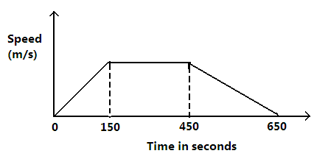

Given that the distance between the two stations is 10450m, calculate the:

(a) Maximum speed, in km/h, the train attained (3mks)

(b) Acceleration (2mks)

(c) Distance the train traveled during the last 100 seconds (2mks)

(d) Time the train takes to travel the first half of the journey (3mks)

1. (a) Draw the graph of for values of x from -4 to 7 (6mks)

**graph**

(b) Hence use your graph to solve the following equations

(i)  (2mks)

(ii)  (2mks)

1. In the figure below, ABCD is a cyclic quadrilateral and that angle ABD = 420, angle BAC= 580 and angle DBC = 360

B

A

E

C

D

Giving reasons, find the values of

(a) Angle DAC (2mks)

(b) Angle ADB (2mks)

(c) Angle ACD (2mks)

(d) Angle CDB (2mks)

(e) Angle CEB (2mks)

1. In the figure below (*not drawn to scale*). AB = 8cm, AC = 6cm, AD = 7cm, CD = 2.82cm and angle CAB = 500

500

8cm

2.82cm

7cm

B

C

D

A

6cm

Calculate (to 2 decimal places)

(a) The length BC, (2mks)

(b) The size of angle ABC (3mks)

(c) The size of angle CAD (3mks)

(d) The area of triangle ACD. (2mks)

PRINTED AND COMPILED BY PERFECT STEPS PUBLISHERS: 0721 745374/0721707626 NAIROBI