NAME:………………………….. ADM. NO………………….

DATE:…………………….. CLASS:……………………..

121

MATHEMATICS

FORM 3

TIME 2 ½ HRS

COUNTY MULTILATERAL EXAMINATION 2016

END OF TERM II EXAM

INSTRUCTIONS

The paper consists of two sections; section 1 and 2.

Answer all the questions in both sections.

Show all the working in the spaces provided below each questions.

Scientific calculators or mathematical tables may be used.

SECTION 1

Answer All the questions in this section.

1.  (2mks)

2. Goatie withdrew some money from a bank. He spent of the money to pay Guruneties school fees and to pay Muchaina’s school fees. If he remained with Kshs. 12,330. Calculate the amount of money he paid for Muchaina’s school fees. ( 4mks)

3. Simplify  ( 3mks)

4. Solve for x in 9x+32x-1=161

5(a) Expand (x – y)6

b) Use the first three terms of the expansion in (a) to find the approximate value of (1.98)6 (3 mks)

6. Given that make x the subject. (3mks)

7. The size of an interior angle of a regular polygon is 3x0 while its exterior angle is (x-20)o. Find the number of sides of polygon. (3mks)

8. Y varies inversely as x, if y =3 when x =1. Find the value of x when y =9. (2 mks)

9. In the figure below, angles BAC and ADC are equal. Angle ACD is a right angle. The ratio of the sides AC: BC=2:3. Given that the area of triangle ABC is 12cm2.Find the area of triangle ACD.

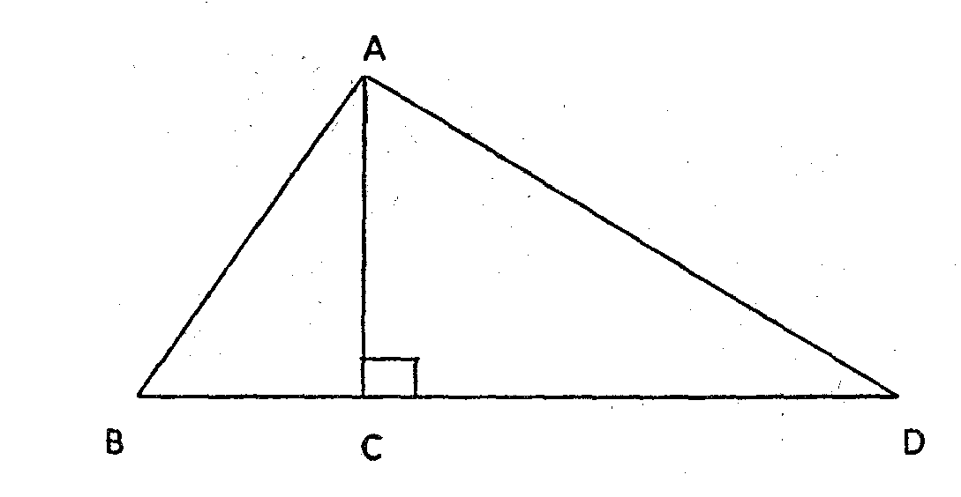

10. Solve for x in the equation.



11. Using a pair of compasses and ruler only. Construct triangle ABC in which AB = 5cm <BAC=300 and <ABC=1050. Draw the centroid of C and label it O. measure AC, BC, OC. (5mks)

12. The figure below is a net of a cuboid with some dots on 3 faces

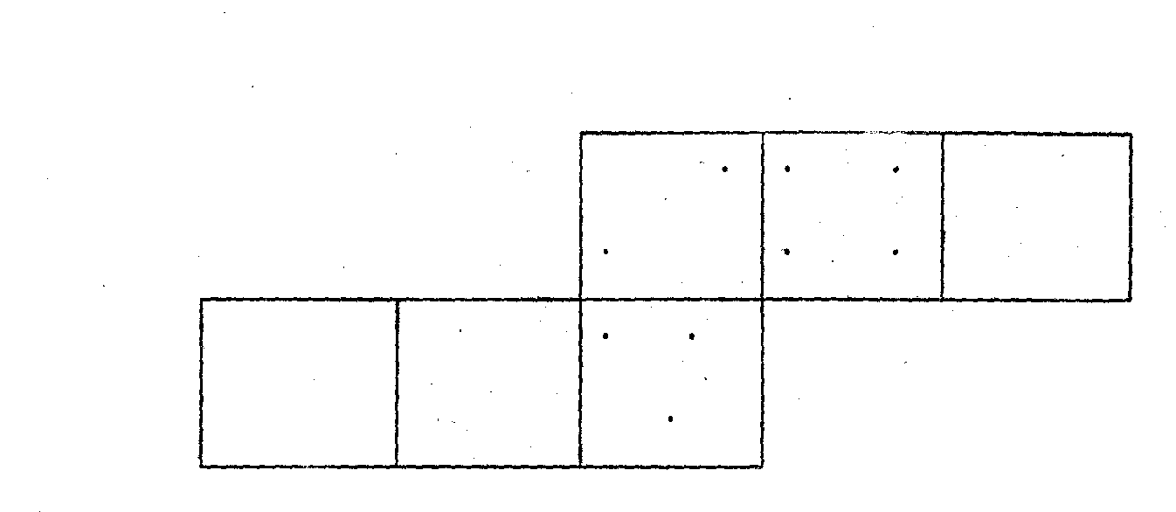

Given that the number of dots on pairs of opposite faces add up to 5, fill in appropriate dots in each of the empty faces. (3 mks)

13. Find the value of x for 

1+2sin (2x+30)= 0 3mks

14. In a bakery, the number of ngumu’s produced in the first month is 250. The number of ngumu’s produced per month increased on the average by 30. Find the expected number of ngumu produced for the first 12 months.

15. A cone has a radius of 10cm and a slant height of 26cm. A frustrum is cut off from his cone such its top is 10cm diameter and its slant height is 13cm. see (diagram below). Calculate the area of the curved surface of the frustrum. (2 mks)

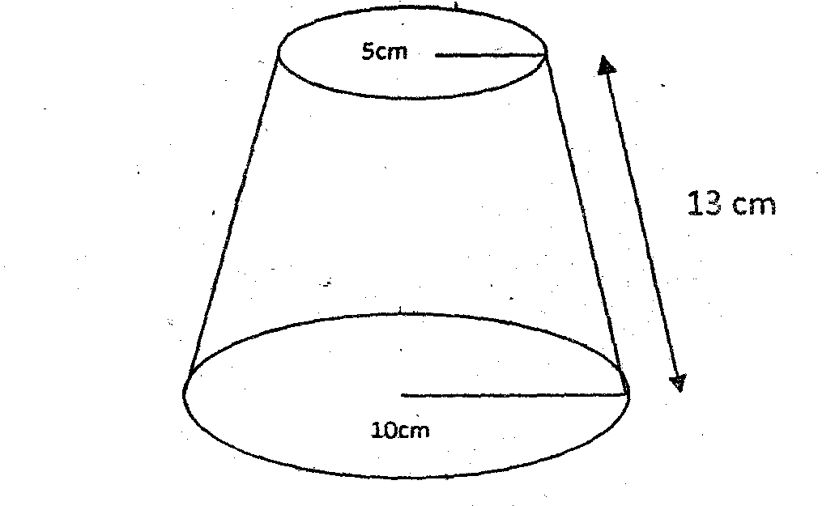

16.

a) Obtain of matrix 

b. Hence solve the simultaneous equation.

2x –y = 1

3x – 19 = -2y (4 mks)

Section 2

Answer all questions (17-21) each question contain (10 mks)

17. Draw the graphfor the range to determine the (5 mks)

(a) Roots of  (1mks)

b) Solution to the equation below using the graphing.

i.  (2 mks)

ii. 4x+2x2=4 (2 mks)

18. The commuting distances in Km for 60 students in a certain school is as follows.

|  |  |  |  |  |  |  |  |  |  |
| --- | --- | --- | --- | --- | --- | --- | --- | --- | --- |
| 2 | 13 | 47 | 10 | 3 | 16 | 29 | 17 | 40 | 4 |
| 6 | 7 | 25 | 8 | 21 | 19 | 15 | 3 | 17 | 14 |
| 12 | 12 | 45 | 1 | 8 | 14 | 16 | 11 | 18 | 23 |
| 18 | 6 | 2 | 14 | 13 | 7 | 15 | 46 | 12 | 9 |
| 9 | 34 | 13 | 41 | 28 | 36 | 17 | 24 | 27 | 29 |
| 16 | 14 | 26 | 10 | 24 | 37 | 31 | 8 | 16 | 12 |

Group the data in a frequency table, starting with 1-5 as the 1st class interval. (4 mks)

a) Calculate the

i. Mean (2 mks)

ii. Median (2 mks)

b) Give the modal class. (1 mk)

19. The table below show’s Kenyan tax rates in a certain year.

Monthly income Tax rates%

1-9,860 10

9,861 – 18,980 15

18,981 – 28,100 20

28,100 – 37,220 35

37,221 – and over 40

Agnes basic salary was shs. 20,600 and was entitled to the following monthly allowances:

Entertainment allowance of shs. 4,000

Medical allowance of shs. 2,880

Transport allowance of shs. 1,040

She was also entitled to a monthly tax relief of shs. 1,056.

Calculate.

i) her monthly taxable income (1mk)

ii) Her P.A.Y.E (5 mks)

iii) Find her net salary per annum in pounds given that she also repays a sacco loan at Shs. 2,000 per month, pays Shs. 150 for union dues and Shs. 300 for NHIF.

(4 marks)

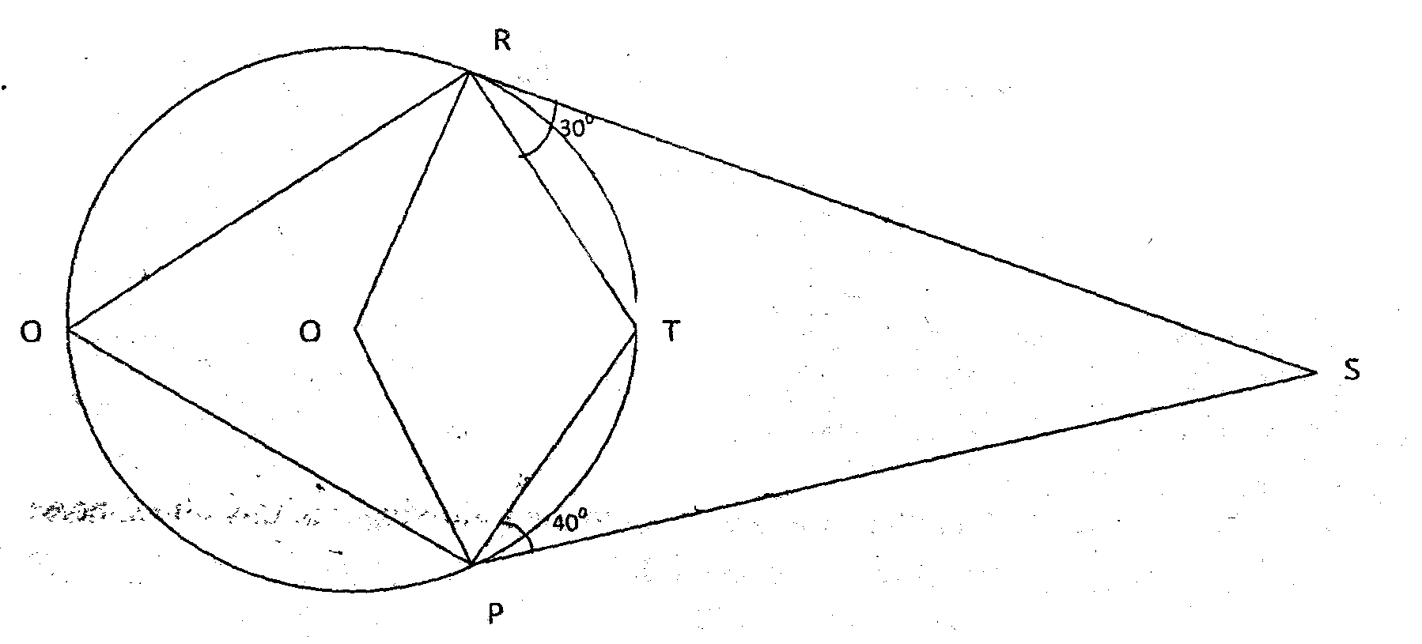

20. In the figure above, O is the centre of the circle. SR and SP are tangents. Angle SPT =400 and SRT = 300. Find.

1. Angle RQP (6 mks)
2. Angle ORP (2 mks)
3. Angle RSP (2 mks)