GATITU MIXED SECONDARY SCHOOL
MATHEMATICS FORM 3 END OF TERM 3 2015 EXAM
SECTION 1: ANSWER ALL QUESTIONS IN THIS SECTION
- Make z the subject of the formula in; 3mks
H= (W+X)^{Z}
5

- Solve the equation below using completing the square method. 3mks
3X² + 5X = -2

- Solve the equation sin x =0.8469 for 0≤x ≤ 360 2mks

- Simplify (1+$√3)$ ( 1- $√3)$ hence evaluate 1/1 +$√$3 to 3 s.f given that $√3$ =1.7321 3mks

- Find the value of x given that log (x + 1) + 2 = log (3x +2) + log 25 3mks

- Use the expansion of (x – y)⁵ to evaluate (9 -8)⁵ correct to 4 decimal places 3mks

- Given that A ( 2x x ² )determine the value of x for which A has no inverse 3mks

- The dimensions of a rectangle are measured and given as 6.9 cm by 3.06 cm. calculate the relative error in its area given your answer correct to four significant figures. 4mks

- Find the compound interest earned on sh 18,000 invested for 2 years at 20% p.a compounded quarterly. 4mks

- The seventh term of an arithmetic sequence is 14 and its fifteenth term is 30. Find the 19th and 50th term. 4mks

- A bag contains 12 green balls and the rest are red , if a ball is picked at random, the probability of it being green is 0.75. find the number of red balls.(3mks)

- An angle of 1.8 radians at the centre of the circle subtends an arc length of 23.4 cm. find
- The radius of the circle in cm 3mks

- The area of the sector enclosed by the arc and the two radii 2mks

- Two baskets A and B each contains a mixture of arranges and lime all the same colour . Basket A contains 26 oranges and 13 limes. Basket B contains 18 oranges and 13 limes. A child selected a basket at random.
- Illustrate this information using a tree diagram 2mks

- Find the probability that the fruit picked was an orange. 3mks

- The third term of a geometric sequence is 24 and its fifth term is 864.
- Write down the first term of the sequence . 3mks

- Hence, find the sum of the first 8 terms of the series. 2mks

SECTION II
ANSWER ANY FIVE QUESTIONS IN THIS SECTION
- Three partners Amina, Bosire and Karuri contributed a total of ksh 4800 000 in the ration 4:5:7 to buy an 8 hectares piece of land. The partners set aside ¼ of the land for social amenities and sub divided the rest into 15m by 25 m plots.
- Find:
- The amount of money contributed by Karuri; 2mks

- The number of plots that were obtained. 3mks

- The partners sold the plots at ksh 50 000 each and spent 30% of the profit realized to pay for administrative costs. They shared the rest of the profit in the ratio of their contributions.
- Calculate the net profit realized. 3mks

- Find the difference in the amount of the profit earned by Amina and Bosire. 2mks

- In a retail shop, the market price of a cooker was ksh 36,000.wanandi bought the cooker on hire purchase terms. She paid 6400 as deposit followed by 20 equal monthly instalments of ksh1750.
- Calculate
- The total amount of money she paid for the cooker. 2mks

- The extra amount of the money she paid above the market price. 1mk

- The total amount of money paid on hire purchase terms was calculated at a compound interest rate on the marked price for 20 months. Determine the rate, per annum , of the compound interest correct to 1 decimal place . 4mks

- Kaloki borrowed ksh 36000 from a financial institution to purchase a similar cooker. The financial institution charged a compound interest rate equal to the rate in (b) above for 24 months. Calculate the interest kaloki paid correct to the nearest shilling. 3mks

- In the figure below,OA = 8.4cm, AC = 7 cm, < AOB = 72 and < ACB = 90

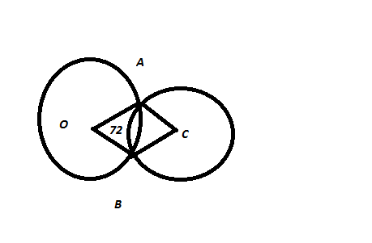

Calculate
- The area of intersection of the two circles 4mks

- The area of the quadrilateral OACB 3mks

- The area of the shaded region 3mks

- The table below shows income tax rates for a certain year

Taxable income in ksh per month | Rate of tax (%)
1-10164 | 10
10165- 19740 | 15
19741- 29316 | 20
29317- 38892 | 25
Over 38892 | 35
In a particular month that year, Ng’eno got ahouse allowance of sh 12,000, a relief of sh 1056 and paid a PAYE of sh. 8040. Calculate ;
- His gross tax 2mks

- His taxable income to the nearest shillings 6mks

- His basic salary per month 2mks

- The figure below shows a cone with a vertex at A and diameter 13 cm. the cone is cut off along DE as shown below.

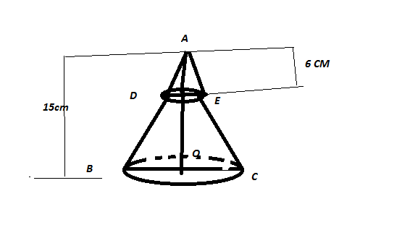
- Find the vertical height AO 2mks

- Find the curved surface area of the frustrum. 4mks

- Find the volume of the frustrum. 4mks

- A square has vertices A(3,0), B (1,3), C(4,5) and D (a,b). find the value of a a and b. 10mks

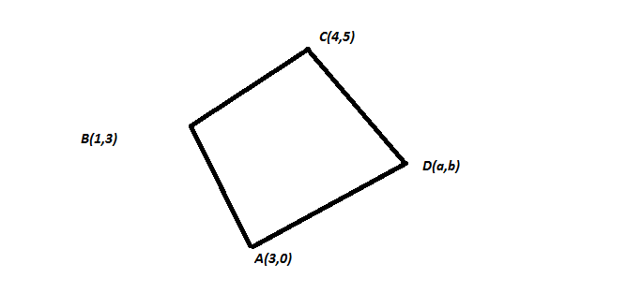

- A clothes dealer sold 3 shirts and 2 trousers for sh 840 and 4 shirts and 5 trousers for sh 1680.
- Form a matrix equation to represent the above information. 3mks

- Use the matrix equation to find the cost of a shirt and a trouser. 7mks

- A number of people decided to contribute sh. 800 towards a charity fund. They agreed to contribute each an equal amount of money. Four of them withdrew from the venture. As a result , each of the remaining people had to contribute sh. 10 more to reach the target . calculate;
- The original number of people for the charity fund. 7mks

- The amount of money each contributed after the withdrawal of the four. 3mks

