NAME…………………………………ADM NO…………DATE…………………

KISIRIRI SECONDARY SCHOOL
P.O. BOX 93-20500 TEL 0721-451-691
CAT TWO OF 1ST TERM 2014
FORM THREE
MATHEMATICS

ONE HOUR

- The table below shows the length of 40 mango tree leaves
Length in mm | frequency
118-126 | 3
127-135 | 4
136-144 | 10
145-153 | 12
154-162 | 5
163-171 | 4
172-180 | 2
Construct a grouped frequency distribution table for the above date to aid you determine
- The mean length of the leaves (5mks)

- The median of the data(4mks)

- The modal class(1mk)

- (a) From a balcony 16m above the ground an observer notices that the angle of depression of the foot of a multi-storeyed building is 18.6º. The angle of elevation of the same building from the balcony is observed to be 50.5⁰. Calculates to the nearest metre the height of the building. (3 marks)

(b) Two goods trains A and B are moving in the same direction at a speed of 108km/hr and 72 km/hr with lengths of 150m and 100m respectively. If train A has just reached train B at 1200hrs, at what time will it completely pass train B? (3 marks)

(c) a rectangle has length (x + 2) and width (x – 1). Determine the value of x. (4mks)

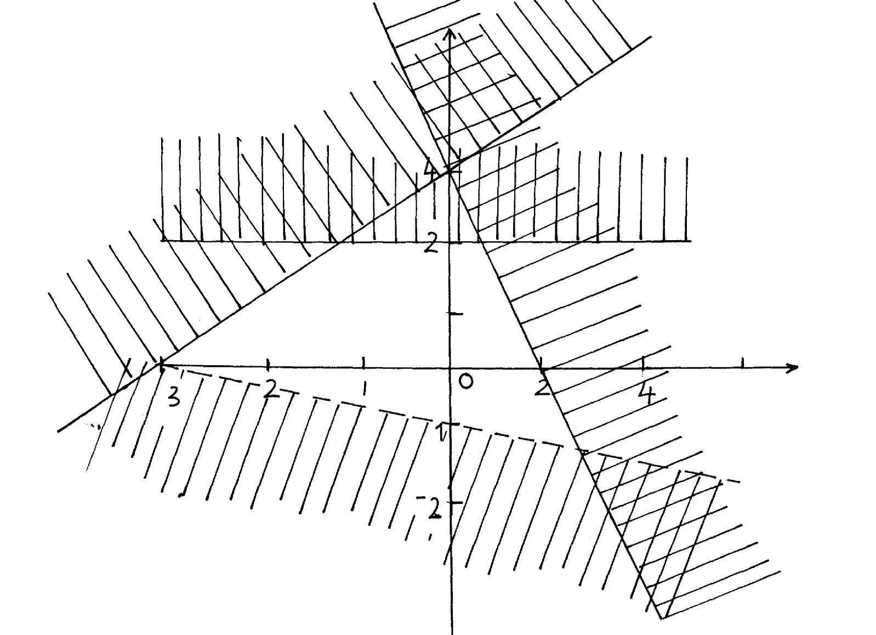
- Below is a region satisfied by four inequalities.
B
C
D
R
- 1
A
y
x

Find the four inequalities that satisfy the region R.
(a) Line A (3 marks)

(b) Line B (3 marks)

(c) Line C (3 marks)

(d) Line D (1 mark)

- The diagram below shows a frustum which represents a bucket with an open end diameter of 30cm and bottom diameter of 24cm. The bucket is 30cm deep and is used to fill an empty cylindrical tank of diameter 1.4m and height 1.2m
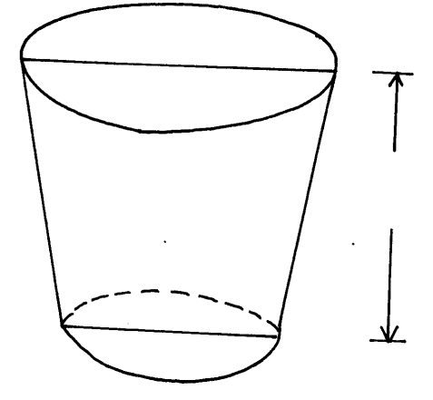
R = 15cm

30 cm

r = 12cm

(a) Leaving π in your answer, calculate;
(i) The capacity of the bucket in litres (6 marks)

(ii) The capacity of the tank in litres. (2 marks)

(b) Determine the number of buckets that must be drawn in order to fill the tank.(2 marks)

