NAME ------------------------------------------------------------ADM NO. --------------------------------
GATITU MIXED SECONDARY SCHOOL
MATHEMATICS FORM 3 MID TERM EXAM TERM 3 2014
SECTION A: answer all questions
- Use logarithms to evaluate. 4mks
(0.07284)²

3 0.06195

- Solve simultaneous equations. 4mks
2x –y =3
X² –xy =-4

- Find the value of x in the following equation. 4mks
49^{(x+1)} + 7^{2x} =350

- A translation maps a point onto (-1,2). What would be the co-ordinates of the object whose image is (3,-3) under the same translation. 2mks

- Simplify completely 3mks
3x² -1 - 2x +1
x² -1 x +1

- The ratio of the lengths of the corresponding sides of two similar rectangular water tanks is 3:5. The volume of the smaller tank is 84 m³. Calculate the volume of the larger tank. 3mks

- Without using logarithm tables, find the value of x in the equation. 3mks
Log x³ + log5x = 5 log2 – log 2/5

- Four farmers took their goats to the market. Mohammed had two more goats than Ali, Koech has three times as many goats as Mohammed, whereas oduboy had 10 goats less than both Mohammed and koech.
- Write a simplified algebraic expression with one variable, representing the total number of goats. 1mk

- Three hatchers bought all the goats and shared them equally. If each butcher got 17 goats. How many did Oduboy sell to the butchers? 3mks

- Mary has 21 coins whole total value is sh. 72. There are twice as Many five shillings coins as there are ten shillings coins. The rest are one shilling coins. Find the number of ten shilling coins that Mary has. 4mks

- Mogaka and Ondugo working together can do a piece of work in 6 days. Mogaka working alone takes 5 days longer than Ondugo. How many days does it take Ondugo to do the work alone? 4mks

- Two athletes in an 800 metre race take 104 seconds and 108 seconds respectively to complete the race. Assuming each athlete is running at a constant speed, calculate the distance between them when the faster athlete is at the finishing line. 2mks

- A plot of land was valued at sh. 50,000 at the start of 1994. It appreciated by 20% during 1994. Thereafter, every year, it appreciated by 10% of its previous year’s value. find
- The value of the land at the start of 1995. 1mk

- The value of the land at the end of 1997. 2mks

SECTION B : answer any three questions
- Helina left town A at 8.00am and travelled towards town B at an average speed of 64km/hrhalf an hpour later Joyce left town B and travelled towards town A at the same speed. If the two towns are 384 km apart:
- At what time did they meet? 5mks

- How far from town B was their meeting point? 2mks

- How far apart were they at 10.30 am? 3mks

- In the figure below AOC is a diameter of the circle centre O; AB =BC and < ACO= 25⁰, EBF is a tangent to the circle at B. G is a point on the minor arc CD.

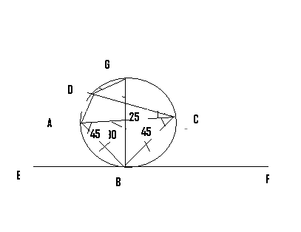

- Calculate the size of
- <BAD 3mks

- The obtuse <BOD 2mks

- <BGD with reasons 2mks

- Show that <ABE = <CBF. Give reasons 3mks

- A company employee earns a basic salary of kshs, 25,000 and is also given taxable allowances amounting to kshs. 10,480
Income in kE p.a | Rate in shs/KE
1 4350 | 2
4351 -8900 | 3
8901 -13,450 | 4
13451 -18,005 | 5
Above 18,006 | 6

Using the table of taxation above
- Calculate the employee’s taxable income per year in Kenya pounds 2mks

- If the employee is entitled to a personal tax relief of ksh 800 per month determine the net tax. 5mks

- If the employee was given 40% increase in his income, calculate the percentage increased his income tax. 3mks

- The probability that a husband and wife will be alive 30years from now is 0.6 and 0.8 respectively. Find the probability that in 30 years time: 10mks
- Both will be alive

- Neither will be alive

- One will be alive

- At least one will be alive

