GATITU MIXED SECONDARY SCHOOL
MATHEMATICS FORM 3 CAT 2 TERM 3 2014
TIME: 1 ¼ HRS
- Given the ratio x:y = 2:3 find the ratio (5X -2 Y ) : (X + Y) 3mks

- It would take 15 men 8 days to dig trench 240 metres long. Find how many days it would take 18 men to dig a trench 360 m long working at the same rate. 2mks

- Given the column vectors
a = b= c=
-3 4 5
2 -6 -10

And that P = 2a – ½ b + 2/5 c express P as a column vector and hence calculate its magnitude /p/ correct to 2 decimals places. 3mks

- Calculate the value of constant K if the coefficient of X ³ term in the expansion of (k +2x)⁴ is 160. 3mks

- The probability that Mwangi passes his exams is 4/5. If he passes the probability that he gets employed is 5/8. If he fails, the probability that he is employed is ¾. Using a tree diagram, find the probability that he is employed. 3mks

- A coffee blender mixes grade A and B in the ratio 3: 2 respectively. If grade A costs shs. 40 per kg and B sh. 30 per kg, at what price per kg should he sell the mixture in order to make a profit of 20% 3mks

- Expand ( 1 – X)⁵ 1mk

- Use the expansion above up to the term in X³ to approximate the value of (0.98)⁵ 2mks

- The figure below shows a triangle of vector in which OS: SP = 1:3, PR: RQ = 2:1 and T is the mid point of OR.

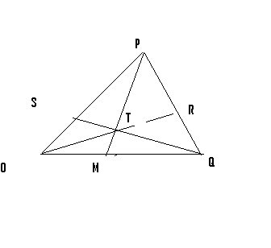

- Given that OP=p and OQ =q, express the following vectors in terms of p and q.
- OR 2mks

- QT 2mks

- Express TS in terms of p and q and hence show that the points Q, T and S are collinear.3mks

- M is a point on OQ such that OM = kOQ and PTM is a straight line. Given that PT:TM = 5:1 , find the value Kk 3mks

- A hot water tap can fill a bath in 5 minutes while a cold water tap can fill the same bath in 3 minutes. The drain pipe can empty the full bath in 4/15. The two taps and the drain pipe are fully open for 1 ½ minutes after which the drain pipe is closed. How long will it take to fill the bath? 10mks

- Expand and simplify the expression 5mks
(10 +2/x) 5

- Use the expansion in (a) above to find the value of 14⁵ 5mks

