NAME ---------------------------------------------------------CLASS --------------------------- ADM NO ----------
GATITU MIXED SECONDARY SCHOOL
MATHEMATICS 121/1
FORM 3 TERM 3 2013 TIME: 2 ½ HRS
SECTION 1 (50 MKS)
ANSWER ALL THE QUESTIONS IN THIS SECTION
- Simplify 3mks
5/6 of (4 1/3 -3 5/6)
5/12 × 3/25 + 1 5/9 ÷2 1/3

- Evaluate 2mks

6(2+9) – 3³ ÷ 9 -4

-4(1 +5)² ÷ 6 – (42 +5)

- Evaluate using of tables of reciprocals, squares and square roots. 4mks

3 √ 0.008 - 10

0.375 37.5²

- If Tan ø =3 /15 , find without using calculators or mathematical tables the value of 3mks

sinø –cos ø
cos ø + sin ø

- simplify completely 3mks
(6a +b) (a+b) – 7b (a+b)
2a² -2b²

- solve for x in 3^{2X +1} – 4^{(3X+1)} + 9 =0 3mks

- A line passes through point (x,2) and is perpendicular to the line 5y – 2x =10 at
125 108
29 29
determine the equation of the line in the form ax +bx + c =0 3mks

8. In the diagram below triangle ABE is similar to triangle ACD and BE is parallel to CD.Determine the values of p and q 3mks
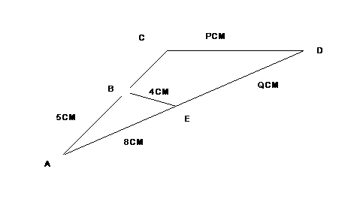

9. Given that the position vectors of P,Q and R are p,q and r respectively and that R is the mid – point of PQ write down a vector equation that relates p,q and r.If p is (5,8), Q (7,4) find r hence state the coordinates of R. 4mks

10. solve the following simultaneous inequalities and represent your solution on a number line 3mks
3 -2x < 5
4 -3x > -8

11. The surface area of a sphere is give by 4^r² if there is an error of 0.03% in ^ and an error of 0.4% in the radius. What would be the error in calculation of area? 3mks

12. James bought a suit for 1,200 and marked it at a price such that after allowing his customer a 10% discount, he would make a profit of 20%. Calculate the selling price of the suit. 3mks

13. In an agricultural research centre, the length of sample of 50 maize cobs were measured and recorded as shown.
Length (cm) | 8 -10 | 11 -13 | 14 -16 | 17 -19 | 20 22 | 23 -25
No of cobs | 4 | 7 | 11 | 15 | 8 | 5

calculate the median 3mks

14. In the figure below.W,X,Y and Z lie on the circumference. WY is the diameter. Determine the values of angle XWY and wvz giving reasons. 3mks

15. Expand 3 +1/8x ^{4,} in ascending powers of X. Hence use your expansion to estimate 3.025⁴ giving your answer correct to 3 decimal places. 4mks

16. An investor deposited 40,000 in a bank compounded at the rate of R p.a semi annually for 2 years and realized ksh. 50,499. Find the rate of compound interest. Give your answer correctly to 4 significant figures. 3mks

SE CTION 2( 50MKS)
ANSWER ANY FIVE QUESTIONS FROM THIS SECTION
17. The heights of a seedling in a nursery were measured and recorded as in the table below.
Xcm | 0≤×<5 | 5≤×<15 | 15≤×<25 | 25≤×<45 | 45≤×<75
No. of seedling | 7 | 46 | 72 | 64 | 11

- estimate the mean height of the tree seedlings in the nursery 4mks

- Using a scale of 1 cm to represent 10 units along the horizontal axis, and a scale of 1 cm to represent 1 unit along the vertical axis, draw a histogram and a frequency polygon to represent the distribution. 6mks

18.
- James walks to school every morning 10 km away from his home. His average speed in the return journey is reduced by 1 km/h and therefore takes 30 minutes more on the return journey. Determine his average speed on his journey to school from home. 4mks

- i) complete the table below for the function y =2x² +3x -6 2mk
x | -4 | -3 | -2 | -1 | 0 | 1 | 2
2x² | 32 |  |  | 2 | 0
3x |  | -9 |  | -3 | 0
-6 | -6 | -6 | -6 | -6 | -6 | -6 | -6
y |  |  |  |  | -6

ii) Draw the graph of y = 2x² + 3x -6 for values -4 ≤ x ≤ 2 3mks

iii) By drawing a suitable line on the same axes, solve the equation 2x² + x -7 =0 1mk

19.
- The points p(2, -1),Q(0, -3),R(2, -4) and S(4, -2) and join them to form a quadrilateral PQRS and give the name of the quadrilateral. 3mks

- P’Q’R’S’ are the image points of the quadrilateral PQRS under a reflection on the line y =x. Draw the quadrilateral P’Q’R’S’ and give its coordinates. 3mks

- Given that P’Q’R’S’ is rotated through =90 about the origin plot the new image P”Q”R”S” and give its coordinates 3mks

- Determine a single transformation that maps P’’Q’’R’’S’’ on to PQRS 1mk

20. Two towns, A and B are 80 km apart. Juma started cycling from town A to town B at 10.00am at an average speed of 40km/h. Mutuku started his journey from town B to town A at 10.30 am and travelled by car at an average speed of 60km/h.
- calculate
- the distance town A when Juma and Matuku met; 5mks

- the time of the day when the two met. 2mks

- Kamau started cycling from town A to town B at 10.21 am. He met Matuku at the same time as Juma did. . Determine Kamau’s average speed. 3mks

21. a. Three towns A,B and C are such that B is 150 km from A on a bearing of 060. The bearing of C from A is 125. The bearing of C from B is 160. Draw a sketch toshow the relative positions of A,B and C. Calculate the distance of C from S and from B. 4mks

b. An airplane flies from town A on a bearing of 345 at 300kmh⁻¹. After 40 minutes of flying the pilot decides to fly directly to C. Determine the time it would take to reach C and bearing on which it would fly ( town A and C are as far as in (a) above 6mks

22. Two circles of radii 3.5 cm and 4.2 cm with centres O₁ and O₂ respectively intersect at points A and B as shown in the figure below. The distance of the centres is 6cm.
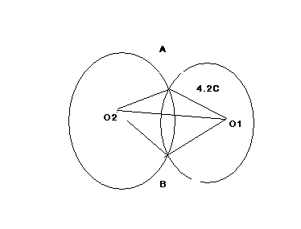

calculate
- < AO₁B to the nearest degree 3mks

- <AO₂B to the nearest degree 3mks

- Area of the quadrilateral O₁AO₂B, correct to 2 decimal places. 3mks

- the shaded area correct to two significant figures (take II =22/7) 1mk

23. In the triangle OAB below, OA =a OB =b and OC =3/2 OA.M divides OB in the ratio3:2
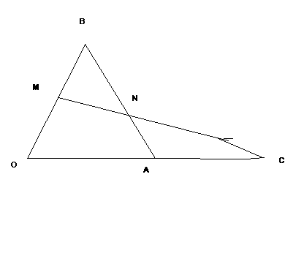
a) Express in terms of a and b only, the vectors. 1mk
- AB

- MC 1mk
b. Given that MN =h C and BN =kBA, express vector MN in two different ways and hence, show that points M,N and C are collinear. 8mks

24. The figure below represents cone of height 12 cm and base radius of 9cm from which a similar smaller ne is removed, leaving a conical hole of height 4 cm.

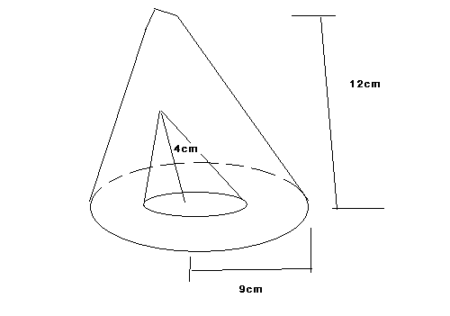
- calculate:
- the base radius of the conical hole; 2mks

- the volume, in terms of II, of the smaller cone that was removed 2mks

- Determine the slant height of the original cone 1mk

- Calculate, in terms of II, the surface area of the remaining solid after the smaller cone is removed. 5mks

