GATITU MIXED SECONDARY SCHOOL
MATHEMATICS FORM 2 END OF TERM 3 2015 EXAM
- Without using mathematical tables or a calculator, evaluate 3mks

3 5.12 ×0.0625
0.5 × 0.08

- Evaluate 3mks

3 - 2

41.31 0.4031

- Find the values of the unknown in 3mks

(1/64)^{t} × 512 ^{10/9} = 4096

- A line passing through the points A (3,n) and B (2n,4) is parallel to another line whose equation is y-2x+ 3 =0. Find the value of n. 3mks

- A ladder 22m long leans against a vertical wall, calculate the height of the wall. If it reaches 16m away from the vertical wall, calculate the height of the wall. 3mks

- Given that sin x=2/3 and x is an acute angle, find without using a calculator or mathematical tables,
- Cos x 2mks

- Sin (90 –x) 2mks

- A plot is in the shape of a triangle. Two of its sides are 190 m and 100m long respectively. If its area is 3650 m², find the angle between the two edges. 3mks

- Find the area of a regular octagon of sides 6.3 cm. 5mks

- Two intersecting circles have their centres A and B with radii 5 cm and 3 cm respectively. If the common chord of the two circles is 4 cm long, find the area of the common region. ( take II = 22/7) 5mks

- The mean of the numbers 8,6,10,15, x, 8 and 9 is 9. Find the mode and the median. 3mks

- A metallic cuboid was melted down and recast into a cube . if the cuboid measured 3 cm by 9 cm by 27 cm, find the length of the cube in centimeters. 3mks

- Find the radius of a sphere whose area is 616cm². 3mks

- Solve for x and y in the equations, 3mks
3^{x+ y} = 81

- Find the equation of a line passing through (-3,5) and is perpendicular to the line passing through (1,3) and (-7,2) 3mks

- The cross section of a roof of a house is in the shape of a triangle and its dimensions are given as shown in the figure below. Calculate the area of the cross- section using the formula area ½ bh 3mks

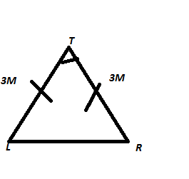
- Find the area in hectares of a triangular piece of land measuring 70m by 45 m by 98m. 3mks

- The figure below shows a kite ABCD in which AB= AD =4cm,BC=CD 6cm, < BAD = 45and < BCD = 25. Calculate the area of the kite correct to four significant figures. 4mks
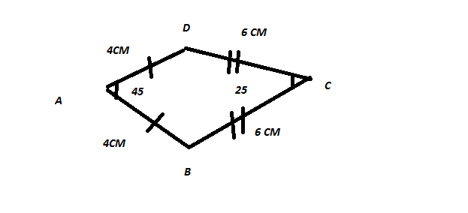

- Find the area of the shaded region in the figure below if the two circles with centres A and B have radii 7cm and 6 cm respectively. The common chord PQ = 10cm (take II =3.142). give your answer correct to three decimal places. 5mks
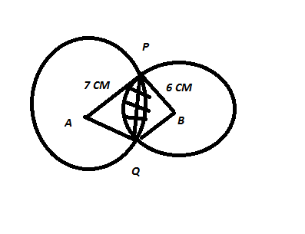

- The figure below shows a frustrum of a solid cone of base radius 12 cm and top radius 8 cm. the vertical height of the frustrum is 24 cm. calculate the total surface area of the frustum. 8mks
