FORM FOUR PAPER 1
MARKING SCHEME
NO | WORKING | MARKS | REMARKS
1 | Numerator  $$\frac{13}{3}-\frac{23}{3}=\frac{26-23}{6}=\frac{1}{2}$$  $$\frac{5}{6}×\frac{1}{2}=\frac{5}{12}$$  Denominator  $$\frac{14}{9}×\frac{3}{7}=\frac{2}{3}$$  $$\frac{5}{12}×\frac{3}{25}=\frac{1}{20}$$  $$\frac{1}{20}+\frac{2}{3}=\frac{43}{60}$$  $$\frac{N}{D}⇒\frac{5}{12}÷\frac{43}{60}=\frac{5}{12}×\frac{60}{43}=\frac{25}{43}$$ | M 1  M 1  A 1
2 | $${125}^{-x}×5^{2(x-1)}={25}^{x+2}$$  $$5^{-3x}×5^{2x-2}=5^{2x+4}$$  $$-3x+\left(2x-2\right)=2x+4$$  $$-x-2=2x+4$$  $$3x=-6$$  $$x=-2$$ | M1  M1  A1 | Simplification  Addition of power
3 | Volume of tank to be filled = $\frac{1}{3}×\frac{22}{7}×0.7×0.7×1.2$  $$=0.616 m^{3}$$  Volume of bucket = $\frac{22}{7}×0.175×0.175×0.2$  $$=0.01925 m^{3}$$  Number of buckets = $\frac{0.616}{0.01925}=32 buckets$ | M 1  M 1  A 1
4 |  | B 1  B 1  B 1 | Construction  Correct labelling  Complete diagram
5 | $60=2^{2}×3×5$  $$42=2×3×7$$  Side of the pavement = LCM  $=2^{2} × 3 × 5 × 7=420 cm$  Least area$=4.2 m × 4.2 m$  $=17.64 m^{2}$ | B1  M1  A1
6 | $\frac{d}{50}+\frac{x}{60}=3$........... (i)  $\frac{d}{60}+\frac{x}{50}=2\frac{13}{15}$ ......... (ii)  $6d+5x=900$ ....... (iii)  $5d+6x=860$ ....... (iv)  From (iii) $d=\frac{900 -5x}{6}$  $$5\left(\frac{900-5x}{6}\right)+6x=860$$  $$5\left(900-5x\right)+36x=5160$$  $$4500-25x+36x=5160$$  $$11x=660$$  $$x=\frac{660}{11}=60 km$$  $$d=\frac{900-5\left(60\right)}{6}$$  $$=\frac{900-300}{6}=\frac{600}{6}=100 km$$  $$x+d=100+60=160 km$$ | M 1  M 1  A 1  B 1
7 | - $AD=3.0±0.1 cm$ |  | B 1 constructing $30°$ at B  B 1 constructing $45°$ at C  B 1 perpendicular from A to BC  B 1
8 | $\vec{AB}=\left(\begin{matrix}8 \\ -7\end{matrix}\right)-\left(\begin{matrix}2 \\ 5\end{matrix}\right)$=$\left(\begin{matrix}6 \\ -12\end{matrix}\right)$  =$\sqrt{6^{2}+({-12)}^{2}}$  $\sqrt{36+144}$= $\sqrt{180}$  13.42 | B1  M1  A1
9 | - Time taken = $\frac{119}{42}+\frac{11}{66}$  $$=3 hours$$  - Average speed = $\frac{130 km}{3 hrs}$  $$=43.33 km/hr$$ | M 1  A 1  M 1  A 1
10 | $∆ ADC and ∆BCE$ are similar  $$\frac{AD}{BE}=\frac{AC}{BC}$$  $$\frac{15}{3}=\frac{8+x}{x}⇒15x=24+3x$$  $$x=2$$  Shaded region = area of $∆BCE$  $$=\frac{1}{2}×2×3=3 cm^{2}$$ | M 1  M 1  A 1
11 | $$\frac{1-\frac{1}{2}}{1+\frac{1}{\sqrt{3}}}$$  $$\frac{\frac{1}{2}-\left(\frac{1}{\sqrt{3}}+\frac{1}{2\sqrt{3}}\right)}{\frac{2}{3}}$$  $$\frac{3-\sqrt{3}}{4}$$ | B1  M1  A1
12 | $$\left(\begin{matrix}1 & 1 \\ -3 & 2\end{matrix}\right)\left(\begin{matrix}x \\ y\end{matrix}\right)=\left(\begin{matrix}8 \\ 1\end{matrix}\right)$$  Inverse  $$\frac{1}{5}\left(\begin{matrix}2 & -1 \\ 3 & 1\end{matrix}\right)$$  $$\left(\begin{matrix}\frac{2}{5} & \frac{-1}{5} \\ \frac{3}{5} & \frac{1}{5}\end{matrix}\right)\left(\begin{matrix}1 & 1 \\ -3 & 2\end{matrix}\right)\left(\begin{matrix}x \\ y\end{matrix}\right)=\left(\begin{matrix}\frac{2}{5} & \frac{-1}{5} \\ \frac{3}{5} & \frac{1}{5}\end{matrix}\right)\left(\begin{matrix}8 \\ 1\end{matrix}\right)$$  $$\left(\begin{matrix}1 & 0 \\ 0 & 1\end{matrix}\right)\left({x \atop y}\right)=\left({3 \atop 5}\right)$$  $$x=3, y=5$$ | B1  M 1  A 1
13 | $$1{\left(-4x\right)}^{0}+6{\left(-4x\right)}^{1}+15{\left(-4x\right)}^{2}+20{\left(-4x\right)}^{3}+…$$  $$1-24x+80x^{2}-1280x^{3}+…$$ | M 1  A 1
14 |  | b1  m1  a1
15 | 3420 French francs into Ksh. $11.25×3420$  $$=Ksh. 38 475$$  Commission = $2\% of 38 475$  $=Ksh. 769.5$  Amount of Euros received = $\frac{37 705.5}{72.50}$  = 520 Euros | M 1  M 1  A 1
16 | Let $\frac{1}{m}$ be the reciprocal  $$3m+\frac{1}{m}=4$$  $${3m}^{2}+1=4m⇒3m^{2}-4m+1=0$$  $${3m}^{2}-3m-m+1=0$$  $$3m\left(m-1\right)-1\left(m-1\right)=0$$  $$\left(3m-1\right)\left(m-1\right)=0$$  $$3m-1=0⟹m=\frac{1}{3}$$  OR  $$m-1=0⟹m=1$$ | M 1  M 1  A 1 | Both values of m
17 | x  14  22.25cm  21cm  - I) Volume  Ratio $\frac{x}{14}=\frac{22.5+x}{21}$  $$21x=14(22.5+x)$$  $$21x-14x=315$$  $$x=45 cm$$  Volume of whole cone  $$=\frac{1}{3}×\frac{22}{7}×21×21×67.5=31 185 {cm}^{3}$$  Volume of small cone  $$=\frac{1}{3}×\frac{22}{7}×14×14×45=9 240 {cm}^{3}$$  Volume of frustum = $31 185-9 240=21 945 {cm}^{3}$  ii) mass of frustum  mass = $21 945×\frac{3g}{{cm}^{3}}=65 835 g$  mass in kg = $\frac{65 835 g}{1000 g}=65.835 kg$  - $20\% of 65.835kg=13. 167 kg$  $65.835-13.167=52.668 kg$  Volume of material remaining = $\frac{56682 }{3}=17 556 {cm}^{3}$  Length of cube = $\sqrt[3]{17 556}=25.99 cm$
18 | - $m_{1}=\frac{6-3}{-1+2}=3$  $\frac{3}{1}=\frac{y-3}{x+2}$  $$y-3=3\left(x+2\right)$$  $$y=3x+9$$  - $m_{2}=-\frac{1}{3}$  $$\frac{-1}{3}=\frac{y-6}{x+1}$$  $$3y-18=-x-1$$  $$x+3y-17=0$$  - $m_{3}=3$  $$\frac{3}{1}=\frac{y-2}{x-2}$$  $y=3x-1$  At $x$ intercept; $y=0, x=\frac{1}{3};x-intercept \left(\frac{1}{3}, 0\right)$  At y intercept; $x=0, y=-1;y intercept=\left(0,-1\right)$  - At point of intersection, y values are equal  $$3x-1=\frac{-x}{3}+\frac{17}{3}$$  $$9x-3=-x+17$$  $$10x=20; x=2$$  $$y=3\left(2\right)-1=5$$  Point of intersection (2, 5) | M 1  A 1  M 1  A 1  M 1  A 1  A 1  M 1  M 1  A 1
19. (a)
$$x$$ | $$-3$$ | $$-2.5$$ | $$-2$$ | $$-1.5$$ | $$-1$$ | $$-0.5$$ | 0 | 0.5 | $$1$$ | $$1.5$$ | $$2$$ | $$2.5$$ | $$3$$ | $$3.5$$ | $$4$$ | $$4.5$$ | $$5$$
$$y$$ | 38 | 28.75 | 21 | 14.75 | 10 | 6.75 | 5 | 4.75 | 6 | 8.75 | 13 | 18.75 | 26 | 34.75 | 45 | 56.75 | 70

19 | - Area = $h\left[y_{o}+y_{1}+y_{2}+…+y_{n}\right]$  = $1\left[28.75+14.75+6.75+8.75+4.75+18.75+34.75+56.75\right]$  $=174$  - Area = $\int_{-3}^{5}{\left(3x^{2}-2x+5\right)dx}$  $$\left[x^{3}-x^{2}+5x\right]\begin{matrix}5 \\ -3\end{matrix}$$  $$=\left(5^{3}-5^{2}+5\left(5\right)\right)-\left({\left(-3\right)}^{3}-{\left(-3\right)}^{2}+5\left(-3\right)\right)$$  $$=\left(125-25+25\right)-\left(-27-9-15\right)$$  $$=125-\left(-25\right)=176 sq units$$  - $\% error= \frac{176-174}{176}×100$  $$=1.136\%$$ |  |  | M 1  M 1  A 1  M 1  M 1  A 1  M 1  A 1
20 | - Mirror line y=-x  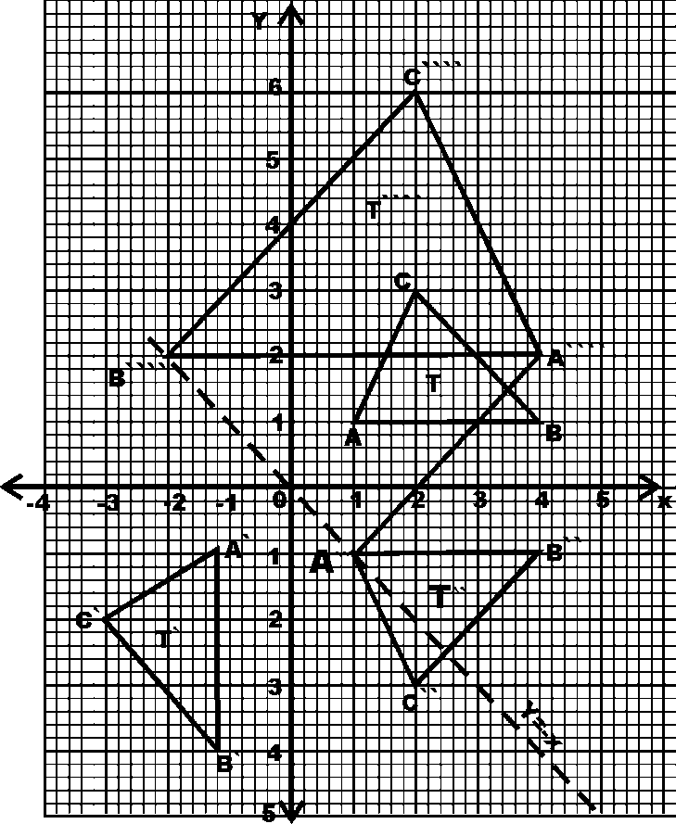  - I)  ii)reflection on line y=0  - Area scale factor (−2)² = 4${(-2)}^{2}=4$  Area of object= $\frac{12}{4}$  =3cm²
21 | - $r^{2}=p^{2}+q^{2}-2pqcos R$  $$={20}^{2}+{35}^{2}-\left(2×35×20\cos{52°}\right)$$  $$=400+1225-861.93$$  $$r^{2}=763.07$$  $$r=27.62 m$$  - $∠QRS=180-52°$  $∠RQS=180-\left(128+18\right)=34°$  $$\frac{q}{\sin{Q}}=\frac{s}{\sin{S}}=\frac{r}{\sin{R}}$$  $$\frac{RS}{\sin{34°}}=\frac{20}{\sin{18°}}$$  $$RS=\frac{20×\sin{34°}}{\sin{18°}}=36.19 m$$  - $∠RQS=180-\left(128+18\right)=34°$  - Area = $\frac{1}{2}ab\sin{θ}$  $$=\frac{1}{2}×20×36.19×\sin{128°}$$  $$=285.18 m^{2}$$ | M 1  M 1  A 1  B 1  M 1  A 1  B 1  M 1 M1  A1
22 | - $V={5t}^{2}-2t+9$  Acceleration $\frac{dv}{dt}=10t-2$  When $t=4$  Acceleration = $10×4-2=38{ms}^{-2}$  - For minimum acceleration, $\frac{dv}{dt}=0$  $$0=10t-2$$  $⟹t=0.2 s$  - Velocity $V={5t}^{2}-2t+9$  Acceleration is minimum when t = 0.2 s  $$V={5\left(0.2\right)}^{2}-2\left(0.2\right)+9$$  $$=0.2-0.4+9$$  $$=8.8 ms^{-1}$$  - Distance = $\int_{1}^{4}{Vdt=\int_{1}^{4}{\left(5t^{2}-2t+9\right)dt}}$  $${\left[\frac{5t^{3}}{3}-t^{2}+9t\right]}_{1}^{4}$$  $$\left(\frac{5{\left(4\right)}^{3}}{3}-{\left(4\right)}^{2}+9(4)\right)-\left({\frac{5(1)}{3}}^{3}-1+9\right)$$  $$\left(\frac{320}{3}-16+36\right)-\left(\frac{5}{3}+8\right)=\frac{380}{3}-\frac{29}{3}=117 m$$ | M 1  M 1 A 1  M 1  A 1  M 1  A 1  M 1  M 1  A 1
23 | - Juma’s earnings before increase:  112% → 8400  100% → 8400 x ¹⁰⁰/₁₁₂=7500  Akinyi’s earnings before increase;  ³/₅X 7500  Increase in Akinyi’s earnings  = 14100 – 8400 – 4500  =1200  % increase in Akinyi’s earnings  =¹²⁰⁰/₄₅₀₀ x 100  ₌ 26 ²/₃ =26.67  - No. of bags bought  = ¹⁴¹⁰⁰/₁₁₇₅  = 12 bags  Profit = (1762.50 -1175)x12  = 7050  Ratio 5700 : 8400 = 19 :28  Profit for Akinyi : 7050 x ¹⁹/₄₇ =2850  Total earning for Akinyi:  5700+2850= 8550
24 | - $y={\left(1\right)}^{3}+4{\left(1\right)}^{2}-3\left(1\right)$  $$=1+4-3$$  $$=2$$  - At turning points; $\frac{dy}{dx}=0$  $\frac{dy}{dx}={3x}^{2}+8x-3$  $${3x}^{2}+8x-3=0$$  $$3x\left(x+3\right)-1\left(x+3\right)=0$$  $$\left(3x-1\right)\left(x+3\right)=0$$  $$x=-3 or x=\frac{1}{3}$$  When $x=\frac{1}{3}$  $$y={\left(\frac{1}{3}\right)}^{3}+{4\left(\frac{1}{3}\right)}^{2}-3\left(\frac{1}{3}\right)=\frac{-14}{27}$$  Point 1 $⟹\left(\frac{1}{3},\frac{-14}{27}\right)$  When $x=-3$  $$y={\left(-3\right)}^{3}+4{\left(-3\right)}^{2}-3\left(-3\right)=18$$  Point 2 $⟹\left(-3, 18\right)$  - $\frac{dy}{dx}={3x}^{2}+8x-3$  $$At x=1$$  $\frac{dy}{dx}={3(1)}^{2}+8\left(1\right)-3=11$  Gradient of normal, $m_{2}=\frac{-1}{11}$  At $x=1$, $y={(1)}^{3}+4{(1)}^{2}-3\left(1\right)=2$  $∴$ Slope = $\frac{dy}{dx}$  $$\frac{-1}{11}=\frac{y-2}{x-1}$$  $$-1\left(x-1\right)=11(y-2)$$  $$-x+1=11y-22$$  $$x+11y=23 OR y=\frac{-x}{11}+\frac{23}{11}$$ | B 1  M 1  M 1  A 1  B 1  B 1  B 1  M 1  M 1  A 1

