**Name**: ....................................................................................... **Index No**: ..................

.**Date**: ............................... **Candidate’s Signature**:...................................................

**121/1**

**MATHEMATICS ALT A**

**Paper 1**

**July/August 2016**

2½ hours

***TOP KCSE EVALUATION TEST-2016***

**Kenya Certificate of Secondary Education (K.C.S.E.)**

MATHEMATICS ALT A

**Paper 1**

***Instructions to candidates***

1. *Write your name and index number in the spaces provided above.*
2. *Sign in the spaces provided above.*
3. *This paper consists of* ***TWO*** *sections:* ***Section I*** *and* ***Section II****.*
4. *Answer* ***ALL*** *the questions in* ***Section I*** *and only five from* ***Section II****.*
5. *All answers and working must be written on the question paper in the spaces provided below each question.*
6. ***Show all the steps in your calculations, giving your answers at each stage in the spaces below each question.***
7. *Marks may be given for correct working even if the answer is wrong.*
8. ***Non – programmable*** *silent electronic calculators* ***and*** *KNEC Mathematical tables may be used except where stated otherwise.*
9. ***This paper consists of 16 printed pages.***
10. ***Candidates should check the question papers to ascertain that all the pages are printed as indicated and that no questions are missing.***

**For Examiner’s Use Only**

**Section I**

|  |  |  |  |  |  |  |  |  |  |  |  |  |  |  |  |  |
| --- | --- | --- | --- | --- | --- | --- | --- | --- | --- | --- | --- | --- | --- | --- | --- | --- |
| **1** | **2** | **3** | **4** | **5** | **6** | **7** | **8** | **9** | **10** | **11** | **12** | **13** | **14** | **15** | **16** | **Total** |
|  |  |  |  |  |  |  |  |  |  |  |  |  |  |  |  |  |

**Section II**

**Grand**

**Total**

|  |  |  |  |  |  |  |  |  |
| --- | --- | --- | --- | --- | --- | --- | --- | --- |
| **17** | **18** | **19** | **20** | **21** | **22** | **23** | **24** | **Total** |
|  |  |  |  |  |  |  |  |  |

**SECTION I** (50 marks)

*Answer* ***all*** *the questions in this section in the spaces provided.*

1. Use tables of reciprocal only to evaluate , hence evaluate ;

 (3 marks)

1. Solve the equation giving the roots correct to two decimal places. (4 marks)
2. 3. The gradient of a line L through points A(2x, 4) and B(-1, x) is 1/7. find the equation of a line perpendicular to L through B (3mks)
3. Using the grid provided below, draw and shade the unwanted regions to show the region satisfied by given the following inequalities;  and  (3 marks)

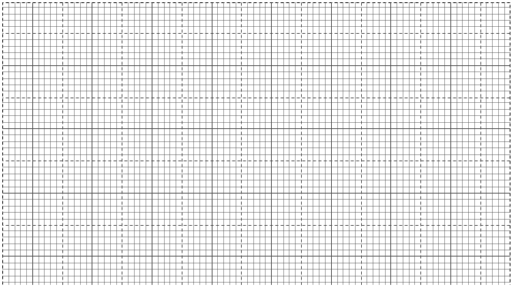

1. A tourist arrived in Kenya with sterling pound (£) 4680 all of which he exchanged into Kenyan money. He spent Ksh. 51,790 while in Kenya and converted the rest of the money into U.S dollars. Calculate the amount he received in U.S dollars if the exchange rates were as follow.

**Buying Selling.**

US $ 65.20 69.10

Sterling Pound (£) 123.40 131.80 (4mks)

6. Given that *Sin θ = 2/3* and *θ* is an acute angle, find without using tables or calculators *tan θ,* giving your answer in surd form. (2mks)

1. Two boys and a girl shared some money .The elder boy got of it, the younger boy got of the reminder and the girl got the rest. Find the percentage share of the younger boy to the girl’s share. (3 marks)
2. Annette has some money in two denominations only. Fifty shilling notes and twenty shilling coins. She has three times as many fifty shilling notes as twenty shilling coins. If altogether she has sh. 3400, find the number of fifty shilling notes and 20 shilling coins. (3 marks)
3. Calculate the value of. (4 marks)

1. The figure below is a velocity time graph for a car

**Velocity (m/s)**

**80**

**24**

**20**

**4**

**0**

**Time (seconds)**

a) Find the total distance traveled by the car (2mks)

b) Calculate the deceleration of the car (2mks)

1. A truck left town A at 9.35 am and traveled towards town B at an average speed of X km/h.

At the same time a lorry left town B and traveled towards town A along the same road. The

distance between the two towns 322km and the two vehicles met at 2.11pm. Given that the lorry

traveled 20km/hr faster than the truck, find the value of X. (4 marks )

1. In the triangle, AB = 8.5cm, AC = 10cm and ABC = BDC = 900.

B

8.5cm

A C

10cm D

Calculate:

* + 1. The length of BC. (1mk)
    2. The length of BD. (2mks)

1. The exterior angle of regular polygon is an eighth of the interior angle. How many sides does the regular polygon have? (3mks)
2. Fifteen men working eight hours a day can complete a certain job in exactly 24 days.

For how many hours a day must sixteen men work in order to complete the same job

in exactly 20 days. (2 marks)

1. A number n is such that when it is divided by 27 and 30 or 45, the remainder is always 3. Find the smallest value of n. (2 marks)

1. Paul t bought 4 spoons and 6 plates for Kshs. 660 and Mrs. Omondi bought 2 spoons and

1 plate less than Paul for Kshs. 510.

* + 1. Find the price of each item. (2mks)
    2. Mrs. Omondi spent Kshs. 2280 to buy the same type of spoons and plates. If the number

of plates she bought were 4 more than the number of spoons, find the number of spoons bought by Mrs. Omondi. (1mk)

**SECTION II** (50marks)

*Answer only* ***five*** *questions in this section in the spaces provided.*

17. A bucket is in the shape of a frustrum with base radius 12cm and top radius 16cm. the slant height of the bucket is 30cm as shown below. The bucket is full of water

a) Calculate the volume of the water. (Take π = 3.142) (6mks)

**12**

**16**

**30**

b) All the water is poured into a cylindrical container of circular radius 12cm. If the cylinder has height 45cm, calculate the surface area of the cylinder which is not in contact with water (4mks)

1. Three business partners, Bela, Joan and Trinity contributed Kshs. 112, 000, Kshs. 128, 000 and Kshs. 210, 000 respectively to start a business. They agreed to share their profits as follows:

30% to be shared equally

30% to be shared in the ratio of their contributions

40% to be retained for the running of the business.

If at the end of the year, the business realised a profit of Kshs. 1. 35million

Calculate:

1. the amount of money retained for running the business at the end of the year. (1mark)
2. the difference between the amounts received by Trinity and Bela. (6marks)
3. Express Joan’s share as percentage of the total amount of money shared between the three partners. (3 marks)
4. A bag contains 5 red, 4 white and 3 blue beads. Two beads are selected at random one after

another without replacement.

(a) Draw a tree diagram and show the probability space. (2mks)

1. From the tree diagram, find the probability that:

(i) The last bead selected is red. (3mks)

(ii) The beads selected were of the same colour. (2mks)

(iii) At least one of selected beads is blue. (3mks)

1. In the figure below, O1 and O2 are the centres of the circles whose radii are 4 cm and 7 cm respectively. The circles intersect at A and B and angle AO1O2 = 60˚

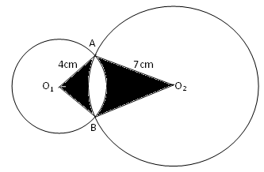

Find by calculation; take π = 3.142

1. The angle AO2O1 (1 marks
2. The area of the quadrilateral AO1BO2 (4 marks)
3. The shaded area (5 marks)
4. Complete the table below for the function for  (3 marks)

|  |  |  |  |  |  |  |  |
| --- | --- | --- | --- | --- | --- | --- | --- |
|  |  |  |  |  |  |  |  |
|  |  |  |  |  |  |  |  |
|  |  |  |  |  |  |  |  |
|  |  |  |  |  |  |  |  |
|  |  |  |  |  |  |  |  |

1. Draw the graph of the function  (3 marks)

(Use a scale of 1cm to represent 1 unit on the x axis. 1 cm to represent 5 units on the y-axis)

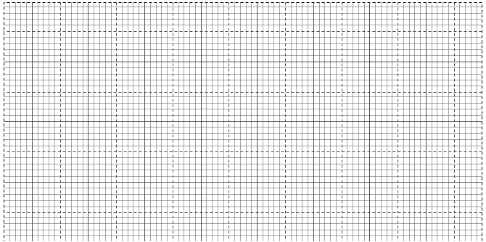

1. Hence use your graph to estimate the roots of the equation

 (4 marks)

1. The following measurements were recorded in a field book using XY as the base line. XY = 400m.

|  |  |  |  |  |
| --- | --- | --- | --- | --- |
|  |  | Y |  |  |
| C | 60 | 340 |  |  |
|  |  | 300 | 120 | D |
|  |  | 240 | 160 | E |
|  |  | 220 | 160 | F |
| B | 100 | 140 |  |  |
| A | 120 | 80 |  |  |
|  |  | X |  |  |

(a) Using a scale of 1: 4000, draw an accurate map of the farm. (4 marks)

(b) Determine the actual area of the farm in hectares. (4 marks)

(c) If the farm is on sale at sh.80000 per hectare, find how much the farm costs. (2 marks)

1. In a maths test, 40 students scored the following marks.

43 39 59 56 58 63 71 40

72 66 47 38 51 50 61 64

32 78 29 32 45 80 70 57

52 46 45 39 58 72 41 55

56 53 66 63 61 46 82 64

Make a frequency distribution table using a class intervals of size 5 and (25 – 29) as the first

class. Calculate the;

(i) Modal class

(ii) Mean

(iii) Median (10 marks )

1. (a) Complete the table below for the function ***y = x2 + 3*** (2mks)

|  |  |  |  |  |  |  |  |  |  |  |  |
| --- | --- | --- | --- | --- | --- | --- | --- | --- | --- | --- | --- |
| ***x*** | 1 | 1.5 | 2 | 2.5 | 3 | 3.5 | 4 | 4.5 | 5 | 5.5 | 6 |
| ***y*** | 4 |  | 7 |  |  | 15.25 | 19 |  | 27 |  | 39 |

(b) Use the mid-ordinate rule with five strips to estimate the area bounded by the curve, the line

*x = 1* and the line *x = 6.* (2 marks)

(c) Use integration to find the exact area in (b) above. (3 marks)

(d) Calculate the percentage error arising from the use of mid-ordinate rule. (3 marks)