**NAME…………………………………….ADM.NO………………CLASS……………**

**DATE:………/……./ 2019**

**121/2**

**MWAKICAN JOINT EXAMINATION (MJET) – 2019)**

**END OF TERM 1 EXAM**

**FORM 3 MATHEMATICS**

**PAPER 2**

**TIME: 2½ HRS.**

**INSTRUCTION TO STUDENTS:**

1. *Write your* ***name****,* ***admission number*** *and* ***class*** *in the spaces provided above.*
2. *Write the* ***date*** *of examination in spaces provided.*
3. *This paper consists of* ***two*** *Sections; Section* ***I*** *and Section* ***II****.*
4. *Answer* ***ALL*** *the questions in Section* ***I*** *and only* ***five*** *questions from Section* ***II****.*
5. *All answers and working must be written on the question paper in the spaces provided below each question.*
6. *Show all the steps in your calculation, giving your answer at each stage in the spaces provided* ***below*** *each question.*
7. *Marks may be given for correct working even if the answer is wrong.*
8. *KNEC Mathematical tables* ***may be*** *used, except where stated otherwise.*
9. *Candidates should check the question paper to ascertain that all the pages are printed as indicated and that no questions are missing.*
10. ***Candidates should answer the questions in English.***

**FOR EXAMINER’S USE ONLY:**

**SECTION I**

|  |  |  |  |  |  |  |  |  |  |  |  |  |  |  |  |  |
| --- | --- | --- | --- | --- | --- | --- | --- | --- | --- | --- | --- | --- | --- | --- | --- | --- |
| 1 | 2 | 3 | 4 | 5 | 6 | 7 | 8 | 9 | 10 | 11 | 12 | 13 | 14 | 15 | 16 | TOTAL |
|  |  |  |  |  |  |  |  |  |  |  |  |  |  |  |  |  |

|  |  |  |  |  |  |  |  |  |
| --- | --- | --- | --- | --- | --- | --- | --- | --- |
| 17 | 18 | 19 | 20 | 21 | 22 | 23 | 24 | TOTAL |
|  |  |  |  |  |  |  |  |  |

**SECTION II**

**GRAND TOTAL**

|  |
| --- |
|  |

***Ensure that all the pages are printed and no question(s) are missing.***

**SECTION 1 (50 Marks)**

Answer all the questions in the spaces provided.

1. Simplify completely

2x2 + x – 3

4x2 – 9 (3mks)

1. Water flows from a pipe at the rate of 250 litres per minute. If the pipe used to drain a tank full of water measuring 3.2m by 2.5m by 2m,how many minutes would it take to drain the tank completely. (3mks)
2. Without using tables, solve for a in the equation. ( 3mks)

Log3 (2a+8)-log39=1+log32

1. The base and perpendicular heights of a triangle measured to the nearest centimetre are 6cm and 4cm respectively.

Find ;

1. The absolute error in calculating area of the triangle (2mks)
2. The percentage error in the area giving the answer to 1 decimal place. (2mks )
3. Use logarithms to evaluate

$\frac{{\left(0.0056\right)}^{1/2}}{1.38×27.42}$ (3 marks)

1. Simplify by rationalizing the denominator (2mks)

3

2 $\sqrt{3}$- $\sqrt{2}$

1. Chords QR and ST intersect at U.QR =5cm, RU=6cm and TU=4cm. Find the length SU. (3mks)

5cm

Q

R

U

T

S

6cm

4cm

1. A scientific calculator is marked at sh 1560 .Under hire purchase a down payment of sh.200 was paid and six monthly installment of sh 250 each. Calculate;
2. The Hire purchase price (2mks)
3. The extra amount paid out over the cash price. (1mk)
4. Make x the subject of the formula. (3mks)
$$p=\frac{a\sqrt{x^{2}+b^{2}}}{y}$$

5. The first term of arithmetic is -7 and the common difference is 4.
6. List the first 6 terms of the sequence. (2mks)
7. Determine the sum of the first 30 terms of the sequence. (2mks)
8. A small cone of height 8cm is cut off from a bigger cone to leave frustum of height 16cm.If the volume of the smaller cone is 160cm3.Find the volume of the frustum. (3mks)
9. Find the angle Ѳ in degrees from the figure below. (3mks)

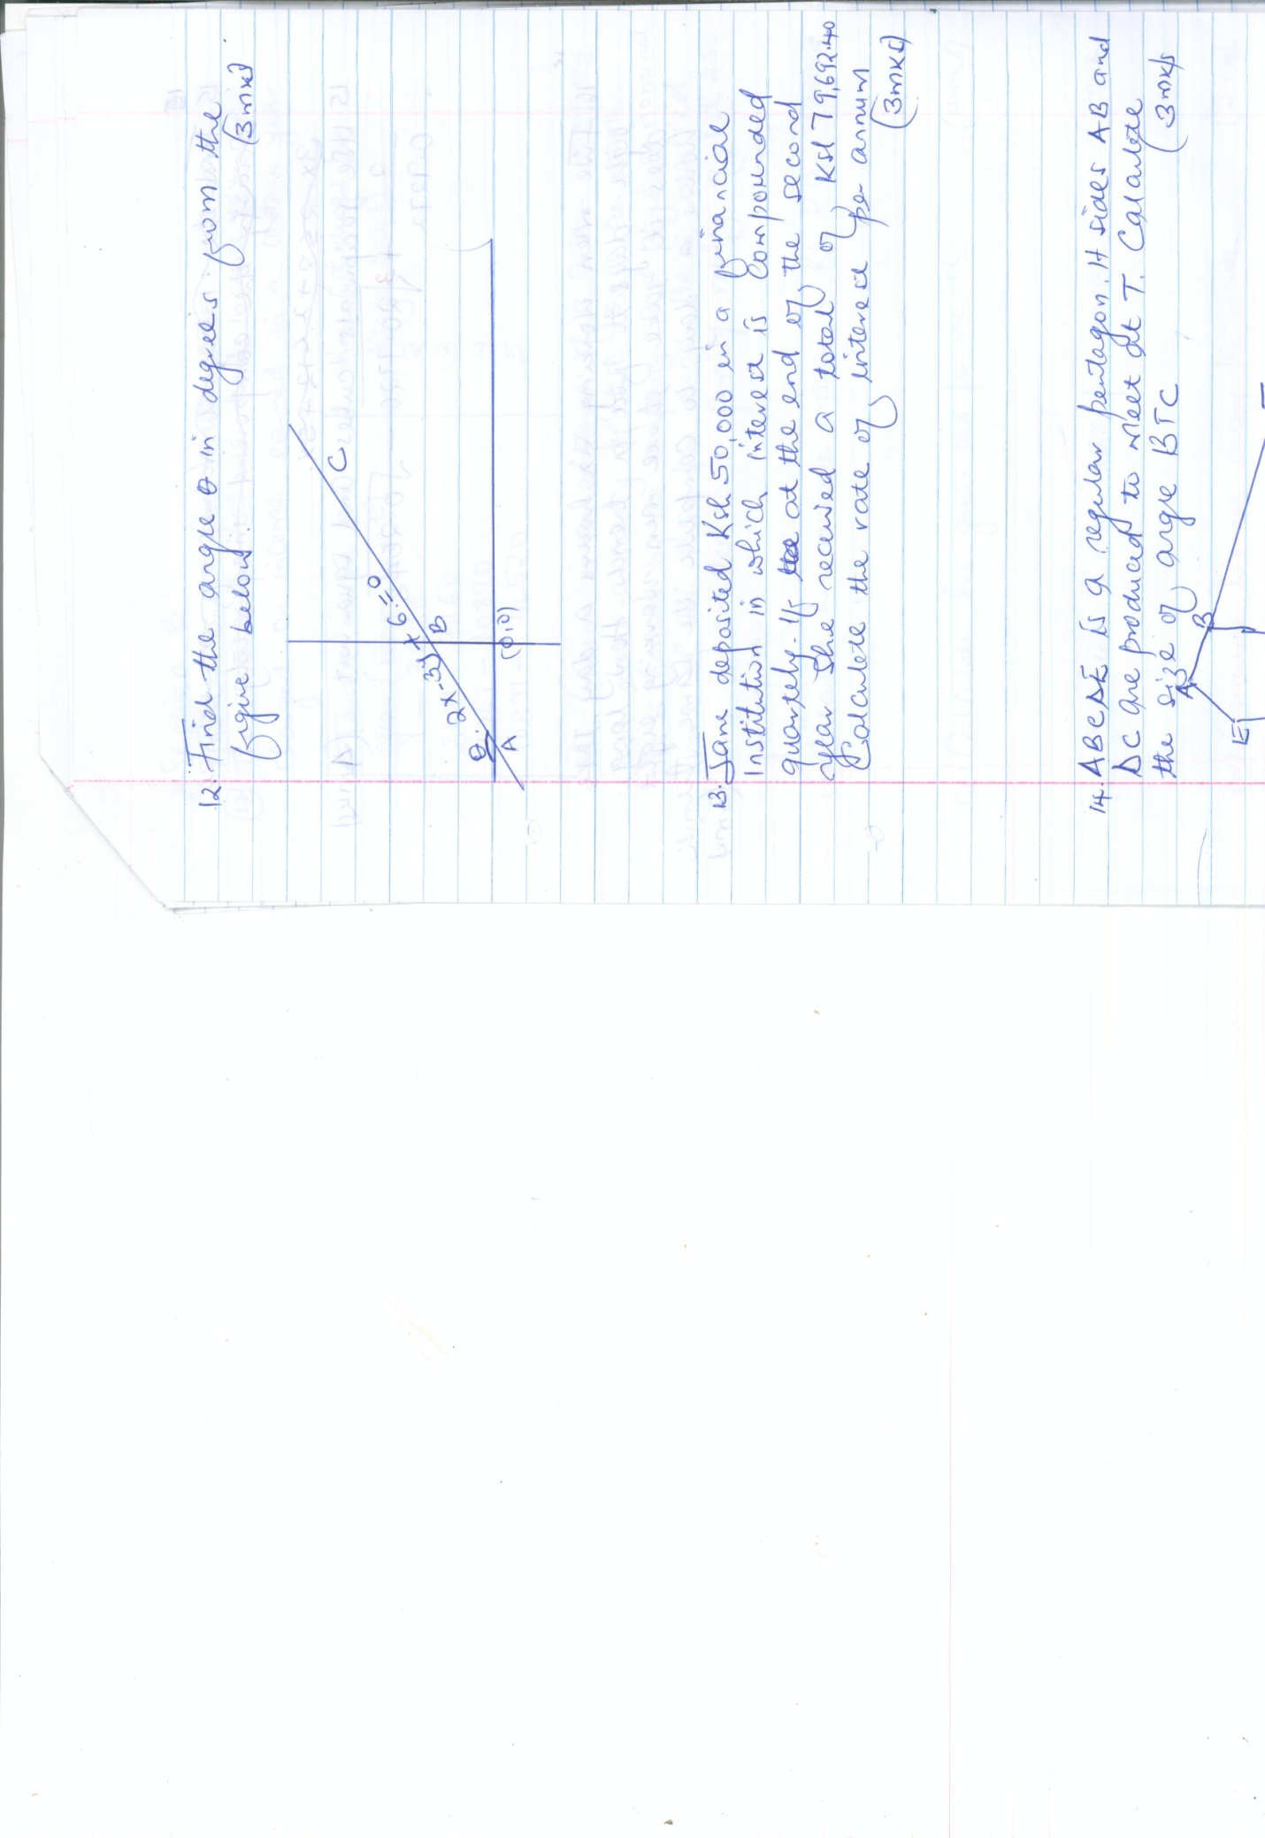

1. Jane deposited ksh.50,000 in a financial institution in which interest is compound quarterly. If at the end of the second year she received a total of ksh.79,692.40. Calculate the rate of interest per annum. (3mks)
2. ABCDE is a regular pentagon .Its sides AB and DC are produced to meet at T. Calculate the size of angle BTC. (3mks)

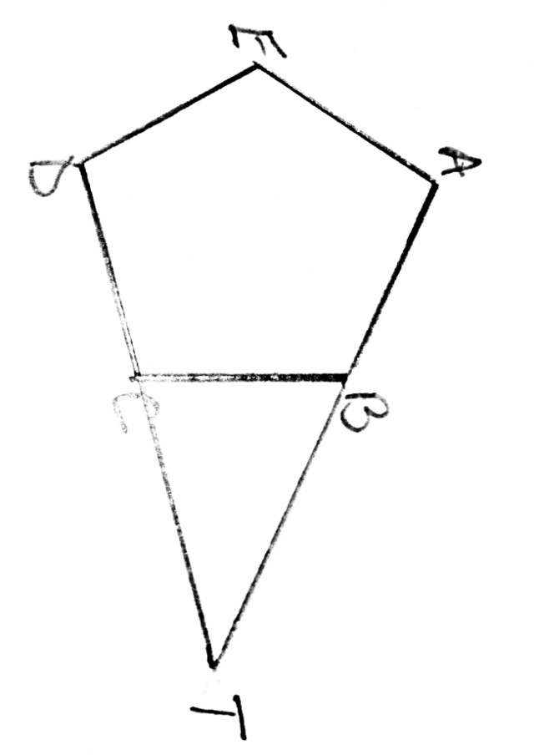

1. Use reciprocals, cubes and square root . (4mks)

2 + 3 -

0.9272

1. Five men working six hours a day take eight days to fill a trench. How long does it take three men working eight hours a day to complete the same trench. (3mks)

**SECTION II (50 marks)**

**ANSWER ONLY FIVE QUESTIONS**

1. The table below shows how income tax was charged on income earned in a certain year.

|  |  |
| --- | --- |
| Taxable income per year)(Kenya pounds) | Rate (shillings per Kenya pound |
| 1-3630  3631-7260  7261-10890  10891-14520 | 2  3  4  5 |

Mr.Gideon is an employee of a certain company and earns a salary of ksh 15,200 per month.He is housed by the company and pays a nominal rent of Ksh.1050 per month.He is married and is entitled to a family relief of ksh.450 per month.

1. Calculate his taxable income in k£ p.a. (2mks)
2. Calculate his gross tax per month . (4mks)
3. Calculate his net tax per month (2mks)
4. Calculate his net salary per month. (2mks)
5. (a) Find the inverse of the matrix (1mk)

A= $\left(\begin{matrix}4 & 3 \\ 3 & 2\end{matrix}\right)$

(b)Rose bought 20bags of oranges and 15 bags of mangoes for a total of ksh.9,500.Chumo bought 30 bags of oranges and 20 bags of mangoes for ksh 13,500.If the price of a bag orange is x and that of mangoes is y.

i. Form two equations to represent the information above. (2mks)

ii. Hence use the matrix A-1 above to find the price of one bag of each item. (3mks)

iii.The price of each bag of oranges was increased by 10% and that of oranges reduced by 10%.the businesswomen (Rose and Chumo) bought as many oranges and as many mangoes as they bought earlier. Find by matrix method the total cost of oranges and mangoes that the businesswomen bought after the percentage charges. (4mks)

1. A radio dealer planned to buy some radios from a wholesale for ksh.340,000 .Before he could buy them prices of each radio was increased by ksh.300.He now discovers that he can only afford to buy 30 radios less than he had planned to buy with some amount of money. Taking x as the intended number of radios.

a)write an expression in terms of x for:

i)original price per radio ( 1mk)

ii)price per radio after the increase (1mk)

b) determine :

i)number of radios he had originally planned to buy ( 5mks)

ii)percentage increase in the price per radio (3mks)

1. Draw the graph of the function y=2x2+4x-3 on the grid provided for -4 $≤x≤2$ (2mks)

|  |  |  |  |  |  |  |
| --- | --- | --- | --- | --- | --- | --- |
| X | -4 | -2 | -1 | 0 | 1 | 2 |
| y |  |  |  |  |  |  |



1. Use the graph to solve the equation

2x2+4x-3=0 to 1 decimal place. (2mks)

1. Use graph y=2x2 + 4-3 to solve 0=2x2+ x-5. (3mks)
2. Given that BC is a tangent to the circle and that angle ABC =1100and angle ABC=1100 and angle CBD=500 .Calculate giving reasons ;

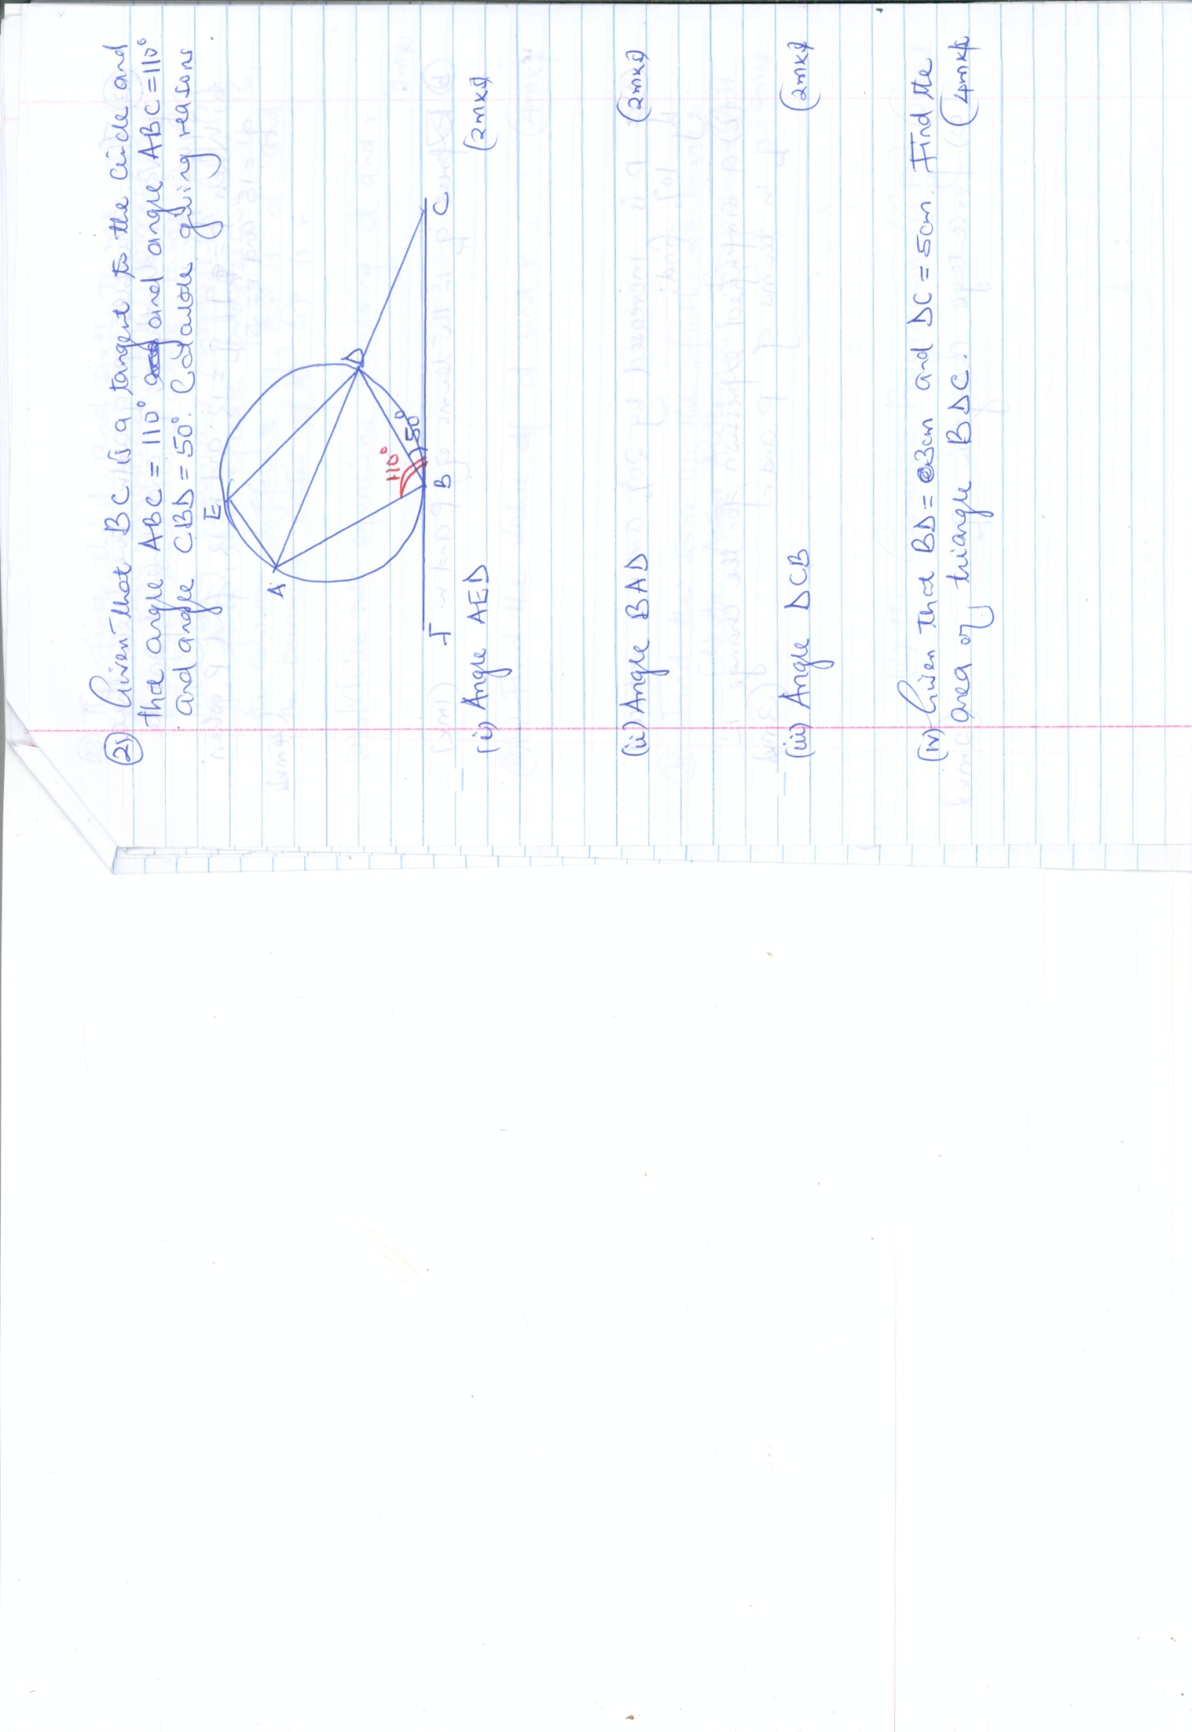

1. Angle AED (2mks)
2. Angle BAD (2mks)
3. Angle DCB (2mks)
4. Given that BD = 3cm and DC=5cm.Find the area of triangle BDC. (4mks)
5. The variances p,q and r are such that p varies directly as q and inversely as the square of r.
6. When p=q,q=12 ,and r=12,find p when q=15 and r=5. (4mks)
7. Express q in the terms of p and r. (1mk)
8. If p is increased by 20% and r is reduced by 10%,find:
9. A simplified expression for the change in q in terms of p and r. (3mks)
10. Percentage change in q. (2mks)
11. The first ,third and sixth terms of an arithmetic progression (AP) corresponds to the first three consecutive terms of an increasing Geometric progression(G.P).The first term of each progression is 16,the common difference of AP is d and the common ratio of the GP is r.
12. (i) Write two equations involving d and r. (2mks)

(ii) Find the value of d and r (4mks)

1. Find the sum of the first 20 terms ;
2. The arithmetic progression (AP). (2mks)
3. The geometric progression(GP) (2mks)
4. The figure below shows a triangle ABC enclosed in a circle AC=10cm BC=7cm and AB=8cm.

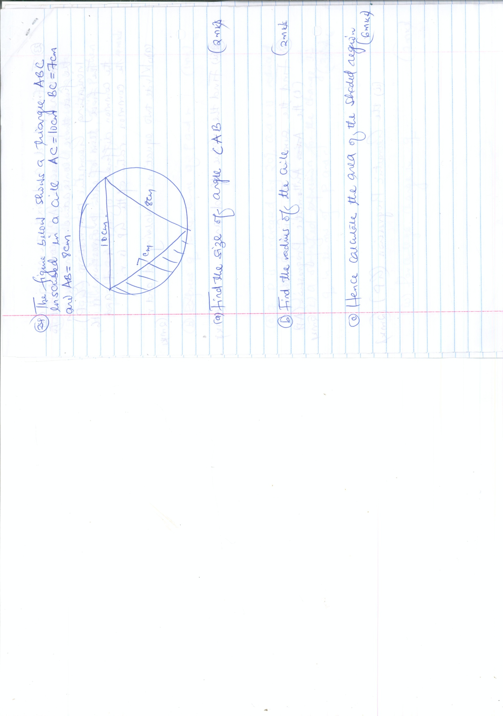

1. Find the size of angle CAB (2mks)
2. Find the radius of the circle (2mks)
3. Hence calculate the area of the shaded region. (6mks)