NAME……………………………………………………………………….. SCHOOL………………………..
CLASS..................... ADM NO…………. INDEX NO……………………………
121/1 MATHEMATICS
FORM 4
PREMOCK JOINT EXAMS
September 2021
Time: 2 ½ Hours
JOINT PREMOCK 2021
Kenya certificate of secondary education (K.C.S.E)
INSTRUCTIONS TO CANDIDATES.
- Write your name and admission number in the space provided at the top of this page.
- This paper consists of two sections; section I and section II
- Answer ALL questions in sections I and only FIVE sections in section II
- Show all the steps in your calculations; giving your answers at each stage in the spaces provided below each question.
- Marks may be given for correct working even if the answer is wrong
- Non-programmable silent electronic calculators and KNEC mathematical tables may be used.
For examiners use only
1 | 2 | 3 | 4 | 5 | 6 | 7 | 8 | 9 | 10 | 11 | 12 | 13 | 14 | 15 | 16 | Total
Section I

17 | 18 | 19 | 20 | 21 | 22 | 23 | 24 | Total |  | Grand total
Section II
This paper consists of 15 printed pages
Candidates should check the question paper to ensure that all the printed pages are printed as indicated and no questions are missing.

SECTION I (50 marks)
Answer all the questions in this section in the spaces provided.
- Evaluate $\frac{-4\left\{\left(-4+-15÷5\right)+-3-4÷2\right\}}{84÷-7+3--5}$ (3 marks)

- Simplify completely the expression: $\frac{6x^{2}y^{2}-20xy+16}{2x^{2}y^{2}-8}$ (3 marks)

- Given that $\cos{θ}=\frac{3}{5}$, find $\sin{θ}-\tan\left({90}^{0}-θ\right)$ without using tables or calculator. (2 marks)

- Under an enlargement, the images of points A(3,1) and B(1,2) are A¹(3,7) and B¹(7,5). Without construction, find the centre and the scale factor of enlargement. (4 marks)

- List all the integral values of x that satisfy the inequalities; (3 marks)
$$x-\frac{3}{2}≤2x+1<5$$

- A bus travelling at an average speed of x km/h left station at 8.15 am. A car, travelling at an average speed of 80km/h left the same station at 9.00 am and caught up with the bus at 10.45 am. Find the value of x. (3 marks)

- The interior angle of a regular polygon with 3x sides exceeds the interior angle of another regular polygon having x sides by ${40}^{0}$. Determine the value of x. (3 marks)

- Use squares, cubes and reciprocals tables to evaluate, to 4 significant figures, the expression:
$\frac{1}{\sqrt[3]{27.56}}+\frac{3}{{\left(0.071\right)}^{2}}$ (3 marks)

- From a point 20m away on a level ground the angle of elevation to the bottom of the window is 27⁰ and the angle of elevation of the top of the window is 32⁰. Calculate the height of the window. (3 marks)

- Solve for x in the equation: $5^{3y+3}+5^{3y-1}=125. 2$ (4 marks)

- Mr. Kanja, Miss Kanene and Mrs. Nyaga have to mark a form three mathematics contest for 160 students. They take 5 minutes, 4 minutes and 12 minutes respectively to mark a script. If they all start to mark at 9.00 am non-stop, determine the earliest time they will complete the marking. (4 marks)

- Evaluate $4.\dot{4}\dot{1}-0.\dot{2}\dot{1}$ (2 marks)

- Two similar cylinders have diameter of 7cm and 21cm. If the larger cylinder has a volume of 6237${cm}^{3}$, find the heights of the two cylinders. (take $π=\frac{22}{7})$ (3 marks)

- The cost of providing a commodity consists of transport, labour and raw materials in the ratio 8:4:12 respectively. If the transport cost increases by 12%, labour cost by 18% and raw materials by 40%, find the percentage increase of producing the new commodity. (3 marks)

- Given that $4p-3q=\left(\begin{matrix}10 \\ 5\end{matrix}\right)$ and $p+2q=\left(\begin{matrix}-14 \\ 15\end{matrix}\right)$, find value of p and q (4 marks)

- In the figure below ABCDE is a cross-section of a solid. The solid has a uniform cross-section. Given that AP is an edge of the solid, complete the sketch showing the hidden edges with a broken lines.
(3 marks)
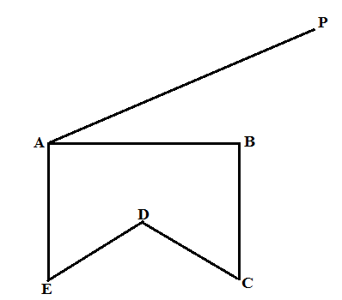

SECTION II (50 Marks)
Answer any five questions from this section in the spaces provided.
- The figure below represents a sector of a circle radius r units. The area of the sector is 61.6 cm² and the length of the arc AB is one tenth of the circumference of the circle from which the sector was obtained. ( Take $π=\frac{22}{7})$
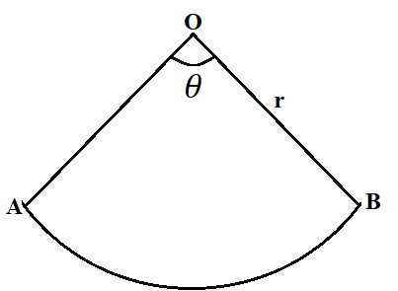
- Calculate;
- the angle $θ$ subtended by the sector at the centre. (2 marks)

- The radius r of the circle. (3 marks)

- If the sector above is folded to form a cone;
- Calculate the base radius of the cone. (2 marks)

- The volume of the cone. (3 marks)

- Two factories A and B produce both chocolate bars and eclairs. In factory A, it costs Kshs x and Kshs y to produce 1 kg of chocolate bars and 1 kg of eclares respectively. The cost of producing 1 kg of chocolate bars and 1 kg of eclairs in factory B increases by the ratio 6:5 and reduce by the ratio 4:5 respectively.
- Given that it costs Kshs 460 000 to produce 1 tonne of chocolate bars and 800kg of eclares in factory A and Kshs 534 000 to produce the same quantities in factory B, form two simplified simultaneous equations representing this information. (3 marks)

- Use matrix method to find the cost of producing 1 kg of chocolate bars and 1 kg of eclaires in factory A. (5 marks)

- Find the cost of producing 100 kg of chocolate bars and 50 kg of eclaires in factory B. (2 marks)

- The vertices of triangle ABC are A(6,2), B(8,2) and C(6,0).
- On the grid provided below, draw triangle ABC. (1 mark)
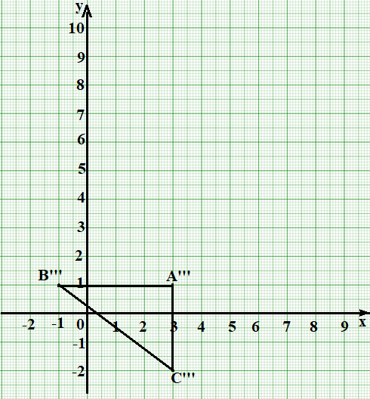

- Triangle A’B’C’ is the image of triangle ABC under a reflection in the line $y=x$. On the same grid draw triangle A’B’C’ and state its coordinates (2 marks)

- Triangle A”B”C” is the image of triangle A’B’C’ under and enlargement scale factor 2 about the centre (-1,9). On the same grid, draw triangle A”B”C” and states its coordinates. (2 marks)

- By construction, find and write down the co-ordinates of the centre and angle of rotation which can be used to rotate triangle A”B”C” onto triangle A’’’B’’’C’’’ shown on the grid above.
(3 marks)

- State any pair of triangles that are:
- Oppositely congruent. (1 mark)

- Directly congruent. (1 mark)

- The figure below shows a velocity-time graph of an object a which accelerates from rest to a velocity of V m$s^{-1}$ then decelerated to rest in a total time of 54 seconds.
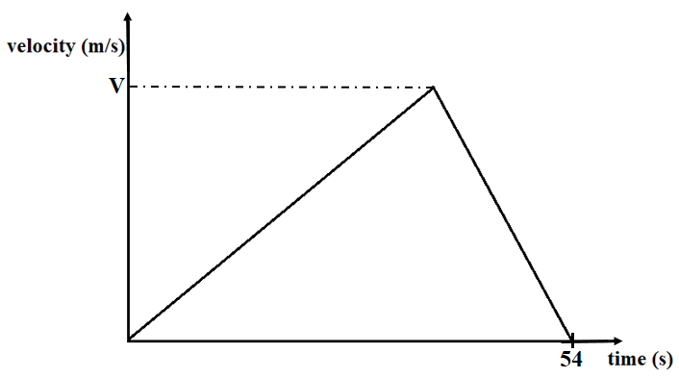
- If it covered a distance of 810 metres;
- Find the value of V. (2 marks)

- Calculate its deceleration, given that its initial acceleration was $1\frac{2}{3}ms^{-2}$ (2 marks)

- A bus left town X at 10.45 am and travelled toward town Y at an average speed of 60 km/h. A car left town X at 11.45 am on the same day and travelled along the same road toward Y at an average speed of 100km/h. The distance between town X and town Y is 500km.
- Determine the time of the day when the car overtook the bus. (3 marks)

- Both vehicles continued towards town Y at their original speeds. Find how long the car had to wait in town Y before the bus arrived. (3 marks)

- The masses to the nearest kilogram of some students were recorded in table below.
Mass(kg) | 41-50 | 51-55 | 56-65 | 66-70 | 71-85
Frequency | 8 | 12 | 16 | 10 | 6
Height of rectangle |  |  |  |  | 0.2

- Complete the table above to 1 decimal place. (2 marks)
- On the grid provided below, draw a histogram to represent the above information. (3 marks)
- Use the histogram to:
- State the class in which the median mark lies. (1 mark)

- Estimate the median mark. (2 marks)

- The percentage number of students with masses of at least 74kg. (2 marks)

- (a) a straight line L₁ whose equation is $9y-6x=-6$ meets the x-axis at Z. Determine the coordinates of Z. (2 marks)

(b) A second line L₂ is perpendicular to L₁ at Z. Find the equation of L₂ in the form $ax+by=c$, where ,b and c are integers. (3 marks)

(c) a third line L₃ passes through the point (2,5) and is parallel to L₁. Find:
- The equation of L₃ in the form $ax+by=c$, where a, b and c are integers. (2 marks)

- The coordinate of point R at which L₂ intersects L₃. (3 marks)

- In the diagram below, the coordinates of points O, P and Q are (0,0), (2,8) and (12,8) respectively. A is a point on OQ such that 4OA=3OQ. Line OP produced to R is such as OR=5OP.
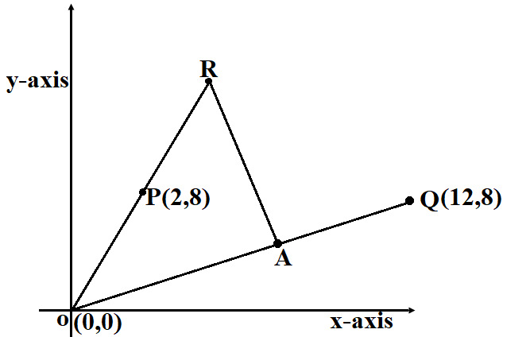
- Find vector RA. (3 marks)

- Given that point L is on PQ such that PL: LQ=12:5, find vector RL. (4 marks)

- Show that R, L and A are collinear. (2 marks)

- Find the ratio of RL:LA. (1 marks)

- Five points, P, Q, R, V and T lie on the same plane. Point Q is 53km on the bearing of 055⁰ of P. Point R lies 162⁰ of Q at a distance of 58km. Given that point T is west of P and 114km from R and V is directly south of P and S40⁰E from T.
- Using a scale of 1:1,000,000, show the above information in a scale drawing. (3 marks)

- From the scale drawing determine:
- The distance in km of point V from R. (2 marks)

- The bearing of V from Q. (2 marks)

- Calculate the area enclosed by the points PQRVT in squares kilometers. (3 marks)

