**Name………………………………………………………………... Index No ……………………………...**

Candidate’s Signature ………………………….

Date: ………………………………...

121/1

**MATHEMATICS**

Paper 1

**JULY/AUGUST 2014**

**Time: 21/2 Hours**

***Kenya Certificate of Secondary Education (K.C.S.E)***

**121/1**

**MATHEMATICS**

Paper 1

**INSTRUCTIONS TO THE CANDIDATES**

* *Write* ***your name*** *and* ***index number*** *in the spaces provided above*
* *This paper contains two sections;* ***Section*** *1 and* ***Section 11****.*
* *Answer all the questions in* ***section 1*** *and only* ***five*** *questions from* ***Section 11***
* *All workings and answers must be written on the question paper in the spaces provided below each question.*
* *Marks may be given for correct working* ***even if*** *the answer is wrong.*
* *Calculations and KNEC Mathematical tables may be used* ***EXCEP****T where stated otherwise.*
* *Show all the steps in your calculations, giving your answers at each stage in the spaces below each question.*

**FOR EXAMINERS’S USE ONLY**

**Section 1**

|  |  |  |  |  |  |  |  |  |  |  |  |  |  |  |  |  |  |
| --- | --- | --- | --- | --- | --- | --- | --- | --- | --- | --- | --- | --- | --- | --- | --- | --- | --- |
| Question | 1 | 2 | 3 | 4 | 5 | 6 | 7 | 8 | 9 | 10 | 11 | 12 | 13 | 14 | 15 | 16 | Total |
| Marks |  |  |  |  |  |  |  |  |  |  |  |  |  |  |  |  |  |

**Section 1I** **GRAND TOTAL**

|  |  |  |  |  |  |  |  |  |  |
| --- | --- | --- | --- | --- | --- | --- | --- | --- | --- |
| Question | 17 | 18 | 19 | 20 | 21 | 22 | 13 | 24 | **Total** |
| Marks |  |  |  |  |  |  |  |  |  |

*This paper consists of 16 printed pages. Candidates should check carefully to ascertain that all the pages are printed as indicated and no questions are missing.*

**SECTION A ( 50 MARKS)**

1. Evaluate  (3mks)



1. A fruit juice dealer sell the juice in pacjket of 300ml, 500ml and 750ml. find the size of the smallest container that can fill each of the packets and leave a remainder of 200ml. ( 3mks)
2. Without using table or calculators, evaluate 
3. Simplify the following quadratic expression.  ( 2mks)
4. In a fundraising committee of 45 people, the ratio of men to women is 7:2. Find the number of women required to join the existing committee so that the ratio of men to women is changed to 5: 4.

(3mks)

1. A student expanded ( x + y)2 incorrectly as x 2+ y 2 calculate the percentage error in the answer if x = 4 and y = 6 (3mks)
2. The figure below shows a trough which is 40 cm wide at he top and 25 cm wide at the bottom. The

trough is 20cm deep and 4.5 m long. Calculate the capacity of the trough in litres. (3mks)

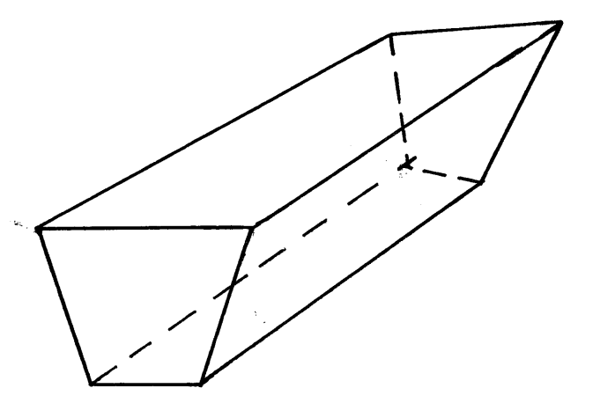

25 cm

40 cm

4.5 cm

1. Jemima’s team entered a contest where teams of students compete by answering questions that earn

either 3 points of 5 points. Jemima’s team scored 44 points after answering 12 questions correctly. How many five-points questions did the team answer correctly. (3mks)

1. Using compass and ruler only construct a triangle Arc such that AB= 6cm ,BC = 5cm and angle

ABC = 67.5o measure the length of AC ( 4mks)

10. Use table of reciprocals only to work out : $\frac{13}{0.156}- \frac{3}{0.6735}$ ( 3mks)

E

9cm

6cm

8cm

B

A

D

C

25 cm

11. In the figure below, angle ABE is equal to angle ADC AE = 6cm, Ed = 9cm and AB = 8cm,

calculate the length of BC ( 3mks)

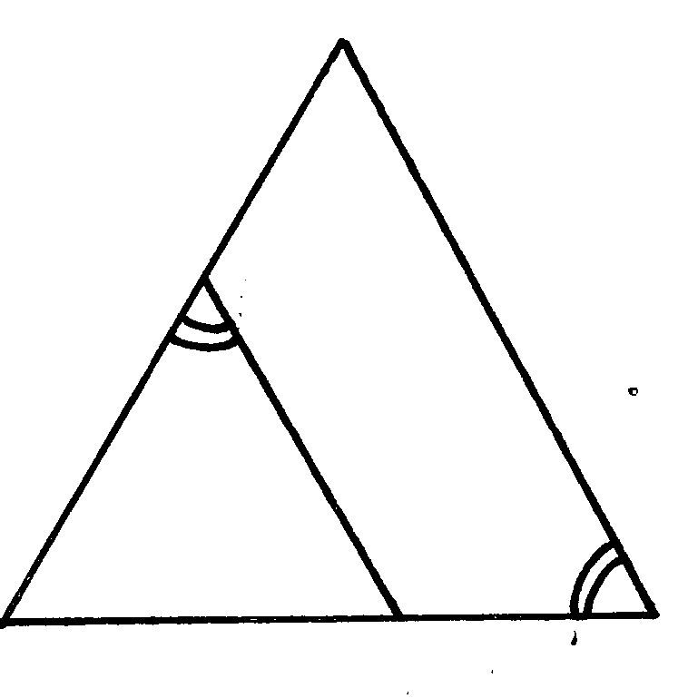

12. Simplify the expression below leaving your answer in rationalized surd form of a + b

(4mks)

13. The two sides of a triangle are given 6 cm and 5 cm. the angle between them is 130o. calculate the

are of the triangle ( giving your answer to 2 decimal places) (3mks)

14. Given that Km + hn = r and that m = $\left(\begin{aligned}-3 \\ -2\end{aligned}\right)$ n = $\left(\begin{aligned}0 \\ 4\end{aligned}\right)$ and r = $\left(\begin{aligned}-6 \\ 0\end{aligned}\right)$. Find the scalars k and h ( 3mks)

~

~

~

~

~

~

15. Give the matrices A = $\left(\begin{matrix}3 & 2 \\ 4 & 1\end{matrix}\right)$ and B = $\left(\begin{matrix}1 & -1 \\ 2 & 3\end{matrix}\right)$ and that C = Ab, find the inverse of C . (3mks)

16. The length of a rectangular mat is 1.5 M longer that its width, Find the length of the mat if its

area is 6.5 m2( give your answer to 4 significant figures) ( 3mks)

**SECTION II**

***Answer only five questions from this section***

17. Five towns V,W,X,UY and Z are situated such that W is 200km east of V. X is 300km from W on a bearing of 150o. Y is 350km on a bearing of 240oX. Z is 150o from V but 200o from X.

Draw the diagram representing the position of the towns. ( use a scale of 1cm to represent 50km) .

(5mks)

(b) From the diagram determine

(i) the distance in km of V from Z (1mk)

(ii) The bearing of Y from W ( 1mk)

(c) A plane heading to town X takes off from town y and flies upwards ofa constant angle which

is less than 90o. After flying a distance of 350okm in the air it sees town x at an angle of depression of 50o. calculate the distance of the plane from x at this point to the nearest km. (3mks)

18. Two circles of radii 3.5 and 4.2 cm with centres O1 and O2 respectively intersect at points A and B

as shown in the figure below. The distance between the two centres is 6 cm.

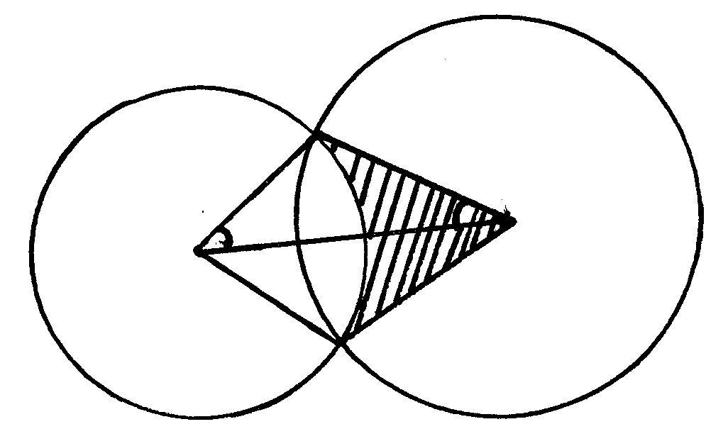

**A**

**3.5 cm**

**4.2 cm**

**α**

**O2**

**O1**

**B**

Calculate

1. The size of AO1B ( to the nearest degree) ( 3mks)
2. The size of  A O2 B ( to the nearest degree) ( 3mks)
3. The area of quadrilateral O1AO2B, correct to 2 decimal places. (2mks)
4. The shaded area correct to two significant figures. ( take $π{22}/7$) ( 2mks)

19 (a) complete the table below for the function y = 2 x 2 + 4 X -3

|  |  |  |  |  |  |  |  |
| --- | --- | --- | --- | --- | --- | --- | --- |
| X | -4 | -3 | -2 | -1 | 0 | 1 | 2 |
| 2x2 | 32 |  | 8 | 2 | 0 | 2 |  |
| 4x-3 |  |  | -11 |  | -3 |  |  |
| Y |  |  | -3 |  |  | 3 | 13 |

(b) Draw the graph of the function y = 2x3 + 4 4x – 3 on the grid provided. (3mks)



(c) Use your graph to estimate the roots of the equation 2x2 + 4x – 3 = 0 ( 1mk)

1. Use your graph to obtain the roots of the equation 2x2 + x – 5 = 0 to 1 decimal place. (3mks)
2. Draw the line of symmetry to pass through the turning point of this curve. (1mk)

20 The table below shows patients who attend a clinic in one week and were grouped by age as shown in

the table below.

|  |  |  |  |  |  |
| --- | --- | --- | --- | --- | --- |
| Age x years | 0≤ x < 5 | 5≤ x < 15 | 15≤ x < 25 | 25≤ x < 45 | 45≤ x < 75 |
| Number of patients | 14 | 41 | 59 | 70 | 15 |

1. Estimate the mean age (4mks)
2. On the grid provided draw a histogram to represent the distribution. (3mks)

Use the scales: 1cm to represent 5 units on the horizontal axis 2 cm to represent 5 units on the

vertical axis.



1. (i) State the group in which the median mark lies ( 1mk)

(ii) A vertical line drawn through the median mark divides the total area of the histogram into

two equal. Using this information estimate the median mark. (2mks)

21. (a) Show by shading the unwanted region, the region which satisfies the following inequalities (8mks)

Y > -3

4y ≤5x + 20

2y < - 5 x + 10

4y≤ -3 3x – 12

(b) calculate the area of this region in a square units ( 2mks)



22. (a) Use trapezium rule with 8 strip to find the are bounded by the curve y = x 2 + 2 and the x – axis,

x = 2 and x = 2 (5mks)

(b) Calculate the actual area in (a) above Hence find the percentage error in the area. (5mks)

23.

O

Y

D

C

A

5cm

B

5cm

E

F

X

12cm

H

12cm

The diagram shows a frustum ABCDEF GH formed from a smaller pyramid ABCDO. The base the top of the frustums are squares of sides 12cm and 5 cm respectively. If Ob = 6cm and each of the slant edges of the frustum is 15 cm long. Calculate to 1 decimal place:

(a) the height OY of the small pyramid (3mks)

(b) the vertical height X Y of the frustum ( 4mks)

(c) the volume of the frustum (3mks)

24. Complete the table below. ( 2mks)

|  |  |  |  |  |  |  |  |  |  |  |  |  |  |
| --- | --- | --- | --- | --- | --- | --- | --- | --- | --- | --- | --- | --- | --- |
| X | -180o | -150o | -120o | -90o | -60o | -30o | 0o | 30o | 60o | 90o | 120o | 150o | 180o |
| 3 sin | -2.90 |  |  | -1.50 |  |  |  |  |  | 2.60 |  | 3.0 |  |
| Cos ( 2x + 30)o | 0.87 |  | -0.87 |  | 0 |  |  | 0 |  |  | 0 | 0.87 |  |

(b) On the same set of axes draw the graph of y = 3 sin  and y = Cos ( 2x + 30) for

- 180 ≤ x ≤ 180o (5mks)



(c) (i)Use the graph in (b) above to solve 3 sin  Cos ( 2x + 30) = 0 (1mk)

(ii) State the period and the amplitude of 3 sin  (2mk)