Manyam Franchised Tests
Mathematics | STD8 | 2HRS | KCPE 2006

Name…………..……………………..…………. School…………………….....………………Date…………

- What is 73121025 written in words?
- Seven million three hundred and twelve thousand one hundred and twenty five.
- Seventy three million one hundred and twenty one thousand and twenty five.
- Seven hundred and thirty one million two hundred and ten thousand and twenty five
- Seventy three million twelve thousand one hundred and twenty five.
- What is 1.28978 correct to three decimal places?
- 1.28
- 1.289
- 1.29
- 1.290
- Mosi sold milk from 7th January to 7th March 2006. For how many days altogether did he sell the milk?
- 58
- 59
- 60
- 61
- In the figure below lines PQ, RQ and SQ have been constructed to meet at Q.
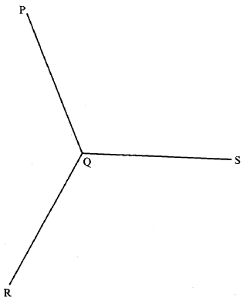

Measure angle SQR.
What is the size of angle SQR?
- 63⁰
- 114⁰
- 117⁰
- 129⁰
- What is the sum of the total values of the digits in the hundreds and ten thousands positions in the number 693582?
- 95 000
- 90 500
- 10 100
- 9 500
- How many vertices does a triangular prism have?
- 2
- 5
- 6
- 9
- Sosti borrowed sh 20 000 from a money lender at a simple interest rate of 5% per month. How much did he pay back altogether at the end of one year?
- Sh 32 000
- Sh 21 000
- Sh 20 060
- Sh 12 000
- The heights in centimeters of 10 pupils are given below:
169, 173, 158, 170, 159, 171, 163, 159, 180, 167
What is the mean height of the pupils?
- 159 cm
- 166.9 cm
- 168 cm
- 1 669 cm
- What is the next number in the pattern:
1.2, 2.4, 4.8, ______ ….?
- 6.0
- 7.2
- 8.4
- 9.6
- The decimals 0.09402, 0.09042, 0.09204 are to be written from the largest to the smallest. Which one of the following is the correct order?
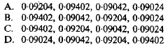

- A rectangular plot of land measures 40m by 30m. there is a wall on one of the longer sides. Four strands of wire are to be used to fence the three remaining sides of the plot. What length of wire is required?
- 4 800m
- 560m
- 400m
- 100m
- In the year 2002, the number of pupils in a school was 800. In 2003 the number of pupils increased by 40%. How many pupils were there in 2013?
- 320
- 480
- 840
- 1120
- A pupil intends to add the fractions$\frac{2}{7}$, $\frac{3}{8}$, and $\frac{5}{6}$ . Which of the following numbers should she choose as the least common denominator?
- 56
- 48
- 168
- 336
- Mukami had 135 two hundred shillings notes which she changed as follows:
Sh 21 000 into one thousand shillings notes
Sh 3 000 into five hundred shillings notes
Sh 2 000 into one hundred shillings notes and the remaining amount on money into fifty shillings notes.
How many notes did she get altogether?
- 67
- 54
- 47
- 20
- A distance of 5 Kilometres is represented on a map by a length of 4 centimeters. What is the scale used?
- 1:125
- 1:1250
- 1:12500
- 1:125000
- What is the value of 7(8²-7²) + 63 $÷$7?
- 16
- 23
- 24
- 114

- What is the value of $x$ in the equation 1$\frac{1}{4}x+4=13-x?$
- 68
- 36
- 7$\frac{5}{9}$
- 4
- Mula sold an item for sh 9 900 and made a loss of 10%. What was the cost price of the item?
- Sh 11000
- Sh 9910
- Sh 9000
- Sh 8910
- Twenty litres of milk was given to a class of 50 pupils to share equally. How many deciliters of milk did each pupil get?
- 0.4
- 4
- 40
- 400
- What is the value of 0.6-0.4 $×$ 0.23 – 0.01?
- 0.036
- 0.044
- 0.498
- 0.518
- A certain quadrilateral has the following properties:
Has two sets of parallel sides
Has all sides equal
Diagonals bisect each other
Some angles are equal
Which quadrilateral has the above properties?
- Parallelogram
- Rhombus
- Square
- Trapezium
- An aeroplane left town F at 22 30 h on Monday. It took 8$\frac{3}{4}$hours to reach town K. when did it reach town K?
- Tuesday 7.15 a.m.
- Tuesday 7.15 p.m.
- Monday 7.15 a.m.
- Monday 7.15 p.m.
- What is the square root of 0.0576?
- 0.0024
- 0.024
- 0.24
- 2.4

- What is the volume, in cm³, of a cylinder whose diameter is 14cm and height 10cm? (take $π=\frac{22}{7}$ )
- 6160
- 1540
- 748
- 440
- Mbogo and Kihara shared some money such that Mbogo got $\frac{3}{4}$ of the money shared out. What was the ratio of Mbogo’s share to that of Kihara?
- 4:3
- 3:1
- 3:4
- 1:3
- Onyango paid sh 950 for an item after getting a discount of sh 50. What percentage discount did he get?
- 5%
- 5$\frac{5}{9}$%
- 5$\frac{5}{19}$%
- 95%
- The figure below is part of a rhombus EFGH. Complete the rhombus.
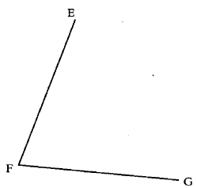
What is the length of half the longer diagonal?
- 3 cm
- 4 cm
- 6 cm
- 8 cm

- Samira bought the following items:
Five half-litre packets of milk @ sh 30
Two crates of soda @ 320
Twenty five loaves of bread @ sh 23
A bottle of water for sh 25
If she had sh 2 000, how much money did she remain with?
- Sh 1602
- Sh 1390
- Sh 635
- Sh 610
- The bar graph below shows the number of kilograms consumed by a school in five days.
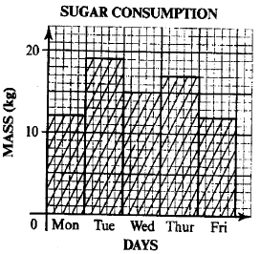
In which pair of consecutive days was the total consumption the highest?
- Mon and Tue
- Tue and Wed
- Wed and Thursday
- Thur and Fri
- A youth group organized a film show to raise funds. Two hundred and eighty men attended the film show. The number of women who attended was half of men. While the number of youths was three times the number of both men and women. The charges were sh 50 per adult and sh 20 per youth. How much money was raised?
- Sh 46200
- Sh 37800
- Sh 25200
- Sh 21000

- In the figure below, JK = JL = 25cm and KM = ML. the perimeter of triangle JKL = 98 cm.
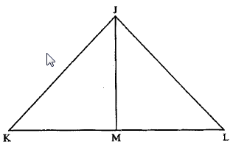
What is the length of the perpendicular line JM in centimeters?
- 25
- 24
- 12
- 7
- Which one of the following expressions is equal to
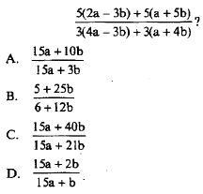
- The following table shows the commission charged when one buys postal orders.
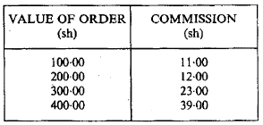
Wangeci wanted to send sh 700 by postal orders. Which one of the postal order combinations given below should she buy in order to pay the least commission?
- Sh 400+sh 300
- Sh 400 + sh 100 + sh 100 + sh 100
- Sh 300 + sh 300 + sh 100
- Sh 200 + sh 200 + sh 200 + sh 100

- An open cylindrical tin of diameter 14cm and height 21 cm was painted on the outside. What was the area painted? ( take $π=\frac{22}{7}$)
- 3234 cm²
- 2464 cm²
- 1232 cm²
- 1078 cm²
- What is the value of $\frac{r(p^{2}+qp)}{r+q}$ given that r=6, p=r+2 and q=p-3?
- 56$\frac{8}{11}$
- 38$\frac{6}{11}$
- 30$\frac{6}{11}$
- 20$\frac{4}{5}$
- Asha and Musa are salespersons employed by two different companies. Asha’s company pays her a monthly salary of sh 1 500 and a 2$\frac{1}{2}\%$ commission on goods she sells above sh 10 000.
Musa’s company only gives him a 6% commission on all goods he sells.
On certain month Asha and Musa each sold goods worth sh 40 000. How much more money was Musa paid than Asha?
- Sh 2400
- Sh 2250
- Sh 900
- Sh 150
- What is the value of 1$\frac{1}{6}+\frac{1}{4}×\frac{2}{3}+\frac{5}{8}?$
- $\frac{59}{72}$
- 3$\frac{1}{72}$
- 3$\frac{53}{72}$
- 7$\frac{5}{8}$
- A pick-up whose mass is one tonne when empty was loaded with 40 bags of sugar each weighing 50kg and three bags of maize each weighing 65kg. What was the total mass, in tonnes, of the loaded pick-up?
- 3.195
- 3.065
- 3.0
- 2.195

- In a relay race Obong’’o ran 600m, which is $\frac{2}{5}$ of the race, in 3 minutes, Kyalo took 5 minutes to complete the rest of the race.
What was the average speed for the whole race in m/s?
- 3
- 3$\frac{1}{8}$
- 3$\frac{1}{6}$
- 3$\frac{1}{3}$
- Forty two men were hired to repair a stretch of road in 14 days. How many more men should be hired if the work was to be finished in 12 days?
- 6
- 7
- 49
- 91
- The number of women passengers in a bus was W. the number of children in the bus was three times that of men passengers but was 6 more than that of women.
Which one of the following expressions shows the total number of passengers in the bus?
- 2$\frac{1}{3}$W+8
- 2$\frac{1}{3}$W-8
- 2$\frac{1}{3}$W+12
- 5W+24
- In the figure below line AB, AC, BC and BD are equal. BDF and CDE are straight lines and angle ABD is a right angle.
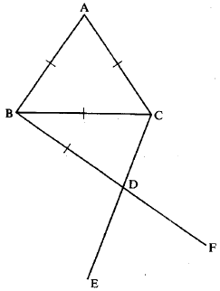
- 30⁰
- 45⁰
- 60⁰
- 75⁰
What is the size of angle EDF?

- The graph below shows muli’s journey from town X to town Y.

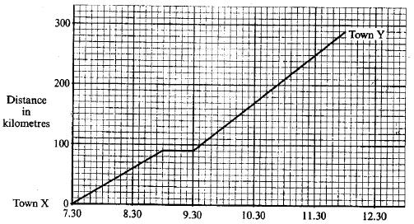

What was the average speed, in km/h, for the whole journey?
- 72$\frac{1}{2}$
- 70
- 64$\frac{4}{9}$
- 44$\frac{4}{9}$
- On line YZ given below, complete the construction of the isosceles triangle XYZ where XY=XZ=8cm. construct a circle centre O which touches the sides of the triangle.

A. 2cm B. 3.6cm
C. 4.3cm D. 5.4cm

What is the radius of the circle?

- The hire purchase price fir a wall cabinet is 25% more than the cash price. Kalulu bought the cabinet on hire purchase terms by paying a deposit of sh 13 200 and the remaining amount in 12 equal monthly installments.
If the cash price was sh 24 000, how much was each monthly installment?
- Sh 400
- Sh 900
- Sh 1400
- Sh 2500
- A flower garden is made up of a semicircle of diameter 14m, a rectangle measuring 20 metres long and 14 metres wide and a quarter of a circle of a circle of radius 14m.
What is the area of the flower garden in m²? ( take $π=\frac{22}{7}$)
- 742
- 665
- 511
- 395$\frac{1}{2}$
- Kamau, wasike and Omollo sell newspapers. One day Omollo sold 20 newspapers more than Wasike who sold 10 newspapers more than Kamau. The total number of newspapers they sold that day was 140.
If Wasike sold y newspapers, which one of the following equations can be used to find the number of newspapers sold by Wasike?
- 3y + 10 = 140
- 3y + 30 = 140
- 3y + 20 = 140
- y + 30 = 140
- Moraa shared money among her four children, Muta, Somo, Nduta and Aroya. Muta got $\frac{1}{3}$of the money while Somo got $\frac{1}{2}$of the remainder. The rest was shared equally between Nduta and Aroya.
What fraction of the money did Aroya get?
- $\frac{1}{12}$
- $\frac{1}{6}$
- $\frac{1}{6}$
- $\frac{1}{2}$

- A tailer had 17.5m of cloth material. From this material she made 2 dresses each requiring 3.75m of material, and 3 jackets each requiring 2.4m of material.
What length of material remained?
- 1.4 m
- 2.8 m
- 11.35 m
- 14.7 m
- An incomplete pattern is shown below.
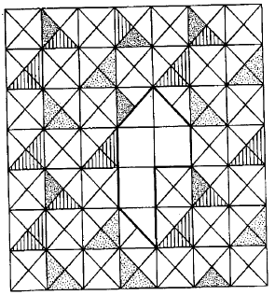
Which one of the shapes below will complete the pattern above? 