MARKING SCHEME
MWAKICAN EXAMINATION
END TERM 1 2015
BILOGY FORM 4 PAPER 2
- (a) Osmosis
(b) Flaccid; crenated

- (a) glucose
(b) Photosynthesis
(c) Light, chlorophyl
- (a) To absorb Co₂ produced
(b) Provides fovourable temperature
(c) H₂O rises in the capillary tube; to occupy space after O₂ is used up
(d) Use a dead organism or do not include X.

- (a) i) Arthropoda;
ii) Arachnida
(b) i) segmented body
Jointed appendages;
Exoskeleton
ii) 4 Pairs legs;
Head and thorax fused to form cephalothorax
- (a) U – Thallus
W – Rhizoids
X – Antheridia
Y – Archegonia
Z – Capsule
(b) X – Produce male gamete
Y – Produce female gamete
Z – Produce spores
- (a) i) Apical dominance
ii) Development of more branches required for increased harvest. E.g. tea & coffee.
(b) Stimulate cell division & cell elongation bading to primary growth
Tropic responses
Stimulate growth of adventitious roots; from the stem
Promotes palheno carpy;
Induce formation of callus tissues
Induce cell division in Cambrian leading to secondary growth.
- (a) long loop of henle
Few & small glomeruli
(b) Nephritis

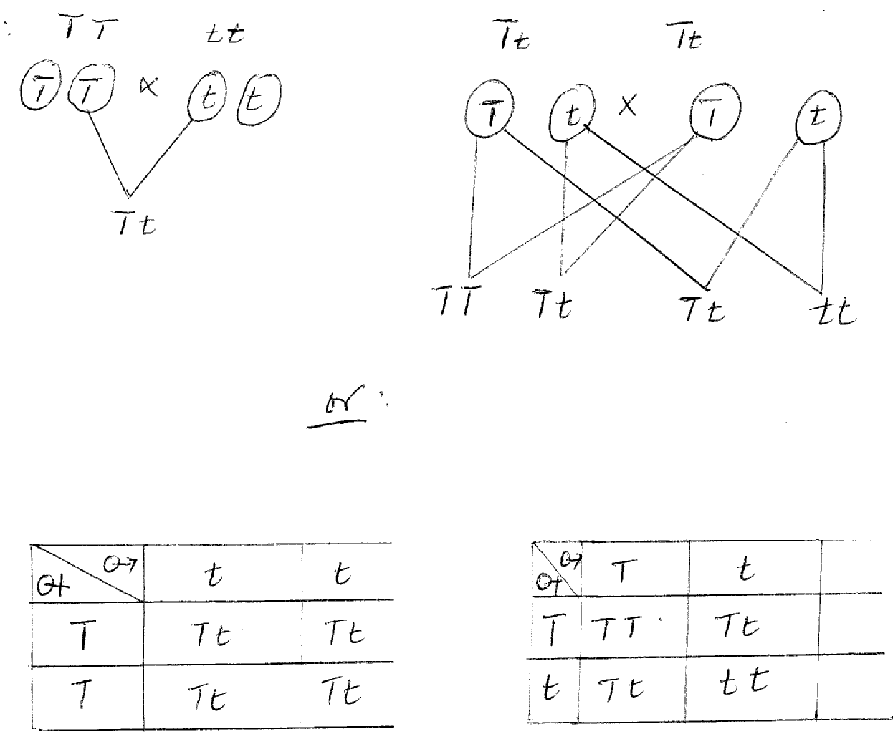

- The earth was a single land mass; (pangea), it broke into parts that drifted away (continental drift)
Organisms that were related become separated and evolved differently;

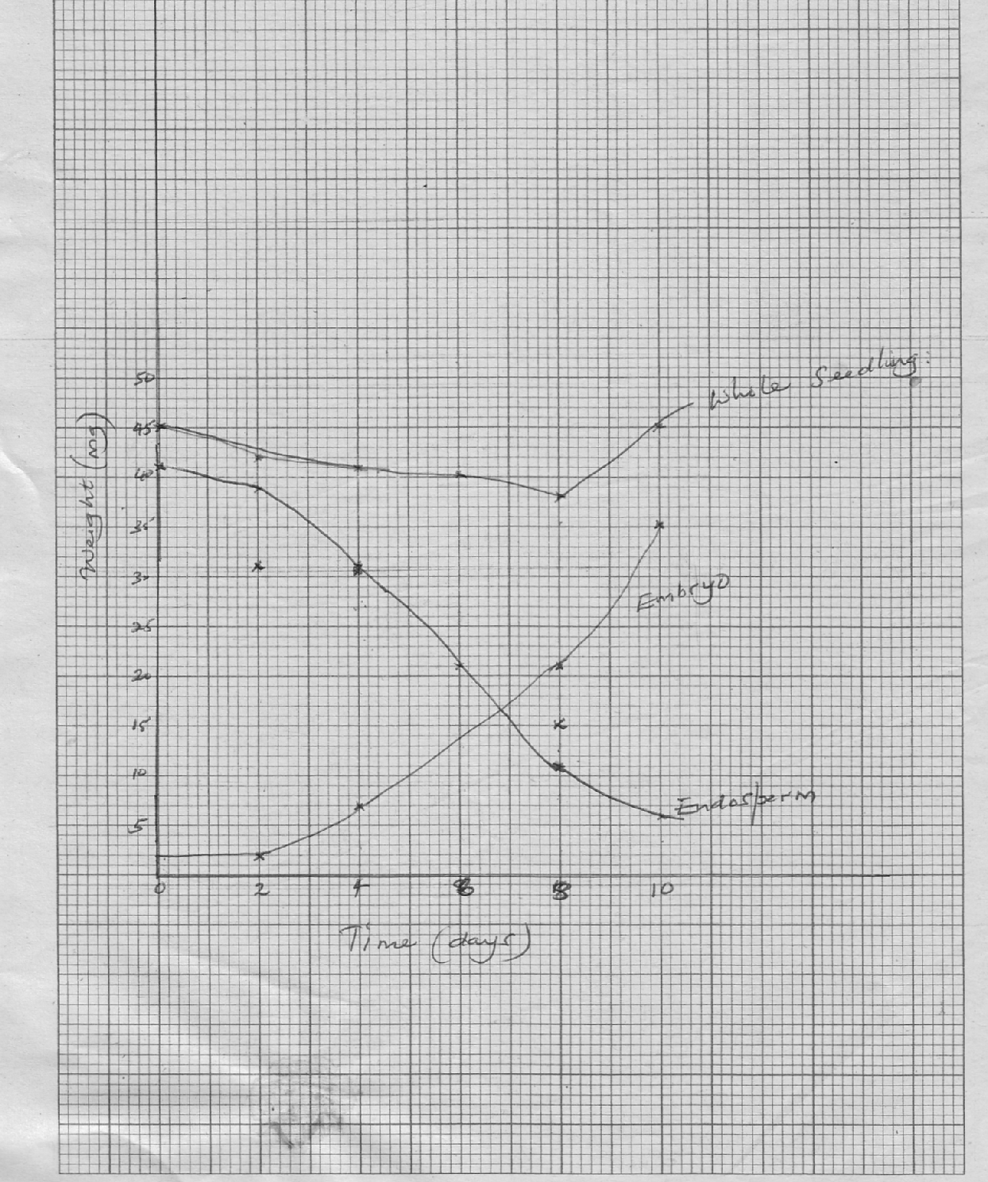
  - (i) Weight of embryo increases steadily; cell under division; new protoplasm is
synthesized; hence increase in weight;
(ii) Decrease in weight; stored food is hydrolysed; and transported to other regions; for
respiration & synthesis of new materials.
  - Hydrolysis of stored food
Activation of hormones & enzymes
Medium for enzyme catalyzed reactions
Medium for transport of hydrolyzed food
- (a) Gaseous Exchange
- Takes place in the spongy mesophyl during the day air diffuses in the large air spaces of the spongy mesophyll through stomata;
- The air dissolves in the thin layer of moisture over the spongy mesophyll cells; carbon dioxide from the air diffuses into the cells (photosynthetic cells) in solution form.
- Oxygen produced during photosynthesis diffuses out of the cells and out of leaves.
- At night air diffuses into the large air spaces & into the thin film of moisture over the spongy mesophyll cells
- Oxygen diffuses into the cells, Carbon(iv)oxide diffuses out of the cells into the air spaces & out of the leaf via stomata.
- Gaseous exchange also occur through the cuticle epidermis of young leaves; epidermis of root in the soil lenticels.
- In the lenticels cork cells are loosely packed; gaseous exchange occur between the loosely arranged cells & atmosphere.
(b)
- Has myogenic muscles that contract & relax rhythmically without fatigue
- Cardiac muscle fibres are interconnected to ensure rapid spread of excitation through the wall of heart ventricle walls thicker than auricle walls & generate high pressure to pump blood over a long distance
- Has coronary artery that supplies the muscles with oxygen and nutrients and remove wastes from the heart muscles
- The pericardium surrounds the heart & prevent it from over dilation
- Has semi-lunar valves that prevent blood in the arteries from flowing back into the ventricles
- Inner layer of pericardium secretes pericardial fluid that lubricates the heart.
- Outer layer of heart covered with fat that acts as shock absorber
- Has Sino arteriole node that acts as pace maker
- A longitudinal septum separates the heart into two preventing mixing of oxygenated & deoxygenated blood
- Adaptation of Epidermis

- Transparent to allow light to penetrate to the photosynthesis tissues
- A single layer of cells to reduce distance over which light penetrates
- Presence of stomata for gaseous exchange
  - Stomata
    - The higher the number the higher the rate of transpiration and vice versa
    - Location of stomata – rate is high when most are on upper leaf surface.
    - Late is lower when stomata are sunken other than exposed;
    - Some plants reverse the stomata rhythm which reduces rate of transpiration;
Leaf size and shape
- When a leaf is blood surface area for evaporation increases which increases rate of transpiration when leaf is narrow rate of transpiration reduces;

Cuticle –
- when leaf has a thick waxy cuticle rate of transpiration reduces wax in water proof when cuticle is thin and not waxy rate of transpiration increases;

Hairly leaves
- Hairs on the leaf surface traps moisture air around the leaf is saturated with water vapour which reduces transpiration.
  - Adaptation of xerophytes
- Have leaves that are reduced in size which reduces surface for evaporation;
- Leaves have waxy cuticle that is thick to reduce evaporation since wax is water proof some leaves are folded to reduce number of stomata exposed to environmental factors.
- Stomata in them are usually sunken; water vapor accumulates in these depressions preventing further water loss’
- They have stomata whose number is greatly reduced to reduce rate of evaporation.

