MOMALICHE 4 CYCLE 8 JOINT EXAM

312/2
GEOGRAPHY
Paper 2
2 ¾ Hours

Instructions to candidates

- This paper has TWO sections A and B
- Answer ALL questions in sections A
- In section B answer question six and any other two questions
- ALL answers must be written in the answer sheets provided.

This paper consists of 4 printed pages
Candidates should check the question paper to ensure
that all the pages are printed as indicated and no questions are missing

SECTION A
Answer ALL questions in this section
1 (a) Apart from floods, name two other environmental hazards experienced in Kenya.
(2 marks)
(b) Outline three methods used to control floods. (3 marks)

2 (a) (i) Define an anadromous fish? (1 mark)

(ii) Give an example of anadromous fish. (1 mark)

(b) Give three reasons for encouraging fish farming. (3 marks)

3 (a) State two formations in which mineral ore occur. (2 marks)

(b) Give three effects of land dereliction on the environment. (3 marks)

4 (a) Differentiate between horticulture and market gardening. (2 marks)

(b) Outline three problems facing horticulture in Kenya. (3 marks)

5 (a) List two functions of the central business district. (2 marks)

(b) State three factors that may lead to rural – urban migrations. (3marks)

SECTION B

6. Study the table below and answer the questions that follow
World production of nuclear power 2002
Continent | Total production mw(2)
Europe  Africa  North America  South America  Asia | 87,467  1,840  87,580  1,561  62,304

(a) Using the data given above draw a pie chart of radius 3cm to represent the world production of nuclear power in 2002 (8mks)
(b) (i) Where is nuclear power derived from (1mk)
(ii) Name a country in Africa where nuclear power is produced (1mk)
(iii) State two uses of nuclear power (2mks)
(iv) List two disadvantages of nuclear power (2mks)

(c) State three benefits enjoyed by Egypt after the construction of the aswan High Dam (3mks)
(d)Explain four factors have influenced the production of hydro – electric power in the United States of America (8mks)

7. (a) Name two counties in Kenya where maize is grown in large scale (2mks)
(b) State four physical conditions necessary for maize growing (4mks)
(c) Explain four problems experienced by maize farmers in Kenya (8mks)
(d) (i) What is the meaning of national food policy (2msk)
(ii) State three reasons why the national food policy was set up in 1981 (3mks)
(e) (i) What are the reasons behind the shortage of maize in Kenya (3mks)
(ii) Which steps should be taken by the Kenya government to alleviate the food shortage problem. (3mks)

8. (a) (i) Give the difference between two-way road and one-way road system in Kenya. (2mks)

(ii) Explain four causes of road accidents on the Kenyan roads. (8mks)

(b) The map below shows the proposed Trans-Africa Railway and the great North road.
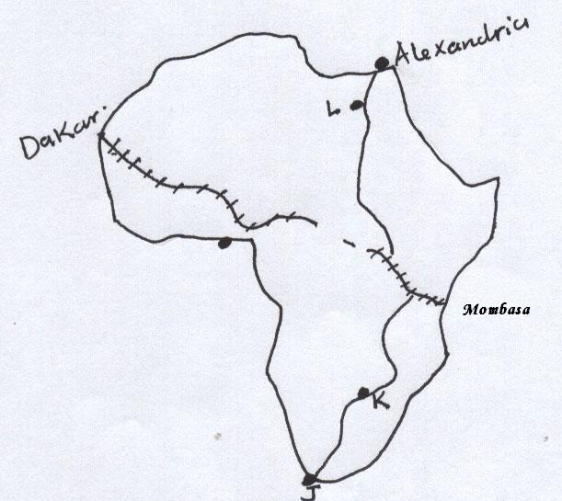

(i) Name the towns marked J, K, & L on the Great North Road. (3mks)

(ii) Name three countries where the Trans-Africa Railway line is not completed. (3mks)

(c) (i) Give four reasons why Railway transport is not well developed in Africa. (4mks)

(ii) State five roles of the St. Lawrence sea-way to the development around the great lakes. (5mks)

9. a ( i) Define the term life expectancy. (2 marks)

(ii)Name three counties with low population in Kenya. (3mks)

(b) Explain how the following factors influence population distribution in Kenya.

(i) Relief. (2 marks)

(ii) Government policy. (2 marks)

(iii) Development of industries. (2 marks)

(c) Explain four efforts the Kenya Government is making to check on the high mortality rate.
(8 marks)

(d) Explain three factors for the reduction of fertility rate in Kenya. (6 marks)

10. (a) Differentiate between Internal trade and International trade. (2mks)

(b) State three problems faced by Kenya in international trade. (3mks)

(c) (i) Identify three major exports from Kenya. (3mks)

(ii) Give three reasons why Kenya should protect her local industries. (3mks)

(d) (i) What is unfavourable balance of trade? (2mks)

- Explain three reasons why Kenya experiences unfavourable
balance of trade. (6mks)
- Explain three measures taken by the Kenyan government
to reduce her unfavourable balance of trade. (6mks)

