NAME ________________________________ ADM No _______________________
CLASS__________________________ Candidate’s Signature _________________
DATE____________________________

443/2
Agriculture
Paper 2
Time: 2 Hours
ASUMBI GIRLS HIGH SCHOOL
TERM 2 - DECEMBER 2021
FORM 4 – AGRICULTURE PAPER 2

INSTRUCTIONS TO CANDIDATES
- Write your name, Admission number and date in the spaces provided.
- This paper consists of three sections; A, B and C.
- Answer All questions in Section A and B in the spaces provided.
- Answer any two questions in Section C in the spaces provided.

For Examiners use only.
SECTION | QUESTION | MAXIMUM SCORE | CANDIDATE’S SCORE
A | 1-17 | 30
B | 18-22 | 20
C |  | 20
 |  | 20
 |  | 20
TOTAL |  | 90

SECTION A

1. Name four dairy breeds of goats. (2 mks)

………………………………………………………………………………………………………

………………………………………………………………………………………………………

……………………………………………………………………………………………………....

………………………………………………………………………………………………………

2. Outline two control measures of roundworm. (1 mk)

………………………………………………………………………………………………………

………………………………………………………………………………………………………

3. State four maintenance practice carried on a wheelbarrow. (2 mks)

………………………………………………………………………………………………………

………………………………………………………………………………………………………

………………………………………………………………………………………………………

………………………………………………………………………………………………………

4. Give three ways of transmitting livestock diseases. (1 ½ mks)

………………………………………………………………………………………………………

………………………………………………………………………………………………………

………………………………………………………………………………………………………

5. State the appropriate use of each of the following farm tool.
i) Stock and die (1 mk)

………………………………………………………………………………………………………

ii) Oil stone (1 mk)

………………………………………………………………………………………………………

6. Distinguish between zoonotic disease and a notifiable disease. (2 mks)

………………………………………………………………………………………………………

………………………………………………………………………………………………………

7. State four reasons for keeping livestock healthy. (2 mks)

………………………………………………………………………………………………………

………………………………………………………………………………………………………

………………………………………………………………………………………………………

………………………………………………………………………………………………………

8. a) What is the intermediate host for liverfluke. (1 mk)

………………………………………………………………………………………………………

b) What is the duration of oestrus cycle in a cow. (1 mk)

………………………………………………………………………………………………………

9. State two advantages of upgrading cattle. (2 mks)

………………………………………………………………………………………………………

………………………………………………………………………………………………………

10. Give the functions of the following parts of a reciprocating mower.
a) swath stick ( ½ mk)

………………………………………………………………………………………………………

b) Shoe ( ½ mk)

………………………………………………………………………………………………………

c) Cutter bar ( ½ mk)

………………………………………………………………………………………………………

11. Give two functions of the albumen in an egg. (2 mks)

………………………………………………………………………………………………………

………………………………………………………………………………………………………

12. State four qualities of good wool. (2 mks)

………………………………………………………………………………………………………

………………………………………………………………………………………………………

………………………………………………………………………………………………………

………………………………………………………………………………………………………

13. Give two reasons why honey harvesting is discouraged at night. (2 mks)

………………………………………………………………………………………………………

………………………………………………………………………………………………………

14. Which hormone stimulates milk let down? (1 mk)

………………………………………………………………………………………………………

15. Give two qualities of a creep feed. (2 mks)

………………………………………………………………………………………………………

………………………………………………………………………………………………………

16. State two reasons for seasoning timber before use in construction. (2 mks)

……………………………………………………………………………………………………

………………………………………………………………………………………………………

17. Name the causal organisms of the following diseases.
a) Anthrax ( ½ mk)

………………………………………………………………………………………………………

b) Nagana ( ½ mk)

………………………………………………………………………………………………………

SECTION B

18. Study the diagram below carefully and answer the questions that follow.

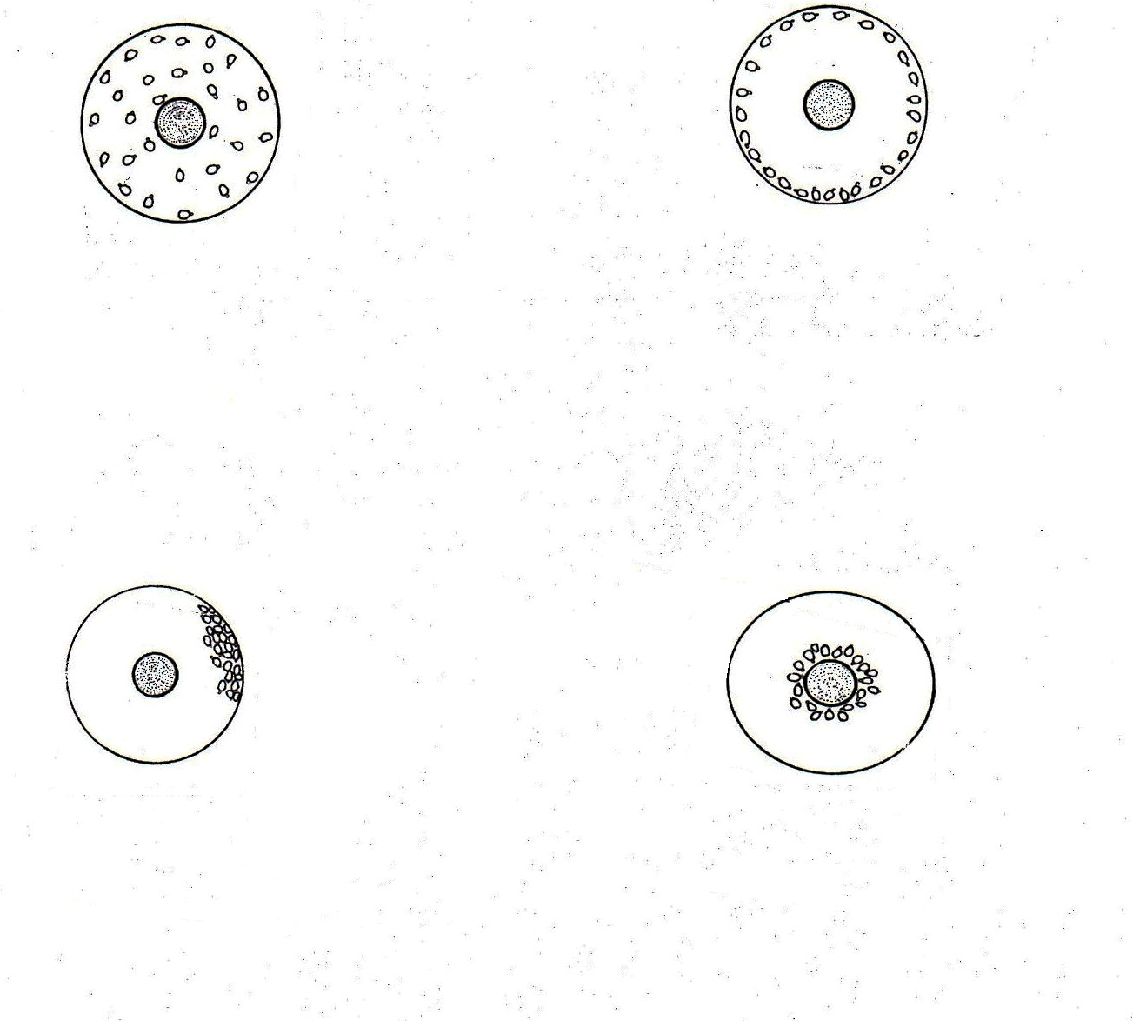

Indicate below each diagram the conditions in the brooder. (4 mks)

19. Study the diagram below and answer the questions

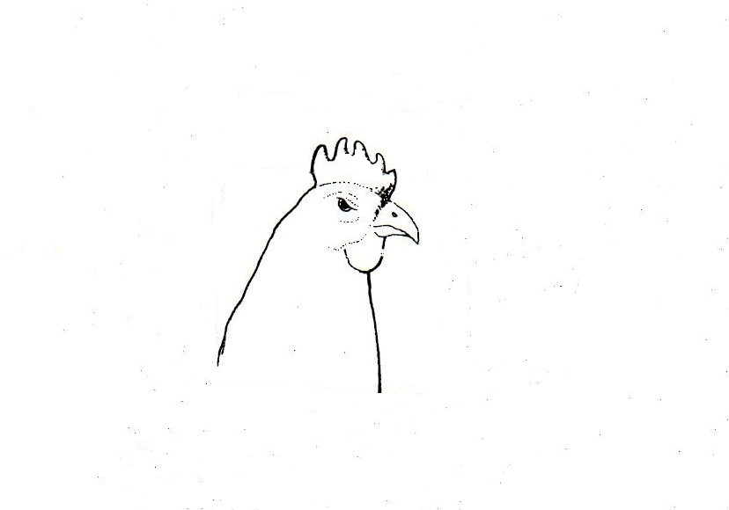

i) Draw a line in the diagram indicating the correct position of debeaking the birds. (1 mk)

ii) Give the reasons for debeaking birds. (2 mks)

……………………………………………………………………………………………………....

………………………………………………………………………………………………………

20. Below are illustrations of animal hooves and an activity being done?

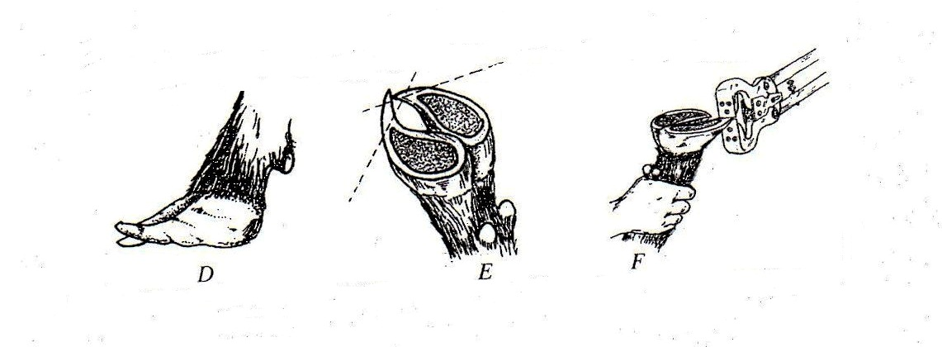

a) What activity is going on in the diagram F? ( ½ mk)

………………………………………………………………………………………………………

b) Which of the above hooves is likely to predispose foot rot infections? ( ½ mk)

………………………………………………………………………………………………………

c) Other than protecting animals from foot rot, give two other reasons for carrying out the above
activity. (2 mks)

………………………………………………………………………………………………………

………………………………………………………………………………………………………

21. The following is an illustration of a handsaw. Study it carefully and answer the questions
that follow.

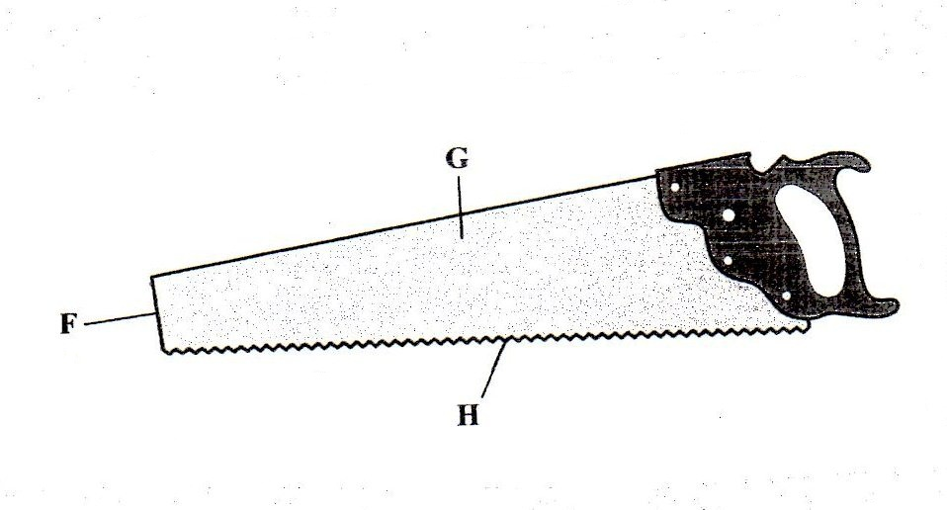

a) Name the parts labelled.
F - (1 mk)

………………………………………………………………………………………………………
G - (1 mk)

……………………………………………………………………………………………………..

b) Explain three maintenance practices that should be carried out on the part labelled H. (3 mks)

………………………………………………………………………………………………………

………………………………………………………………………………………………………

………………………………………………………………………………………………………

22. The illustrations below represent the different stages of development of a three host tick.
Study it carefully and then answer the questions that follow.

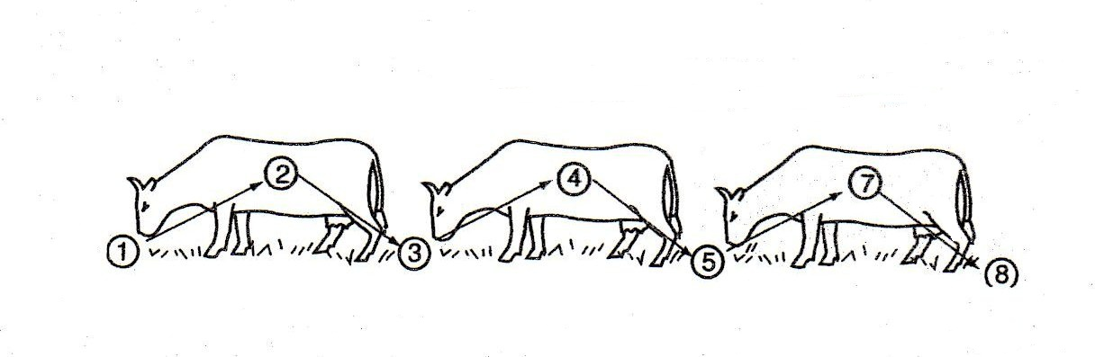

a) Briefly explain what is happening in the following stages. (2 mks)
1 –
………………………………………………………………………………………………………
4 –
………………………………………………………………………………………………………
5 –
………………………………………………………………………………………………………
7 –
………………………………………………………………………………………………………

b) Why could it be difficult to control the above tick using acaricides? (1 mk)

………………………………………………………………………………………………………

c) Name the most common sites the tick can be found on the body of an animal. (2 mks)

………………………………………………………………………………………………………

………………………………………………………………………………………………………

SECTION C

23. (a) Describe the control measures of cannibalism in layers. (10 mks)
(b) State five maintenance practices of a mould board plough. (5 mks)
(c) State the advantages of a four stroke engine. (5 mks)

24. (a) Describe six effects of parasite on livestock (6 mks)
(b) Explain five reasons for maintaining farm tools and equipment (5 mks)
(c) Discuss the management of layers in a deep litter system (9 mks)

25. (a) Explain the practices observed in clean milk production (8 mks)
(b) Explain the importance of fences in a farm (12 mks)

………………………………………………………………………………………………………

………………………………………………………………………………………………………

………………………………………………………………………………………………………

………………………………………………………………………………………………………

………………………………………………………………………………………………………

………………………………………………………………………………………………………

………………………………………………………………………………………………………

………………………………………………………………………………………………………

………………………………………………………………………………………………………

………………………………………………………………………………………………………

………………………………………………………………………………………………………

………………………………………………………………………………………………………

………………………………………………………………………………………………………

………………………………………………………………………………………………………

………………………………………………………………………………………………………

………………………………………………………………………………………………………

………………………………………………………………………………………………………

………………………………………………………………………………………………………

………………………………………………………………………………………………………

………………………………………………………………………………………………………

………………………………………………………………………………………………………

………………………………………………………………………………………………………

………………………………………………………………………………………………………

………………………………………………………………………………………………………

………………………………………………………………………………………………………

………………………………………………………………………………………………………

………………………………………………………………………………………………………

………………………………………………………………………………………………………

………………………………………………………………………………………………………

………………………………………………………………………………………………………

………………………………………………………………………………………………………

………………………………………………………………………………………………………

………………………………………………………………………………………………………

………………………………………………………………………………………………………

………………………………………………………………………………………………………

………………………………………………………………………………………………………

………………………………………………………………………………………………………

………………………………………………………………………………………………………

………………………………………………………………………………………………………

………………………………………………………………………………………………………

………………………………………………………………………………………………………

………………………………………………………………………………………………………

………………………………………………………………………………………………………

………………………………………………………………………………………………………

………………………………………………………………………………………………………

………………………………………………………………………………………………………

………………………………………………………………………………………………………

………………………………………………………………………………………………………

………………………………………………………………………………………………………

………………………………………………………………………………………………………

………………………………………………………………………………………………………

………………………………………………………………………………………………………

………………………………………………………………………………………………………

………………………………………………………………………………………………………

………………………………………………………………………………………………………

………………………………………………………………………………………………………

………………………………………………………………………………………………………

………………………………………………………………………………………………………

………………………………………………………………………………………………………

………………………………………………………………………………………………………

………………………………………………………………………………………………………

………………………………………………………………………………………………………

………………………………………………………………………………………………………

………………………………………………………………………………………………………

………………………………………………………………………………………………………

………………………………………………………………………………………………………

………………………………………………………………………………………………………

………………………………………………………………………………………………………

………………………………………………………………………………………………………

……………………………………………………………………………………………………

………………………………………………………………………………………………………

………………………………………………………………………………………………………

………………………………………………………………………………………………………

………………………………………………………………………………………………………

………………………………………………………………………………………………………

………………………………………………………………………………………………………

………………………………………………………………………………………………………

………………………………………………………………………………………………………

………………………………………………………………………………………………………

………………………………………………………………………………………………………

………………………………………………………………………………………………………

………………………………………………………………………………………………………

………………………………………………………………………………………………………

………………………………………………………………………………………………………

………………………………………………………………………………………………………

………………………………………………………………………………………………………

………………………………………………………………………………………………………

………………………………………………………………………………………………………

………………………………………………………………………………………………………

