ASUMBI GIRLS HIGH SCHOOL
TERM 2 – DECEMBER 2021
FORM 4 – BIOLOGY PAPER 1

231/1
FORM 4 BIOLOGY
PAPER 1
DEC -2021

Time: 2 HOURS

NAME ______________________________________________________________________

CLASS ___________________ADM NO _____________SIGNATURE_________________

INSTRUCTIONS TO CANDIDATES

- Write your name, admission number and class in the spaces provided above.

- Answer all the questions in this paper.

- Answers must be written in the spaces provided.

- Additional pages must not be inserted.

- This paper consists of 9 printed pages. Candidates should check the question paper to ensure that all the pages are printed as indicated and that no questions are missing.

FOR EXAMINERS USE ONLY

Questions | Maximum Score | Candidate Score
1-30

1(a) State two external features found in class Mammalia only. (2mks)

........................................................................................................................................................................................................................................................................................................................
........................................................................................................................................................................................................................................................................................................................
(b) Name the taxonomic unit that comes immediately after Family in classification. (1mk)

........................................................................................................................................................................................................................................................................................................................

2 (a) Name the basic functional unit of the skeletal muscle. (1mk)

........................................................................................................................................................................................................................................................................................................................

(b) Distinguish between a tendon and a ligament. (1mk)

........................................................................................................................................................................................................................................................................................................................

3. (a) State two advantages of using a coverslip when preparing a specimen for observation
under the light microscope. (2mks)

........................................................................................................................................................................................................................................................................................................................
........................................................................................................................................................................................................................................................................................................................

(b) How is the low power objective lens manipulated to focus a specimen for observation
under a light miscroscope? (2mks)

........................................................................................................................................................................................................................................................................................................................
.......................................................................................................................................................................................................................................................................................................................

4. Explain the significance of the following in the feeding of a mammal
(a) Long tongue in herbivores. (1mk)
........................................................................................................................................................................................................................................................................................................................
(b) Canine in carnivores. (1mk)
........................................................................................................................................................................................................................................................................................................................
5. Name the part of maize seed that elongates to bring about hypogeal germination. (1mk)
........................................................................................................................................................................................................................................................................................................................
6. (a) State two characteristics of living organisms that are specific to plants. (2mks)
........................................................................................................................................................................................................................................................................................................................
........................................................................................................................................................................................................................................................................................................................

(b) State the name given to the study of;
- The cell (1mk)

........................................................................................................................................................................................................................................................................................................................

- Microorganisms (1mk)

........................................................................................................................................................................................................................................................................................................................

7.What is the function of the following structures in the human reproductive organs;
(a) Fallopian tubes (1mk)

........................................................................................................................................................................................................................................................................................................................
(b) Epididymis (1mk)

........................................................................................................................................................................................................................................................................................................................

(c) Scrotal sac (1mk)
........................................................................................................................................................................................................................................................................................................................
8. Under what conditions do animals use the following food for respiration;
(a) Carbohydrates (1mk)
........................................................................................................................................................................................................................................................................................................................

(b) Fats (1mk)
........................................................................................................................................................................................................................................................................................................................

(c) Tissue proteins (1mk)
........................................................................................................................................................................................................................................................................................................................
9. Distinguish between convergent and divergent evolution (1mk)

........................................................................................................................................................................................................................................................................................................................
10. Fingerlings of fish were introduced to two different ponds. Those fingerlings in pond one all
died within four days but the fingerlings in pond two survived. Suggest the likely reasons
why the fingerlings in one pond died. (3mks)

........................................................................................................................................................................................................................................................................................................................
........................................................................................................................................................................................................................................................................................................................

11. (a) State the functions of the following parts of a light microscope
- Objective lens (1mk)

........................................................................................................................................................................................................................................................................................................................

- Fine adjustment knob (1mk)

........................................................................................................................................................................................................................................................................................................................
(b) Using a microscope a student counted 66 cells across the field of view whose diameter was
6000m. Calculate the average length of cells. Show your working.

........................................................................................................................................................................................................................................................................................................................
12. Why is a change in dry mass of an organism the best indicator of growth? (2mks)

............................................................................................................................................................
............................................................................................................................................................

13. Other than the visceral organs in the body name two other parts of the body where smooth
muscles are found. (2mks)

........................................................................................................................................................................................................................................................................................................................
14. State the role of each of the following components of skin
- Melanin (1mk)

........................................................................................................................................................................................................................................................................................................................

- Sebum (1mk)

........................................................................................................................................................................................................................................................................................................................

- Adipose tissue. (1mk)

........................................................................................................................................................................................................................................................................................................................

15 How does a sunken stomata help a plant avoid excessive water during gaseous exchange?
(3mks)
........................................................................................................................................................................................................................................................................................................................
........................................................................................................................................................................................................................................................................................................................

16. Name the substances produced as a result of anaerobic respiration in
- Yeast (1mk)

........................................................................................................................................................................................................................................................................................................................

- Human muscles (1mk)

........................................................................................................................................................................................................................................................................................................................

17. Why is Lamarck’s theory of evolution not accepted by biologist today? (2mks)

........................................................................................................................................................................................................................................................................................................................

18. Give two reasons why animals have specialised organs for excretion as compared to plants. (2mks)
........................................................................................................................................................................................................................................................................................................................
........................................................................................................................................................................................................................................................................................................................

19. The diagram below illustrate a response by a certain plant
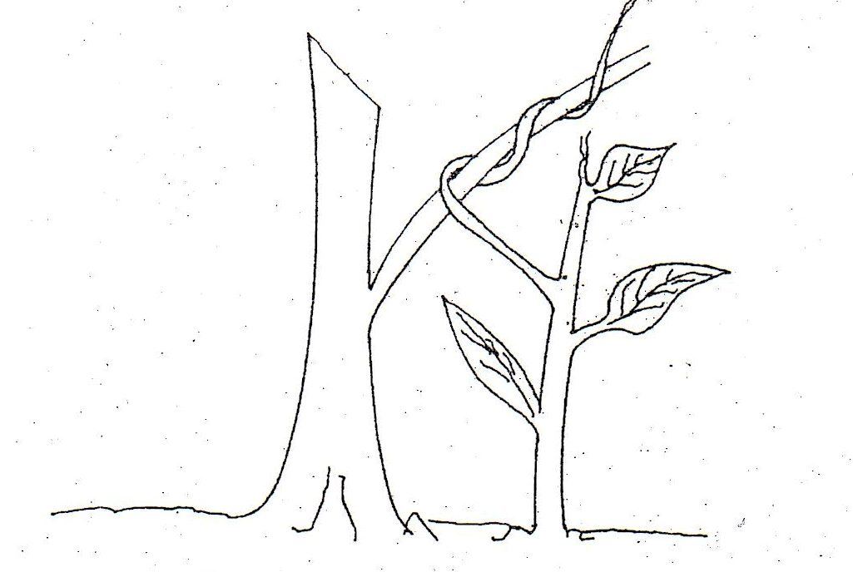
(a) Name the type of response (1mk)
........................................................................................................................................................................................................................................................................................................................

(b) Explain how the response illustrated above occurs (3mks)

........................................................................................................................................................................................................................................................................................................................
........................................................................................................................................................................................................................................................................................................................
........................................................................................................................................................................................................................................................................................................................

20. (a) What is meant by the term wilting. (1mk)
........................................................................................................................................................................................................................................................................................................................
(b) Explain how an increase in temperature affects the rate of active transport. (2mks)

........................................................................................................................................................................................................................................................................................................................ ........................................................................................................................................................................................................................................................................................................................
21. Explain four adaptive characteristics features of respiratory surfaces. (4mks)
........................................................................................................................................................................................................................................................................................................................
........................................................................................................................................................................................................................................................................................................................
........................................................................................................................................................................................................................................................................................................................ ........................................................................................................................................................................................................................................................................................................................

22. (a) State two advantages of complete metamorphosis to the life cycle of an insect. (2mks)

........................................................................................................................................................................................................................................................................................................................

(b) Distinguish between primary and secondary growth in plants (2mks)

........................................................................................................................................................................................................................................................................................................................
........................................................................................................................................................................................................................................................................................................................
23. The table below shows the level of two gases X and Y, in blood entering and leaving the
lungs during the process of gas exchange.
Gas | Level of gas in cm³ per/100cm of blood
 | Blood entering lungs | Blood leaving lungs
X | 10.6 | 19.0
Y | 58.0 | 50.0

(a) Name gases X and Y. (2mks)

X.........................................................................................................................................................Y........................................................................................................................................................
(b) How much gas X enters 100cm³ of blood, before the blood leaves the lungs. (2mks)

........................................................................................................................................................................................................................................................................................................................
............................................................................................................................................................
24. In a flower name the parts that make up;
- Gynoecium (1mk)
........................................................................................................................................................................................................................................................................................................................
- Androecium (1mk)

........................................................................................................................................................................................................................................................................................................................

25. State two sites for gaseous exchange in submerged aquatic plants. (2mks)

........................................................................................................................................................................................................................................................................................................................

26. Viability of a seed is a necessary internal condition for germination. State two factors that
may lead to low viability. (2mks)

........................................................................................................................................................................................................................................................................................................................

27. Name two disorders in human caused by chromosomal mutation. (2mks)

........................................................................................................................................................................................................................................................................................................................
28. State two characteristics that researchers select in breeding programme. (2mks)

........................................................................................................................................................................................................................................................................................................................
............................................................................................................................................................
............................................................................................................................................................
29. A man and his wife are able to roll their tongues but their children cannot. Rolling tongue
is controlled by a dominate gene. What are the genotypes of the parents. (Use letter T to
represent the gene for tongue rolling) (2mks)

........................................................................................................................................................................................................................................................................................................................
............................................................................................................................................................
30. State the economic importance of the following plants excretory products.
- Papain (1mk)

........................................................................................................................................................................................................................................................................................................................

- Colchicine (1mk)
........................................................................................................................................................................................................................................................................................................................
- Tannin (1mk)

........................................................................................................................................................................................................................................................................................................................

(b) State two advantages of homiotherms over poikilotherms. (2mks)
........................................................................................................................................................................................................................................................................................................................
........................................................................................................................................................................................................................................................................................................................
END

