ASUMBI GIRLS HIGH SCHOOL
TERM 2- DECEMBER 2021
FORM 4 - BIOLOGY PP 2

MARKING SCHEME

1
(a) C; Ammonia is very toxic and highly soluble hence requires a lot of water for dilution;
producing large amount of dilute urine; Max 2

(b) D; There is a shortage of water hence excrete little amount of using to conserve water;
2 mks

(c) A D
Short loop of Henle Long loop of Henle;
Many and large sized glomeruli Few and small sized glomeruli;
2x1= 2mks

(d) - Uses metabolic water;
- Reduced level of sweating; 2x1= 2mks

2.
- Tympanic membrane
- Receives sound waves (from the air); and vibrates;
- To transmit them to the ear ossicles/ maleus/ stripes; Rej hammer, anvil and stirrup
2x1=2mks
- Pinna
- Collects sound wave;
- Concentrates sound waves and directs it to the auditory meatus/ ear canal;
2x1=2mks

- Ear ossicles
- Amplify/transmit sound vibrations; from the tymphanic membrane to the inner ear/venestra ovalis/oval window;

(b)Two defects of mammalian eye
- Short- sightedness/myopia;
- Astigmatism;
- Long-sightedness/hypermetropia;
- Squintedness;
- Oldsight(presbyopia);
Mark the first two 2x1=2mks)

3
(a) Fish were caught, age determined; 2 years old retained; length measured and recorded. This
was done repeatedly until a large number were measured; the total length divided by number
of fish; (4mks)

(b) Lake A has hard water with more calcium than Lake D necessary for bone formation;
Fish in A grow faster and greater bone length than fish in Lake D;
Lake A has more food which fish eat than lake D;
Max – 2mks

(c) Receives light energy directly from the sun; and energy is lost from one trophic level to the
Next; 2x1= 2mks

4.
(a) To destarch /remove starch from the leaf; Acc plant (1mk)

(b) Carbon (IV) oxide; Acc Co₂ Rej if (iv) in small letter (1mk)

(c) (i) (Test for) starch; Rej Iodine test (1mk)

(ii) P- Retained the colour of iodine solution/Brown/yellow; (1mk)
Q Turned blue –black; (1mk)

(iii) P- Did not photosynthesis/No starch was formed because sodium hydroxide pellets
absorbed Carbon (IV) oxide; (1mk)

Q- Photosynthesis /starch was formed because Carbon (IV) oxide was in the flask; (1mk)

(d) Control (experiment); (1mk)

5.
(a) Sickle cell anemia; (1mk)

(b) Advantage – individuals having this trait hardly/rarely suffer from malaria;
Disadvantage - Suffocation due to insufficient supply of oxygen during strenuous
activity;
2x1= 2mks

(c) Parental phenotypes sickle cell trait

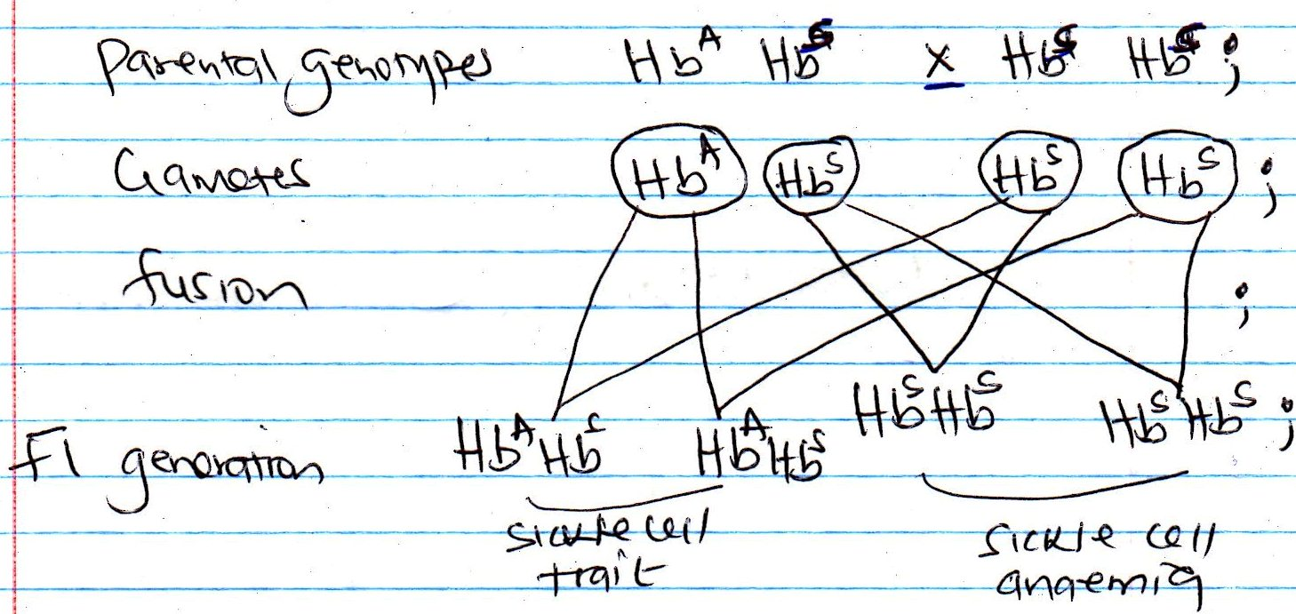
;

6. 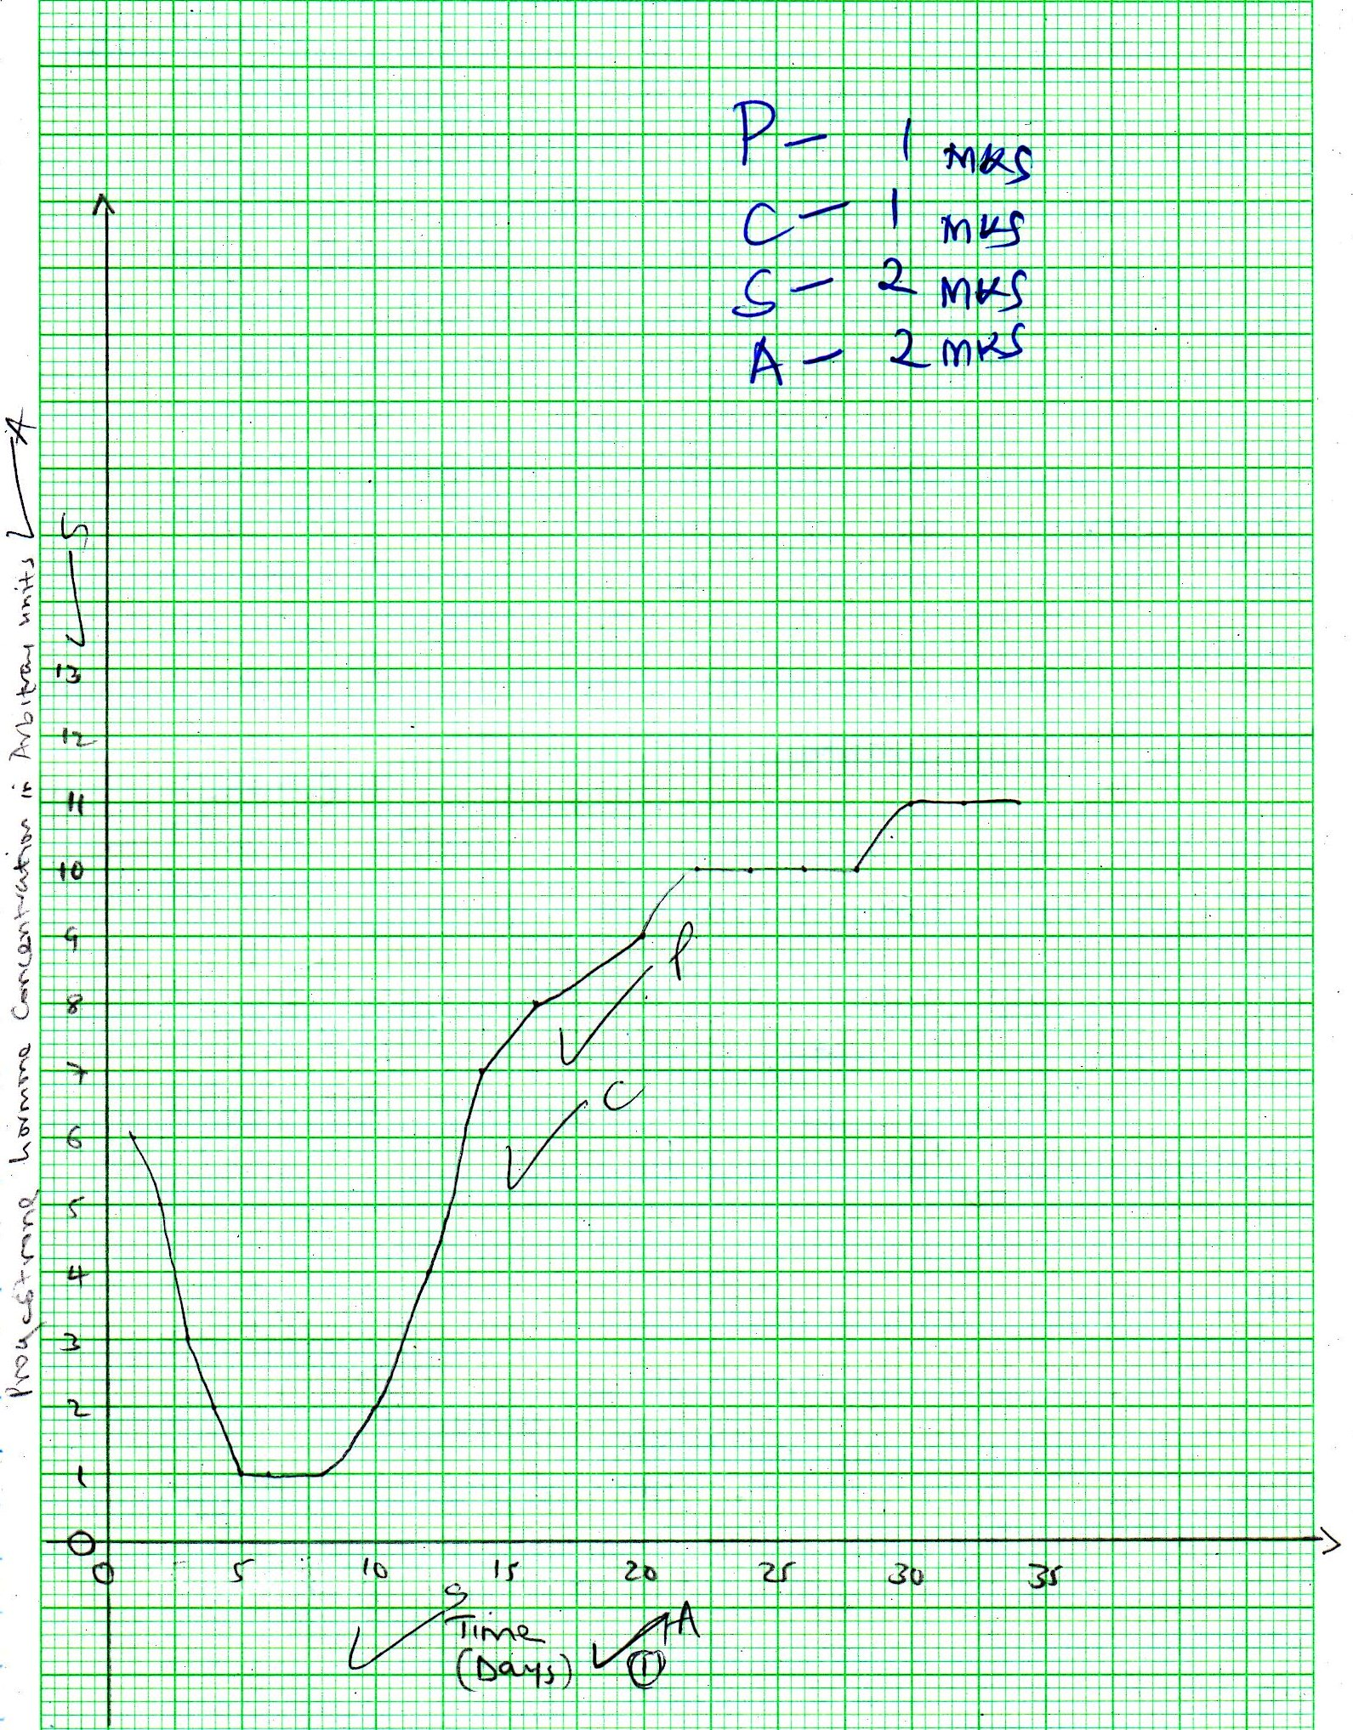

- Day 1 - day 5
Level of progesterone was going down; causing the shedding of the endometrium; (2mks)

- Day 14 – day 28
Level of progesterone increasing rapidly; this occur after menstruation to cause healing of the cells of the uterus; (2mks)

- Day 28 – day 35
Level of progesterone increases further; this is because implantation has taken place and progesterone is required to maintain pregnancy; (2mks)

(c) Production of progesterone after 28th day increases due to release of egg and formation of
Corpus luteum; in preparation for conception; and also to maintain pregnancy; (3mks)

(d) Ovulation; (1mk)

(e) Oestrogen and luteinizing hormone
Oestrogen; – to stimulate repair and healing of the endometrium/wall of the uterus stimulates the anterior lobe of pituitary gland to produce the luteinizing hormone; (2 mks)

Luteinising hormone;- stimulates ovulation; (2 mks)

Q7.
- Water exists as a thin film in the soil between soil particles;
- The concentration of cell sap of root hair cells is greater than that of the surrounding solution in the soil;
- Thus drawing water molecules across the (cell wall and) membrane into the root hair cells; by osmosis;
- Water drawn into the root hair cells dilutes the cell sap/making it less concentrated than that in the adjacent cortex cells of the root;
- (Due to the osmotic gradient)water moves from the root hair cell into the cortex cell; Then from cell to cell (by osmosis);
- Across the endodermis by active transport; into the xylem vessels; (of the root)
- Then conducts the water up the xylem (vessels) of the stem;
- Into the xylem of the leaves;
- Water is pushed rises up by root pressure;
- (in the xylem vessels) water rises by capillarity; cohesive; and adhesive forces;
- Water moves as a continuous /an interrupted water column in the xylem (vessels) up the tree to the leaves;
- As water vaporizes from the spongy mesophyll cells, their cell sap becomes more concentrated than adjacent cells;
- This increases the osmotic pressure of the spongy mesophyll cells;
- As a result water flows into the cell from other surrounding cells, which in turn takes in water from xylem vessels within the leaf veins;
- This creates a pull/ sunction force/ transpiration pull;
- That pulls a stream of water from xylem vessels in the stem and roots;
- The transpiration pull maintains continuous column of water from the roots;
Total points 23 Max 20

8. Carbohydrates digestion in human being

(a) In the mouth; food is chewed; to increase surface area of enzyme activity;
(Saliva contains) salivary amylase ptyalin; saliva (mixes with food and) provides an alkaline medium; for amylase/ptyalin (enzyme);
Salivary amylase acts on starch and converts it to maltose;
In the duodenum; food is mixed with bile; and pancreatic juice;
Bile provides alkaline medium; for activity of duodenal enzymes; ACC. correct example of enzyme.
ACC .Sodium hydrogen carbonate for bile Rej Sodium bicarbonate
And neutralizes acidic chime /food from stomach;
(Pancreatic juice contains) pancreatic amylase; which converts starch to maltose; Acc Amylose for starch
In the ileum; epithelial cells in the ileum secretes succus eutericus/intestinal juices; which contains invertase/sucrase; which acts on sucrose and converts it to fructose and glucose;
Lactase; which acts on lactose and converts it to glucose and galactose; Maltase; which acts on maltose and converts it to glucose;
Total 23 Max 12 mks

(b) –Energy from the sun is trapped by chlorophyll in green plants; which occupy the 1st trophic
Level producers; and used during photosynthesis; food /carbohydrates are made; Energy in
form of food goes to the herbivores /primary consumers which feed on green plants; which
occupy the 2nd trophic level; in the herbivore/primary consumers food/carbohydrate is
digested; absorbed and assimilated; when carnivores/ secondary consumers; feed on
herbivores energy floes to them / to the 3rd trophic level;
Tertiary consumers feed on carnivores; etc. plants, herbivores, carnivores die;
material/energy flows to the decomposers;
Total 14 max 8

