ASUMBI GIRLS HIGH SCHOOL
TERM 2 – DECEMBER 2021
FORM 4-BIOLOGY PAPER 3

Name: …………………………………………………………… Index no ……..…...................................

Class: ……………………………………………………....…. Candidate’s sign ……………………....

Date: ……………………………………………………………

231/3
BIOLOGY
PAPER 3

TIME: 1 ¾ HOURS

Kenya Certificate of Secondary Education (K.C.S.E.)
FORM FOUR

Biology
Practical

INSTRUCTIONS TO CANDIDATES:
- Write your name and admission number in the spaces provided.
- Sign and write date of examination in the spaces provided above
- Answer all the questions in section A and B
- You are required to spend the first 15 minutes of the 1 ¾ hours allowed for this paper reading the whole paper carefully.

For Examiner’s Use Only:

QUESTIONS | MAXIMUM SCORE | CANDIDATE’S SCORE
1 | 10
2 | 16
3 | 14
TOTAL | 40

1. (a) Place 2ml of bicarbonate indicator in a clean test tube. Add dilute hydrochloric acid drop by
drop and shake after each drop till there is a permanent color change.
- State the resulting color 1mk
…………………………………………………………………………………………………………………
…………………………………………………………………………………………………………………
…………………………………………………………………………………………………………………
- To the mixture obtained above, now add sodium hydroxide solution dropwise until there is a permanent color change. Record your observations 1mk
…………………………………………………………………………………………………………………
…………………………………………………………………………………………………………………
- From your observations in a) i) and a) ii) above, what is the nature of the bicarbonate indicator 1mk
…………………………………………………………………………………………………………………
…………………………………………………………………………………………………………………
(b) Place 10ml of a fresh bicarbonate indicator in boiling tube. Using a drinking straw, bubble air through the bicarbonate indicator until there is color change
- Record your observation 1mk
…………………………………………………………………………………………………………………
…………………………………………………………………………………………………………………
- What does the color obtained in b) i) above suggest about the nature of the gas breathed out 1mk
……………………………………………………………………………………………………………………………………………………………………………………………………………………………………
c) Rinse the measuring cylinder and use it to place 2ml of lime water solution in a clean test tube. Rinse the drinking straw in (b) above and use it to bubble air through lime water solution
- Record your observation 1mk
……………………………………………………………………………………………………………………………………………………………………………………………………………………………………
- Suggest the identity of the gas that give rise to the observations above 1mk
…………………………………………………………………………………………………………………
…………………………………………………………………………………………………………………
(d) (i) Name the physiological process in cells that leads to formation of gas named in (c)( ii)
above 1mk
…………………………………………………………………………………………………………………
…………………………………………………………………………………………………………………
(ii) Write down a word equation for the process named in (d) (i) above 1mk
…………………………………………………………………………………………………………………
…………………………………………………………………………………………………………………
(iii) What is the importance of the identified process in cells of living organisms 1mk
…………………………………………………………………………………………………………………………………………………………………………………………………………………………………….
2. Below are photographs of two seedlings labeled K and L. Examine them.
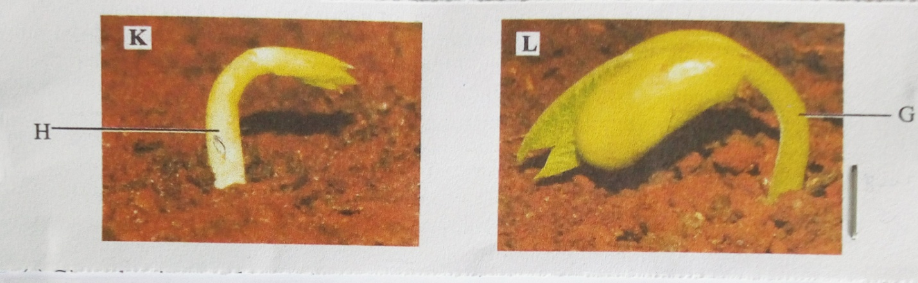
- Given that the two plants belongs to the same class, name the class and give a reason based on the observable features in any of the two seedlings or both. 2mks
Class
…………………………………………………………………………………………………………………
Reason(s)
……………………………………………………………………………………………………………………………………………………………………………………………………………………………………
…………………………………………………………………………………………………………………
- i) State giving a reason, the type of germination that occurs in each of the two seedlings 4mks
K
…………………………………………………………………………………………………………………
……………………………………………………………………………………………………………………………………………………………………………………………………………………………………
L
………………………………………………………………………………………………………………………………………………………………………………………………………………………………………………………………………………………………………………………………………………………
ii) Explain how the two types of germination you have stated in (b) (i) above occur 2mks
K
……………………………………………………………………………………………………………………………………………………………………………………………………………………………………
L
……………………………………………………………………………………………………………………………………………………………………………………………………………………………………
- Name the parts labelled H and G on the seedling 2mks
H
…………………………………………………………………………………………………………………
G
…………………………………………………………………………………………………………………
- As germination progresses, both seedlings straightens. Explain how this occurs. 4mks
……………………………………………………………………………………………………………………………………………………………………………………………………………………………………………………………………………………………………………………………………………………………………………………………………………………………………………………………………………………………………………………………………………………………………………………………
- Name the type(s) of root system that will develop in the two seedlings 1mk
…………………………………………………………………………………………………………………
- State another observation that will be made as seedling L straightens 1mk
………………………………………………………………………………………………………………….
3. The photographs below are specimens from the same animal of two different bones each shown in two views. Examine them.
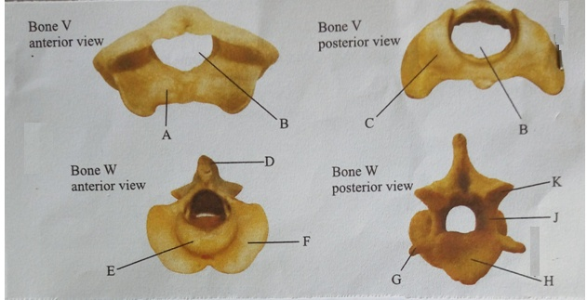
- Identify the two specimens 2mks
Specimen V……………………………………………………………………………………….
Specimen W………………………………………………………………………………………
- Give four observable differences between bones V and W 4mks
Bone V | Bone W
- Name the structure that articulates with part labeled A 1mk
…………………………………………………………………………………………………………………..
- State two roles of opening labeled B 2mks
………………………………………………………………………………………………………………………………………………………………………………………………………………………………………………………………………………………………………………………………………………………
- Name the part labelled E and state its role 2mks
Name
………………………………………………………………………………………………………………….
Role
………………………………………………………………………………………………………………………………………………………………………………………………………............................................
- Which of the labelled part(s) are used for articulation with adjacent vertebra 1mk
………………………………………………………………………………………………………………….
- State a common role of the parts labelled H and J 1mk
……………………………………………………………………………………………………………………………………………………………………………………………………………………………………..
- Which of the labeled part(s) is(are) used for muscle attachment 1mk
…………………………………………………………………………………………………………………..
…………………………………………………………………………………………………………………

