PAPER 2
CHEMISTRY

Form 4

Paper 2

MARKING SCHEME

MARKING SCHEME

- Noble gases
- K and W
- Q, it has lowest nuclear charge hence electrons in the energy level are least pulled towards the nucleus
- Q₃M₂ or Mg₃N₂

- Used for making sufuria /cooking pan
Property – good conductor of heat
- Used for making overhead cables
Property – not easily corroded / good conductor of electricity (penalize electrical cables)

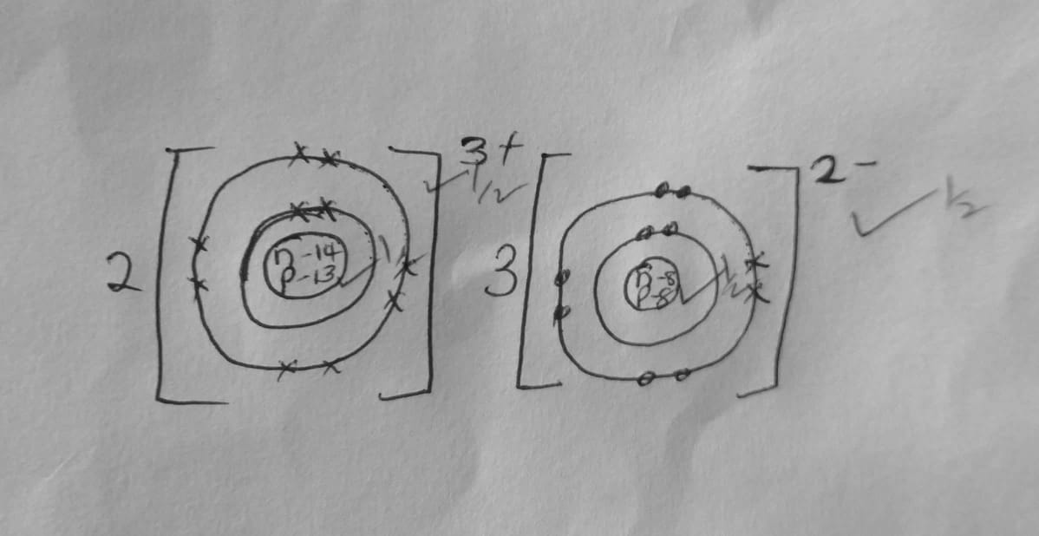

- It has molecular structure with weak van der waals forces of attraction between the molecules which require little energy to break.

- Butanoic acid
- 2,5 _ dibromo -4-methylpent-1,3-diene
- Enthyl propanoate

- P-soapy detergent
Q – soaplesss detergent
- Q – does not form scum with hard water or it lathers easily
- It is biodegradable
- It is non-biodegradable hence pollutes the environment

- Ethene
- Ethanol and concentrated sulphuric (VI) acid

- Top pan balance
- Electronic balance
- Beam balance

    - Due to incomplete combustion, it produces white hot carbon particles that emittes a lot of light
    - It produces soot that makes apparatus dirty
    - It does not produce much heat

- Nitrogen and oxygen
- It can be separated by physical means
Components of air are not chemically combined
- Pass air through lime water (Ca(OH)2) the lime water forms white precipitate indicating presence of carbon(IV)oxide

- Frasch process
- A – hot compressed air
C – super heated water
- It has low boiling point
It is insoluble in water

- Sulphur (IV)oxide
- Catalytic chamber
- Concentrated sulphuric (VI)acid
- Water

- H₂S₂O_{7(l)} + H₂O_{(l)} H₂SO_{4(l)}
- To remove impurities which may poison the catalyst

- Manufacture of fertilizer
- Manufacture of detergent
- Manufacture of dyes and paints
- Used in lead acid accumulators
(any one correct)

- Zinc blende (penalize zinc sulphide )
- ZnO
- Reduction using carbon or carbon (II) oxide
- It is converted to zinc sulphate and electrolyzed

{b}
- Sulphur {IV} oxides/SO₂
- Carbon {IV} oxide /CO₂
{c}
- Sulphur {IV} oxide leads to formation of acid rain
- Carbon oxide causes global warming
{d}
- Zinc is used to galvanise iron to prevent it form rusting
- To make brass an alloy of copper and zinc {any one correct}

- {a}
- Electrolysis is the chemical decomposition of an electrolyte using electrical energy
{b}
- Complete the circuit by making contact between the two solutions
- Maintains balance of charges in electrolytes by providing ions to replace those that are used up or those that are formed
{c} {i} M – it has the most negative $E^{θ}$ value
{ii} M and N
{iii} E$φ$ =E$φ$ R-h-s
+0.52 – [-2.69]
=+3.21v
{ii} Q = 1 t
=0.25 x 130x60
=1950C

{iii} 1950C deposits 0.9g
84g
84x1950
0.9
=182,000C
1 F 96,500C
182,000C

182000x1
96500
1.88 =2F
Charges is 2+

- [a]
- Add magnesium oxide to HNO₃/HCL/H₂SO₄ till in excess

- -Filter to obtain the filtrate
- -Add Na2CO3[any soluble carbonate] solution
- -Filter to obtain insoluble magnesium carbonate
- -Rinse and dry between filter papers

{b}
{i} NaHSO₄ /KHSO₄
{ii} Solid A – NaNO₂/Sodium nitrate
Gas B – O₂/oxygen
{iii} Mixed with helium is used by mountain climbers and deep sea divers
- Air enriched with oxygen is used in hospitals by patients with breathing difficulties

{c}
- Availability
- Cost of fuel
- Heating value

{any two correct}

