NAME…………………………………..……………….. DATE………………………………………

ADM NO. …. ……….……….…………………...…..… SIGNATURE ……………………..………

CLASS………………………………………………….

312/1
GEOGRAPHY
PAPER 1
TIME: 2 ¾ HRS

ASUMBI GIRLS HIGH SCHOOL
TERM 2– DECEMBER 2021
FORM 4 – GEOGRAPHY PAPER 1

INSTRUCTIONS TO CANDIDATES
- Write your name and Admission number in the spaces provided above.
- This paper has TWO sections: A and B.
- Answer ALL the questions in section A. In section B answer QUESTION 6 and any other TWO
- ALL answers MUST be written in the Answer Booklet provided.
- Do not remove any pages from this booklet.
- This paper consists of 4 printed pages. Candidates should check to ensure that all pages are printed as indicated and no questions are missing

FOR OFFICIAL USE ONLY
SECTION A | 6 | 7 | 8 | 9 | 10 | TOTAL

SECTION A (25 MARKS)
Answer all the questions in this section.
- a) What is the relationship between Geography and medicine. (2 marks)
b) State three characteristics of Planet earth. (3 marks)

- (a) What are harmattan winds. (2marks)
(b) The diagram below shows a type of wind

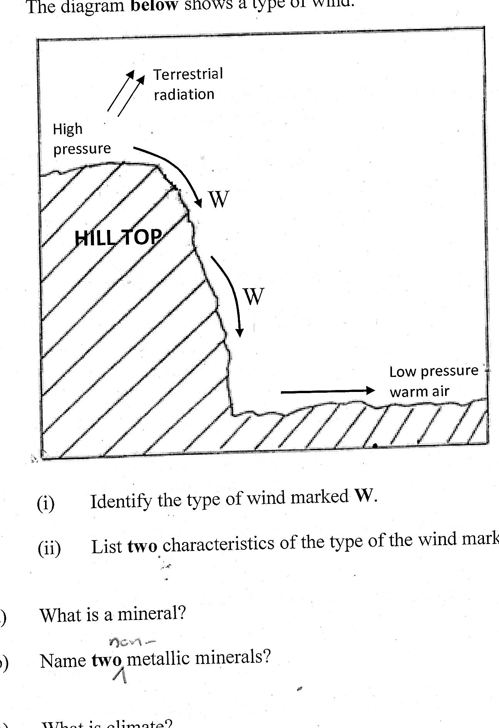

- Identify the type of wind marked W (1 mark)
- List two characteristics of the type of wind marked W (2 marks)

- (a) What are limbs in a fold? (2 marks)
(b) List three theories put forward by scientists on the formation of Fold Mountains. (3 marks)

- (a) Distinguish between a seismic focus and epicenter. (2marks)
(b) Identify three major earthquake belts of the world. (3marks)

- (a) Name two warm ocean currents in Africa. (2marks)
(b) State three factors that influence ocean water temperature. (3marks)

SECTION B (75 MARKS)
Answer question 6 and any other two questions from this section
- a) (i) Give the map tittle (2mark)
(ii) Give the longitudinal extent of the area covered by the map (2 marks)
b) (i) Give the index to adjoining sheet to the North west of the area covered by the map (1mark)
(ii) Convert the scale of the map to statement scale. (2 marks)
(iii) Calculate the area covered by western province. Give your answer in square km (2 marks)

c) (i) Using a vertical scale of 1cm rep 20m draw a cross section from grid reference 260940 to 320940. (3marks)
On it mark and label the following (4marks)
- kadimu Bay
- Road C501/2
- Main Tracks
- thicket
(ii) Calculate the vertical exaggeration (2 marks)
d) (i) Citing evidence, identify three the social activities carried out in the area covered by the map. (3marks)
(ii) Describe the relief of the area covered by the map. (4marks)

- a. (i) Name three forces responsible for the shape of the earth (3 marks)
(ii) Give four proofs that the earth is spherical in shape (4 marks)

b. (i) What is international dateline (2 marks)
(ii) What is the longitude whose local time is 5:00 p.m. when the local time at Longitude 0° is 8:00p.m? (2 marks)

c. Use the diagram below to answer the questions that follow.
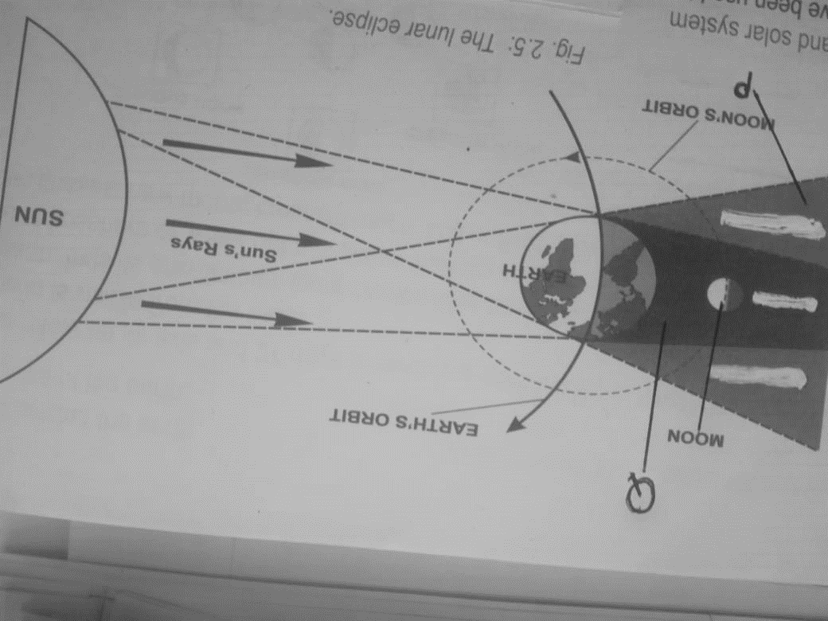
i) What type of eclipse is represented by the diagram how does it occur? (3 mark)
ii) Name the features marked P and Q (2 marks)
d. The diagram below represents the structure of the earth. Use it to answer the questions that follow.
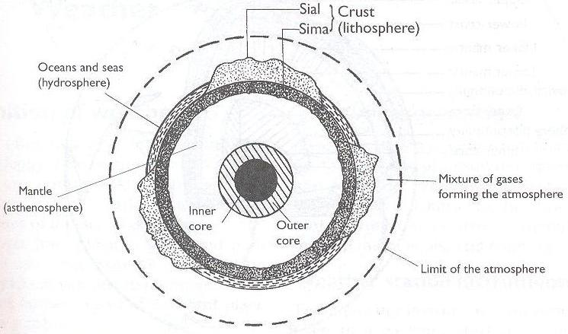
A
C
B
(i) Name the parts marked A, B and C. (3 marks)
(ii) Give four characteristics of the layer marked B (4 marks)
(ii) Name any two constituents of the atmosphere. (2 marks)

- a. (i) What is a climax vegetation? (2 mark)
(ii) State four characteristics of the mediterenean type of vegetation (4 marks)
b. Explain three factors which influence the distribution of vegetation in Kenya (6 marks)
c. Give Reasons why Tundra region has scanty vegetation. (3 marks)
(c) Write the names of the grasslands found in the following areas (3 marks)
(i) East Africa
(ii) Canada
(iii) Argentina
(d) You are required to carry out a field study of the vegetation within the local environment:
(i) Apart from identifying the different types of plants, state three other activities you will carry out during the field study. (3 marks)
(ii) Give three reasons why it would be necessary to sample out part of the area covered by the vegetation for the study (2 marks)
(iii) List three methods they may have used to collect data (2marks)
9. (a) Distinguish between river regime and river discharge. (2 marks)
(b) (i) State three factors influencing river transport. (3 marks)
(ii) Explain three ways through which a river transports its load. (6 marks)
(c) With the aid of a well labelled diagram, describe how a river braid is formed. (6 marks)
(d) Students of Buruburu Girls High School carried out a field study on river rejuvenation on River Athi.
(i) State three causes of river rejuvenation they found out. (3 marks) (ii) Name any three types of meanders they are likely to have identified. (3 marks)
(iii) Identify two problems they may have encountered during the field study. (2 marks)
10. (a) (i) What is soil? (2 marks)
(ii) Identify two components of soils. (2 marks)
(iii) Differentiate between soil structure and soil texture. (2 marks)
(iv) Name two types of soil according to soil texture. (2 marks)
(b) Explain how the following factors influence the formation of soil.
(i) Climate (2 marks)
(ii) Topography (2 marks)
(c) The diagram below shows a soil catena.
HILL TOP |  |  | VALLEY BOTTOM
W | X | Y | Z
(i) Name the type of soils found in position W and Z. (2 marks)
(ii) State two characteristics of soils found in section marked W and Z. (4 marks)
(d) Explain two causes of chemical soil degeneration. (4 marks)
(e) State three measures of conserving soils. (3 marks)

