ASUMBI GIRLS HIGH SCHOOL
TERM 2– DECEMBER 2021
FORM 4 – MATHEMATICS PAPER 2

MARKING SCHEME
 | WORKING | MARKS | COMMENTS
1 | No. Log  1.000------ 0.03506--- 28.5 ------- + 90.35 118.87------ 4.917×10⁰ 4.917 0.0000 2.5448 1.4552 2.0751÷3 0.6917 | M1  M1  M1  A1 | For + and –  For +  For ÷
2. | $\frac{3}{2+√2}$ + $\frac{4-√2}{2-√2}$  = $\frac{3(2-\sqrt{2)}+(4-√2)(2+√2)}{(2+√2)(2-√2)}$  = $\frac{\begin{aligned}6 \\ 3\sqrt{2}+8+4\sqrt{2}-2\sqrt{2}-2\end{aligned}}{4-2}$  =$\frac{12-√2}{2}$ | M1  M1  A1
3 | (p-3q)⁵ = p⁵+5p⁴(-3q)-10p³(-3q)²+10p²(-3q)³  = p5 +-15p⁴q +90p³q² -270p²q³  - Coefficient =-15  - 4th term =-270p²q³
4 | b=$\sqrt{k}-ac$  $b^{2}$=$k-c$  c=$\frac{k-b^{2}}{a}$  c=$\frac{1^{2}-2^{2}}{4}$ = -$\frac{3}{4}$ | M1  A1
5 | $$\left({\begin{matrix}3x & x-6\end{matrix} \atop \begin{matrix}-6 & 2x-2\end{matrix}}\right)$$  D = 3x$\left(2x-2\right)$ -6$\left(x-6\right)$=0  =6$x^{2}$-6x-6x+6=0  =6$x^{2}$-12x+6=0  =6$x^{2}$-6x-6x+6 =0  6x$\left(x-1\right)$- 6$\left(x-1\right)$=0  $\left(x-1\right)$(6x-6)=0  X=1 | M1  M1  A1  3
6 | Error = $\frac{\frac{max-min}{2}}{actual}$× 100  = $\frac{½(2041.2-1573.2)}{40×45}$ × 100  = 13$\%$ | M1M1  A1  3
8 | Log₂8(2+3x) = log₂4(2x+6)  16 +24x = 8x + 24  16x = 8  X= ½ | M1  M1  A1  3
9 | 5.2(RT) = 3.2x4.7  RT = $\frac{3.2 x 4.7}{5.2}$  = 2.59  RS = 5.2 + 2.89  = 8.09
 | 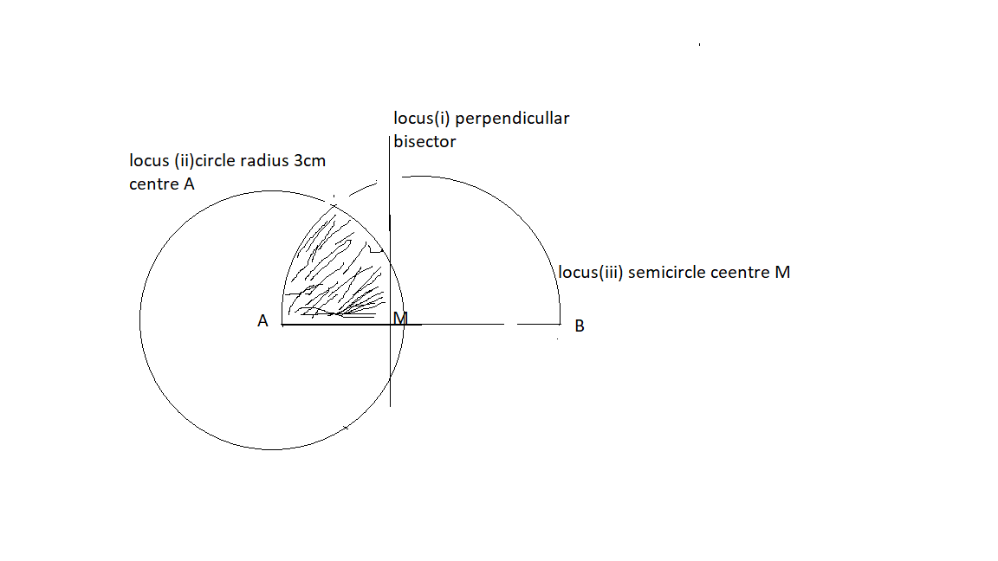 | B1  B1  B1  B1 | For perpendicular bisector  Circle centre A  Semicircle  Shaded region
11 | 3X² + 3Y² – 18X + 12Y – 9 =0  X² + Y² -6X +4Y =0  X² - 6X + 9 + Y² +4Y + 4 = 3+ 9+4  (X - 3)² + (Y + 2)² = 16  Centre (3,-2)  Radius = 4 | B1  B1  B1  3 | For factorized  For centre  For radius
12 | 147 $≫$ 105$\%$  Cp = $\frac{100}{105}$ x 147 = sh 140  Let the ratio b 1$⋮$ n  = $\frac{100x1+150n}{1+n}$ 140  100 +105n = 140 + 140n  10n = 40  n =4  ratio $1⋮4$ | M1  M1  B1  3
13 | Total tax= 3038+1162= 4200  Tax calc  $\frac{8400}{20}$ x2 = 840  $\frac{9600}{20}$ x3 = 1440  $\frac{x}{20}$ x 4 = 1920  total = 4200  x= $\frac{1920x20}{4}$ = 9600  Income = (18000+9600) x $\frac{100}{115}$  = sh 24000 | M1  M1  M1  A1  4
14 | x (x+3) -12=0  x² + 3x-12 = 0  x2+ 4x-x -12 =0  x(x+4)-1(x+4)=0  (x-1)(x+4)= 0  X=1 x=-4 | M1  M1  A1  3 | For determinant equated to 0  Factors
15 | .$\frac{240}{sin45}=\frac{b}{\begin{aligned}sin105 \\ \end{aligned}}$  b = $\frac{240}{sin45}$ x sin105  327.8461 | B1  M1  A1  3
16 | 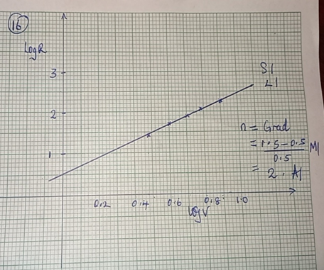
 | SECTION II
17 | X -2 -1.5 -1 0 1 2 3 4 5  y -23 -8.625 1 9 7 1 -3 1 19  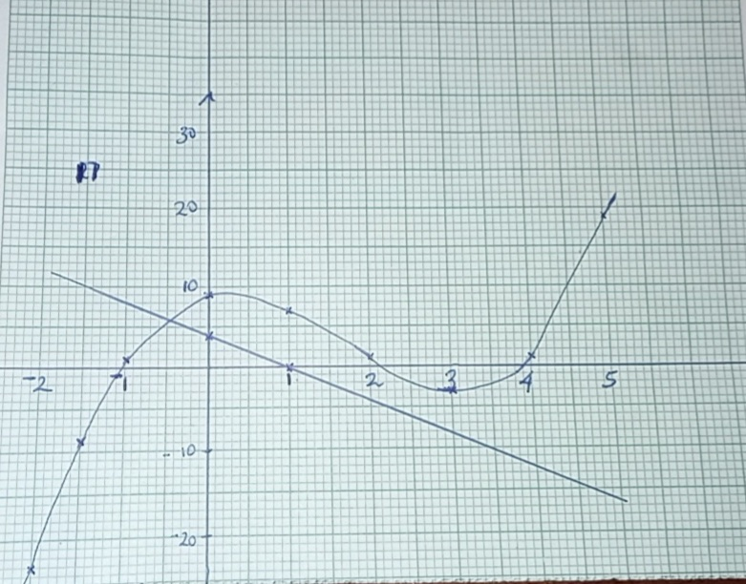
18 i  Ii  iii | Y = nX + $\frac{m}{X}$  Y = nX + $\frac{m}{X}$  135 = 2n + $\frac{m}{2}$  140 = 3n + $\frac{m}{3}$  4m + n = 270  9m + n = 420  5m = 150  M = 30  n = 270-120 =150  y= 30x + $\frac{150}{x}$  y = 30x10 + $\frac{150}{10}$  = 315  30x + $\frac{150}{x}$ = 180  30 x² +150 =180x  30 x² – 180x +150 = 0  (x-5)(x-1)= 0  X=5 or x=1 | M1  M1  A1  B1  B1  M1  A1  M1  M1  A1  10 | For both equations  Elimination of one unknown
19a  b ( i)  ii  iii | a a+3d a+ 12d  a+ 2d + a+ 10d =30  2a + 12a =30  $\frac{a+3d}{a}$ = $\frac{a+12d}{a+3d}$  (a+3d )² = a² + 12ad  9d² -6ad + 9d² = a² +12ad  9d² – 6ad =0  9d²- 90d(15-6d) = 0  9d² -90d +36d² = 0  45 d² + 90d = 0  9d (5d - 10)= 0  d = 0 or d= 2  a = 15-6d  = 15-12  = 3  r = $\frac{a+ 3d}{a}$ = $\frac{3+6}{3}$  = 3  S₁₀ = 3(3¹⁰ -1) / 2 = 888572 | B1  M1  M1  M1  A1  A1  M1  A1  M1A1  10
20a  b | Dist AB = $\frac{α}{360 }$ x 2$π$ R Cos$θ$  3000 = $\frac{α}{360 }$ x 2$π$ R Cos$30$  Α = 31.15⁰  60α cos $θ$ = 5x600  α = 50/cos60  = 100⁰  K = 100 – 45  = 55⁰  Long diff = 45⁰ + 55⁰ =90⁰  Time diff = 100 x4 / 60  = 6hrs 40mins  Time at Q = 10.45am + 6hrs 40 mins  17 25 HRS  Time when the plane reached 17 25hrs + 5 hrs  22 25 HRS | M1  A1
21 i  ii  iii  iv | P(wakes up early) = p(BE’ or B’ E’)  = $\frac{2}{3 }$ x $\frac{2}{5}$ + $\frac{1}{3 }$ x $\frac{6}{7}$  = $\frac{11}{14}$  P(wakes up early but late for class)= P(BEC’ or B’ EC’)  = $\frac{2}{3 }$ x $\frac{2}{5}$ x $\frac{5 }{7}$ + $\frac{1}{3 }$ x $\frac{1}{7}$ x $\frac{5}{7}$  = $\frac{26}{147}$  P(bed late but early for class)= P(B’EC or B’ E’C)  = $\frac{1}{3 }$ x $\frac{1}{7}$ x $\frac{2 }{7}$ + $\frac{1}{3 }$ x $\frac{6}{7}$ x $\frac{1}{4}$  = 25/294  P(late) = P(BEC ‘or B E’C’ or B’EC’ or B’E’C’)  = $\frac{2}{3 }$ x $\frac{3}{5}$ x $\frac{5 }{7}$ + $\frac{1}{3 }$ x $\frac{1}{7}$ x $\frac{5}{7}$ + $\frac{2}{3 }$ x $\frac{2}{5}$ x $\frac{3 }{4}$ + $\frac{1}{3 }$ x $\frac{6}{7}$ x $\frac{3}{4}$  =$\frac{1289}{1470}$ | M1  A1  M1  A1  M1  A1  M1  A1  10
22 | - 1 k 3 = 5  0 1 1 1  3 + k = 5  K = 2  1 2  - 1  - a b 1 -2 = 2 -3  c d 3 3 4 -1  a + 3b = 2  -2a + 3b = -3  3a = 5 a = 5/3  3b = 2 – 5/3  3b = 1/3 b= 1/9  c + 3d = 4  -2c + 3d = -1  3c = 5 c = 5/3  d = (4 – 5/3)/ 3 d= 7/9  5/3 1/9  5/3 7/9  - 2 1 3 0 3  0 2 1 3 -2  7 3 3 = 15  2 6 -2 -6  (15,-6) | M1  A1  B1  M1  M1  M1  A1  M1  A1  B1
23 | - 52x + 32y ≥ 500  13x + 8y ≥ 125………………………………………1  200x + 300y ≥ 3500  2x + 3y ≥ 35…………………………………………..2  x + y ≤ 15 ………………………………………………3  x ≥ 0 , y ≥ 0
24 | a. $\int_{2}^{3}{(t2 – 2t + 4) dt}$  [t³/3 – t² + 4t] ³  ²  (27/3 – 9+12) – (8/3 -4 +8)  12 – 4 - 8/3  8 – 8/3  (24-8)/3  16/3 or 5 1/3  b. t² – 4t + 4 = 0  t = 4 ± √(16-4(4)  2  4 ± 0 = 2  2  c.  a = dv/dt  = 2t – t (at t = 2)  a= 2(2) – 2  a= 2 m/s² | M 1  M1  M1  A1  M1  M1 A1  M1  M1  A1

