**ASUMBI GIRLS HIGH SCHOOL**

**TERM 2 – DECEMBER 2021**

**FORM 4 – PHYSICS PAPER 3**

**MARKING SCHEME**

1. iii)

|  |  |  |  |  |  |  |
| --- | --- | --- | --- | --- | --- | --- |
| Length from A to B(cm) | 80 | 76 | 72 | 68 | 64 | 60  2.5 |
| Time for 10 oscillations(s) | 10 | 11 | 12 | 13 | 14 | 15  √1 |
| Periodic timeT(s) | 1.0 | 1.1 | 1.2 | 1.3 | 1.4 | 1.5  √1 |
| T2(s2) | 1.00 | 1.21 | 1.44 | 1.69 | 1.96 | 2.25  2.5 |
| 2 | 1500 | 1380 | 1300 | 1080 | 1040 | 960 |
|  | 750 | 690 | 650 | 540 | 520 | 480  √1 |
| cos | 0.2588 | 0.3883 | 0.4226 | 0.5878 | 0.6157 | 0.6691  √1 |

f)√1√1√1

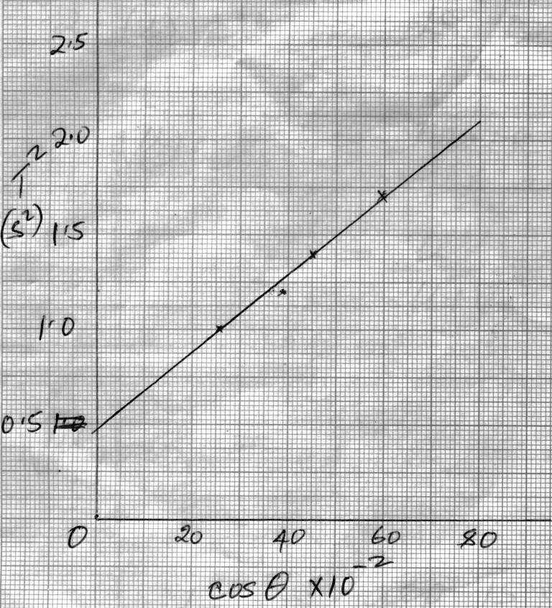

g)Slope, 

20 x10-2, 0.375 , 75 x 10-2, 2.0 1

 1 = 2.951

h) 

**√1**√**1** = 5.353 √**1**

1. **PART A**

a) (viii)

|  |  |  |  |  |
| --- | --- | --- | --- | --- |
| Angle i0 | 10 | 20 | 30 | 40 |
| Distance x (cm) | 5.2 | 4.5 | 3.9 | 3.4 |



(ix) b = 6.2 cm

(x) Ax = 4.25 cm

(xi) Refractive index = 6.2 = 1.45 ± 0.05

4.25

Q2.a) iii) **PART I**

**Table III**

|  |  |  |  |  |  |  |
| --- | --- | --- | --- | --- | --- | --- |
| **L(cm)** | 100 | 80 | 60 | 40 | 20 | 0 |
| **V(volts)** | 0.5 – 0.7  0.08 – 0.12 | 0.6 – 1.0  0.13 – 0.17 | 0.7 – 1.1  0.18 –1 0.22 | 0.8 – 1.2  0.33 – 0.37 | 0.9 – 1.3  0.68 – 0.72 | 1.1 – 1.5  1.23 – 1.27 |
| **I (A)** | 0.12 – 0.16  0.04 – 0.08 | 0.14 – 0.18  0.06 – 0.10 | 0.15 – 0.19  0.08 – 0.12 | 0.16 – 0.20  0.12 – 0.16 | 0.17 – 0.21  0.14 – 0.18 | 0.18 – 0.22  0.16 – 0.20 |

Try both tables and use the one that gives advantage to the candidate . For each correct value / entry give ½ for a maximum of 5 for both v and I

**Total (5mrks)**

iv)

Axes :- should be well labeled with correct units 1

Scale :- Simple and uniform1

Plotting : correct should be smooth and passing through at least 3 correctly plotted points within 1 small square1

***N/B curve should be continuous***

**Total (5mrks)**

1. For drawing a tangent at I = 0.15A 1

Slope = V

I

= 0.85 - 0.65 ½ correct intervals from tangent

0.175 – 0.13

= 4.4444 V/A

Or 4.4444 1 For correct evaluation to 2 d.p rounded or truncating

½ For units

***N/B if curve is wrong***

***i.e Co, this part is awarded zero.***

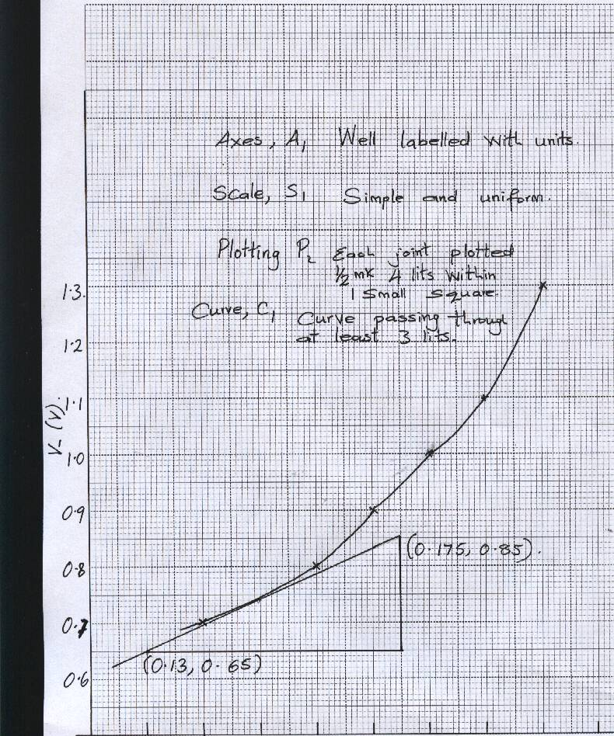

0.12 0.13 0.14 0.15 0.16 0.17 0.18 0.19 0.20 0.21

I (A)

1. x = 1.5 – 2.0 cm 1 to 1 d.p