Name………………………………………………… Index No. …………………….

School ………………………………………………...

511/1
MUSIC
PRACTICAL PERFORMANCE
Paper 1
15 MINUTES PER CANDIDATE

BUTULA SUB-COUNTY JOINT EVALUATION 2021
Kenya Certificate of Secondary Education (K.C.S.E)

511/1
MUSIC
PRACTICAL PERFORMANCE
Paper 1
30 MINUTES PER CANDIDATE

INSTRUCTIONS TO CANDIDATES.
- This paper consists of four pages, the cover, sight singing and assessment sheet for the Examiner.
- The candidate shall only need page 2 for sight singing.

For Examiner’s Use only
QUESTION | MAXIMUM MARK | SCORE
1. WESTERN SET PIECE | 15
2. AFRICAN PIECE (own choice) | 15
3. TECHNICAL EXERCISES | 10
4. SIGHT SINGING | 10
 | 50
Candidates should check the question paper to ensure that all pages are printed as indicated
and no questions are missing

PRACTICAL PERFORMANCE
SCORE SHEET
CANDIDATE’S NAME …………………………………………………………………………….
INDEX NUMBER …………………………………………………………………………………..
SCHOOL …………………………………………………………………………………………….
DATE ………………………………………………………………………………………………..
 |  | MARKS | SCORE
1. | WESTERN PIECE  Accuracy of Notes  Dictions | 2  2
 | Dynamics | 3
 | Phrasing and breathing | 3
 | Musicianship | 5
 | TOTAL | 15
2. | AFRICAN PIECE
 | Suitability | 2
 | Co-ordination | 2
 | Style/variation/Transition | 3
 | Involvement | 3
 | Tone/pace (speed) | 5
 | TOTAL
3. | TECHNICAL EXERCISES
 | Test 1 | 2
 | Test 2 | 2
 | Test 3 | 2
 | Test 4 | 2
 | Test 5 | 2
 | TOTAL | 10
4. | SIGHT WORK
 | Accuracy of Notes | 5
 | Flow of Notes | 5
 | TOTAL | 10
 | GRAND TOTAL | 50
FINAL MARK……………………………………………………………………………………………..
SIGHT SINGING PIECES: VOICE AND RECORDER

Study the following and sing / play or Recorder any of them at sight as directed by the examiner. (10mks each)
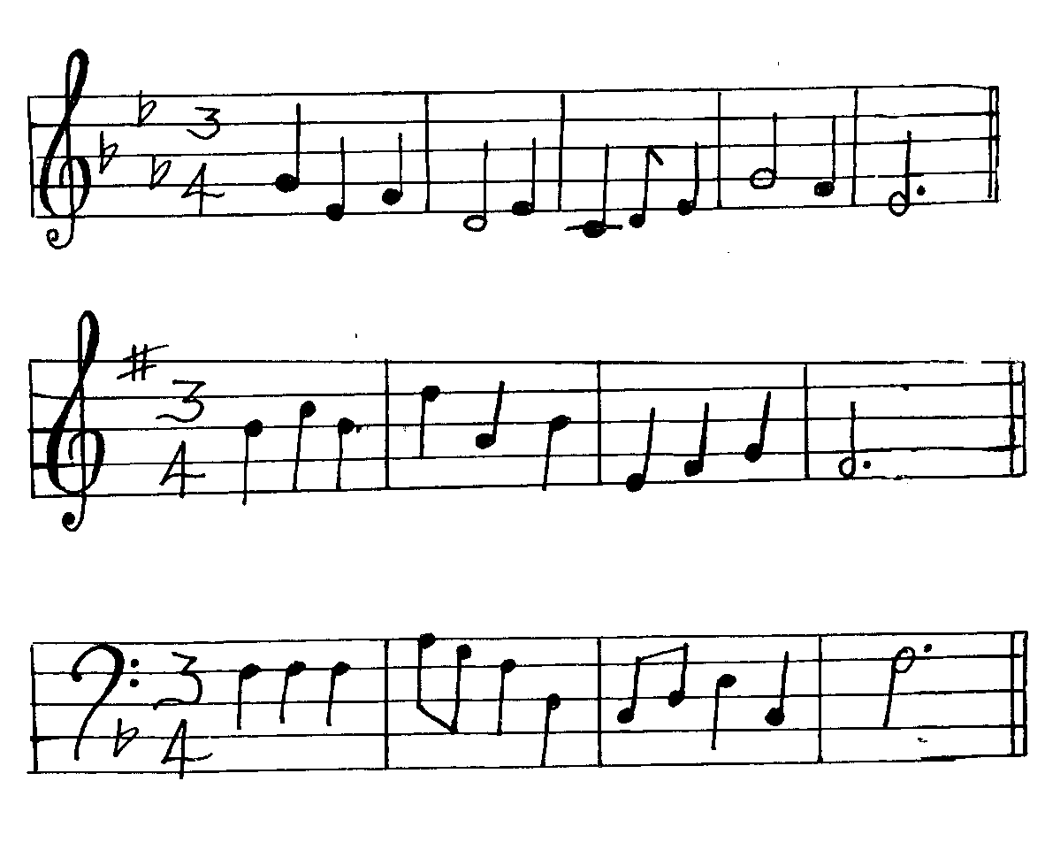
.
1.

2.

3.

END

