NAME:………………………………………………………… INDEX NO. ………..……………
SCHOOL………………………………………….………………………………………………… CANDIDATE’S SIGN……………………………….
DATE…………………………

233/1
CHEMISTRY
PAPER I
TIME 2HRS
BUTULA SUB-COUNTY JOINT EVALUATION EXAM - 2021.
Kenya Certificate of Secondary Education (K.C.S.E)
MARKING SCHEME
FORM 4 JOINT EXAMS
DECEMBER 2021

231/1
CHEMISTRY
PAPER I
TIME 2 HRS

INSTRUCTIONS TO CANDIDATES.
- Write your name and Index number in the spaces provided.
- Answer all the questions in the spaces provided below each question.
- All working MUST be clearly shown where necessary.
- Sign and write the date of examination in the spaces provided above.
- Electronic calculators may be used.
For Examiner’s use only.
Question | Maximum score | Candidates’ Score
1 – 28 | 80
TOTAL

- a) (a) Give two reasons why glass apparatus are used for heating in the laboratory. (2 marks)
Have high m.p and b.p
Are good conductors of heat
b) The diagram below shows a laboratory apparatus.
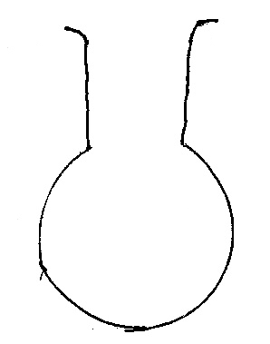

- Name the apparatus (1 mark)
Round-bottomed flask√ 1½

- (a) State Graham’s law of gaseous diffusion (1 mark)

The rate of diffusion of a gas is inversely proportional to the square root of its density under the same conditions of temperature and pressure.

(b) 60 cm³ of ozone (O₃) diffused through a semi permeable membrane in 80 seconds. Calculate the time taken for 90 cm³ of nitrogen (IV) oxide (NO₂) to diffuse under the same conditions. (O=16, N=14). (3mks)
60cm3 of ozone takes 80seconds
90cm3 of ozone takes 120seconds
NO2 =56 O3 = 48

TNO2 = √RMM. NO2
TO3 √RMM. O3

TNO2 = 120√56
√48 = 129.6 seconds

- The grid below is part of the periodic table. Study it and answer the questions that follow. The letters are not actual symbols of elements.

A |  |  | D | E |  |  | H | I
B | C |  | M |  | F | G |  | J

- What is the name given to the chemical family of element C? (1 mark)
Alkaline earth metals
b) Compare the ionization energies of B and M. Explain. (2 marks)
M has higher ionization energy than B
M has smaller atomic radius with a stronger nuclear force of attraction thus more energy is required to remove an electron in its outermost energy level.
- Describe how a sample of Lead (II) chloride can be prepared using the following reagents dilute nitric (V) acid; dilute hydrochloric acid and lead carbonate (3mks)

React excess lead carbonate with dilute nitric (v) acid√ ½ . Filter √½ to obtain lead nitrate as filtrate ; react the filtrate with dilute hydrochloric acid ; a precipitate of lead (ii) chloride is formed ; wash the residue of pbCl₂ and dry between filter papers.

- a) Distinguish between nuclear fission and nuclear fusion. (1 mark)

Nuclear fission is the splitting process a heavy nuclide undergoes when bombarded by a fast-moving neutron while nuclear fusion occurs when nuclei combine together when they are made to collide at high velocity resulting in the formation of a heavy nucleus and release of energy.
b) Calculate the values of P and Q in the following nuclear equation.
${}_{92}^{239}U$ ${}_{Q}^{p}{Th}$ +2α+2β (2 marks)
239 = p + (2*4) + 0 ½
p =239 – 8.
P = 231 ½
92 = Q + (2*2) + (2*-1) ½
92 = Q + 2
Q = 92 – 2
Q = 90 ½

- I. When aqueous solution of Iron(II)chloride and potassium thiocyanate are mixed, the equilibrium below was achieved:
Fe³⁺_{(aq)} + CNS⁻_{(aq)} Fe(CNS)²⁺_{(aq)}
(brown) (colourless) (blood red)
State and explain the effect of adding a few drops of potasium hydroxide to the equilibrium mixture. (2marks)
Equilibrium will shift to the ½ left/ backward reaction favoured // more brown will be formed OH⁻ ions precipitates Fe³⁺ ions in form of Fe(OH)₃
II. Given the reaction below
Zn_{(s)} +2HCl_{(aq)} ZnCl_{2(aq)} +H_{2(g)}
State how the following factors affect the rate of reaction giving explanation
(a) Using Zinc powder instead of granules (1mk)
Increase the rate of reaction. Because it increases the surface area of contact with hydrochloric acid.√1
(b) Heating the reactants (1mk)
Increases the rate of reaction because increase in temperature increase kinetic energy resulting in higher frequency of collision of particles.√1

- Study the flow chart below and answer the questions that follow.
Ethanol
Ethene
U
L
K

Step 1
Step 2
Polymerization

Step 3. Temp. of 150⁰C
Nickel catalyst, H₂

(a) Identify substances : K, U, L (1 mark)
K – Ethane ½
U - Polythene ½
L – Water
Any two correct answers
(b) State the conditions for the reaction in step 1 to occur. (1 mark)
Temperature – 180⁰C ½
Conc. Sulphuric vi acid ½
- The following data refer to an element X.
Isotope | P | Q | R
Mass | 54 | 56 | 57
%abundance | 6 | 92 | 2
Calculate the relative atomic mass of element X (2mks)

(54*6) + (56*92) + (57*2)
100
55.9 ½

- a) State Faraday’s law of electrolysis (1 mark)
The mass of a substance produced during electrolysis is directly proportional to the quantity of electricity passed.
b) When a current of 2.5 amperes was passed through a cell containing N²⁺ ions of a metal for 25minutes, the mass of the cathode increased by 0.36g. Determine the relative atomic mass of element N. ( 1 Faraday = 96500 coulombs) (3mks)
Q = It
Q = 2.5 x 25 x 60 = 3750C √ ½
N²⁺ - 2 faradays √ ½
1 faraday – 96500 x 2 √ ½
3750C -= 0.36g
∴96500 x 2 = 0.36 x 96500 x2
3850
= 18.528
= 18.5 √ ½

- The diagram below represents a set-up used to prepare oxygen gas.
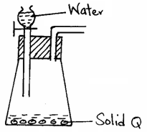

- Name substance Q. (½ mark)
Sodium Peroxide
- Complete the set-up to show how dry oxygen gas is collected. (1½ marks)
(c) Write the equation for the reaction that occurs when magnesium burns in air (1 mark)
2 Na₂O₂ + 2 H₂O 4NaOH + O₂
(aq) (l) (aq) (g)

- In an experiment to investigate the reaction between acids and metal carbonates, a student reacted zinc carbonate with dilute hydrochloric acid, and the resulting gas was bubbled in excess through lime water in a boiling tube.
(a) State and explain the observations made in the boiling tube at the end of the experiment (2 marks)
The white precipitate dissolves to form a colourless solution. 1 This is due to formation of soluble calcium hydrogen carbonate. 1

(b) Write an equation for the reaction took place at the end of the experiment. (1 mark).
CaCO₃(s) + H₂O(l) + CO₂(g) Ca(HCO₃)₂(aq) 1

- Use the thermo-chemical equations below to answer the questions that follow.

C_{(s)} + O_{2(g)} CO_{2(g) Δ}H = -406KJ mol⁻¹
H_{2(g)} + ½ O_{2(g)} H₂O_{(l)} _{Δ}H = -286KJmol⁻¹
C₃H_{8(g)} + 5O_{2(s)} 3CO_{2(g)} + 4H₂O_{(l)} _{Δ}H = -2209KJmol⁻¹
Draw an energy cycle diagram and use it to calculate the heat of formation of propane. (3 marks)
3C_{(s)} + 4 H_{2(g)} C₃H_{8(g)} ½

3O_{2(g)} 2O_{2(g)} 5O_{2(g)} ½

3CO_{2(g)} + 4H₂O_{(l)}

_{Δ}H_{f} = [3(-406) + 4(-286)] – [-2209] 1
= [-1218 – 1144] + [2209]
= -153 KJmol⁻¹ 1

- A student mixed equal volumes of Ethanol and ethanoic acid. He added a few drops of
concentrated Sulphuric (VI) acid and warmed the mixture.
(i) Name and write the formula of the main products (1 mark)
Name Ethylethanoate
Formula CH₃COOCH₂CH₃
(ii) Which homologous series does the product named in (i) above belong? (1mk)
Esters

- The apparatus below was set up to show the catalytic oxidation of ammonia. Study the diagram and answer the questions that follow
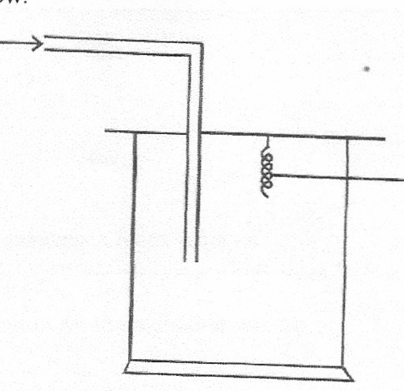
Dry NH_{3(g)}

Hot nichrome wire

(i) Write an equation for the reaction that takes place in the gas jar (1mk)
4NH_{3(g)} + 5O₂ _{(g)} 4NO_{(g)} + 6H₂O_{(g)}

(ii) What is the role of hot nichrome wire? (1mk)
Hot nichrome wire catalyses the reaction between ammonia and oxygen / oxidation of NH_{3√1.}

(iii) Write the formula of the complex ion formed when excess ammonia gas is passed
through a solution containing Zn²⁺ ions. (1mk)
²⁺
Zn (NH₃)₄ _{√1}

- a) Define the term allotrope (1mk)
Existence of an element in different forms but in the same physical state.

(b) Name two non-crystalline allotropes of sulphur (1mk)
Rhombic
Monoclinic
(c) Diamond and graphite are both allotropes of carbon. Explain why graphite is used as a lubricant whereas diamond is used as an abrassive . (1 mark)
Van der waal forces in graphite white in diamond there is strong covalent bonds

- The table below shows PH values of some solutions

Solution | A | B | C | D
PH values | 13 | 7 | 1 | 6.5
(a) What solution reacts vigorously with Magnesium metal? (1 mark)
C
(b) Industrial Hydrochloric acid (1 mark)
C
(c) Which solution forms complex ions with zinc (II) oxide? (1 mark)
C

- Draw the structural formula for each of the following compounds
(a) 4,4-dimethylpent-2-ene (1mk)

(b) Give the systematic IUPAC name of the following substances
ii) CH₃ CH Br CH Br CH₃ (1mk)
2, 3 – dibromobutane

- A hydrated salt has the following composition by mass. Iron is 20.2%, oxygen is 23.0% sulphur is 11.5%, water 45.3%. Its relative formula mass is 278. Determine the formula of the hydrated salt.
(Fe=56, S=32.0, O=16, H=1) (3mks)
Fe O S H₂O
Mass 20.2 23.0 11.5 45.3
R.A.M 56 16 32 18
Moles 0.36 1.44 0.36 2.52
Mole Ratio 1 : 4 : 1 : 7

Empirical Formula FeSO4.7H2O Molecular formula FeSO4.7H2O

- The diagram shows the apparatus used to separate different dyes in food colouring.
A
B

I Name the parts labeled A & B (1 mark)

A: Solvent front

B: Baseline
II The diagram below shows electrolysis of lead bromide
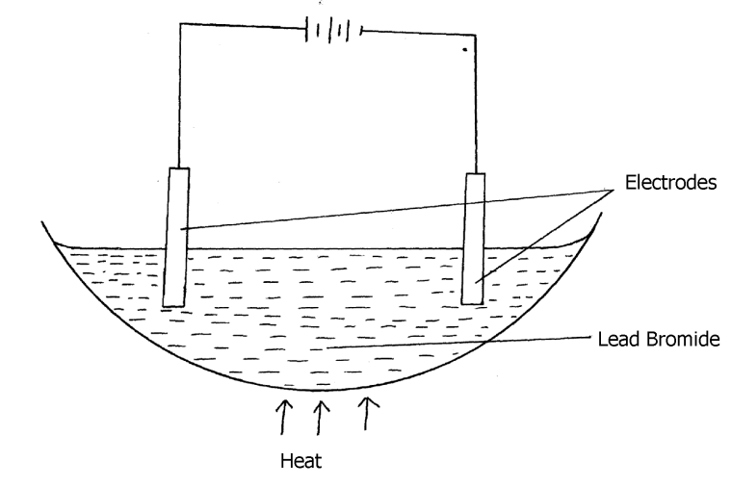
a) Label the anode and cathode (1mk)
On the diagram ( left hand electrode – Anode, right hand electrode – Cathode)

b) Write half equations to shows reactions at cathode. (1mk)
Pb²⁺_{(l)} + 2e⁻ Pb_{(s)}

- The set-up below shows the products formed when solid lead (ii) nitrate is heated.

Heat gas y

-
-
Lead II Nitrate - -
Crystals-

liquid x ice cold mixture

a) Identify:
(i)Liquid x …………………………………………………………… (½ mark)

Dinitrogen tetraoxide / N₂O₄ ½
ii) Gas y……………………………………………………………… (½ mark)
Oxygen/ O₂ ½
(iii) Write an equation for the reaction taking place in the combustion tube. (1 mark)

- Study the flow chart below and answer the questions that follow.

Iron

Heat Compound T HCl _{(aq)} Gas U +
FeCl_{2(aq)}

Sulphur

(a) Name : (i) Compound T
Iron (II) sulphide √ ½
(ii) Gas U
Hydrogen sulphide √ ½

(b) State a physical property that you could use to identify gas U. (1 mark)
Gas has a characteristic smell of rotten eggs √1

- (a) The melting point of phosphorous trichloride is -918⁰ C and that of sodium chloride is 801⁰ C. Explain the huge difference in their melting points. (2mks)
PCl₃ has simple molecular structure held by weak van der waals forces wit require less energy to break. While NaCl has strong ionic bonds with giant ionic structure that require more energy to break.

- The electronic arrangement of two stable ions Q²⁺ and P²⁻ are 2.8.8 and 2.8.8 respectively.
(a) Write the electron arrangement of neutral atoms Q and P. (1 mark)
Q – 2.8.8.2
P – 2.8.6
(b) What is the most likely structure of an oxide element P? (1 mark)
Simple molecular structure
- The structures shown below represents two cleansing agents A and B.
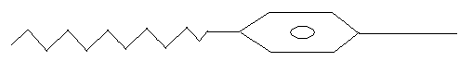
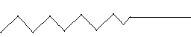
COO⁻Na⁺ SO₃⁻Na⁺
A B
(i) Identify the cleansing agents A and B (1 mark)
A – soapy detergent
B – soapless detergent
(ii) Explain how the cleaning properties of the above cleansing agents can be improved. (1 mark)
Tetraoxophosphate materials/compounds are added to the cleansing agents. The compounds prevent formation of compounds with Ca²⁺, Mg²⁺ ions hence no scum is formed.
- Sulphur burns in air to form sulpur (IV) oxide. A simple energy level energy level diagram for the reaction is given below. Study the diagram and answer the questions that follow:
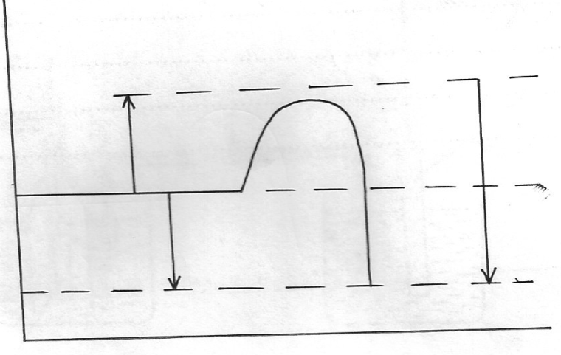
SO_{2(g)}
ΔH₂
ΔH₃
ΔH₁
S_{(g)} + O_{2(g)}
Reaction co-ordinate
Energy

Activation Enaergy

(a) On the diagram indicate the activation energy (1 mark)
(b) Write an expression for ΔH₃in terms of ΔH₁and ΔH₂ (1 mark)
ΔH₃ ₌ ΔH₁ ₋ ΔH₂
- Study the flow chart below and use it to answer the questions that follow:
Solution containing Pb²⁺
Step I
Na₂SO_{4(aq)}
Lead metal
Solid R
Step II
Few drops of NaOH_{(aq)}
Step III

White precipitate
Step IV

Colourless solution

(a) Identify the reagent used in step I. (1mk)
Dilute Nitric v acid
(b) Name solid R. (1mk)
Lead II Sulphate
(c) Explain the observation in step IV. (1mk)
Amphoteric lead hydroxide reacts with basic sodium hydroxide forming a complex ion. (tetrahydroxo lead II ions) which are colourless.
- Study the set- up below and answer questions that follows.
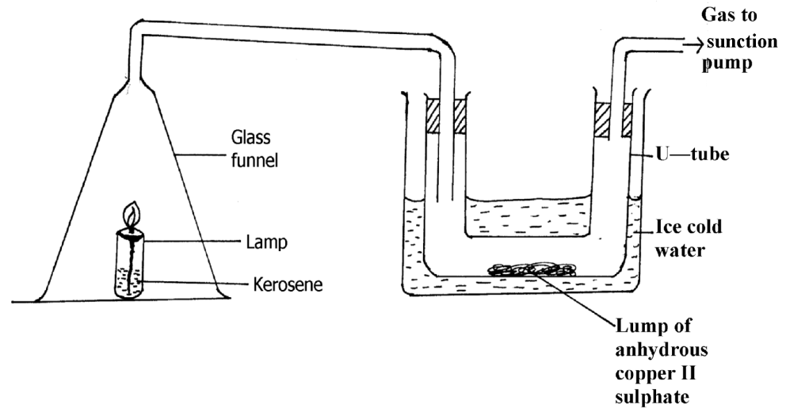
a) State and explain the observation made in the U- tube. (1½ marks)
Colour of anhydrous copper II sulphate changes from white to blue 1. The kerosene
lamp burns to produce CO₂ and H₂O water combines with anhydrous copper II sulphate (white ) to form hydrated copper (II) sulphate blue.

b) Explain what will happen to lamp when the sunction pump is turned off. (1½ marks)
The lamp goes off .This is due to accumulation of CO₂ which is denser than air.
- Using dot ( •) and crosses ( x) diagram to represent electrons in the outer most energy levels only show bonding in;
(a) Phosphine molecule.PH⁺₄.( P = 15 , H = 1) (1 mark)
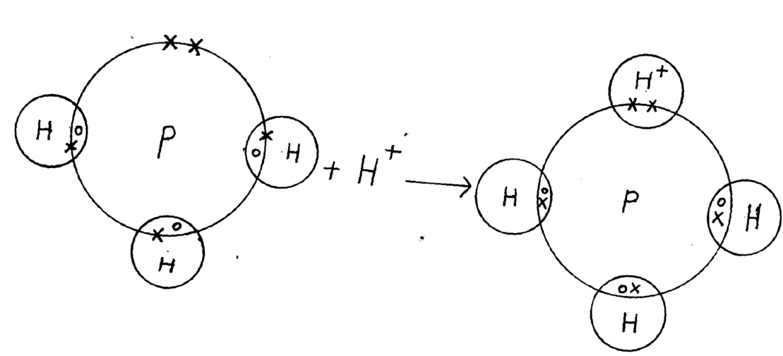
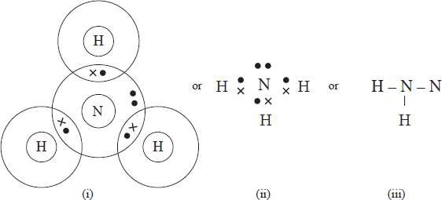
(b) Ammonia (NH₃) (1 mark)

- The set up below was used to prepare dry sample of chlorine gas.
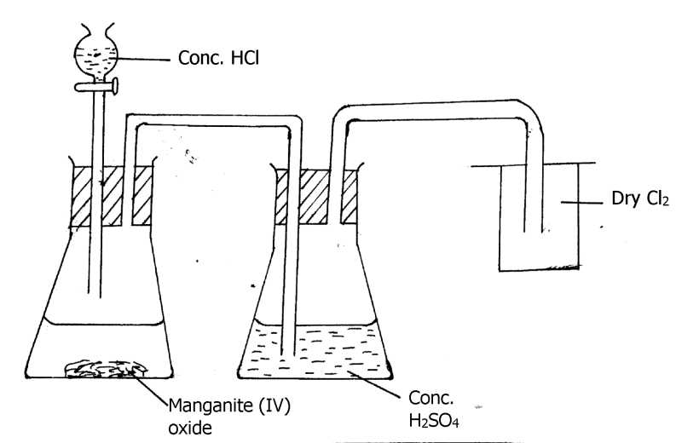
a) What is the function of manganese (IV) oxide in the preparation of chloride (1 mark)
It is an oxidizing agent.
b) Write a chemical equation for the formation of chlorine gas. (1 mark)
c) Explain the observations made when chlorine gas is bubbled through a solution of iron II sulphate. (2 marks)
The colour of iron II sulphate changes from pale green to red brown.
Chlorine gas oxidizes Iron II ions to Iron III ions

THIS IS THE LAST PRINTED PAGE.

