NAME…………………………………………….…… INDEX NO………………
SCHOOL…………………………………………SIGN…………………
DATE……………………………………………
233/2
THEORY PAPER
DECEMBER 2021
TIME: 2 HOURS

BUTULA SUB-COUNTY JOINT EVALUATION 2021
Kenya Certificate of Secondary Education

Instructions to candidates
- Write your name, index number and the name of your school in the spaces provided above.
- Sign and write the date of examination in the spaces provided above.
- Answer all questions in this question paper.
- All working MUST be clearly shown where necessary.
- KNEC mathematical tables and non-programmable silent electronic calculators may be used.
- Candidates should check to ascertain that all pages are printed as indicated and that no questions are missing.

For Examiner’s Use Only
Question | Maximum score | Candidate’s score
1 | 12
2 | 11
3 | 9
4 | 13
5 | 11
6 | 12
7 | 12
Total | 80

This paper consists of 11 printed pages. Check to ascertain no pages are missing.
- The grid below forms part of the periodic table. Study it and answer the questions that follow. The letters do not represent the actual symbols of the elements

P |  |  |  | T | V | W | Y | M
 | Q |  | S | U |  | X
 | R |  |  |  |  |  | Z

      - What is the name of the chemical family to which element P belongs? (1mk)
…………………………………………………………………………………………
      - An element N has an atomic number of 15. Write down its electronic arrangement and hence fix it in its right position on the grid above. (2mks)

Electronic arrangement ………………………………………………
      - Compare the size of the atom of R and that of its ion. Explain your answer. (2mks)
…………………………………………………………………………………………………………………………………………………………………………………………………………....................................................................................................................................................................................................................................................................................................
      - Give the formula of the compound formed between (1mk)

        - P and W …………………………………………………………………………

        - T and Y …………………………………………………………………………..

      - Compare the melting points of element Q and S. Explain. (2mks)
………………………………………………………………………………………………………………………………………………………………………………………………………………………………………………………………………………………………………
      - Give two advantages that element S has over element Q in making electric cables. (2mks)
………………………………………………………………………………………………………
………………………………………………………………………………………………………
      - Draw (a) dot (.) and cross (x) diagram to represent the bonding in compound formed
between T and Y (2mks)

- (a)An investigation was carried out using the set-up below. Study it and answer the questions that follow.
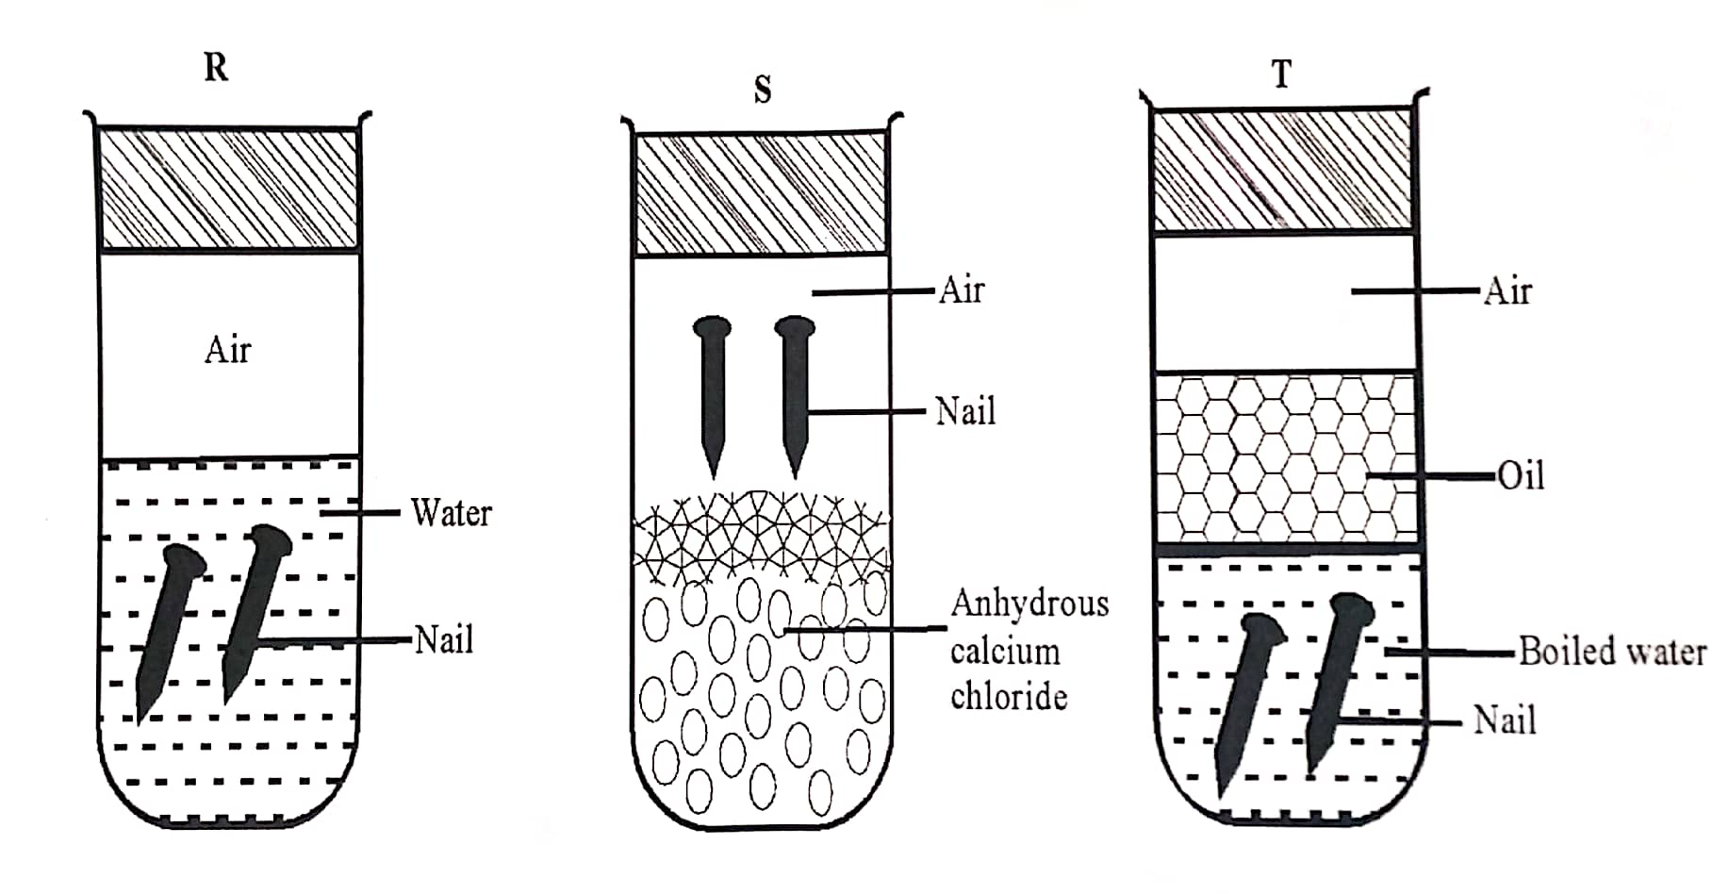
ii) State and explain what will happen in two test-tubes R and T after seven days. (2mks) ………………………………………………………………………………………………………………………………………………………………………………………………………………………………………………………………………………………………………
ii) Give one reason why some metals are electroplated. (1mk) ………………………………………………………………………………………………………………………………………………………………………………………………………………………………………………………………………………………………………

- The reduction potential of elements K, L, M, and P are as given below
IONS | REDUCTION POTENTIAL
K⁺ | -1.46v
L²⁺ | +0.49v
M²⁺ | -2.69v
N⁺ | +0.52v
P⁺ | -0.86v

- Which letter represents the, strongest reducing agent? Give a reason. (2mks)
…………………………………………………………………………………………………………………………………………………………………………………………………….
- Which two letters represent elements whose half cells would form an electrochemical cell with the largest e.m.f? (1mk)
…………………………………………………………………………………………………
- Calculate the e.m.f of the cell formed in (ii) above (2mks)

(d) During the electrolysis of a molten chloride of metal Q, a current of 0.25A was passed though the molten chloride for 2 hours and 10minutes. Given that 0.9grams of metal Q were deposited at the cathode.
- Calculate the quantity of electricity passed (1mk)

- Charge carried by the ions of metal Q given that R.A.M of metal Q is 84 (2mks)

- (a)(i) Name the allotropies of sulphur (1mk)
................................................................................................................................................................................................................................................................................................................................................................................................................................................

(ii) Sulphur is mined using the Frasch process which uses super-heated water at 170⁰c and hot compressed air.

- Explain how water at 170⁰c is obtained. (1mk) .......................................................................................................................................................................................................................................................................
- State one role of the super-heated water (1mk) ...........................................................................................................................................................................................................................................................................................................................................................................................................
- State and explain what happens when wet petals of red flowers are put in a gas jar full of sulphur (IV) oxide (2marks)
....................................................................................................................................................................................................................................................................................................................................................................................................................................................................................
............................................................................................................................................................
- Write an equation for the reaction of sulphur(IV) oxide and concentrated Nitric (V) acid (1mark)
.......................................................................................................................................................
.......................................................................................................................................................
- (i) Name the catalyst used in contact process (1mark)

................................................................................................................................................

(ii) An equilibrium exists as

2SO_{2(g)} + O_{2(g)} 2SO_{3(g)}

State and explain what happens if more oxygen is added to the system (2 marks)
............................................................................................................................................................
............................................................................................................................................................
............................................................................................................................................................
............................................................................................................................................................

- (a) A hydrocarbon contains 85% carbon. Its molecular mass is 70g.

(i) Determine its empirical and molecular formula. (C = 12, H = 1). (4mks)

- Draw two positional isomers of the hydrocarbon. (1mk)

- In an experiment an organic compound was reacted with absolute ethanol in the presence of concentrated sulphuric (VI) acid to form a compound whose formula is
CH₃ CH₂CH₂ COOCH₂ CH₃
(i) Name
I The type of reaction that took place. (1mk)

_________________________________________________________

II What is the role of concentrated sulphuric (VI) acid in the experiment?

_______________________________________________ (½mk)

- Write the structural formula and give the systematic name of the acid used in the above experiment. (2mks)

- Study the flow diagram below and answer the questions that follow.
E
B
Ethylpropanoate
C

CH₃CH₂OH

Polymer
A

CH₂CH₂
Step II

II
Reagent Q
Step V
Step III
Ni / H₂
Step I
Step IV
KMnO_{4(aq)}/H⁺
Reagent P Step III
KMnO_{4(aq)}/H⁺
^{Step IV}

- Identify the following compounds.

B ____________________________________________________ (½mk)

C ____________________________________________________ (½mk)

A ____________________________________________________ (½mk)

E ____________________________________________________ (½mk)

- Name the process in steps.

I ____________________________________________________ (½mk)

II ___________________________________________________ (½mk)

IV ___________________________________________________ (½mk)

- Reagent

P ____________________________________________________ (½mk)

Q ___________________________________________________ (½mk)

- Study the flow chart below and answer the questions that follow.
Ore N
Na OH _{(s)}
Step (i)
Step (ii)
Q
Solution x
Residue
Al₂O₃
Molten mixture
Step (iii)
Molten Aluminium
Electrolysis
(iv)

- Name one Ore of N. (1mk)
………………………………………………………………………………………………
- Explain why the ore is first dissolved in excess sodium hydroxide solution (1mk)
………………………………………………………………………………………………
………………………………………………………………………………………………
- Name the major compound present in the residue. (1mk)
………………………………………………………………………………………………
- Give the formula of the aluminum compound present in solution X (1mk)
- Explain how to obtain aluminum hydroxide from solution X (2mks)
………………………………………………………………………………………………
………………………………………………………………………………………………
- (i) Write an equation of the reaction that takes place in (e) above (1mk)
………………………………………………………………………………………………
(ii)What is the role of cryolite (Na₃ AlF₆) in the extraction of Aluminium: (1mk)
………………………………………………………………………………………………
……………………………………………………………………………………………
(iii) Explain why Na⁺ and F –ions are not discharged during electrolysis in step (iv) (1mk)
………………………………………………………………………………………………
……………………………………………………………………………………………
(iv)Aluminium is a good conductor of electricity. State two uses of aluminum based on that property. (2mks)
………………………………………………………………………………………………
………………………………………………………………………………………………
- I. State Le chateliers principle on equilibrium? (1mk) …………………………………………………………………………………………………………………………………………………………………………………………………………………………………………………………………………………………..…..
II. Bromine reacts with water in accordance with the following ionic equation.
Br_{2 (aq)} + H₂O(l) Br ⁻_{(aq)} + OBr ⁻_{(aq)} + 2H⁺_{(aq)}
Explain how addition of sodium hydroxide solution would affect the given equilibrium. (2mks)
………………………………………………………………………………………………
………………………………………………………………………………………………………………………………………………………………………………………………

b) 3g of a powdered carbonate of metal X of formula XCO₃ were mixed with 13.2cm³ of 2M hydrochloric acid. The mass of the reaction vessel and its contents was recorded at various times. From these readings, the total loss in mass of the reaction vessel and its contents was calculated and recorded as shown in the table below
Time (sec) | 30 | 60 | 90 | 120 | 150 | 180 | 210
Total loss in mass (g) | 0.08 | 0.37 | 0.90 | 1.19 | 1.28 | 1.32 | 1.32
- On the grid provided below, draw a graph of total loss in mass (y-axis) against time (3mks)

i) Calculate the rate of reaction at the 120th second. (2mks)
……………………………………………………………………………………………………....
ii) Explain why there is no change in mass between 180 and 210 seconds. (1mk)
………………………………………………………………………………………………………
iii) Write an equation for the reaction that takes place. (1mk)
iv) Calculate the relative atomic mass of X (C=12.0, O=16.0) (2mks)
………………………………………………………………………………………………………………………………………………………………………………………………………………………………………………………………………………………………………………………………………………………………………………………………………………………………
- The flow chart below shows industrial manufacture of sodium carbonate.
Study it and answer the questions that follow.
NaCl_{(aq)} Ca(OH)₂
NH_{3(g)}
D
Chamber 3
Chamber 1
Chamber 4
Chamber 2
Chamber 5
A C

Carbon (IV) oxide B Water B

Na₂CO₃
(a) Name substances A, B, C and D. (2mks)
A ………………………………………
B ………………………………………
C ……………………………………….
D ………………………………………
(b)Write equation for the reactions taking place in chamber 3. (1mk)
Chamber 3
……………………………………………………………………………………………
(c) Name the physical process in chamber 4 and 5. (2mks)
Chamber 4
………………………………………………………………………………………………
Chamber 5
………………………………………………………………………………………………
(d) Name one source of cheap carbon (IV) oxide for Solvay process. (1mk)
………………………………………………………………………………………………
(e) Briefly explain how sodium chloride required for this process is obtained from sea water. (2mks)
………………………………………………………………………………………………………
………………………………………………………………………………………………………
f) Below are allotropes of carbon.
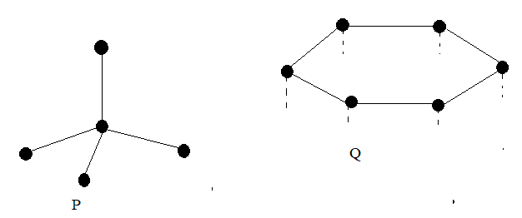
(i) Identify the allotropes
P ………………………………………………………. ½mk

Q ……………………………………………………… ½mk
(ii) Allotrope Q can be used as a lubricant. Explain. (2mks)
............................................................................................................................................................
........................................................................................................................................................................................................................................................................................................................
............................................................................................................................................................

- Give a reason why burning charcoal jiko in a poorly ventilated room is dangerous. (1mk)
............................................................................................................................................................
............................................................................................................................................................

This is the last printed page

