**NAME:…………………………………………………..INDEX NO:………………………………**

**DATE:………………………………………**

**121/1**

**MATHEMATICS**

**DECEMBER, 2021**

**PAPER 1**

**TIME: 2½ HOURS**

**BUTULA-SUB COUNTY JOINT 2021**

***Kenya Certificate of Secondary Education***

**MATHEMATICS Alt. A**

**2 ½ Hours**

**Instructions to candidates.**

1. Write your name and index number in the spaces provided above.
2. Sign and write the date of the examination in spaces provided above.
3. This paper consists of two sections: Section **I** and **II**.
4. Answer ***all*** the questions in section I and ***only five*** questions from section II.
5. Show ***all*** the steps in your calculations, giving your answer at each stage in the space provided.
6. Marks may be given for correct working even if the answer is wrong.
7. Non-programmable silent electronic calculators and **KNEC** mathematical tables may be used, except where stated otherwise.
8. ***Candidates should check the question paper to ascertain that no questions are missing.***
9. ***Candidates should answer the questions in English.***

**For examiner’s use only**

**SECTION I**

|  |  |  |  |  |  |  |  |  |  |  |  |  |  |  |  |  |
| --- | --- | --- | --- | --- | --- | --- | --- | --- | --- | --- | --- | --- | --- | --- | --- | --- |
| 1 | 2 | 3 | 4 | 5 | 6 | 7 | 8 | 9 | 10 | 11 | 12 | 13 | 14 | 15 | 16 | TOTAL |
|  |  |  |  |  |  |  |  |  |  |  |  |  |  |  |  |  |

**SECTION II**

|  |  |  |  |  |  |  |  |  |
| --- | --- | --- | --- | --- | --- | --- | --- | --- |
| 17 | 18 | 19 | 20 | 21 | 22 | 23 | 24 | TOTAL |
|  |  |  |  |  |  |  |  |  |

**GRAND**

**TOTAL**

**SECTION I (50 MARKS):**

**Answer all the questions in this section in the spaces provided.**

1. Without using a calculator evaluate.



(3 marks)

1. The distance between Jane’s home and her school is 4/5 of 8km. One day she run ¼ of the way and walked the rest of the journey. What distance did she walk? (3marks)
2. Otiende works for a coffee processing company as a sales man. He is paid on Monthly basis as per agreement below.
3. A basic pay of sh. 20,000 per Month.
4. A commission of 2% for goods sold up to a maximum of sh. 200,000.
5. A commission of 4% for goods sold over sh. 200,000 in that Month.

In a certain Month he sold goods worthy sh. 600,000. Calculate his total pay for that Month. (3marks)

1. The figure below is a triangular prism of uniform cross-section in which AF = FB =3cm, AB = 4cm and BC = 5cm. Draw a clearly labeled net of the prism. (3marks)

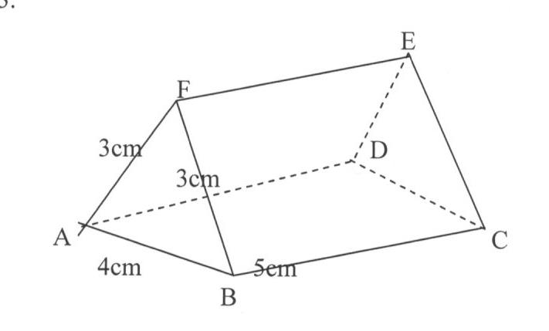

1. Solve for y in the equation. $8^{y+1}-2^{3y+1}=48$ (3marks)
2. Simplify the expression; $\frac{{12x}^{2}+ax-{6a}^{2}}{{9x}^{2}-{4a}^{2}}$ (3marks)
3. A line P whose equation is $y = 1/3x + 4$ is parallel to another line Q. Find the equation of line Q in the form $y= mx + c$ given that it passes through Point ( 3, 6) (3marks)
4. The figure below shows a triangle ABC in which AB = 6cm, BC = 11cm and angle ABC = 1000. Calculate to the decimal places the length of AC. (3marks)

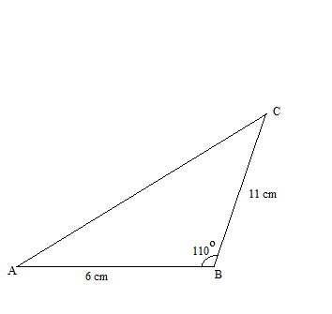

1. A football match between Bercelona FC and Liverpoo FC started at 1500hrs. It lasted for the official 90 minutes with a half time break of 15 minutes. The referee added five extra minutes for injuries and other stoppages. Find the time the match ended. (3marks)
2. Find the region defined by the following inequalities (3marks)

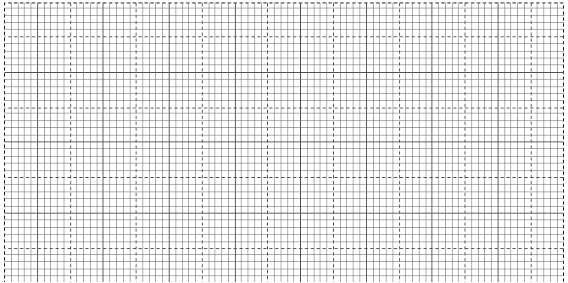  2*y* < *x* + 4; 4*y* ≥ -*x* – 4; *x* ≤ 2

1. The GCD three numbers is 6 and their LCM is 900. If two of the numbers are 36 and 60, find the least possible third number. (3 marks)
2. The mass of two similar cans is 960g and 15000g. If the total surface area of the smaller can is 144cm2, determine the surface area of the larger can. (3 marks)

1. The width of a rectangular hall of Busiada Girls Secondary School is 16m less than its length. Calculate the length of the hall if its area is 32m2. Hence calculate its perimeter. (4marks)
2. Town A is 80km due east of town B. Town C is on a bearing of 2340 form town B. If town C is 100km from town A, by scale drawing find the distance of town C from town B. (4marks)
3. a) Find the inverse of the matrix $\left(\begin{matrix}7 & 4 \\ 3 & 2\end{matrix}\right)$. (1mark)

b) Using matrix method, solve the simultaneous equations. (2 marks)

16. Use tables of square roots and reciprocals to find the value of *x*. (3marks) $x=\sqrt{\frac{1}{15.36}+\frac{3}{1.302}}$

**SECTION II (50 marks).**

**Answer *only five* questions in this section in the spaces provided.**

1. The figure below shows a frustrum. The top and bottom radii are 5cm and 10cm respectively, while the vertical height of the frustrum is 12cm.

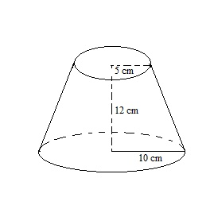

Find the:-

a) Slant height of the frustum. (3marks)

b) Curved area of the frustum. (3marks)

c) Volume of the frustum. (4marks)

1. Bumala is a market centre 600km from Kisumu town.A bus starts from Kisumu for Bumala at 7.00am at an average speed of 80 km/h. At 8.30 am a car started from Kisumu to Bumala and moved at an average speed of 120 km/hr. Calculate

i) The distance bus covered before the car started moving. (3marks)

ii) The relative speed for the two vehicles. (2marks)

iii) The time the car overtook the bus. (1 mark)

iv) Distance covered by the car before overtaking the bus. (2marks)

v) Distance from Bumala to the car at the time the car was overtaking the bus. (2marks)

1. The height of 36 students in a class was recorded to the nearest centimeter as follows:-

148 159 158 163 166 155 155 179 158

161 160 157 165 165 175 173 172 178

147 168 157 172 165 154 170 157 167

155 159 173 171 168 160 172 156 167

1. Make a frequency distribution table using a class interval of 5 and starting with the class

145 – 149. (2marks)

b) From the table above

i) Calculate the mean mark (3marks)

ii) Calculate the median (3marks)

1. Draw a frequency polygon using the table in (a) above. (2 marks)



1. Bujumba Boys Secondary School. Intends to buy a certain number of chairs For Ksh. 16,200. The supplier agreed to offer a discount of Ksh. 60 per chair which will enable the school to get 3 chairs more.

Taking *y* as the originally intended number of chairs:-

1. Write an expression in terms of *y* for

i) Original price per chair. (1mark)

ii) Price per chair after discount. (1mark)

1. Determine

i) The number of chair the school originally intended to buy. (4marks)

ii) Price per chair after discount. (2marks)

iii) The amount of money the school would have saved per chair of it got the intended number of chairs at a discount of 15%. (2marks)

1. a) Without using a protractor, construct triangle ABC such that angle ABC = 600, BC = 8cm and AC = 9cm.Measure AB. (3marks)

b) Drop a perpendicular from A to BC and measure its length. (2marks)

1. Hence calculate the area of triangle ABC. (2marks)
2. Locate a point D on BC such that the area of triangle ABC is three times that of triangle ABD. (3marks)
3. In triangle ABC, shown below, AB = a AC = b point M lies on AB such that AM: MB = 2:3 and point N lies on AC such that AN: NC = 5:1 line BN intersects line MC at X.

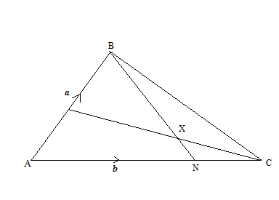

1. Express the following in terms of ***a*** and ***b***

i) **BN** (1 mark)

ii) **CM** (1 mark)

1. Given that **BX** = k**BN** and **CX** = r**CM** where k and r are scalars

i)Write two different expressions for **AX** in term of a, b, k and r (4marks)

ii) Find the values of k and r (4 marks)

1. A triangle ABC has vertices A(2,1), B(5,2) and C(0,4).

  (a)On the grid provided plot the triangle ABC. (2 marks)

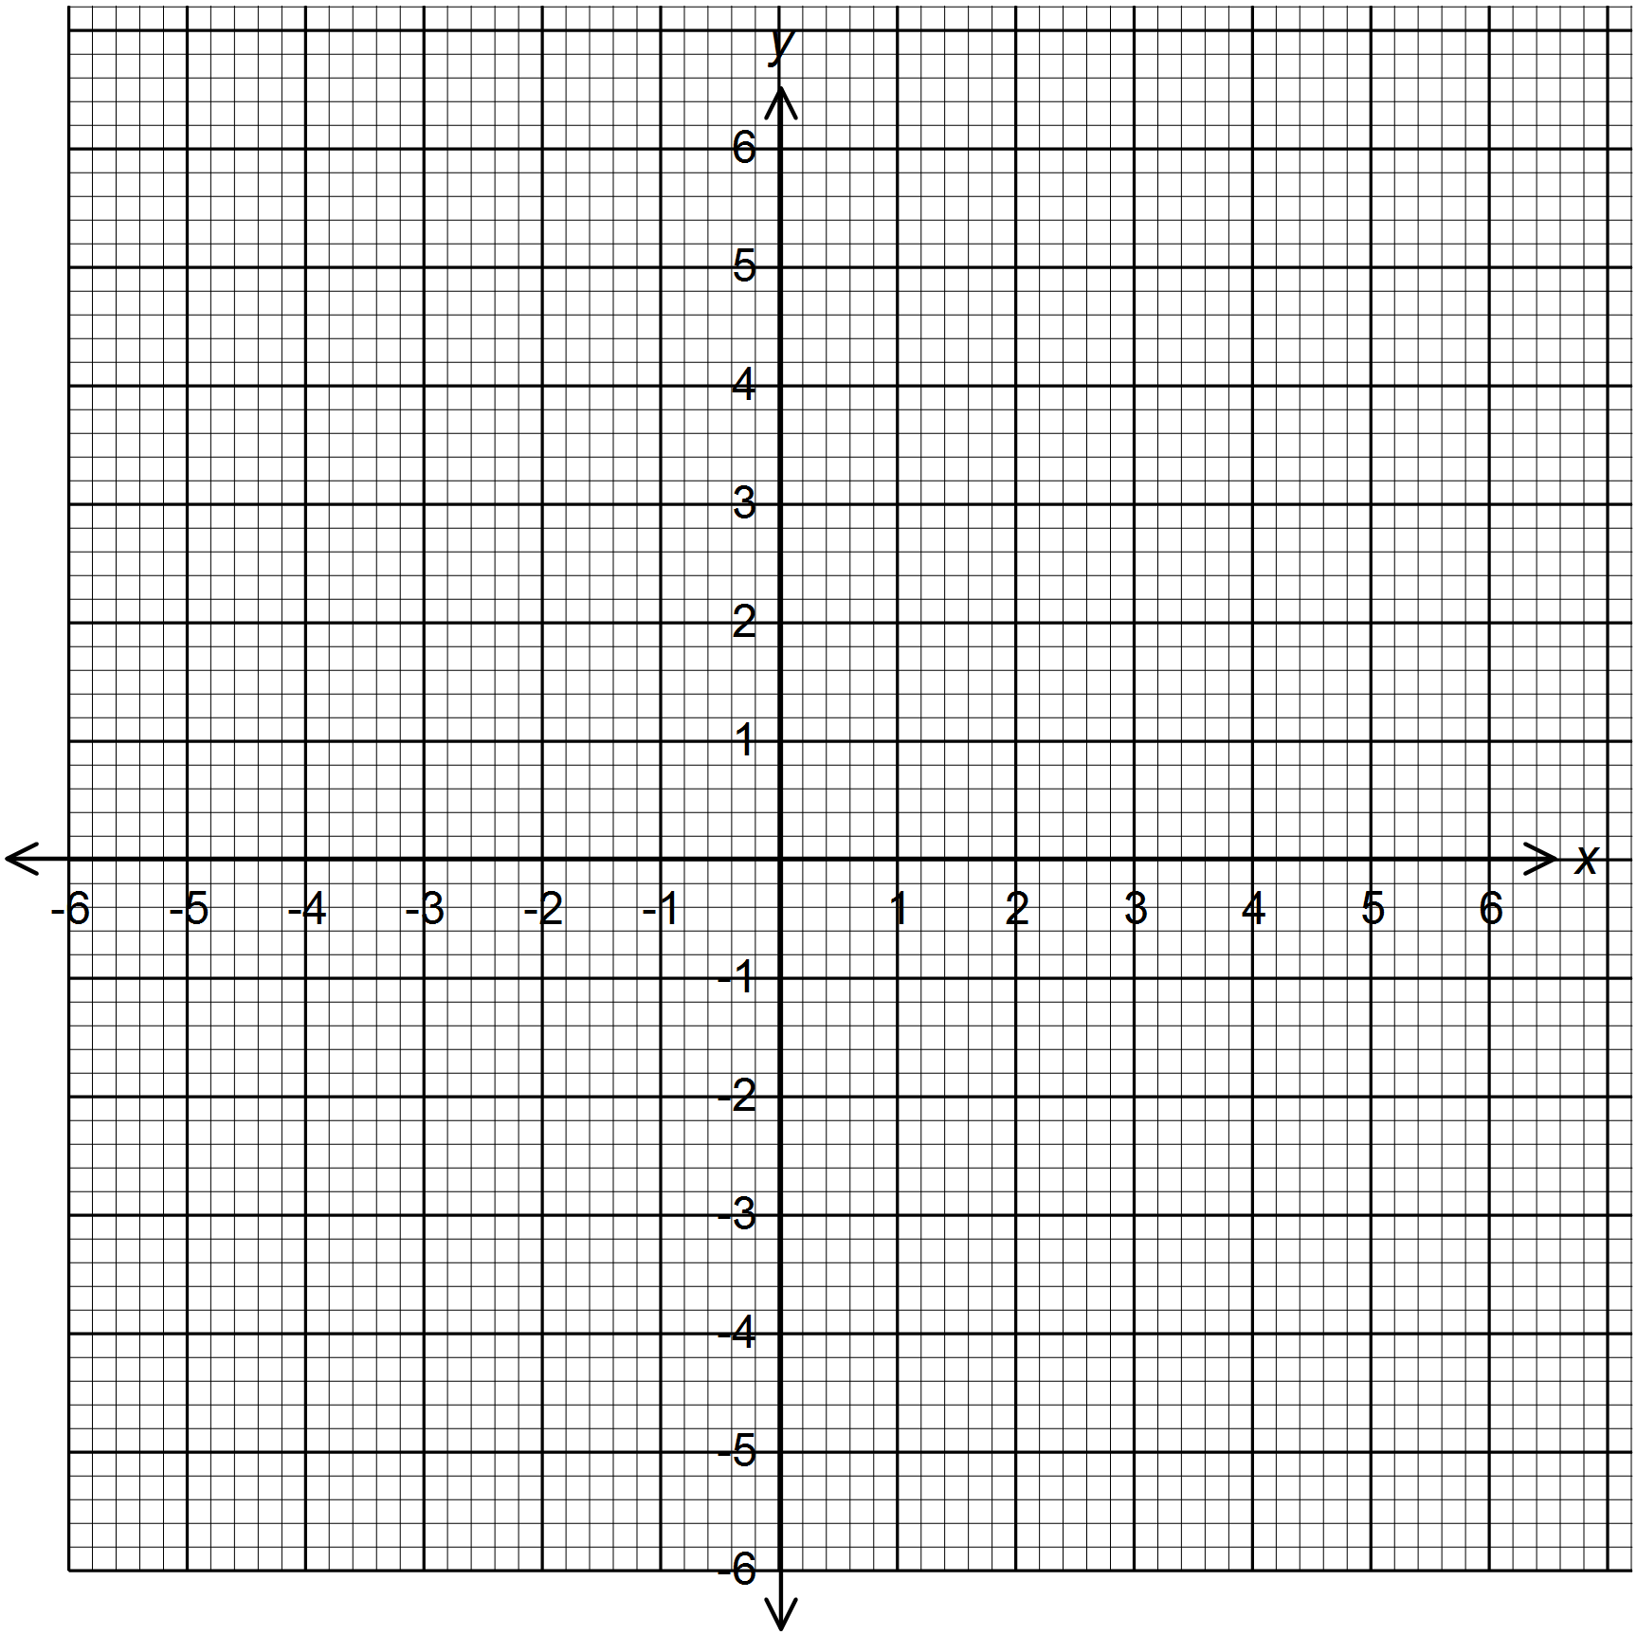

(b) A1B1C1 is the image of ABC under a translation . Plot A1B1C1 and state its coordinates. (2 marks)

(c) Plot A11B11C11 the image of A1B1C1 after a rotation about the origin through a negative quarter turn. State its coordinates. (3 marks)

(d) A111B111C111 is the image of A11B11C11 after a reflection on the line y = 0.

Plot A111B111C111 and state its coordinates. (3 marks)

1. The displacement h metres of a particle moving along a straight line after t seconds

is given by h = -2t3 + 3/2 t2 + 3t

(a) Find the initial acceleration. (3 marks)

(b) Calculate

(i) The time when the particle was momentarily at rest. (3marks)

(ii) Its displacement by the time it comes to rest momentarily. (2 marks)

(c ) Calculate the maximum speed attained. (2 marks)

***THIS IS THE LAST PRINTED PAGE***