**Kenya Certificate of Secondary Education**

312/1 ─ GEOGRAPHY ─ Paper 1

BUTULA SUB-COUNTY EXAMINATION

TIME: 2 Hrs 45Mins

DECEMBER, 2021

Name:…………………………………..…………… Index No ………………..……

Candidate’s Signature………………………………. Date: ………………………...

School: ………………………………………………. Stream: ……………………..

Instructions to candidates

1. ***Write your Name and IndexNumber in the spaces provided above,***
2. ***Sign and Write the date of Examination in the spaces provided above;***
3. ***This paper consists of two Sections; A and B.***
4. ***Answer all the questions in Section A.***
5. ***Answer question6 and any other two questions from Section B.***
6. ***Answers must be written in the spaces provided at the end of question 10.***
7. ***This paper consists of 4 printed pages,***
8. ***Candidates should check the question paper to ascertain that all the pages are printed as indicated and that no questions are missing.***
9. ***Candidates should answer the questions in English.***

For Examiner’s use only

|  |  |  |  |
| --- | --- | --- | --- |
| **Section** | **Question** | **Maximum score** | **Candidate’s score** |
| **A** | 1 – 5 | 25 |  |
| **B** | 6 | 25 |  |
|  | 25 |  |
|  | 25 |  |
| TOTAL SCORE | |  |  |

SECTION A

***Answer ALL questions in this section.***

1. The diagram below shows a six’s thermometer.



a) Name the parts marked P, Q and R. (3 marks)

b) The table below represents the rainfall and temperatures data of station X.

|  |  |  |  |  |  |  |  |  |  |  |  |  |
| --- | --- | --- | --- | --- | --- | --- | --- | --- | --- | --- | --- | --- |
| Month | J | F | M | A | M | J | J | A | S | O | N | D |
| Temp °C | 28.9 | 29.7 | 30.3 | 29.9 | 29.7 | 29.2 | 28.4 | 28.7 | 29.6 | 30.1 | 29.2 | 28.7 |
| Rainfall mm | 9.0 | 8.0 | 21.0 | 49.0 | 25.0 | 9.0 | 20.0 | 10.0 | 4.0 | 10.0 | 17.0 | 11.0 |

i) What is the annual range of temperature? (1 mark)

ii) Calculate the total rainfall of the station. (1 mark)

2. a) What is rock metamorphism? (2 marks)

b) Give three examples of chemically formed sedimentary rocks. (3 marks)

3. The diagram below shows erosional features of the waves at the coast. Use it to answer question

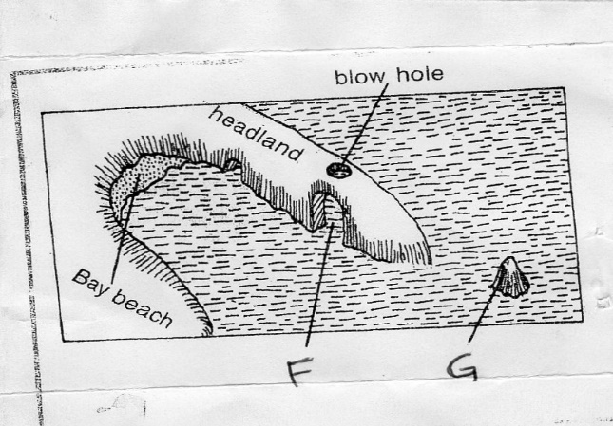

(a) Identify the features marked **F** and **G**. (2 marks)

(b) Give three submerged upland coasts (3 marks)

4(a) Describe how lava-dammed lake are formed. (3 mrks)

(b) State two ways in which lakes influence the climate of the surrounding areas. (2mrks)

5(a) Distinguish between soil profile and soil catena (2 marks)

(b) Give three soil forming processes. (3 mark)

**SECTION B**

**Answer question 6 and any other two questions from this section**

**6.** Study the map of Kijabe 1:50000(sheet 134/3) provided and answer the following questions.

a) i) State the title of the map (2 marks)

ii) Convert the ratio scale into statement scale (2mks)

iii) Identify the physical features found on grid source 4293

b) i) What is the bearing of the cattle dip at Ewaso Kedong valley from grid reference 3193

(2 marks)

ii) What is the exact height of Kijabe hill at grid 2699. (2 marks)

iii) Explain three factors that influence settlement in the area covered by the map (6mks)

iv) Name two methods used to show relief. (2 marks

c) Describe relief of the area covered by the map (5 marks

d) Field study was carried out in Kijabe .

i)State two types of vegetation the researchers identified. (2 marks)

ii) State two challenges they encountered. (2 marks)

7. (a) (i) What is folding? (2 Marks)

(ii) Name three fold mountains formed during Caledonian Orogeny. (3 Marks)

(b) State four characteristics of folded landscape. (4 Marks)

(c) The diagram below shows a type of fold.

(i) Name the type of fold. (1 Mark)   
  
  
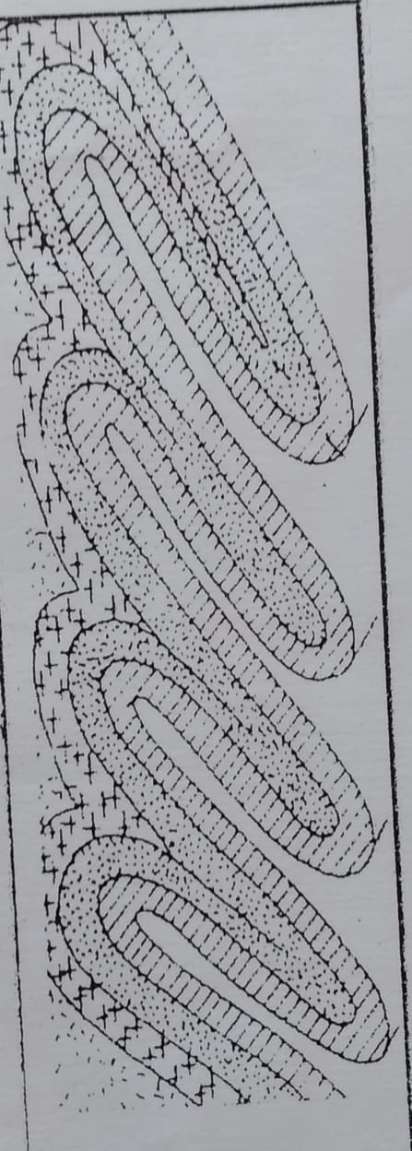

(ii) Describe how the above type of fold is formed. (7 Marks)

(d) Explain four effects of Fold Mountains on human activities. (8 Marks)

8a. Name three types of desert landscapes. (3 marks)

b. Explain three ways through which the wind carries out erosion in the desert. (6 marks)

c. With an aid of a well labeled diagram, describe how a rock pedestal is formed. (6 marks)

  d).State two factors which influence transportation of materials by wind in deserts. (2 marks)

 e).Explain four ways through which desert influence human activities. (8 marks)

9.The diagram below represents underground featured in a limestone area. Use it to answer questions

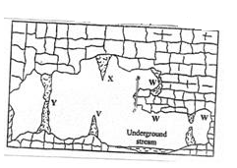

a). i). Name the featured marked X, V and W. (3 mrks)

ii). Describe how the feature marked Y is formed (6 mrks)

b). i). What is an artesian basin? (2 mrks)

ii). Explain three factors which influence the formation of features in limestone areas (6mrks)

c). You are supposed to carry out a field study of an area eroded by water.

i). Give three reasons why you would need a map of the area of study (2 mrks)

ii). Name two erosion features you are likely to identify during the field study (2 mrks)

**10. a** i) Define the term glaciation. (2 mrks)

ii) Name three types of glaciers. (3 mrks)

**b)** Describe how the following features found in upland glaciated landscape are formed.

i) U-shaped valley (5 mrks)

ii) Pyramidal peak (5 mrks)

**c)** Explain three significances of upland glaciated features to human activities. (6 mrks)

**d)** Suppose you were to carry out a field study of glaciated lowland.

i) State two advantages of using oral interview to collect information during the field study. (2mrks ii) Name two features found in glaciated lowland that you are likely to study. (2 mrks)