Name……………………………………………………. Index Number ………………………

Candidate’s Signature…………………………………School…………………………………….
Date......................................

312/2
GEOGRAPHY MARKING SCHEME
Paper 2
Nov. 2021
Time: 2hours and 45 minutes

THE KENYA NATIONAL EXAMINATIONS COUNCIL
BUTULA CLUSTER FORM 4 JOINT EVALUATION
Kenya Certificate of Secondary Education (KCSE)
GEOGRAPHY Paper 2
23/4 hours
Instructions to candidates
(a) This paper has two sections: A and B.
(b) Answer all the questions in section A.
(c) Answer question 6 and any other two questions from section B.
(d) All answers must be written in the answer booklet provided.
(e) This paper consists of 6 printed pages.
(f) Candidates should check the question paper to ascertain that all the pages are printed as indicated and that no questions are missing.
(g) Candidates should answer the questions in English.

QUESTION
SECTION A
6
7
8
9
10
TOTAL SCORE

SECTION A
Answer all the questions in this section
1.(a) Name two exotic species of trees planted in Kenya. (2 marks)
- Pine
- Cypress
- Blue gum /eucalyptus
- Wattle
- Kei-apple
- Jacaranda
- Bomb ax
- Grevilea
- Cedar
b) State three reasons why it is necessary to carry out Afforestation programmers in Kenya. (3 marks)
- To protect water catchment areas
- To protect soil from erosion by wind/water
- To ensure sustainable supply of forest products
- To put more land under forest cover
- To check the extinction of indigenous trees.
- To regulate climate
2 a) Name two water canals found in Africa. (2mks)
- Jonglei canal
- Suez canal
b) Give three roles of transport on industry. (3mks)
- transportation of raw materials to industries
- transportation of finished goods to the market
- transportation of workers to industries

3. (a) State three measures which the government of Kenya has taken to reduce infant mortality. (3Marks)
- The has been widespread immunization for children to control diseases
- The government provides free medical services for children/free mosquito nets
- The government provides parental education to ensure better care for children breastfeeding campaigns/family planning
- There is a government policy granting longer maternity/paternity leave for mothers to take care of the new born
- Research on infant related diseases has been stepped up
- The government encourages provision of homes for orphans
- Training of traditional midwives
- The government has increased/improved medical facilities
(b) Give two negative effects of low population growth in a country. (2 Marks)
- It leads to under utilization of resources/slow economic growth
- It leads to reduced market for goods
- It leads to an increased ageing population in a country/leads to high dependency
- It leads to reduced labour force/productivity
- Its expensive to provide social security

4 a) Give any two minerals found in the Rhur region of Germany. (2mks)
- Limestone
- Iron
- Coal
b) Identify three main types of industries found in Kenya. (3mks)
- Primary
- Secondary
- Tertiary
5. a) List two factors influencing trade ( 2 marks)
      - Capital
      - Market
      - Government policy
      - Security
      - Availability of goods
b) Identify THREE major imports to Kenya. (3 marks)

- Machinery
- Fertilizers
- Pharmaceuticals
- Crude oil
- Skilled labour
- Wheat
- Iron and Steel
- Textiles

SECTION B
Answer question 6 and any other two questions from this section

6. 6. Study the photograph below and answer the questions that follow.

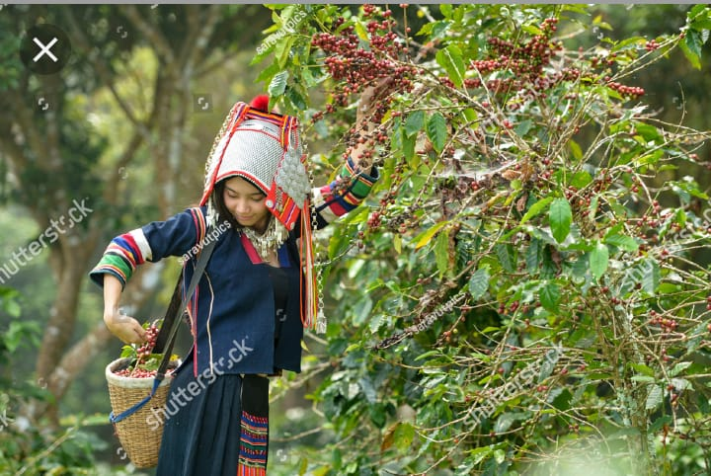

a i) Identify the type of photograph above. (1mk)
Ground close-up

ii) Give two reasons for your answer above. (2mks)
- The camera is held horizontal to the object
- There is one main feature/activity
- Features behind are obscured

iii) Draw a rectangle measuring 8cm by 6cm. on it, mark and label the main features.
(4mks)

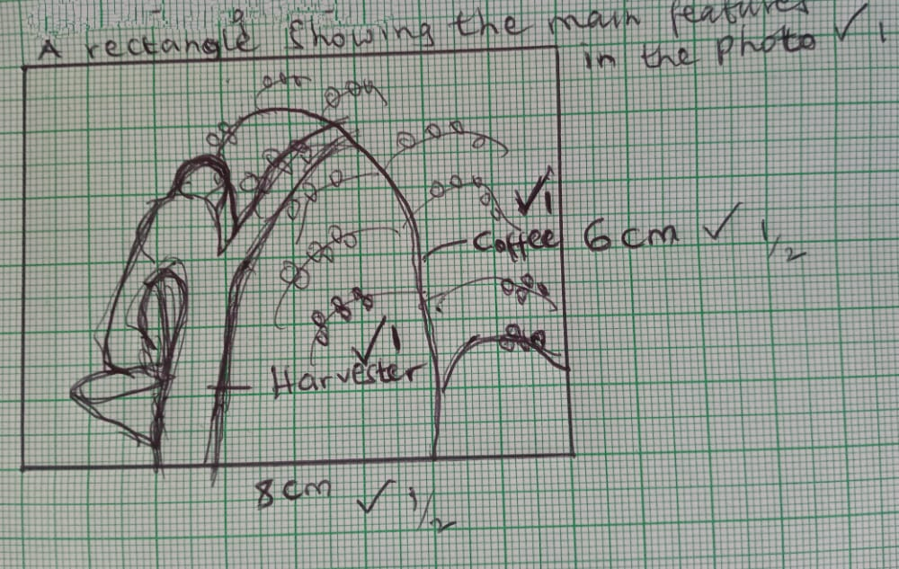

b i) Name two types of coffee grown in Kenya. (2mks)
- Robusta
- Arabica
ii) Name three counties in Western Kenya where coffee is grown. (3mks)
- Bungoma
- Kakamega
- Vihiga

iii) give three conditions favoring coffee growing in Kenya (3marks)
- Moderate to high temperatures of 14-16 degreed Celsius
- Moderate to high rainfall ranging between 1,000-2,000mm per annum
- Deep fertile volcanic soils
- Undulating landscape with hill slopes and gentle slopes

c i) State three problems facing coffee farmers in Kenya. (3mks)
- Soil exhaustion
- Climatic hazards
- Pests and diseases
- Price fluctuations
- Poor roads
- Delays in payments
- Mismanagement.
ii) Identify three ways in which the government has attempted to promote coffee farmers in Kenya. (3mks)
- Improved road transport
- Research on new species has been conducted
- Control of pests and diseases
- Advanced loans to farmers
- Provided extension workers to advice farmers
- Helped in marketing coffee

D) Explain two reasons why coffee production is more developed in Brazil than in Kenya.
(4mks)
- Brazil has more extensive land for coffee farming than Kenya
- Brazil has more developed transport network in form of roads and railway
- There is more efficient marketing in Brazil than in Kenya
- Brazil face s few climatic hazards compared to Kenya which faces prolonged drought.

7.
a) i) Apart from the sun, name three other sources of energy
- Water, Wind, Wood, Tides, Biomass
(Any 3x1=3mks)
ii) State four advantages of using solar energy
- Cheap source of energy
- Available almost every where
- It can be stored and used later
- Environmentally friendly
- Inexhaustible source of energy. (Any 4x1=4mks)

b) State four ways in which Kenya has benefited from hydroelectric power scheme
- Provision of electricity
- Foreign exchange
- Fishing grounds
- Modified the local climate
- Control of floods
- Improvement of transport and communication. (Any 4x1=4mks)
c)Explain five factors favouring development of Hydroelectric power projects
- Hard basement rocks to provide a firm foundation for dam construction
- Presence of waterfalls to provide a massive hydraulic force head for power generation
- Regular/large volume of water to ensure continuous power generation
- Non porous rocks to prevent water loss/seepage underground
- Presence of a deep narrow valley/gorge to provide a large reservoir behind the dam/reduce cost of building embankments
- Government policy – availability of land/space for setting up the plant
- Market to buy the produced HEP
- Adequate capital to set up the project since it involves high capital outlay

(Any 5x2=10mks)
d) Explain two impacts of energy crisis in the society
- Is a situation where the demand for oil is higher than supply, leading to high oil prices
- Increased transport cost
- Increase in price of oil, increases price of other commodities
- Affect balance of trade
- Agriculture inputs such as fertilizers would become more expensive

(Any 2x2=4mks)

8 a) Define the term land reclamation. (2mks)
Land reclamation is the practice by which less useful land is converted into more useful land.

ii) State three ways through which land can be rehabilitated in Kenya. (3mks)
- Planting vegetation,
- Making terraces,
- building gabions,
- adding manure,
- filling up quarries.

b) A part from Mwea Tebere, identify any three irrigation schemes in Kenya. (3mks)
- Perkerra irrigation scheme,
- Bura, Ahero,
- West Kano,
- Bunyala, etc.

ii) Explain three physical factors that influenced the location of Mwea Tebere irrigation scheme. (6mks)
- Mwea plains have black cotton soils suitable for rice farming.
- Gently sloping land to make it possible for irrigation .
- Permanent rivers of Nyamidi, Murubara and Thiba that provided water for irrigation.
- High temperatures suitable for cultivation of rice and irrigation.
- Loamy soils suitable for cultivation of other crops to support families.

c) Give three problems facing Mwea Tebere irrigation scheme. (3mks)
- Diseases such as malaria and bilharzia
- Delayed payments
- Weeds
- Financial mismanagement
- Poor access roads
- Pests

d) Identify two benefits of Zuyder Zee project in Netherlands. (2mks)

- Creation of large fresh water lakes
- Provision of infrastructure and other social amenities.
- Has reduced tidal flooding.

- Explain three similarities between land reclamation in Kenya and Netherlands.
(6mks)
- In both, reclaimed land is located in low lying areas such as shallow coastal areas and swamps.
- In both, floods are used to control water from entering the reclaimed areas.
- In both, ditches and canals are used to drain water from reclaimed areas.
- In both, scientific methods such as use of fertilizers to improve soil fertility are used.
- In both countries the government organizes the work of reclaiming land.

9 a) Define the term Mining. (2mks)
Extraction of valuable minerals and fossil fuels from the earth’s crust
ii) List three ways in which minerals occur.
- Beds and seams
- Lodes and veins
- Alluvial deposits
- Weathering products
b) i) Identify any three minerals mined within the rift valley of Kenya. (3mks)
- Diatpomite
- Flourspar
- Soda ash
- oil
ii Mention any two problems associated with underground mining. (2mks)
- Flooding from subterranean water
- Collapse of tunnel roofs
- Dust leading to respiratory diseases
c) Study the diagram below and answer the questions that follow

- Name the part labeled WXY (3mks)
W- Gas
Y- Oil
Y- Water
- State three conditions that favor the formation of an oil reservoir. (3mks)
- Presence of sedimentary rocks
- Presence of organic remains/fossils
- Presence of pressure to compress or organic remains
- Presence of porous rocks.

d) Students carried out a field study in a mining site.

i) State one objective of the study. (1mk)
- To identify the type of mineral mined
- To establish the significance of the mining activity
- To find out the problems affecting the mining activity
ii) Give two methods they used to collect data. (2mks)
- Questionnaires
- Conducted interviews
- Collected rock samples of the ore
- Took photographs
iii) Identify the features they may have observed to conclude that the land has been
derelicted. (3mks)
- Open pits/Quarries
- Heaps of soil material
- Cleared vegetation
- Bare surface
iv) A part from land dereliction, give three other effects of mining on the environment.
(3mks)
- Pollution
- Loss of biodiversity
- Disruption of water table
- Soil erosion
10 a) Define the term environment. (2mks)
External conditions that surround a plant or an animal.
ii) State three farming methods that assist in soil conservation. (3mks)
Contour farming
Mulching
Crop rotation

b) i) State three ways in which people are affected by floods. (3mks)
- Loss of lives and property
- Destruction of transport and communication lines
- Displacement of people
- Spread of waterborne diseases like cholera
ii) Explain three methods in which floods can be controlled. (6mks)
- Dykes are constructed along river banks levee of rivers to increase their height in order to prevent water from over flowing
Dredging of river channels to deepen/ widen them to make it possible for them to accommodate excess water
- Dams are build across the rivers to control the amount of water discharges downstream/ construction of earth dams to hold back water
- Training/ re- directing a river/ straightening of a river to control its wild flow ( training means cut meander loops
- Planting of trees in the catchment areas to reduce surface run off and increase infiltration
- Divering tributaries to other rivers to reduce the volume

c) Give two causes of water pollution. (2mks)
- Oil leaks from ships/ trucks
- Industrial effluent when discharged into rivers/ lakes
- Washing away ( into rivers and lakes) chemical/ fertilizers/ pesticides/ insecticides
- Washing/ bathing/ watering animals in rivers/ lakes
- Disposing of raw sewages into rivers/ lakes
- Surface turnoff/ soil erosion into water depositing silt
- Dumping of solid waste into water courses

ii) State three effects of water pollution on environment. (3mks)
- It may cause death of aquatic life
- It destroys aesthetic/ beauty of beach/ water bodies
- It leads to spread of waterborne diseases
- Causes foul smell
- Results to sutrophictaion/ water hyacinth/ water weeds/ alga

iii) Explain any three ways in which drought and desertification can be controlled.(6mks)

- Planting drought resistant crops
- Establishment of irrigation programs
- Afforestation and reforestation.
- Destocking of livestock to reduce on soil erosion and overgrazing
- Protection of water catchment areas.

