Name…………………………………………………………………………………………….Index No…………………………
School………………………………………………………Date……………… Candidate’s signature……………………

232/1
PHYSICS
Paper 1
DECEMBER 2021
Time 2 HOURS
BUTULA SUBCOUNTY JOINT EXAMINATION 2021
Kenya Certificate of Secondary Education (K.C.S.E)
INSTRUCTIONS TO CANDIDATES
1. Write your index no in spaces provided.
2. This paper consists of two sections A and B
3. Answer all questions in the spaces provided
4. Non-programmable calculators and mathematical tables may be used
5. Show all your workings
SECTION | QUESTION | MAX. SCORE | CANDIDATES SCORE
A | 1 – 13 | 25
B | 14 | 10
 | 15 | 09
 | 16 | 13
 | 17 | 12
 | 18 | 11
 | TOTAL | 80
This paper consists of 12 printed pages.
Candidates should check the question paper to ensure that all
pages are printed as indicated and no questions are missing

SECTION A (25 MARKS)
Answer all questions in this section.
- Figure 1 shows air flowing through a pipe of non-uniform cross-sectional area. Two pipes A and B are dipped into the liquid as shown.
Figure 1
A
B
Air
Liquid
- Indicate the levels of the liquid A and B. (1mk)

- Explain the answer in 11 (a) above. (1mk)
------------------------------------------------------------------------------------------------------------------------------------------------------------------------------------------------------------------------------------------------------------
- A block of copper of mass 2kg and specific heat capacity of 400J/kg/K initially at 121⁰C is
immersed in water at 20⁰C. If the final temperature is 21⁰C, determine the mass of water. (Specific heat capacity of water is 4200J/kg/k) (3mks)
--------------------------------------------------------------------------------------------------------------------------------------------------------------------------------------------------------------------------------------------------------------------------------------------------------------------------------------------------------------------------------------------------------------
- Sketch a graph of velocity against time of a steel ball which is dropped to fall through glycerine in a measuring cylinder (2mks)

- State one advantage of a force pump over lift pump. (1mk)
-----------------------------------------------------------------------------------------------------------------------------------------
- Name two forces that determine the shape of an oil drop on a table. (2mks)
------------------------------------------------------------------------------------------------------------------------------------------------------------------------------------------------------------------------------------------------------------------------
- When hot tea is simultaneously poured into thick glass and thin glass of similar material, the thick glass is more likely to crack. Explain the observation. (2mks)
------------------------------------------------------------------------------------------------------------------------------------------------------------------------------------------------------------------------------------------------------------------------
- Some water in a tin can was boiled for some time. The tin can was then sealed and cooled. After sometime it collapsed. Explain this observation (2mks)
------------------------------------------------------------------------------------------------------------------------------------------------------------------------------------------------------------------------------------------------------------------------
- The figure below shows a uniform Metre rule pivoted at 30cm mark. It is balanced by
weight of 2Nsuspended at the 5cm mark.
Determine the weight of the meter rule (3mks)
----------------------------------------------------------------------------------------------------------------------------------------------------------------------------------------------------------------------------------------------------------------------------------
- The figure below shows tow identical containers with water at different levels.
A B
State and explain which container is stable. (2mks)
----------------------------------------------------------------------------------------------------------------------------------------------------------------------------------------------------------------------------------------------------------------------------------
- The figure below shows a mass of 200g connected by a string through a hollow tube to
mass of 0.5kg. The 0.5kg mass is kept stationary in the air by whirling the 200g mass round
in a horizontal circle of reading 1.0metre
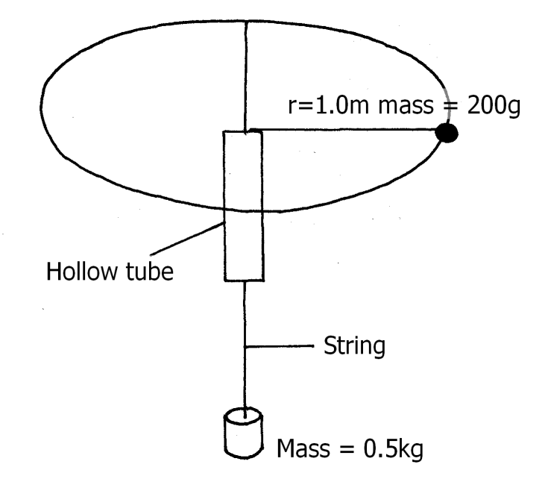
Determine the angular velocity of the 200g mass (3mks)
----------------------------------------------------------------------------------------------------------------------------------------------------------------------------------------------------------------------------------------------------------------------------------
----------------------------------------------------------------------------------------------------------------------------------------------------------------------------------------------------------------------------------------------------------------------------------
- State reason why heat transfer by radiation is faster than by conduction (1mk)
------------------------------------------------------------------------------------------------------------------------------------
- A body is projected vertically upwards from the top of a building. If it lands on the base of the building, sketch the velocity time graph for the motion (2mks)
----------------------------------------------------------------------------------------------------------------------------------------------------------------------------------------------------------------------------------------------------------------------------------

SECTION B: 55 MARKS
Answer all questions in this section.
- (a) Distinguish between latent heat of fusion and specific latent of fusion. (1mk)

------------------------------------------------------------------------------------------------------------------------------------------------------------------------------------------------------------------------------------------------------------------------
- Figure 8 shows a block of ice. A thin copper wire with two heavy weights hanging from its ends-passes over the block. The copper wire is observed to pass through the block of ice without cutting it in a process known as regelation.

- Explain this observation, (3mks)

- What would be the effect of replacing the copper wire with a cotton thread? (1mk)

- Explain. (2mks)

- Figure 9 shows one method of measuring the specific latent heat of fusion of ice. Two funnels A and B, contain crushed ice at 0°C.
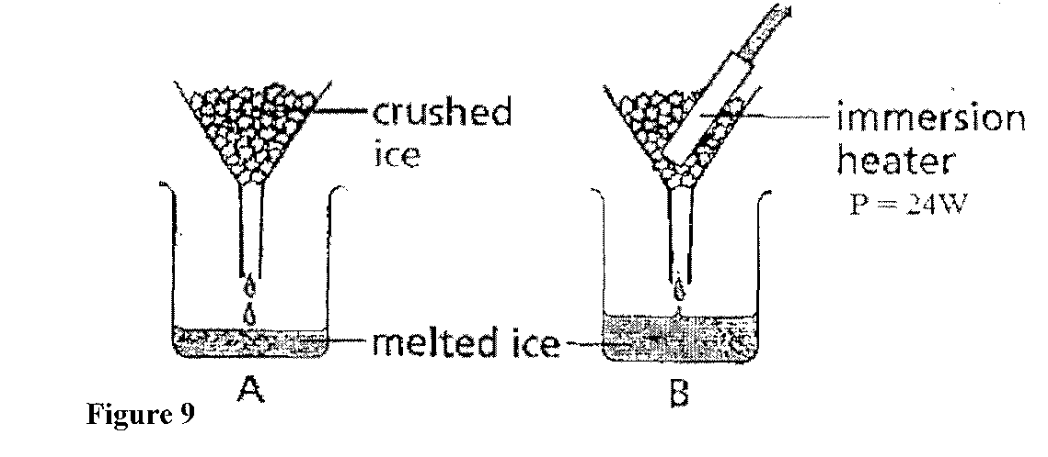
The mass of melted ice from each funnel is measured after 11 minutes. The results are shown below.
Mass of melted ice in A = 24g
Mass of melted ice in B = 63g
- What is the reason for setting up funnel A? (1mk)

- Determine the:
I Quantity of heat supplied by the heater. (2mks)

II mass of ice melted by the heater. (1mk)

III specific latent heat of fusion of ice. (2mks

- State any one form of energy (1mk)

b) An electric crane lifts a load of 2000kg through a vertical distance of 3.0m in 6
seconds
Determine:
- The work done (2mrks)
....................................................................................................................................................................................................................................................................................................................................................................................................................................................................................................................................................................
- The power developed by the crane. (2mrks)
......................................................................................................................................... ......................................................................................................................................... ..................................................................................................................................................................................................................................................................................

- The efficiency of the crane if it is operated by an electric motor rated 12.5kw. (2mrks)
...........................................................................................................................................................................................................................................................................................................................................................................................................................
- A bob of mass 20g is suspended using a string 4m long from a support and swung through a vertical height of 0.9m as shown in figure 9 below.
Fig. 9
4m
Bob
0.9m

Determine;
- The potential energy of the bob at its position shown. (2mrks)
..............................................................................................................................................................................................................................................................................................................................................................................................................................................................................................................................................................................................................................................................................
(ii) The speed of the bob when passing through the lowest point during the swing. 2mks

15 (a) State Hooke’s Law (1mrk)
--------------------------------------------------------------------------------------------------------------------------------------------------------------------------------------------------------------------------------------------------------------------------------
(b) The diagram below shows a graph of force against extension for a certain spring.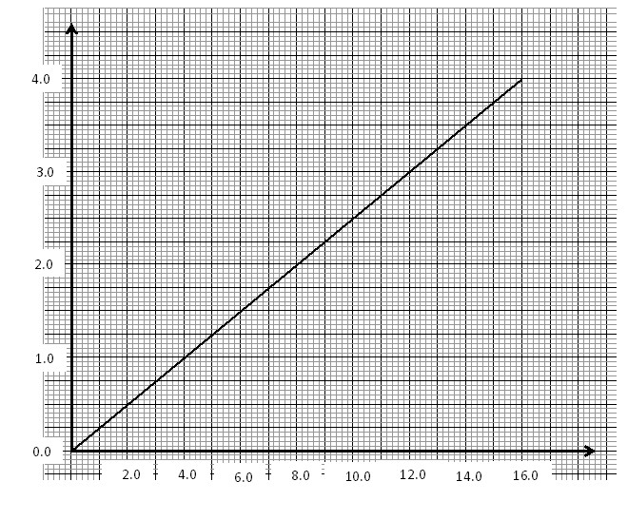
Extension (cm)
Force (N)

- What is the spring constant of the spring? (2 marks)
--------------------------------------------------------------------------------------------------------------------------------------------------------------------------------------------------------------------------------------------------------------------------------------------------------------------------------------------------------------------------------------------------------------
- What force would cause two such springs placed side by side to stretch by 10cm. (2mrks)

c) The three springs shown below are identical and have negligible weight. The extension produced on the system of springs is 20cm.
Determine the constant of each spring. (2mks)
--------------------------------------------------------------------------------------------------------------------------------------------------------------------------------------------------------------------------------------------------------------------------------------------------------------------------------------------------------------------------------------------------------------
- State what is meant by an ideal gas. (1mk)
--------------------------------------------------------------------------------------------------------------------------------------------------------------------------------------------------------------------------------------------------------------------------------
b) The pressure acting on a gas in a container was changed steadily while the temperature of the gas was maintained constant. The value of volume V of the gas was measured for various values of pressure. The graph shows the relation between the pressure, p, and the reciprocal of volume $\frac{1}{V}$.
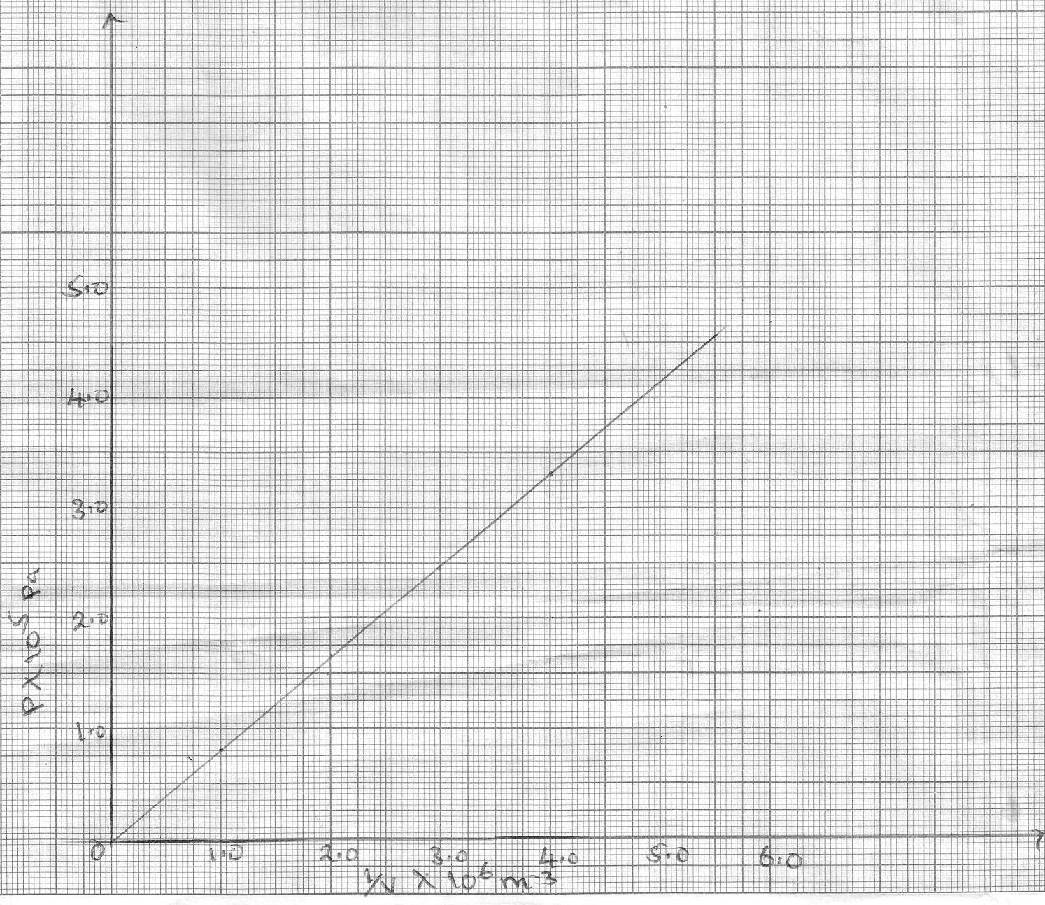
$P$ x 10⁵ pa
$\frac{1}{V}$ x 10⁶m⁻³

- Suggest how the temperature of the gas could be kept constant. (1mk)
-----------------------------------------------------------------------------------------------------------------------------------------
- Given that the relation between pressure P and the volume V of the gas is given by: PV = k, where k is constant, use the graph to determine the value of k. (3mks)

- What physical quantity does k represent? (1mk)

- State one precaution you would take when performing such an experiment. (1mk)

- A gas occupies a volume of 4000 litres at a temperature of 37ºC and normal atmospheric pressure. Determine the new volume of the gas if it heated at constant pressure to a temperature of 67ºC. (Normal atmosphere pressure p = 1.01 x 10⁵pa) (3 marks)

- The figure below shows a metal sphere of mass 400kg and volume 0.6m³ fully submerged in sea water of density 1030kg/m³
Determine;
- The tension in the cable holding the sphere. (4mks)

- The radius of the sphere. (2mks)

- The weight of a solid in air is 5N. When it is fully immersed in a liquid of density 800kg/m³ its weight is 4.04N. Determine;
- The upthrust of the liquid. (1mk)

- The volume of the solid. (2mks)

- A small drop of oil has a volume 5x10⁻¹⁰m³ when it is put on surface of some clean water it forms a circular film of0.02m²in area.

- Describe how the oil patch /film is formed. (2mks)

- Why does the film form into a circular shape (1mk)

- What in the size of a molecule of oil? (3mks)

