**NAME …………………………..……….. DATE ………………………………….…**

**INDEX NO. ……….……….……… SIGNATURE ……………..…………..**

**PHYSICS**

**PAPER 3**

**NOVEMBER/DECEMBER 2021**

**TIME: 2 $\frac{1}{2}$ HOURS.**

**BUTULA SUB COUNTY JOINT EVALUATION**

*Kenya Certificate of Secondary Education.*

**232/3**

**PHYSICS**

**PAPER 3**

**TIME: 2 $\frac{1}{2}$ HOURS.**

**INSTRUCTIONS TO CANDIDATES**

* Write your name and your index number in the spaces provided above.
* This paper consists of **two** sections **A** and **B**
* Answer **all** questions in section **A** and **B** in the space provided
* All working **must** be shown in the spaces provided in this booklet.
* Mathematical tables and silent electronic calculators may be used
* This paper consists of 11 printed pages. Candidates should check to ensure that all pages are printed as indicated and no questions are missing

**FOR OFFICIAL USE**

|  |  |  |  |  |  |  |  |  |  |  |  |
| --- | --- | --- | --- | --- | --- | --- | --- | --- | --- | --- | --- |
| Question 1 | a | c | e | f | G | h | I | j | m | n |  |
| Max score | 2 | 2 | 1 | 2 | 1 | 2 | 2 | 2 | 5 | 2 |  |
| Cand score |  |  |  |  |  |  |  |  |  |  |  |

|  |
| --- |
|  |

|  |  |  |  |  |  |  |  |  |  |  |
| --- | --- | --- | --- | --- | --- | --- | --- | --- | --- | --- |
| Question 2 | b | C | 5 | e | F | g | h | j |  |  |
|  | 2 | 5 | 5 | 2 | 2 | 1 | 2 | 1 |  |  |
|  |  |  |  |  |  |  |  |  |  |  |

***This paper consists of 10 printed pages. Candidates should check the question paper to ascertain that all pages are printed as indicated and that no pages are missing***

**Question one**

You are provided with the following:

* A micrometer screw gauge (to be shared)
* A vernier calliper (to be shared)
* Glass tube
* A wire labelled **M**
* Some cello tape
* One 50 g mass
* A meter rule
* 100 ml beaker
* A stand boss and clamp
* A stop watch
* Candle
* A screen
* Some water
* measuring cylinder

**PART A**

Proceed as follows

1. Using a micrometer screw gauge , measure and record the diameter of the wire labelled **M** (2 mark)

**d= 0.35 $±0.02$**  mm ½ mark each

**d=**0.00035 …m ½ mark each

1. Using wire **M** make a spring as follows :
2. Use some sellotape to fix one end of the wire M (about 2.5 cm) along the glass tube ;
3. Hold firmly the part of the wireunder the tape with one hand. Use the other hand to wind 30 turns as closely and tightly as possible (*see* ***figure 1***)

.

(c) Remove the sellotape and release the spring from the tube

(*The spring will slightly unwind and some turns will disappear*)

Bend the free ends as shown in **figure 2**

1. Using a vernier callipers , measure and record the external diameter d of the spring

(2 mark)

**D =**  ...0.81 $±0.2$ cm ½ merk eachg

**D**= …0.0084m

(e ) suspend the spring and a 50g mass from a retort stand as shown in **figure 3**

Count and record the number of turns **N**of the suspended spring (1mark)

**N =**……………25 $±2$

(f) Using the 50g record the extension **X** of the spring (2mark)

**X =** 2.3 $±2$ cm 1 dp amust

**X =**0.023 $±$. M correct evaluation

(g) Determine **c** given that(1mark)

C= $\frac{0.4}{x}$

½ correct evaluation

½ four significant figures

(h) Determine**n** given that (2marks)

**C = $\frac{{nd}^{4}}{{8ND}^{3}}$**

**Correct substitution 1 mark**

**Correct evaluation 1 mark ignore units**

1. With the spring still loaded with the 90g, pull the lower mass slightly downwards and let go so that the mass oscillates vertically. Record the time **t** for 20 oscillations. Hence determine the period **T**

t= 8.84 $±0.5$ (s) 2dp (1mark)

T = 0.442 $±$ (s) corr eva (1mark)

(j) Determine Z given that

T =2π $\sqrt{\frac{m}{z}}$

Where m is the mass in kg on the spring (2 marks)

Correct sub 1 mark

Correc eval ( atleast 4sf) 1 mark

Question two

**PART B**

1. You are provided with the following:

* A candle
* Metre rule
* White screen
* Lens holder
* Convex lens

Proceed as follows:

(k)Place the lens on a metre rule. Arrange the set up as shown in the figure 3 below.

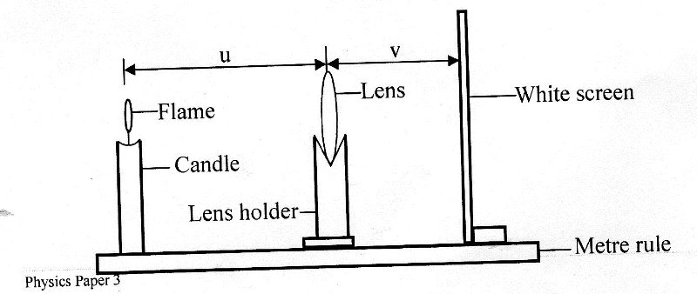

1. Adjust the position of the lens so that it is a distance u = 30cm from the candle. Adjust the position of the screen until a well focused image of the flame is formed on the screen. Measure and record in the table 2, the image distance v, between the screen and lens.
2. Repeat part (b) for other values of (u) shown in the table 2 and complete the table.

|  |  |  |  |
| --- | --- | --- | --- |
| u (cm) | 30 | 35 | 40 |
| v (cm)( each correc i mark | 27.0 $±2$ | 22.0 $±2$ | 20.0 $±2$ 1 dp a must |
| x = $\frac{v}{u}$ | Correct sub | All correct | 1 mark |
| y = $\frac{v}{(x+1)(cm)}$ | Correct eval | 1mark |  |

. (5mks)

1. Determine the mean value of y (2marks)

Correct sub 1 mark

Correct evaluation 1 mark

**Question 2**

**PART A**

. You are provided with the following apparatus

* A voltmeter
* An ammeter
* A wire x mounted on a metre rule
* 8 connecting wires with crocodile clips
* Micrometer screw gauge
* A switch
* A jockey
* One new dry cell and a cell holder.

**Proceed as follows:**

1. Connect the apparatus provided as shown in the circuit in figure 1below.

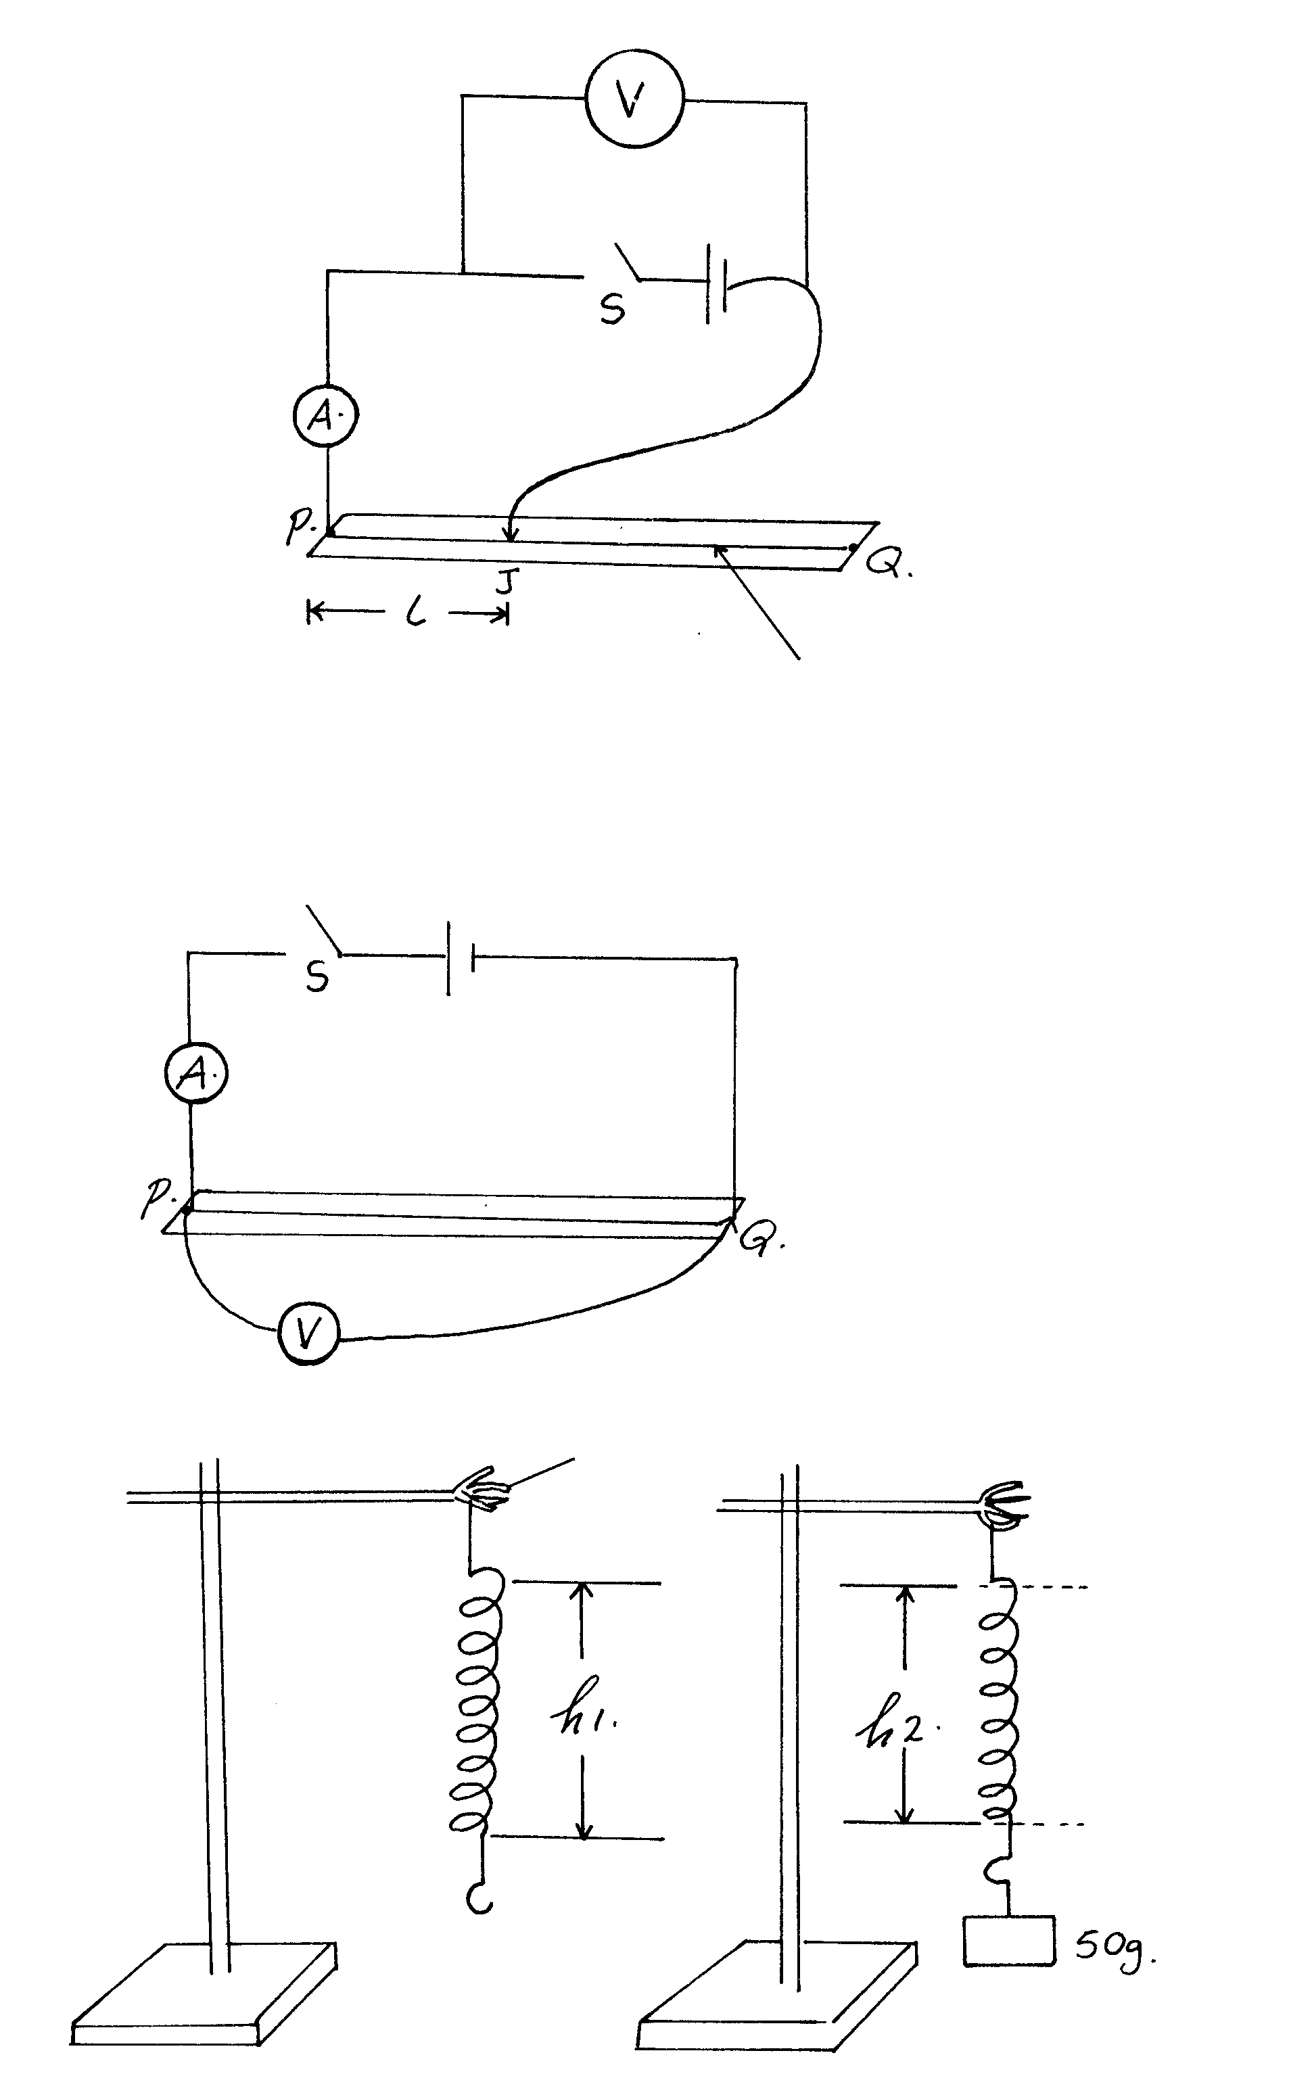

jockey

Metre rule

Wire x

1. With the crocodile clip at L = 10 cm , close the switch S and record the ammeter and voltmeter reading.

I =.......0.14 $± 0.02$ (1/2 mark)

V =........0.25 $±0.05$ (1/2 mark )

1. Repeat the procedure in (b) for other values of l = 10cm, 20cm, 30cm, 40cm, 50cm and 60 and recordthe readings in the table below 1 below. ( 5marks)

|  |  |  |  |  |  |  |
| --- | --- | --- | --- | --- | --- | --- |
| Length. L. (cm) | 10 | 20 | 30 | 40 | 50 | 60 |
| Voltmeter reading , V (volts) (1/2 each) | 0.25 | 0.20 | 0.15 | 0.12 | 0.1 | 0.1 |
| Ammeter reading , I(A) (1/2 each) | 0.14 | 0.12 | 0.10 | 0.10 | 0.08 | 0.07 |

d)Plot a graph of potential difference, V(y-axis) against the Current I .(5 marks)

plotting 2 half for each correctly plotted points maximum of four points

s1 for simple and uniform

L1 straight line

A 1 well labelled axis with units

1. Determine the slope of the graph (2marks)

Correct sub 1 mark

Correct evaluation 1 mark

f)Given that V= E – I r, use your graph to determine the value of;

(i) E (2mk)

y- intercept

(ii) r (1mks)

gradient

(g)Measure the diameter d of the wire x using the micrometer screw gauge. (1 mark)

d =....0.25 $±0.05$ mm ½ mark

D...................m correct conversion

(h) Dismantle the apparatus and set up the circuit as shown figure 2 below.



1. Close the switch S and record the ammeter and the voltmeter readings (1mark)

I =...0.06 $± 0.02$ 1/2 mark each

V =...............1.20 $±0.05$

Hence find R, the resistance of the wire x.

R = ..................Ω sub (1mk)

1. Given that R = 4ρ

π d2 ,

determine ρ (2 mks)

su 1 mark

evaluation 1 mark

**THIS IS THE LAST PRINTED PAGE**