NAME_____________________________ADMISSION NO.__________CLASS________

231
BIOLOGY (Theory)
DECEMBER 2021
2$\frac{1}{2}$ Hours
KENYA CERTIFICATE OF SECONDARY EDUCATION
FORM THREE BIOLOGY PAPER
MARKING SCHEME

SECTION A
1a.Distinguish between homoiotherms and poikilotherms {2 marks}
Homoitherms-
Homoitherms-They regulate their body temperature using heat generated by metabollic processes;
Poikilotherms-
Poikilotherms-They do not regulate their body temperature;they gain heat from external environment;
b)(i).How is energy stored in a cell? {1 mk}
In form of adenosine triphosphate
(ii). How is the energy released when the cell needs it? {1mk}
The terminal bond of adenosine triphosphate is broken to release energy
2. Name three kingdoms apart from plantae and Animalia in order of decreasing complexity
{3 marks}
Fungi/mycophyta;protoctista;monera;
3. When preparing a temporary slide of black jack stem, Kamau was asked to carry out the following steps. Give a reason why each step was carried out.
a).Use a sharp razor to obtain a thin slice of the stem {1 mk}
To allow light to pass through the specimen or to avoid destroying the cells
b), Place a drop of water on the slice on the microscope slide {1 mk}
To prevent cells from drying up
c).Add a drop of methylene blue dye on to the specimen on the microscope slide {1 mk}
To provide contrast for clear observation of different parts;
d), Lower the cover slip gently onto the place over the slice of the stem {1 mk}
To avoid trapping air bubbles
4. List down two factors that maintain populations of animals carrying capacity {2 marks}
Competition of food/shelter/water/mates;predation;diseases/parasites;
5. State three ways in which atmospheric nitrogen can be”fixed” into nitrates{3 marks}
in the root nodules of legumes;by By free living micro organisms in the soil/water;by rhizobium lightning during thunderstorms
6(a).Reproduction is a characteristic of living things. State two importance of it in living things {2 marks}
Procreation;improves the quality of species;
(b).State two ways in which flowering plants prevent self pollination{2 marks}
Protandry;protogyny;incompatibility/self sterility
(c),What is the importance of cross pollination?{1 mk}
Source of variation/hybrid
7.List down four symptoms of diabetes mellitus{4 marks}
Passing urine frequently/polyuria;glucose in the urine/excess glucose in blood;frequent thirst;loss of weight;excessive eating/hyperphagia;low immunity;
8.Why are plants able to accumulate most of their waste products for long?{2 marks}
Most of the waste products are harmless;wastes are converted into harmless products;
9.List down four roles of liver in homeostasis in the human body{4 marks}
Regulation of blood glucose;deamination of excess glucose;detoxification;maintenance of body temperature/thermoregulation
10. (a) Give one physiological difference between a plant cell wall and a cell membrane (1mk)
Cell wall is permeable to solutes while cell membrane is selectively permeable
(b) State two structural differences between a cell wall and a cell membrane (2mks)
Plant cell wall made of cellulose while cell membrane is made up of lipoprotein
Cell wall is rigid while cell membrane is flexible
11. (a) Give reasons why muscle cells, sperm cells and kidney cells have large numbers of mitochondria. (2mks)
They are very active; hence have many mitochondria to produce energy.
(b) State the role of cristae found in the mitochondria. (1 mk)
Provide a large surface area for attachment of enzymes used in respiration.

- Name the chemical reaction in which glucose is broken down to form pyruvic acid(1 mk)
Glycolysis
12.a)What is the significance of diffusion to plant pollination (1 mark)
Scent produced by flowers attract insects to the flower which pollinate them
b)Explain why movement of air molecules is not energy driven process (1mark)
air molecules move by diffusion

13.A student added equal amounts of blood to equal volumes of salt solutions of different concentrations. She observed and counted the red blood cells under the microscope at the beginning of the experiment and at the end of the experiment. The results were as shown below.
Set up | Concentration of salt | Beginning | After 30 min.
A | 0.1% | Normal | Normal but small
B | 0.05% | Normal | Very few but large

Account for the results in set up.
(i) Set up A (2mk)
The solution is hypertonic to cell cytoplasm; cells lost water to the solution by osmosis and become crenated;
(ii) Set up B (2mk)
Solution hypotonic to cell content; Cells absorbed water by osmosis to become large and
become haemolysed;
14.An experiment was set up as show below.
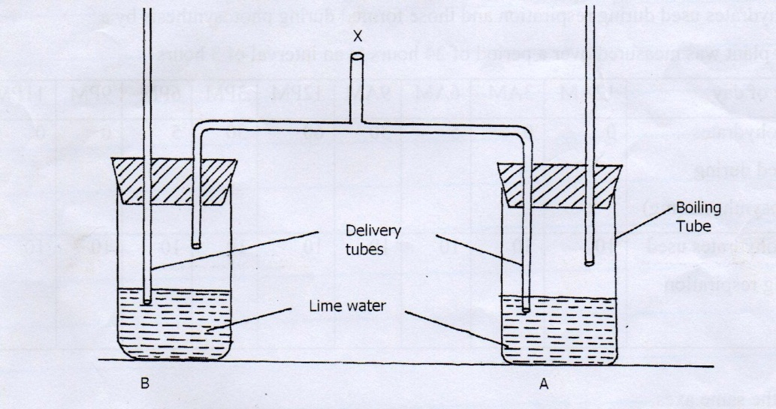

- A student blew air in and out through point X. Using arrows indicate how air gets in and out of the set up [2mks]

(b) [i] In which of the tube would lime water form white precipitate first. [1mk]
A
ii] Give a reason. [1mk]
exhaled air containing more carbon (IV) is bubled through solution A;
15.Photosynthesis is an enzyme controlled process which occurs within the chloroplasts in plant cells. Where in the chloroplast;
i)Is chlorophyll located? (1mk)

granum

ii)are enzymes located? (1mk)
stroma

iii)in what form are carbohydrates transported in the phloem? (1mk)
glucose

16.study the photographs below and answer the questions that follow.
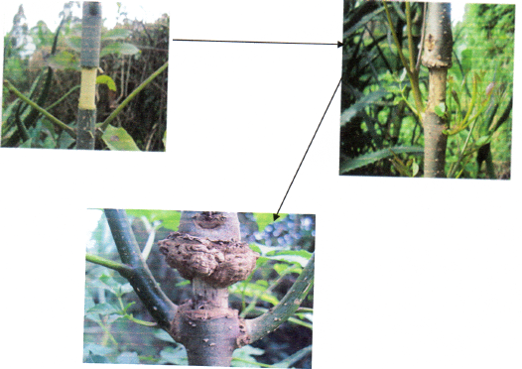

i) Name the process being investigated. (1 mark)

translocation

ii) Name the plant tissue involved in the physiological process illustrated above. (1 mark)

phloem

iii) Name the physiological process involved in the process illustrated above .(1 mark)

active transport/mass flow through diffusion

iv) list one adaptation of the tissue named in (ii) above (1 mark)
has companion cell with numerous mitochondria to provide energy required for translocation
has sieve plate to support sieve tubes
has plasmodesmata for exchange of materials between sieve tube and companion cell
has sieve pores for passage of filaments from one sieve tube to another; any correct

SECTION B

17. You are provided with photographs of plants labeled E, F, G, H, I, J and K
Use them to answer question that follows.

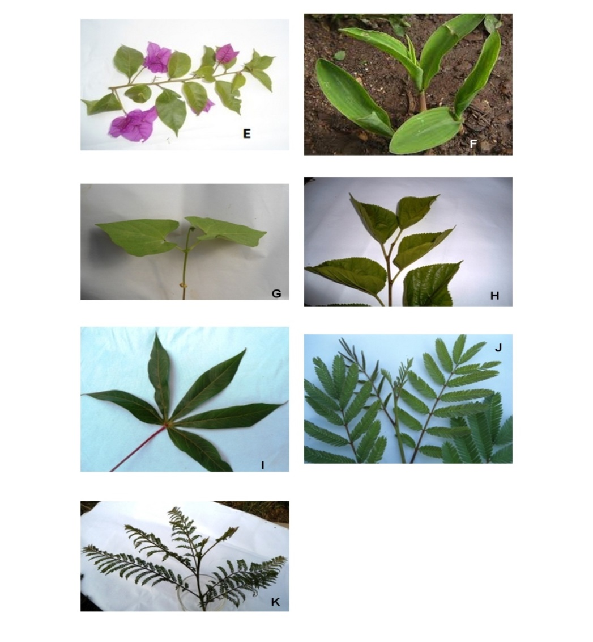
(i). Complete the dichotomous key below using observable features in the photograph given. (4mks)
1(a] simple leaf………………………………………………………………..go to 2
(b) Compound leaf………………………………………………………….. go to 5
2(a) Leaf with parallel veins……………………………………………… Poaceae
(b) leaf with net veins…………………………………................................... go to 3
3[a] leaf notched at the base ……………………………………….………. Phaseolus
b] Leaf not notched at the base………………………………………..…… go to 4
4 Leaf with smooth margin……………………………………………. Nyctaginaceae
(b) leaf with serrated margin................................................................ Rosaceae
5(a) Leaf palmate……………………………..…..……………………….. Euphorbiaceae
(b)leaf bipinnate……………………………………………………..…….. go to 6
6(a)leaflets pointed at the tip…………………………………….……… Fabaceae
(b) Leaflets rounded at the tip …………………………………………… Bignoniaceae

(ii) Use the completed dichotomous key to identify the plant (6 mks)
Specimen Steps Followed Identify
E 1a, 2b, 3b,4b ; Rosaceae;
F 1a, 2a ; Poaceae;
G 1a, 2b, 3a ; Phaseolus;

18. Below are the only types of human teeth found in an individual. Use them to answer the questions
that follow
A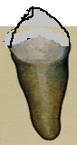 B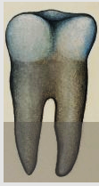 C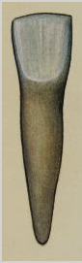
a) Write the order in which the teeth appear from front to back. 1mk
CAB
b) What is the role of teeth in human digestion? 2mks
mastication/breakdown of food into small pieces ;to increase surface area for enzyme action;
c) Are the teeth above from a nursery pupil or a secondary school student? 1mk
secondary
d) The pancrease of a patient was surgically removed. What was the effect on
i) Food digestion?2mks
food digestion in duodenum will cease; due to absence pancreatic enzymes;

ii) Blood sugar regulation?2mks
blood sugar regulation will cease; due to lack of insulin and glucagon hormones;

19. a) Name the essential parts of a flower. (2mks)
Gynoecium;
androecium;

b)i)At what stage of mitosis do chromosomes replicate to form daughter chromatids (1mark)
prophase

ii) State three differences between mitosis and meiosis (3marks)
mitosis | Meiosis
Produces two daughter cells | Produces four daughter cells
Each cell formed is diploid | Each cell formed is haploid
No variations | variations

c) How are female parts of wind pollinated flowers adapted to perform their function? (2marks)
Stigma is large and feathery to trap pollen
Stigma is hangs outside to trap pollen easily
Long style to expose the stigma to pollen

20. Describe how xerophytic plants are structurally adapted to their habitat. (20marks)

Their leaves are modified into spines/thorn like structures; to reduce surface area exposed for transpiration; their stomata are sunken; and water vapour accumulate on the sunken depression; lowering water vapour concentration gradient; between the atmosphere and the sub-stomatal air spaces; this reduces the rate of transpiration;
Leaves have thick waxy cuticles; to reduce cuticular transpiration;
The number of stomata is reduced to minimal; to reduce stomatal transpiration; Plants are deep rooted; so that the roots reach and absorb water found in deeper layers in the soil;
They have parenchyma cells (in the stem and leaves); for storage of water when it is in adequate supply for use during drought, (the cactus whose leaves and stem appear succulent);
Some have hairy leaves; that trap water vapour in between them to lower the diffusion gradient hence reducing water loss;
Most xerophytes have superficialt roots; which grow extensively close to the soils surface; enabling them to absorb maximum amount of water after a short shower; 20 mks

