MARKING SCHEME
231/3
Biology paper 3
(Practical)
1 ¾ HRS
December 2021.
MOKASA MOCK
Kenya Certificate of Secondary Education 2021
231/3
Biology paper 3
(Practical)
TIME: 1 ¾ HRS
December 2021.

1. You are provided with irish potato tuber labeled specimen K, use it to answer questions that follow.
Cut out two cubes whose sides measure 1cm from the irish potato provided
Label three test-tubes as, A, B and C and put them into the test-tube rack.
A ) Crush one cube to obtain a paste and add about 15 cm³ of distilled water to the paste to form a solution and then carry out the following procedure;
i) Use a measuring cylinder to pour 10 cm³ of potato extract solution into test-tube A.

ii) Use the measuring cylinder to transfer 5 cm³ of potato solution extract from test-tube A to test- tube B.

iii) Use the measuring cylinder to add 5 cm³ of distilled water to test-tube B. Place a stopper in test-tube B and shake it.

iv) Remove the stopper. Use the measuring cylinder to transfer 5 cm³ of the liquid in test- tube B to test-tube C.

v) Use the measuring cylinder to add 5 cm³ of distilled water to test-tube C. Place a stopper in test-tube C and shake it. Using a measuring cylinder reduce the volume of solution C to 5 cm³.
a) Table below shows the percentage concentration of the potato extract solution.

test-tube | percentage concentration of potato extract solution
A | 100.00
B | 50.00
C | 25.00

Complete the Table above by calculating and writing in the percentage concentration of potato extract solutions in test-tube B and C. 2mks

b ) Using a measuring cylinder pour 1 cm³ to each of hydrogen peroxide to the contents in test tube A to C and make the observations 3mks

Test tube | Observations
A | A lot/ more/ high amount of effervescence/bubbles
B | Moderate/ average amount of bubbles/effervescence
C | Little / few/small amount of effervescence/bubbles

( i) What was the aim of the investigation above 1mk

To determine the effect of catalase (enzyme) concentrarion on the rate of reaction/oxygen production

(ii) write the word equation for the reactions taking place in the test tubes 1mk
catalase
Hydrogen peroxide Water + Oxygen
enzyme
(iii) What will be the expected observation if the irish potato was replaced with a piece of mammalian liver 1mk
More effervescence/ bubbles produced when of liver was used as compared to when of irish potato was used.

(iv) Explain your answer in c (iii) above 2mk
Liver is animal excretory organ; liver has a high concentration of catalase enzymes to break down high level of toxic hydrogen peroxide produced in the liver.

(B) Crush the remaining cube to obtain the paste. Use the reagents provided to and carry out food test on the extract. (4mks)

TEST | PROCEDURE | OBSERVATIONS | CONCLUSION
Iodine test | To 2 ml of food substance/ potato extract (solution) add 2/3 drops of iodine solution and shake | The colour changes to blue – black | Starch present
Benedict’s test | To 2 ml of food substance/ potato extract (solution) add equal amount of Benedict’s solution and heat to boil | The blue colour of Benedict’s solution is retained/ remain | Reducing sugars absent

2. You are provided with specimens labeled L and M. Study them then answer questions that follow:
a) Identify the specimens. (2mk)
L..Axis vertebra
M..Lumbar vertebra
b) Name the part of the body where each is found. (2mk)
L..Neck region
M..Abdominal region
c) State three adaptive characteristic features of the bone L. (3mks)
Has an odontoid process that fits into the neural canal of the atlas and allows for rotational movements of the head.
Has a broad neural spine for attachment of neck muscles.
Has a neural canal for passage of spinal cord
Has a neural arch that protects the spinal cord
d)State two observable differences between bones L and M. (2mks)
Bone L | Bone M
Has short transverse processes | Large,well-developed transverse processes
Has an odontoid process | Lacks odontoid process

e) Study the diagrams below and answer questions that follow.

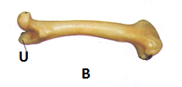C
I) Identify the bone labelled C in the diagram. (1mk)
Humerus
II) Name the type of joint and bone formed at the proximal and distal end of bone B (4mks)
Proximal end.
(i)Bone…Pelvic/hip girdle
(ii)Type of joint…ball and socket join
Distal end:
(i)Bone(s)…Tibia and fibula
(ii)Type of joint…Hinge joint

3. The photo graphs labelled W, X, Y and Z show seedlings that were grown under different conditions. Examine them.
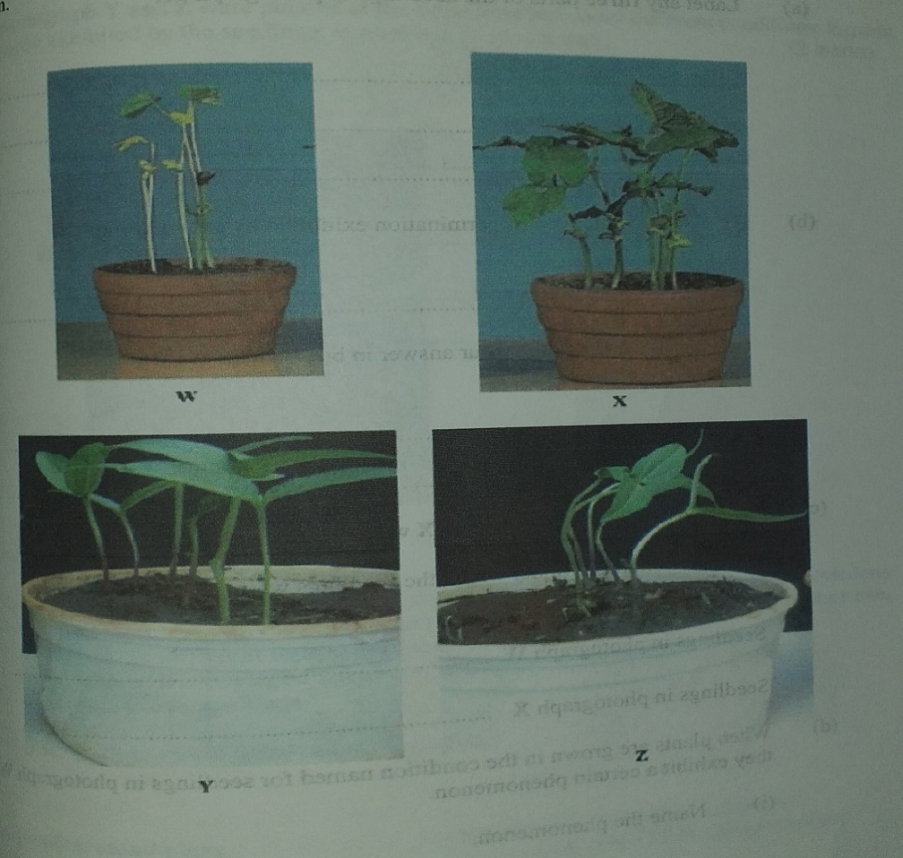
(a) Label any two parts of the seedlings in photograph W. (2 marks)

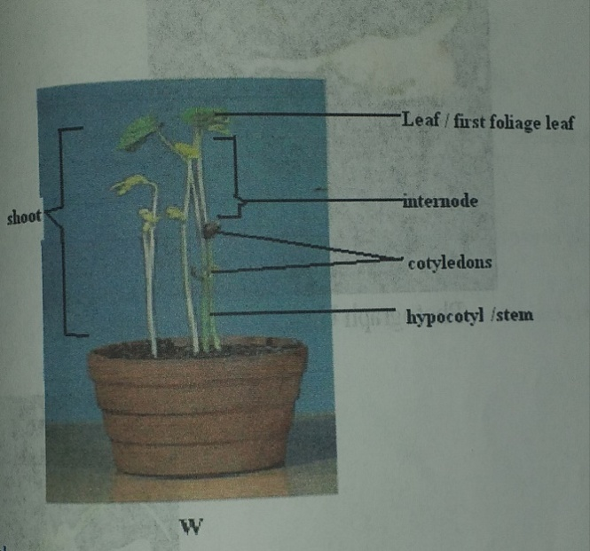

(b)(i)Name the type of germination exhibited by the seedlings. (1 mk)
Epigeal
(ii) Give a reason for your answer in b(i) above. (1 mk)
Cotyledons move above the ground/above soil
(c)Seedlings in photographs W and X were planted at the same time. State the conditions under which the seedlings were grown. (2 Mks)
(i) Seedlings in photograph W.
Grown in the dark/insufficient light/absence of light
(ii) Seedlings in photograph X.
Grown in light/sufficient light/adequate light
(d) When plants are grown in the condition named for seedlings in photograph W, they exhibit a certain phenomenon.
(i) Name the phenomenon. (1 mk)
Etiolation
(ii) State the significance of the phenomenon named in d(i). (1 mk)
To reach /search/obtain/seek light
(e) Using observable features only, state two differences between the seedlings in photographs W and X. (2mks)
W | X
Long internodes/stems | Short internodes/stem
Long and thinner stem | Short and thicker stem
Yellow/light green leaves | Green leaves
Small leaves | Large/big leaves

(f) Seedlings in photographs Y and Z were planted at the same time but under different conditions. Explain how the response exhibited by seedlings in photograph Z occurred. (2 mks)

Seedling subjectedto unidirectional/source of light; causes Auxins to migrate/diffuse/move to the dark side of the shoot; high auxins conc. On the dark side;causing faster cell elongation on that side than on the lit side hence the bending

N/B sequence must be right

