312/1
GEOGRAPHY
PAPER 1
DECEMBER 2021
Time: 2 ¾ hours

M O K A S A 2 J O I N T E X A M I N A T I O N
Kenya Certificate of Secondary Education
GEOGRAPHY
PAPER 1

Instructions to candidates
- This paper contains two sections: A and B.
- Answer ALL the questions in section A. In section B, answer question 6 and any other TWO questions.
- All the answers must be written in the answer sheets provided.

SECTION A

Answer all the questions in this section

1. (a) Define Physical Geography. (2 marks)

(b) State three importance of studying Geography. (3 marks)

2. (a) Distinguish between weather and climate. (2 marks)

(b) Give three characteristics of ITCZ. (3 marks)

3. (a) List three sources of sedimentary rocks. (3 marks)
(b) Give two examples of mechanically formed sedimentary rocks. (2 marks)

4. (a) Describe two ways in which biological weathering takes place. (2 marks)

(b) Identify three benefits of weathering to human activities. (3 Marks)
5. (a) What is a river confluence? (2 marks)
(b) List three processes of river erosion. (3 marks)

SECTION B

Answer question 6 and any other two questions in this section

6. Study the map of Yimbo 1: 50000 (sheet 115/1) provided and answer the following questions.

(a) (i) Give the latitudinal extent of the map. (2 marks)

(ii) What is the highest point of Usengi Hill? (2 marks)

(iii) Measure the length of the provincial boundary to the North West of the area covered by the map. Give your answer in kilometers.
(2 marks)

(iv) What is the area of Western Province in the area covered by the map?
(2 marks)

(b) The rectangle below represents the area in the map extract bounded by Eastings 30 and 39 and Northings 90 and 96.
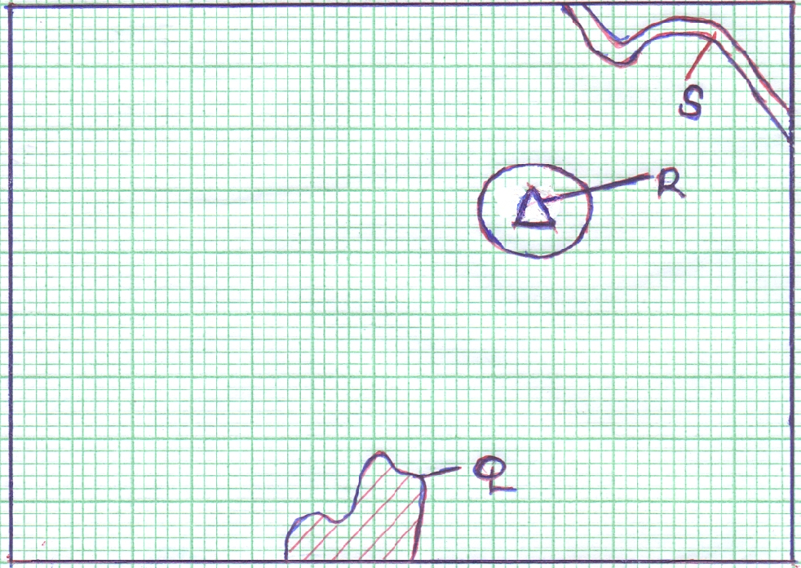

Name the features marked Q, R and S. (3 marks)

(c) Describe the characteristics of River Yala. (6 marks)

(d) (i) Describe the relief of the area covered by the map. (4 marks)

(ii) Explain two factors which have influenced the distribution of
Settlement in the area covered by the map. (4 marks)

7. (a) (i) What is folding? (2 marks)

(ii) State three factors that influence folding. (3 marks)

(b) (i) Apart from over thrust fold, name four other types of rocks.
(4 marks)

(ii) With the aid of well-labelled diagrams, describe the formation of an
Overthrust fold. (8 marks)

(c) Explain four significance of Fold Mountains to human activities. (4 marks)

8. (a) Give three ways in which the shape of landmasses may influence the
Movement of ocean waters. (3 marks)
(b) Distinguish between Constructive waves and the Destructive waves.
(2 marks)

(c) Describe three processes of wave erosion along the coast. (9 marks)

(d) The diagram below shows a wave deposition feature.
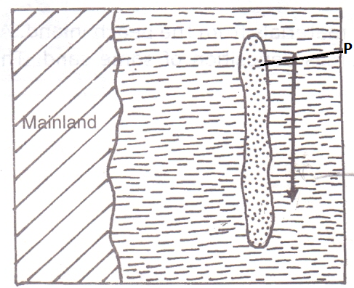
(i) Identify the feature labelled P. (1 mark)

(ii) State two factors that favors the formation of the feature named in (i)
above (2 marks)

(e) Students from Gedi Secondary School conducted a field study on coastal landforms.

(i) Identify three objectives for their study. (3 marks)

(ii) Give three preparations they made for their study. (3 marks)

(iii) Mention two methods they might have used to collect information before the actual field study. (2 marks)

9. (a) (i) Define underground water. (2 marks)

(ii) Explain how the following factors influence availability of
Underground water. (2 marks)
- Slope of the land
- Vegetation cover

(b) (i) State three conditions that are necessary for the formation of an
Artesian well. (3 marks)

(ii) State three problems that are associated with an artesian well.
(3 marks)

(c) (i) Differentiate between a Karst scenery and Karst region. (2 marks)

(ii) The diagram below shows the underground features in limestone
areas.

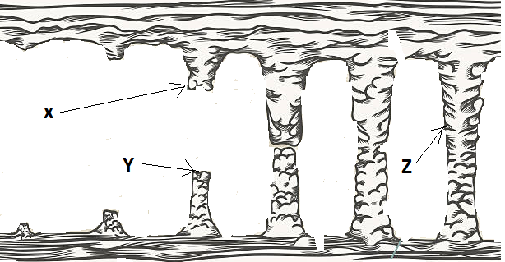

Identify the features marked X, Y and Z. (3 marks)

(d) Form four students of a school are planning to carry out a field study on a Karst landscape around their school.

(i) Name two surface features are likely to identify.
(2 marks)

(ii) Give three reasons why they needed a working schedule. (3 marks)

(iii) Why was it necessary for them to divide into groups during their study? (3 marks)

10. (a) What is soil? (2 marks)

(b) (i) Name three components of soil. (3 marks)

(ii) Describe how the following factors influence the formation of soil.
- Topography (3 marks)
- Nature of the parent rock (3 marks)

(c) (i) Define soil profile. (2 marks)

(ii) The diagram below represents a well-developed soil profile. State the characteristics of horizon A. (4 marks)

(d) Explain four ways in which farming practices may lead to loss of soil fertility.
(8 marks)

