Name: …………………………………………………………………………….. Class: ………… Adm.No……………..
School: …………………………………………………………………………… Date: ………………………………………
Sign:………………………………………..
121/1
MATHEMATICS
PAPER 1
DECEMBER 2021
TIME: 2 ½ HOURS

M O K A S A II J O I N T E X A M I N A T I O N - 2021
Kenya Certificate to Secondary Education
MATHEMATICS (PAPER 1)
TIME: 2 ½ HOURS

Instructions
- Write your name, class, admission number, school, date and signature in spaces provided above.
- The paper contains two sections A and B.
- Answer all questions in section A and any five questions from section B in the spaces provided below each question.
- Show all the steps in your calculations giving your answers at each stage in the spaces below each question.
- Non-programmable silent electronic calculator and mathematical tables may be used except where stated otherwise.

For Examiner’s Use Only
1 | 2 | 3 | 4 | 5 | 6 | 7 | 8 | 9 | 10 | 11 | 12 | 13 | 14 | 15 | 16 | TOTAL
SECTION A

SECTION B
PERCENTAGE
SCORE

17 | 18 | 19 | 20 | 21 | 22 | 23 | 24 | TOTAL

SECTION A

Answer all questions in this section in the spaces provided

1. The sum of two numbers exceeds their product by one. Their difference is equal to their product less five. Find the two numbers. (3 marks)

2. Musa has twenty shillings more than Aisha. After he spends a quarter of his money
and Aisha ⅕ of hers, they find that Aisha has 10 shillings more than Musa. How much money did both have? (4 marks)

3. The number 2942m08 is divisible by 11. Find the least value of m and the square of m. (3 marks)

4. Give the inequalities which define the region R in the diagram shown below. (3 marks)

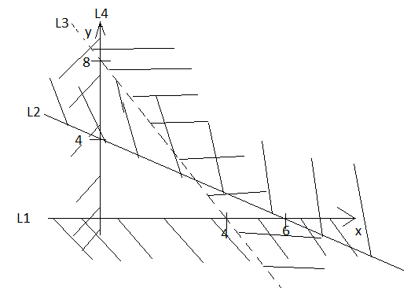

5. Given P = $\begin{matrix} 2 & 0 \\ -2 & 1\end{matrix}$ , Q = $\begin{matrix}4 & -1 \\ 3 & 2\end{matrix}$ and R = $\begin{matrix}2 & -1 \\ -4 & 5\end{matrix}$ , find PQ + R.
(3 marks)

6. A Kenyan businessman bought goods from Japan worth 2,900,000 Japanese Yen. On arrival in Kenya, custom duty 10% was charged on the value of the goods. If the exchange rates were as follows:
1 US dollar = 118 Japanese Yen
1 US dollar = 78 Kenyan Shillings.

Calculate the duty paid in Kenya Shillings. (3 marks)

7. Solve the equation; (3 marks)
$4^{x}+2^{2x+1}=36$

8. Line AB is perpendicular to a line whose equation is $y - 2x + 7= 0$ and passes through point $(-4, 5).$ Determine the equation of AB in the form y = mx + c.
(3 marks)

9. Simplify the following expression. (3 marks) $\frac{\cos^{2}{θ}-1}{\sin{θ}}$

10. Without using a calculator evaluate using squares, square roots and reciprocal tables the following:- (3 marks)
$\frac{2}{{30.16}^{2}}+ \frac{10}{\sqrt{588.3}}$

11. Two of the exterior angles of an irregular polygon are 63⁰ each. The remaining exterior angles are each 26⁰. Determine the number of sides of the polygon.
(3 marks)

12. A number when divided by 10, 15 and 18, the reminders are 7, 12 and 15 respectively. Find the lowest number. (3 marks)

13. The figure below shows part of a circle. Complete the circle and determine the radius and the centre of the circle. (3 marks)

14. In the figure below, DC is a tangent to the circle centre O at D. AOBC is a straight line meeting DC at C. DC = 12 and BC = 8. Find the radius of the circle. (3 marks)

O
C
8 cm
B
A

12cm
D

15. x varies directly as the cube of y and inversely as the square root of z. When x=24, y=2 and z=16. Find z in terms of x and y. (3 marks)

16. Evaluate; $\int_{-1}^{2}{\left({-x}^{3}+5x-2\right)}dx$ (4 marks)

SECTION B

Answer any five questions in this section
17. The figure below is a model representing an open storage container. The model
whose total height is 80 cm is made up of a frustum top, a hemispherical bottom and the middle part is cylindrical. The diameter of the top of the frustum is 28 cm, the base of the frustum diameter of the cylindrical and hemispherical part is 42 cm. The height of the cylindrical part is 29 cm.

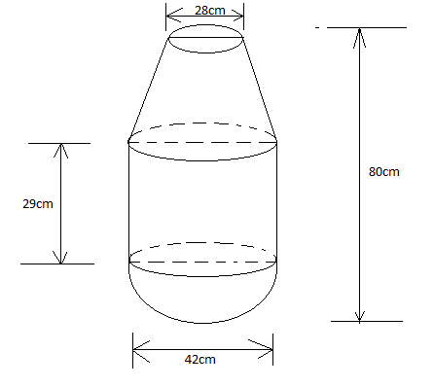

(a) Calculate the surface area of the solid above (5 marks)

(b) The actual height of the container is 8 metres. Calculate the capacity of the
container to the nearest litre. (5 marks)

18. The table below shows marks scored by 40 students in a Mathematics test.
Marks | 30-39 | 40-49 | 50-59 | 60-69 | 70-79
No. of Students | 2 | 10 | 13 | 8 | 7

- Using and assumed mean of 54.5, calculate the mean mark. ( 5 marks)

- Calculate the variance. (3 marks)

- Calculate the standard deviation. ( 2 marks)

19. Two policemen were together at a road junction. Each had a walkie talkie. The maximum distance at which one could communicate with the other was 2.5km. One of the policemen walked due East at 3.2km/h while the other walked due North at 2.4km/h. The policeman who headed east travelled for x km while the one who headed North travelled for y km before they were unable to communicate.

(a) Draw a sketch to represent the relative positions of the policemen. (1 mark)

(b) (i) From the information above form two simultaneous equations in form of x
and y. (2 marks)

(ii) Find the value of x and y. (5 marks)

(iii) Calculate the time taken before the police were unable to communicate. (2 marks)

20. Complete the table of the functions y = 1+x-2x² (2marks)
x | -3 | -2 | -1 | 0 | 1 | 2 | 3
-2x² | -18 |  |  | 0 | -2
1 | 1 | 1 | 1 | 1 | 1 | 1 | 1
y | -20 | -9 |  |  | 0

b) Draw the graph of the function y = 1+x -2x² on the graph paper provided (3marks)

c) Use your graph to find the value for x in the equations 1 + x -2x²=0 ( 1 mark)

d) By drawing a suitable line graph on the same graph find the value for x which satisfies the equation 5 + 2x -2x²=0 (3marks)

e) State the maximum point of the function y = 1+x -2x² (1mark)

21. (a) The position vectors of points A and B are a and b respectively. C is another point
with position vectors $c= \frac{6}{4}b - \frac{2}{4}a$. Express in terms of $a$and $b$vectors.

(i) $\vec{AB}$ (1 mark)

(ii) $\vec{CB}$ (1 mark)

(iii) $\vec{CA}$ (1 mark)

(iv) Show that A, B and C are collinear. (3 marks)

(v) Determine the ratio AB:BC (1 mark)

(b) Given that $\vec{OP}=3i+8j-3k and \vec{OP}=3i+2j+2k.$ Find $|PQ|$ correct to 2dp.
(3 marks)

22. (a) Given a curve $y=10+3x-x^{2}$ , use the trapezoidal rule with 5 trapezia to
estimate the area bounded by the curve from $x=-1 to x=4.$ (4 marks)

(b) Find the actual area under the curve by integration method from $x=-1 to x=4.$
(4 marks)

(c) Find the percentage error introduced by the approximation. (2 marks)

23. (a) A man standing 20m away from a building notices that the angles of
elevation of the top and bottom of a flagpole mounted at the top of the building are 64⁰ and62⁰ respectively. Calculate the height of the flagpole.
(4 marks)

(b) The angles of elevation of the top of a tree from P and Q which are 30m apart
are 22⁰ and 32⁰ respectively. Given that the two points are on the same side of the tree and on a straight line, determine the height of the tree. (6 marks)

24. The displacement s metres after t seconds is given as $s={-t}^{3}+3t^{2}+4$.

(a) Find its initial acceleration. (3 marks)

(b) Calculate;

(i) The time when the particle was momentarily at rest. (3 marks)

(ii) The acceleration in ${m/s}^{2 } when t=3s$ (2 marks)

(c) Find the maximum velocity attained by the particle. (2 marks)

