NAME………………………………………………...………….……ADM. NO………………….. …………

Candidates Signature:……………………………………..

Date:…………………………………………..

443/1

AGRICULTURE

Paper 1

Time: 2 hours

Kenya Certificate of Secondary Education

AGRICULTURE

PAPER 1

2 HOURS

INSTRUCTIONS TO CANDIDATES
- Write your name and Adm. Number in the spaces provided above.
- Sign and write the date of examination in the spaces provided above.
- This paper consists of three sections A, B and C
- Answer all the questions in section A and B
- Answer any two questions in section C
- All answers should be written in the spaces provided.
- This paper consists of 8 Printed pages
- Candidates should check the question paper to ascertain that all the pages are printed as indicated and that no questions are missing.

For Examiner’s use only
Section | Questions | MAXIMUM SCORE | CANDIDATE’S SCORE
A | 1 - 16 | 30
B | 17 - 19 | 20
C |  | 40
Total Score |  | 90

SECTION A (30 marks)
Answer all the questions in this section in the spaces provided.
- State four characteristics of shifting cultivation (2 marks)
………………………………………………………………………………………………………………………………………………………………………………………………………………………………………………………………………………………………………………………………………………………………………………………………………………………………………………………………………………………………………………………………………………………………
- Give four reasons why a well drained soil is suitable for crop production (2 marks)
………………………………………………………………………………………………………………………………………………………………………………………………………………………………………………………………………………………………………………………………………………………………………………………………………………………………………………………………………………………………………………………………………………………………

- State four factors which determine the depth of ploughing (2 marks)
………………………………………………………………………………………………………………………………………………………………………………………………………………………………………………………………………………………………………………………………………………………………………………………………………………………………………………………………………………………………………………………………………………………………

- State three advantages of overhead irrigation over surface irrigation (1¹/₂ marks)
………………………………………………………………………………………………………………………………………………………………………………………………………………………………………………………………………………………………………………………………………………………………………………………………………………………
- a)State the law of demand (1 mark)
………………………………………………………………………………………………………………………………………………………………………………………………………………………………………………………………………………
b) State four factors that determine the demand of a commodity in a free
Market economy (2 marks)
………………………………………………………………………………………………………………………………………………………………………………………………………………………………………………………………………………………………………………………………………………………………………………………………………………………………………………………………………………………………………………………………………………………………
- state four ways in which plant nutrients may be lost from the soil (2 marks)
………………………………………………………………………………………………………………………………………………………………………………………………………………………………………………………………………………………………………………………………………………………………………………………………………………………………………………………………………………………………………………………………………………………………

- a)Differentiate between macro nutrients and micro nutrients (1 mark)
………………………………………………………………………………………………………………………………………………………………………………………………………………………………………………………………………………
b) State four functions of calcium in plant growth and development (2 marks)
………………………………………………………………………………………………………………………………………………………………………………………………………………………………………………………………………………………………………………………………………………………………………………………………………………………………………………………………………………………………………………………………………………………………
- Explain the following terms as used in farm account (4 marks)
- Cash account
…………………………………………………………………………………………………………………………………………………………………………………………………………………………………………
- Ledger
…………………………………………………………………………………………………………………………………………………………………………………………………………………………………………
- Balance sheet
…………………………………………………………………………………………………………………………………………………………………………………………………………………………………………
- Purchase order
…………………………………………………………………………………………………………………………………………………………………………………………………………………………………………

- State four factors that influence spacing when planting a pure stand maize (2 marks)
………………………………………………………………………………………………………………………………………………………………………………………………………………………………………………………………………………………………………………………………………………………………………………………………………………………………………………………………………………………………………………………………………………………………

- State four reasons for pruning fruit crop (2 marks)
………………………………………………………………………………………………………………………………………………………………………………………………………………………………………………………………………………………………………………………………………………………………………………………………………………………………………………………………………………………………………………………………………………………………

- State four ways by which a farmer can make efficient use of pasture crop (2 marks)
………………………………………………………………………………………………………………………………………………………………………………………………………………………………………………………………………………………………………………………………………………………………………………………………………………………………………………………………………………………………………………………………………………………………
- List four characteristics of a good root stock for grafting (2 marks)
………………………………………………………………………………………………………………………………………………………………………………………………………………………………………………………………………………………………………………………………………………………………………………………………………………………………………………………………………………………………………………………………………………………………
- Give four factors to consider when grading tomatoes for fresh market (2 marks)
………………………………………………………………………………………………………………………………………………………………………………………………………………………………………………………………………………………………………………………………………………………………………………………………………………………………………………………………………………………………………………………………………………………………
- Give three ways through which checkdams control soil erosion (1¹/₂ marks)
………………………………………………………………………………………………………………………………………………………………………………………………………………………………………………………………………………………………………………………………………………………………………………………………………………………………………………………………………………………………………………………………………………………………
- State two uses of gross margin analysis in farm business (1 mark)
………………………………………………………………………………………………………………………………………………………………………………………………………………………………………………………………………………

SECTION B
Answer all the questions in the spaces provided
- The diagrams illustrated below shows arable weeds. Study them carefully and answer the questions that follow

B
A

- Identify the weeds A and B (2 marks)
A……………………………………………………………………………………………………………………………B……………………………………………………………………………………………………………………………

- Why is it difficult to control weeds A and B (2 marks)
A……………………………………………………………………………………………………………………………B……………………………………………………………………………………………………………………………

- List three economic importance of the weeds illustrated above (3 marks)
………………………………………………………………………………………………………………………………………………………………………………………………………………………………………………………………………………………………………………………………………………………………………………………

- The diagram shows a pest that attacks beans in the field. Study it carefully and answer the questions that follow.
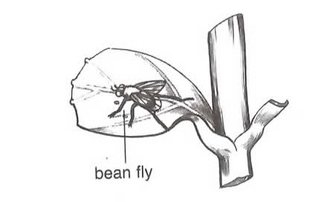

- Identify the pest illustrated above (1 mark)
…………………………………………………………………………………………………………………………

- List three cultural methods of controlling the pest illustrated above (3 marks)
………………………………………………………………………………………………………………………………………………………………………………………………………………………………………………………………………………………………………………………………………………………………………………

- State two other pest that attack beans in the field (2 marks)
……………………………………………………………………………………………………………………………………………………………………………………………………………………………………………………

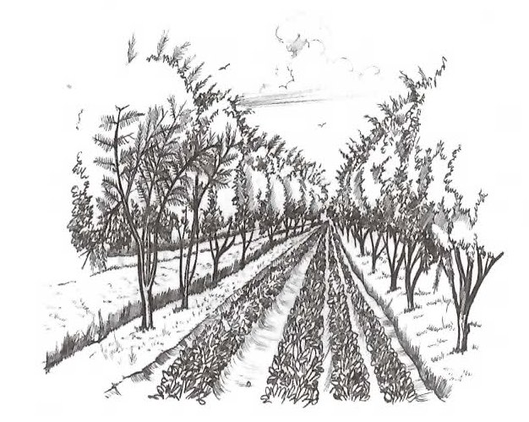
- The diagram below illustrates an agroforetsry practice. Study it carefully and answer the questions that follow.

- Identify the agroforestry practice illustrated above (1 mark)
…………………………………………………………………………………………………………………………
- List three benefits of the above agroforestry practice (3 marks)
……………………………………………………………………………………………………………………………………………………………………………………………………………………………………………………………………………………………………………………………………………………………………………………………………………………..
- State three sites for agroforestry trees (3 marks)
……………………………………………………………………………………………………………………………………………………………………………………………………………………………………………………………………………………………………………………………………………………………………………………………………………………….

SECTION C
Answer ONLY two questions in this section in the spaces provided after the questions
- a) Give four examples of joint products in livestock production (4 marks)
b) List four variable inputs in poultry production (4 marks)
c) A farmer can combine dairy meal and homemade feeds as shown below

Dairy meal (Kg) | Homemade feed (Kg) | Marginal rate of substitution
1 | 48 | O
2 | 39 | V
3 | 32 | 7
4 | 27 | W
5 | 23 | 4
6 | 21 | X
7 | 20 | 1
8 | 19 | Y

- Given the above information calculate the marginal rate of substitution and give values of V,W,X and V (4 marks)
- Given that of homemade feeds is Ksh 800 per kilogram and that of homemade feeds is Ksh 200 per kilogram. Calculate the least cost combination(4 marks)
- Outline four activities that may be undertaken in organic farming (4 marks)
- a)State and explain five roles of agriculture in economic development of Kenya (5 marks)
b) Describe measures which should be taken to minimize water pollution on a
farm (10 marks)
c) State and explain the various land tenure systems practiced in Kenya (5 marks)
- a) Outline six management practices that should be carried out on a vegetable nursery after sowing seeds until the seedlings are ready for transplanting (6 marks)
b) Explain four precautions that should be observed when harvesting cotton (4 marks)
c) Explain five ways in which the Kenyan government can improve maize production to ensure food security in the country (10 marks)
……………………………………………………………………………………………………………………………………………………………………………………………………………………………………………………………………………………………………………………………………………………………………………………………………………………………………………………………………………………………………………………………………………………………………………………………………………………………………………………………………………………………………………………………………………………………………………………………………………………………………………………………………………………………………………………………………………………………………………………………………………………………………………………………………………………………………………………………………………………………………………………………………………………

………………………………………………………………………………………………………………………………………………………………………………………………………………………………………………………………………………………………………………………………………………………………………………………………………………………………………………………………………………………………………………………………………………………………………………………………………………………………………………………………………………………………………………………………………………………………………………………………………………………………………………………………………………………………………………………………………………………………………………………………………………………………………………………………………………………………………………………………………………………………………………………………………………………………………………………………………………………………………………………………………………………………………………………………………………………………………………………………………………………………………………………………………………………………………………………………………………………………………………………………………………………………………………………………………………………………………………………………………………………………………………………………………………………………………………………………………………………………………………………………………………………………………………………………………………………………………………………………………………………………………………………………………………………………………………………………………………………………………………………………………………………………………………………………………………………………………………………………………………………………………………………………………………………………………………………………………………………………………………………………………………………………………………………………………………………………………………………………………………………………………………………………………………………………………………………………………………………………………………………………………………………………………………………………………………………………………………………………………………………………………………………………………………………………………………………………………………………………………………………………………………………………………………………………………………………………………………………………………………………………………………………………………………………………………………………………………………………………………………………………………………………………………………………………………………………………………………………………………………………………………………………………………………………………………………………………………………………………………………………………………………………………………………………………………………………………………………………………………………………………………………………………………………………………………………………………………………………………………………………………………………………………………………………………………………………………………………………………………………………………………………………………………………………………………………………………………………………………………………………………………………………………………………………………………………………………………………………………………………………………………………………………………………………………………………………………………………………………………………………………………………………………………………………………………………………………………………………………………………………………………………………………………………………………………………………………………………………………………………………………………………………………………………………………………………………………………………………………………………………………………………………………………………………………………………………………………………………………………………………………………………………………………………………………………………………………………………………………………………………………………………………………………………………………………………………………………………………

