231/2 - BIOLOGY PAPER 2 (THEORY)
DECEMBER 2021
SUKELLEMO JOINT MOCK EXAMINATION
MARKING SCHEME
- Below is a diagram showing part of human digestive system.

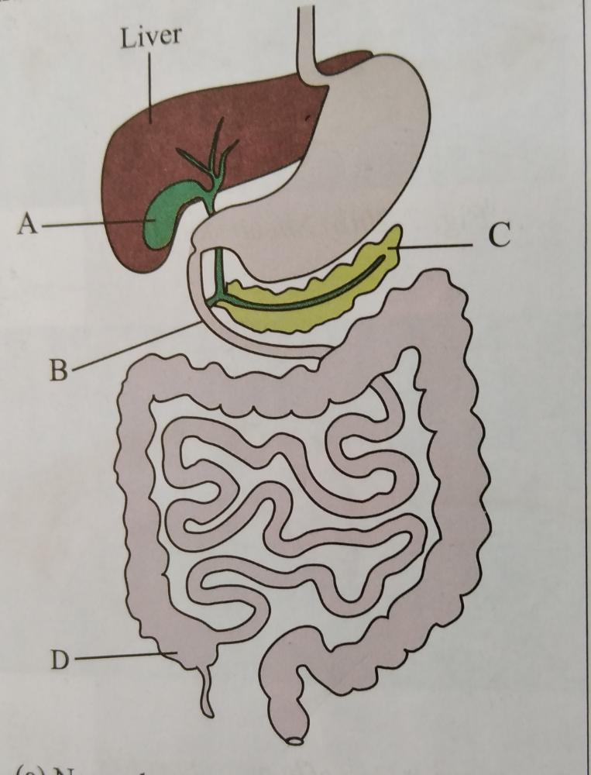

(a)Name the parts labelled B and C. (2mks)
B Duodenum;
C Pancreas;
b (i)Name the substance produced by the part labelled A. (1mk)
Bile;
(ii) State the functions of the substance named in b(i) above. (1mk)
Emulsifies fat;
Neutralizes acidic chyme;

c) What is the functional relationship between the part labelled A and the liver (1mk)
The liver synthesizes bile which is stored in organ A;
d) The part labelled D is poorly developed in humans. Name the group of mammals in which it is well developed and describe its role. (3mks).
Herbivores;
Contains bacteria which secrete enzyme cellulase; which digests cellulose;
- Study the diagram of the mammalian ear and answer the question that follow. 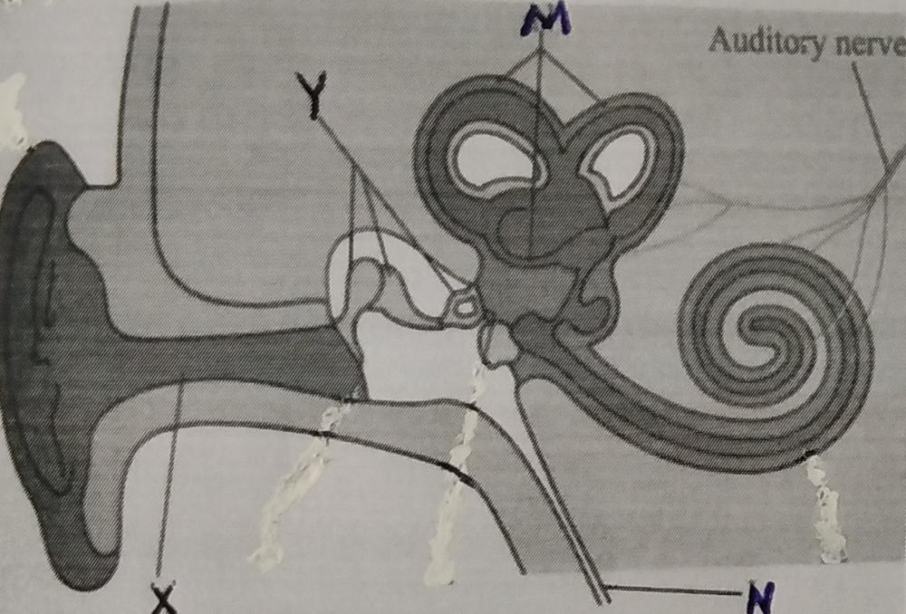
- Name the parts labelled X, Y and N. (2mks)
X- External auditory meatus;
Y- Ear ossicles;
Z-Eustachian tube;
- State how the parts labelled Y are adapted to their functions.
They are bony (solid) and small forming a lever system that amplifies and transmits vibrations to the oval window;
They are loosely held by suspensory ligaments which enables them to transmit vibrations;
c(i) Besides hearing, state one other function of the ear. (1mk)
Maintaining body posture/Balance;
(ii) Which of the labelled parts is responsible for the function you have stated in c(i) above. (1mk)
M;
(d) What would happen if the auditory nerve is completely damaged?
Deafness;
Lack of balance; Mark any one.
- In human beings, the allele for a curved thumb (T) is dominant over the allele for a straight thumb (t).
(a) State the possible genotypes of individuals who have curved thumbs. (2mks)
TT; Tt;
(b).Work out the genotypic and phenotypic ratio of a cross between a heterozygous male and a female with a straight thumb. (5mks)
Tt X tt ;

;
t
t
t
T

; phenotypic ratio
Curved thumb : straight thumb
Tt Tt tt tt 2 : 2
Genotypic ratio Tt : tt 1 : 1 ;
1:1;
- What is mutation. (1mk)
Mutation is a sudden/spontaneous change in the genetic make up of an organism;
- The diagram below shows part of a longitudinal section of a young root.

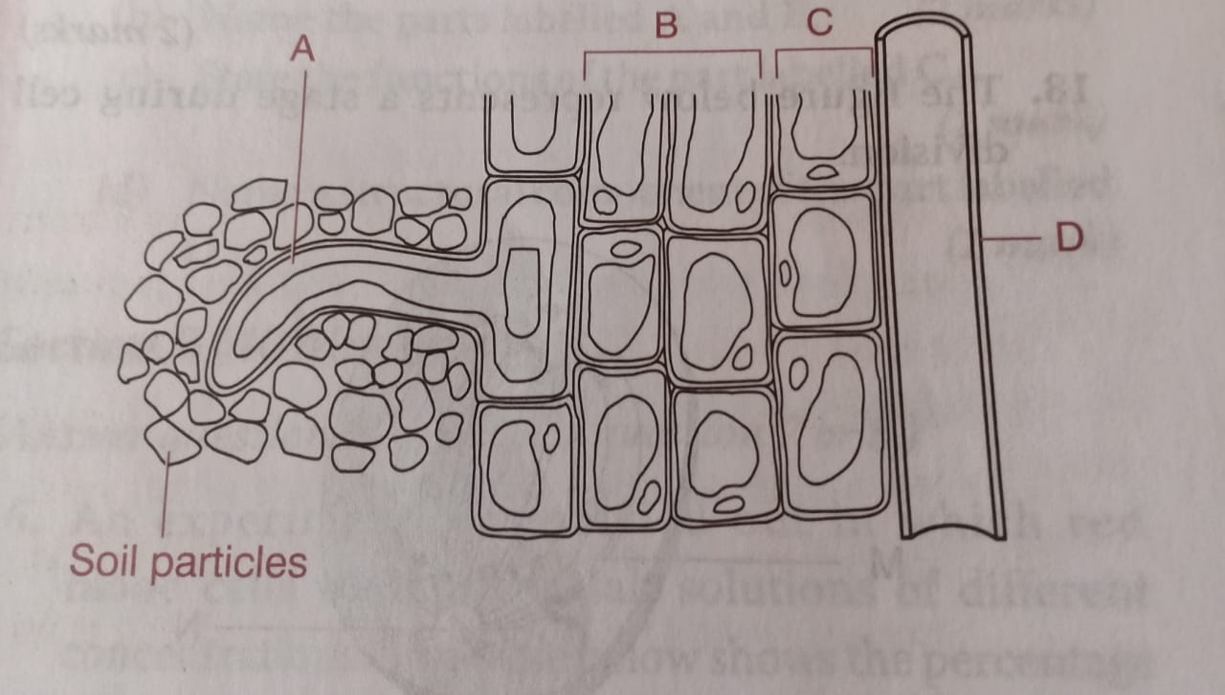
- Name the parts labeled: (2mks)
B – Cortex;
C- Endodermis;

- State the significance of cell A. (1mk)
Absorption of water and mineral salts;
(c) Explain how water from the soil reaches tissue D. (4mks)
Water is absorbed into the root hair cell by osmosis; due to higher concentration in the root hair cell than in the soil water; water dilutes the cell sap of the root hair cell thus water moves into the adjacent epidermal cells by osmosis; continues and water moves into cortex cells by osmosis, into the endodermis; and eventually into the part D (xylem of the root) 5mks max 4mks
(d)State one adaptation of part D to its function. (1mk)
- Its walls are lignified to prevent it from collapsing;
-Narrow lumen for capillarity;
-Lack cross walls for continuous flow of water; Mark 1st one
- A student obtained a piece of petiole of pumpkin leaf and split it lengthwise into two halves. She placed one of the split in solution A and the other in solution B. After 30 minutes she observed that the split in solution A was firm, rigid and curved outwards while the one in solution B was soft, flabby and curved inwards.
(a) Account for the observations made for split in A and B.
A (3mks)
Solution A is hypotonic to the cell sap of the cortical cells; The cortical cells gain water by osmosis; and become turgid; Epidermal cells have waterproof cuticle; hence gains little /no water; resulting to the curvature outward. 5mks max 3mks
B (3mks)
Solution B is hypertonic to the cell sap of the cortical ells; The cortical cells lose water by osmosis; and become flaccid; Epidermal cells do not gain water (due to the presence of the cuticle); hence the curvature inwards. 4mks max 3mks
(c ) State two roles of the process that was being investigated in this experiment. (2mks)
Absorption of water;
Support in herbaceous plants;
Feeding in insectivorous plants;
Movement of water from cell to cell; Mark 1st 2.
- The data provided below represent the growth of a pollen tube of a certain plant species over a given time.
Time in minutes | 0 | 30 | 60 | 90 | 120 | 150 | 180
Growth in millimetres | 0 | 2.6 | 7.6 | 15.6 | 19.8 | 21.4 | 21.8

- Draw a graph of growth of pollen tube against time. (6mks

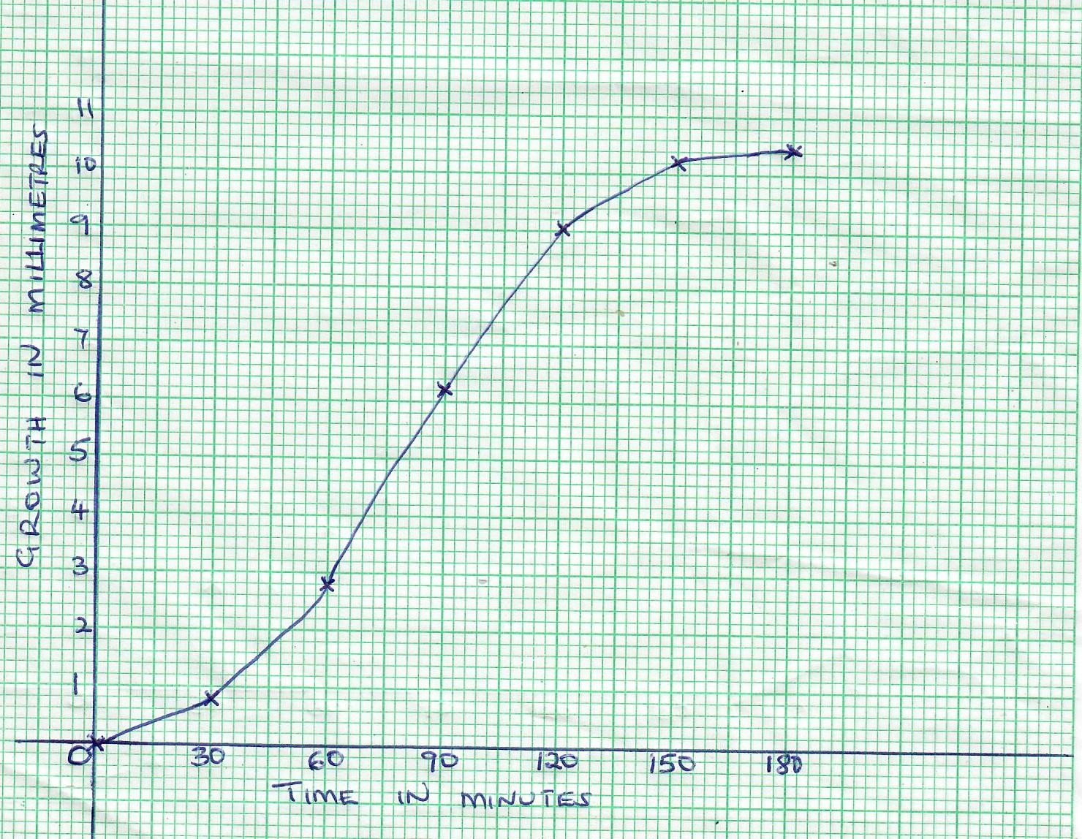

- (i) At what intervals was the growth of the pollen tube measured. (1mk)
30 minutes;
(ii) At what time was the length of the pollen tube 18mm? (1mk)
105 minutes;
(c) With reasons describe growth pattern of the pollen tube between:
(i) 0 to 120 minutes (1mk)
Rapid growth;

Reason (1mks)

Availability of sugars/sucrose/nutrients; hence rapid growth
- 120 to 180 minutes (1mk)
Slow growth;
Reason (1mks)
Less nutrients resulting to competition; hence slow growth
- Apart from nutrients, state two factors that affects the growth of pollen tube (2mks)
Temperature;
pH;
- State two functions of the pollen tube. (2mks)
-Secretes enzymes that digest the stigma /style/ovary tissues
-Offer passage for the male nuclei to own and polar nuclei/embryosac;
(e)Describe what happens when the pollen tube enters the embryo sac. (4mks)
Tip of the pollen tube bursts open/tube nucleus disintegrates; One of the male nucleus fuses with the egg cell nucleus; to form a diploid zygote; while the other male nucleus fuses with the polar nuclei; to form a triploid endosperm nucleus; 5 mks max 4 mks
- (a) Define the following terms: (3mks)
- Excretion-Is the process by which organisms remove metabolic waste from the body;
- Egestion-Removal of undigested/indigestible food materials;
- Secretion-Production of substances by glands that are useful to the body;
(b) Describe how urea is formed in human body. (7mks)
Urea is formed from excess amino acids;
Excess amino acids are deaminated; in the liver; forming carboxyl group and amino group; the amino group is converted to ammonia; which is toxic Ammonia enters the ornithine cycle where it combines with carbon (IV)oxide; to form urea; which is less toxic
(c ) Explain the various methods of excretion in plants giving examples of waste product in each case. (10mks)
Diffusion of gases eg. carbon( IV) oxide; oxygen through the stomata/lenticels;
Some wastes are stored in tissues in non toxic forms; eg caffeine; nicotine, quinine
Some of these tissues/organs drop off from plants;
Some wastes are released by transpiration; through stomata eg water vapour ;
Others are released by guttation; through hydathodes eg water;
Others are released by exudation; eg latex; gum resins
11 mks max 10 mks
- (a) Why is locomotion important to animals? (4mks)
searching for food/ mates/ shelter;
Migration away from unfavourable places;
Escape from predators / enemies;
Colonization of new areas;
(b) Explain how a finned fish is adapted to swimming. (16mks)
Vertebral column consists of a series of vertebrae; held together loosely so that its flexible;
Myotomes/ muscles; associated with vertebral column produce movement;
The sideways and backwards thrust of the tail and body against water; result in resistance of the water pushing the fish sideways and forwards in a direction opposed to the thrust;
Head is inflexible; to maintain the forward thrust;
Body streamlined; to reduce resistance;
Presence of fins; for forward movement/balance in water;
Presence of swim bladder; make fish buoyant;
Scales tip towards the back; provide smooth surface to reduce resistance(friction);
Body covered with mucus making it slippery; hence reducing friction during movement in water;
18 mks max 16 mks

